**KIJISET EXAMITION CHEMISTRY PAPER 1 MARKING SCHEME**

**Chemistry pp1**

**233/1**

1. i)X 2.8.2

Y 2.8.7

ii) ionic bond

giant ionic structure

iii)

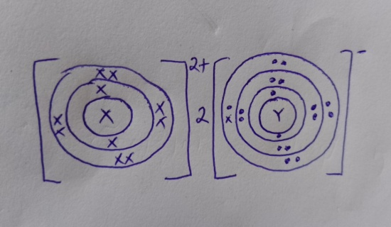

2. (i) N 1

(ii) P 1 – it is a weak base1

3. It produces less heat 1 mk

Makes apparatus dirty

4. Alkene

Alkanols 1mk

5a) Soap / soapy detergent

b) B ( 1)– does not form scum with hard water / economical( 1)

6. a) i) n = 92

m = 36

ii) Production of energy or electricity for domestic and industrial use.

b. 228 224 + 4He or ( ∝ )

Th Ra

90 88 2

7.  *- Immiscible*

*-Different densities*

8. a) i) Dehydration ( ½ )

ii) Oxidation ( ½ )

b) Cu(s) + 2H2SO4(l) CuSO4(aq) + SO2(g)  + 2H2O(l) (1)

9(a) (i) Yield increases; volume of the reactants higher than volume of the product. (1mk)

(ii) Yield decreases; high temperature favours backward reaction. (1mk)

(b) Finely divided iron. (1mk)

1. 10. 

 ½

 ½

 ½

 ½

 ½

 ½

(3mks)

11.  1

Breaking of C= c bond + 610 KJ

Breaking of Br-Br Bond = 193 KJ 1

Formation of 2c – Br Bond = - 280x2 KJ 1

243KJ

b) Addition reaction 1

12. (a) Brine ( conc. Sodium Chloride Solution ) NaCl (aq)

Ammonia gas NH3 (g)

Calcium Carbonate CaCo3

Any 2 ½ each

(b) Heating 1

(c) Ammonia and Carbon (IV) Oxide 1

Reject water.

13. Add excess ½ copper turnings to 50% nitric acid. ½ Filter ½ to obtain Copper (II) Nitrate solution. ½ Add Sodium Carbonate ½ Solution and Copper (II) Carbonate will precipitate. Filter ½ and allow the residue to dry.

14.

* 1. A Bright white flame and a white powder✓1
  2. ✓1
  3. Gas C is Insoluble in water ✓1

15. A – Diamond 🗸½

B – Graphite 🗸½

(b) - Drilling metals . Any 🗸½

- Jewelling.

(c) B 🗸½ Existence of delocalised electrons 🗸½ which conduct electric current. 🗸½

16. a) Zn(s) + HCl(aq)  ZnCl2(aq) + H2(g)

b) Water

c) Hydrogen formed is oxidized to water.

17. No effect on blue litmus paper (1), methylbenzene non- polar thus doesn’t dissociate hydrogen chloride to hydrogen ions which turn blue litmus paper red.(1)

18 . ***H2SO 3(aq) + Dye H2SO4 (aq) + Dye + [o] ✓1***

***(coloured) (coloureless)***

***HOCl(aq) + Dye HCl (aq) + Dye + [o] ✓1***

***(coloured) (colourless)***

**19. a) *It acts as an impurity in the ice hence lowering its melting point. ✓ ½***

**b) *Salt accelerates the rate of rusting of the iron parts of the motor vehicles. ✓ ½***

**20. a) *The rate of diffusion of a fixed mass of gas is inversely proportional to the square root of its density at constant temperate and pressure. ✓1***

b)

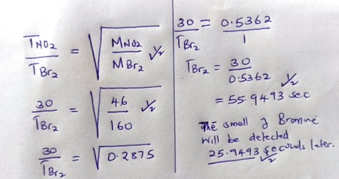

21.

***a) The reaction is exothermic $∴$ heat produced maintains the reaction***

***b) Platinum***

***c) 4 NH3(g) + 5 O2(g) 4 NO (g) + 6 H2O(l)***

1. ***22.*** alternative A

Q =it

= 0.4 x 30 x 60 1

=720C 1

Pb2+(aq) + 2e 🡪 Pb(s) 1

2 x 96500C ½ 🡪 207 ½

720C = 🡪 ?

 ½

 ½

Alternative B

Q = it

= 0.4 x 30 x 60

= 720 C ½

No. of farads = 7.46 x 10-3

96500

= 7.46 x 10-3

2F 🡪 207g

7.46 x 10-3 F 🡪 ?

 ½

= 0.77g ½

***23.*** a) SO42-

b) Ba2+(aq) + SO42-(aq) BaSO4(s) ✓1

c) Al(OH)4 (aq) -✓1

24. a)

|  |  |
| --- | --- |
| Fe | O  **2:3**  **Fe2O3** |
| 7 | 3      ½  1.5 |

b) 2 Fe2 O3(s) + 3 C(s) 4 Fe(s) + 3 CO2(g)🗸

***25.***  (a) - Zinc blende ✓ ½

- Calamine ✓ ½

(b) 2ZnS(s) + 3O2(g) 2ZnO(s) + 2SO2(g) (any 1 x 1mk)

(for Zinc blende)

OR ZnCO3(s) ZnO(s) + CO2(g)

(for calamine)

(c) - Galvanising iron

- Making brass (Alloy of Zinc and copper) (Any 2 x ½ mk)

- Used as a negative electrode in dry cells.

(or outer casing of dry-cells)

26. (a) An oxide which reacts with both acids and alkalis ✓1

(b) ZnO, PbO, Al2O3 (any 2 x ½ mk)

27. (a) *- Hydrated Iron (III) oxide*

(b) *- High temperatures*🗸¹

*- Acidic conditions*🗸¹

*- Salty conditions first two*

*28.* PCl3 – have simple molecular structure 🗸½ and weak van der waal forces. 🗸½

NaCl – has ionic bond 🗸½ and giant ionic 🗸½ structure ionic bonds are

stronger than van-der-waal bond hence high melting point. 🗸¹