NAME :…………………………………………………………. INDEX: ……………………
CANDIDATES SIGNATURE: ………………………………...DATE :…………………….

CHEMISTRY PAPER 1 233/1
TIME: 2HOURS
FORM 4 END OF TERM 2 EXAMINATIONS 2021
INSTRUCTIONS:
- Answer all the questions in the spaces provided.
- Mathematical tables and silent non-programmable electronic calculators may be used.
- All working must be clearly shown where necessary.
- Candidates should answer the questions in English.

For examiners use only
Question | Maximum  score | Candidates  score
1-29 | 80

- Element Y has atomic number 8 while X has 16 .
- Write electronic arrangement of X and Y (1mk)
X-

Y-

- Name the type of bond and structure formed when X and Y react. (2mks)
Bond-

Structure-

- Explain why it is not advisable to leave a jiko with a burning charcoal in a closed room where one is sleeping. (2mks)

- The following equation shows a reversible reaction

H_{2(g)} + Br_{2(g}) 2HBr_{g} -74.4KJ
Red Brown Colourless
State and explain the observation that can be made when
- Temperature is increased. (1 ½ mks)

- Pressure is reduced. ( 1 ½ mks)

- A mixture contains zinc oxide, iron (iii) chloride and potassium chloride. Describe how each of the substances can be obtained from the mixture. (3mks)

- Using a dot (.) and cross (x) diagram, draw the structure for silicon (IV) chloride. (2mks)
(Atomic numbers Si= 14, Cl=17)

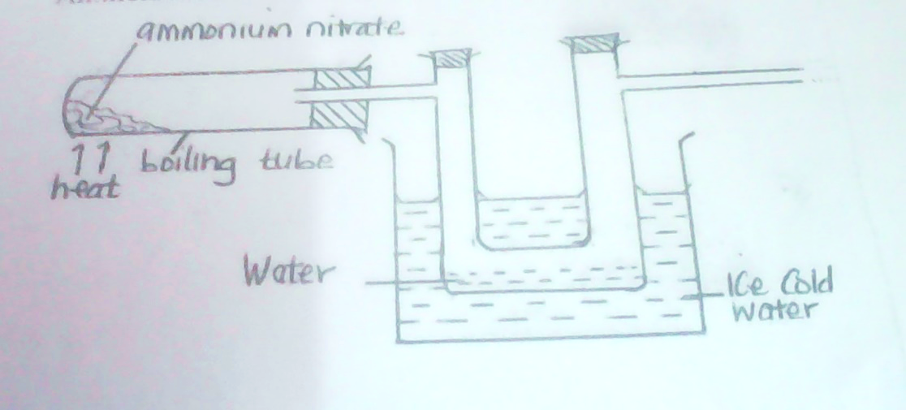

- Ammonium nitratewas gently heated as shown above.
- Complete the diagram to show how the gas is collected. (1mk)

- Write the equation for the reaction occurring in the boiling. (1mk)

- State one chemical test that can be used to identify the gas collected in the above set up. (1mk)

- (a) What is a saturated solution? (1mk)

(b) 115g of a saturated solution at 65ºc is found to contain 65g of potassium nitrate. Calculate the solubility of potassium nitrate at 65ºc. (2mks)

- What do you understand by the term prescription in relation to drugs? (1mk)

- Starting with sodium solid, describe how a sample of sodium hydrogen carbonate crystals may be prepared. (3mks)

- State boyles law. (1mk)

b. a gas occupies 500cm³ at 27ºc and 100,000 pa. What will be its volume at 0ºc and 101325 pa. (3mks)

11. Write equations to show the effect of heat on each of the following:
a) Sodium hydrogen carbonate (1mk)

b) Silver nitrate (1mk)

- Anhydrous iron (ii) sulphate (1mk)

12.A student electroplated a spoon with copper metal. Write an equation for the process that took place at the cathode. (1mk)

b) Calculate the time in minutes required to deposit 1.184g of copper if a current of 2 amperes was used. ( 1 faraday = 96500 coulombs, cu= 63.5). (2mks)

13. In the extraction of Sulphur by the frasch process, hot compressed air at 15 atmospheres is forced down the innermost pipe.
(a)What is the role of the hot compressed air? (1mk)
(b)Which allotrope of sulphur;

- Is stable below the transition temperature at 96⁰c. (1mk)

- has prismatic crystals (1mk)

14. The graph below shows the radioactive decay for a sample 400g of iodine -131.
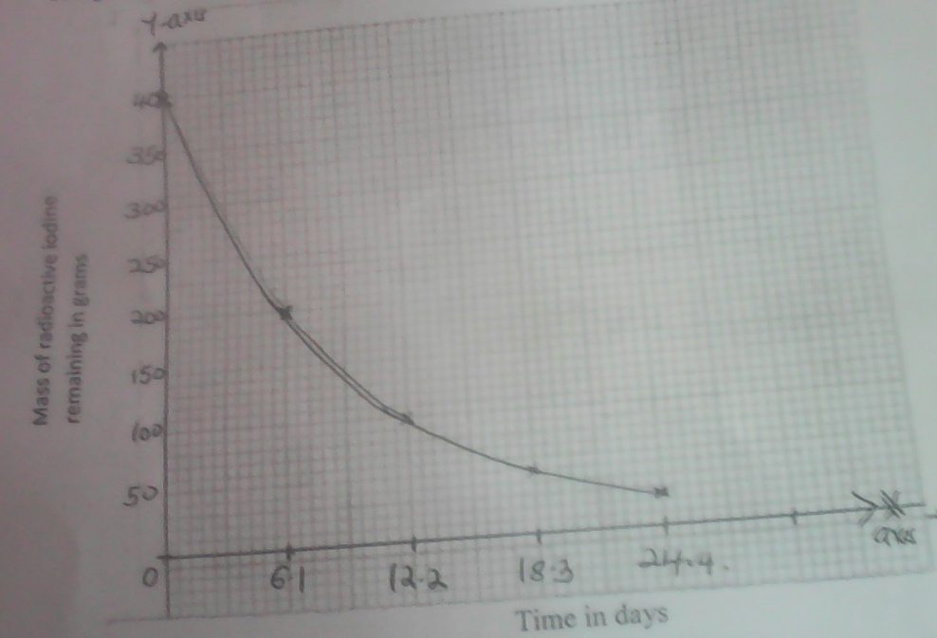

- Define half life. (1mk)

- From the graph determine the half life of iodine -131. (1mk)

- Determine the mass of the isotope present after 36.6 days. (1mk)

15. A certain salt was found to form a solution when exposed to air. Name the process undergone by the salt. (1mk)

b. give one example of such a salt. (1mk)

16. State and explain two observations made when a spatula of sodium carbonate solid is added to aluminum chloride solution in a boiling tube. (2mks)

Observation

Explanation

17. The structure below shows a portion of a polymer

H H H H

C C C C

C₆H₅ H C₆H₅ H n
n

- Draw a repeat unit of the polymer. (1mk)

- Name the polymer. (1mk)

18. Give one use and difference between the apparatus below. (3mks)

 | Use | difference
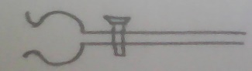

19. Element R has two isotopes with mass numbers 29.46 and 31. If the relative atomic mass of element R is 30, determine the percentage abundances of each isotope. (3mks)

20. When chlorine is bubbled through water, the resulting solution acts as a bleaching agent.
a)Write an equation for the reaction between chlorine gas and water. (1mk)

b)Using an equation, explain how the resulting solution acts as a bleaching agent(1 mk)

21. In an experiment, dry hydrogen gas was passed over heated lead (ii) oxide as shown in the diagram below.

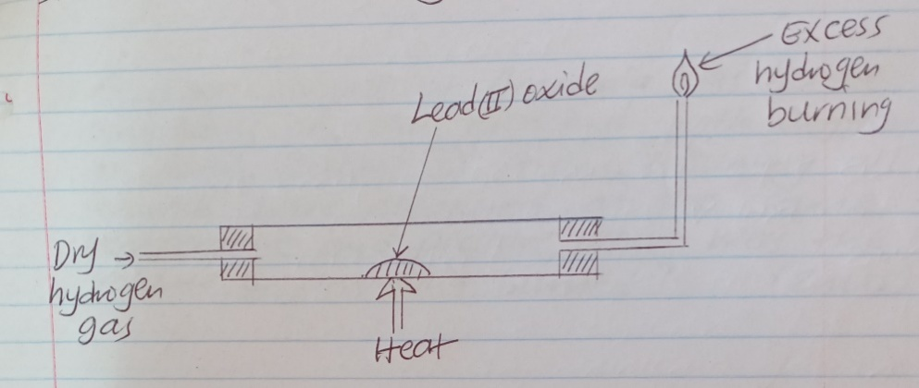

State and explain the observations made in the combustion tube. (3mks)

22. State gay-lussacs law. (1mk)

b) A given volume of ammonia gas burned completely in air enriched with oxygen to form 300cm³of steam and nitrogen gas. Assuming all volumes were measured at the same temperature and pressure, what was the volume of ammonia burned. (2mks)

23. The diagram below shows the apparatus for preparation of hydrogen sulphide gas.

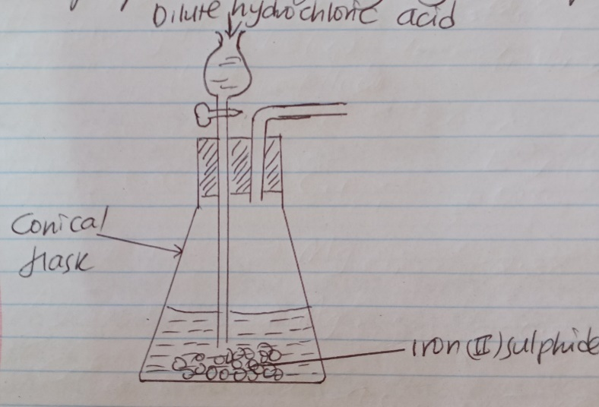

- Complete the diagram to show how hydrogen sulphide gas is collected. (2mks

- Write an equation for the reaction that takes place in the conical flask. (1mk)

- This experiment should only be carried out in fume cupboard. Explain (1mk)

24. The table below gives some properties of three elements in group vii of the periodic table. Study it and answer the questions that follow.
Element | Atomic  no | Melting  point(ºC) | Boiling  Point (ºC)
Chlorine | 17 | -101 | -34.7
Bromine | 35 | -7 | 58.8
iodine | 53 | 114 | 184

- Which element is in liquid form at room temperature? Give a reason (1mk)

- Explain why the boiling point of iodine is much higher than that of chlorine. (2mks)

25. Study the set up below and use it to answer the questions that follow.

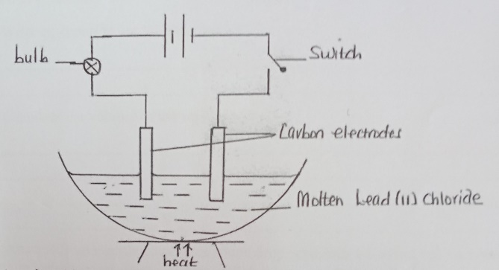

- State and explain an observation that would be make at the anode when the circuit is completed. (2 mks)
- Write an equation for the reaction at the cathode. (1 mk)
26. In preparation of amnonia gas 30cm3 of nitrogen gas and 30cm3 of hydrogen gas were exploded in a vacuum
(i) Write an equation for this reaction. (1 mk)

(ii) Calculate the volume of the residual gases. (2 mk)

27. juice extracted from a nettle plant were added drop wise into a boiling tube containing 5cm3 potassium hydrogen carbonate solution until there was no further change.
(a) Explain the observation made in the boiling tube when the reaction was going on. (2 mks)

- What observation would have been made if the nettle juice were added to silver metal in a boiling tube? Explain (1 mk)

28. The set up below was used to prepare and collect carbon (ii) oxide in the laboratory.
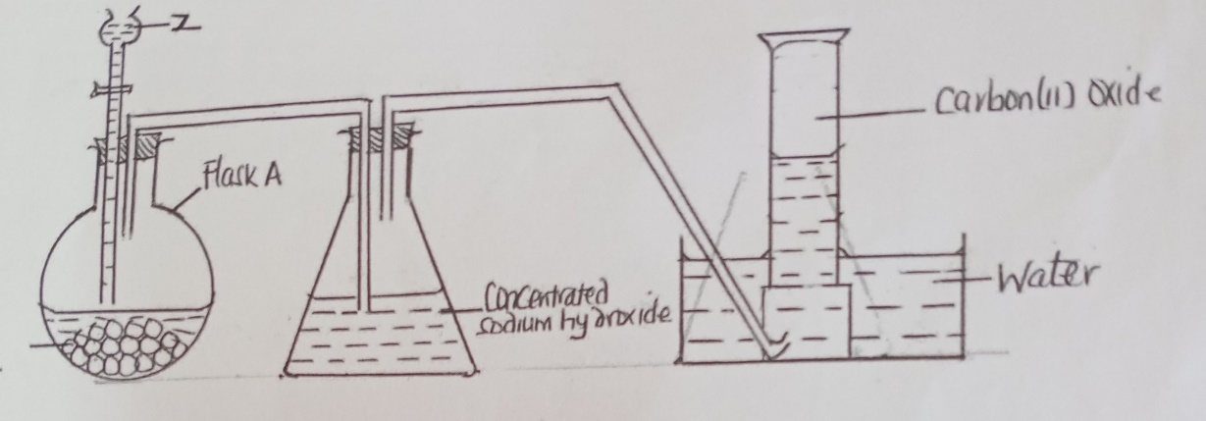

(i) Identify Z and give its role in the reaction. (1 mk)
(ii) Write an equation for the reaction in the flask a. (1 mk)
(iii) Give one use of carbon (II) oxide. (1 mk)

29. When 94.5g of hydrated barium hydroxide Ba(OH)2.nH2O was heated toa constant mass, 51.3g of anhydrous barium hydroxide was obtained. Determine the empirical formula of the hydrated barium hydroxide (Ba = 137, O=16, H=1) (3 mks)

