Name ………………………………………………………….Index No………………………………….
Candidates signature ……………………………………. Date…………………………………………….

233/2
CHEMISTRY
Paper 2
Theory
2 hours

ARISE AND SHINE TRIAL 1 EXAMINATION -2022
Kenya Certificate of Secondary Education (K.C.S.E)

Instructions.
- Write your named and index number in the spaces provided above.
- Answer all questions in the spaces provided in the question paper.
- Mathematical tables (KNEC) and silent electronic calculators may be used.
- All workings must be clearly shown where necessary.
- Candidates should answer the questions in English.

For examiners use only.
Question | Maximum score | Candidate’s score
1 | 12
2 | 10
3 | 12
4 | 12
5 | 12
6 | 12
7 | 10

- The grid below shows part of the periodic table. Use it to answer question the follow. The letters do not represent actual symbols.
 |  |  |  |  |  | S | U | V
P | R |  |  |  |  | T |  | W
Q

(a). Which of the elements has the highest atomic radius? Explain. (2 marks)
………………………………………………………………………………………………………………………………………………………………………………………………………………………………………………………………………………………………………………………………………………………
………………………………………………………………………………………………………………….
(b). Identify the most reactive non-metal. Explain. (2 marks)
………………………………………………………………………………………………………………………………………………………………………………………………………………………………………………………………………………………………………………………………………………………
………………………………………………………………………………………………………………….
(c). Give the electron configuration of:
(i). Element S. (¹/₂ mark)
……………………………………………………………………………………………………………………………………………………………………………………………………………………………………
(ii). Element Q. (¹/₂ mark)
……………………………………………………………………………………………………………………………………………………………………………………………………………………………………
(d). Compare the atomic radius of P and R. Explain. (2 marks)
………………………………………………………………………………………………………………………………………………………………………………………………………………………………………………………………………………………………………………………………………………………
………………………………………………………………………………………………………………….
(e). Given that the atomic mass of W is 40. Write down the composition of its nucleus. (1 mark)
………………………………………………………………………………………………………………………………………………………………………………………………………………………………………………………………………………………………………………………………………………………

(f). Write the formula of compounds formed between
(i). Element P and S. (1 mark)
……………………………………………………………………………………………………………………………………………………………………………………………………………………………………
(ii). Element R and T. (1 mark)
……………………………………………………………………………………………………………………………………………………………………………………………………………………………………
(g). Give the formula of one stable Ion with an electron arrangement of 2.8 which is
(i). Negatively charged. (1 mark)
……………………………………………………………………………………………………………………………………………………………………………………………………………………………………
(ii). Positively charged. (1 mark)
……………………………………………………………………………………………………………………………………………………………………………………………………………………………………
2. Study the flow chart below and answer the question that follows.

Polymer P
CH₃CHCH₂
Substance T
Q
Substance W
Gas V
Step V H⁺/KMnO₄
Step IV conc
H₂SO₄

Br₂
Step III
Step I H₂, Nickel
Step II

Na₂CO_{3(s)}
Step VI

- Identify the following
- Substance W ……………………………………………………………. (1mark)

- Gas V ………………………………………………………………….... (1 mark)
- Name the processes involved in the following steps
- Step I …………………………………………………………………… (1 mark)

- Step II ………………………………………………………………….. (1 mark)

- i. What type of reaction is taking place in step V. ( 1mark)
....................................................................................................................................................................................................................................................................................................................................
(iii). Draw the structure and give their IUPAC name for the following compounds. (4 marks)
Compound | Structure | Name
Q | (1 mark) | ( 1mark)
P | (1 mark) | (1 mark)
- Write the equation that took place in step III. (1 mark)
……………………………………………………………………………………………………………………………………………………………………………………………………………………
3. Study the standard electrode potentials for the half cells given below and answer the questions that follow.
Eº (volts)
A⁺_{(aq)} + e⁻ A_{(s)} -2.92
B⁺_{(aq) +} e- B_{(s)} + 0.52
C⁺_{(aq)} + e- 1/₂C_{2(g)} 0.00
D²⁺ + 2e- D_{(s)} -0.44
¹/₂E_{2(aq)} + e⁻ E_{(aq)} +1.36

a. Identify the strongest oxidising agent. Explain. (2 marks)
………………………………………………………………………………………………………………………………………………………………………………………………………………………………………………………………………………………………………………………………………………………
………………………………………………………………………………………………………………….
b. (i). Which two half cells would produce the highest potential difference combined. (1 mark)
……………………………………………………………………………………………………………………………………………………………………………………………………………………………………
(ii). Give the cell diagram for b (i) above (1mark)
…………………………………………………………………………………………………………………………………………………………………………………………………………………………………….
c. (I). Explain whether the reaction represented by the equation below can take place. (2 marks)
2A⁺_{(aq)} + D_{(s)} A_{(s)} + D²⁺_{(aq)}
(II). 90cm³ of acidified water was electrolysed using the set up below.

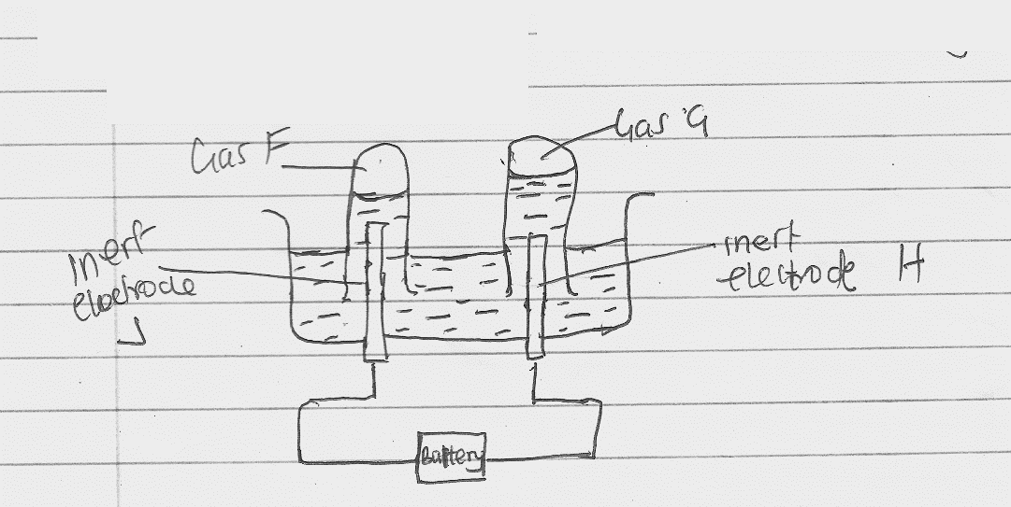

- Identify electrodes H and J
H - …………………………………………………………………… .(¹/₂ mark)

J - …………………………………………………………………… (¹/₂ mark)

- Describe how gas F can be identified. (2marks)
...................................................................................................................................................................................................................................................................................................................................................................................................................................................................................................................................................................................................................................................................................................
- In the above experiment 5A of electricity was passed through the acidified water for 3 minutes and 21 seconds. Calculate the volume of gas G produced at room temperature and pressure molar gas volume at r.t.p= 24000cm³/ F=96 500c. (3 marks)
.............................................................................................................................................................................................................................................................................................................................................................................................................................................................................................................................................................................................................................................................................................................................................................................................................................................................................................................................................................................................................................................................................................................................................................................................................................
4.(a). The following results were obtained in an experiment
Mass of crucible + Lid = 19.52g
Mass of crucible + Lid + Magnesium ribbon = 20.36g
Mass of crucible + Lid + Magnesium oxide = 20.92g

(i). Use the results to determine the percentage mass of magnesium and oxygen in magnesium oxide.
(2 marks)
..................................................................................................................................................................................................................................................................................................................................................................................................................................................................................................................................................................................................................................................................................................
(ii). Determine the empirical formula of magnesium oxide.
(Mg = 24, O = 16)
.............................................................................................................................................................................................................................................................................................................................................................................................................................................................................................................................................................................................................................................................................................................................................................................................................................................................................................................................................................................................................................................................................................................................................................................................................................
(b). Sodium hydroxide pellets were accidentally mixed with sodium chloride. 8.8g of the mixture were dissolved in water to make one litre of solution. 50cm³ of the solution was neutralised by 20cm³ of 0.25M Sulphuric acid.
(i). Write an equation for the reaction that took place. (1mark)
.........................................................................................................................................................................................................................................................................................................................................................................................................................................................................................................................
(ii). Calculate the:
(I). number of moles of the substance that reacted with sulphuric acid. (2 marks)
....................................................................................................................................................................................................................................................................................................................................................................................................................................................................................................................................................................................................................................................................................................

(II).number of moles of the substances that would react with sulphuric acid in the one litre solution. (2 marks)
....................................................................................................................................................................................................................................................................................................................................................................................................................................................................................................................................................................................................................................................................................................
(iii). The percentage of sodium chloride in the mixture. (2 marks)
(H = 1.0, Na = 23.0, Cl = 35.5, O = 16.0)
....................................................................................................................................................................................................................................................................................................................................................................................................................................................................................................................................................................................................................................................................................................
5. (a). In an experiment to determine the heat of combustion of ethanol the following data was collected.
Volume of water = 450cm³
Initial temperatures of water = 25ºc
Final temperature of water = 46.5ºc
Mass of ethanol + lamp before heating = 125.5g
Mass of ethanol + lamp after heating = 124.0g

Calculate:
(i). Heat evolved during the experiment (Density of water = 1g/cm³, specific heat capacity of water
= 4.2k/kg⁻¹k⁻¹. (2 marks)
....................................................................................................................................................................................................................................................................................................................................................................................................................................................................................................................................................................................................................................................................................................
....................................................................................................................................................................................................................................................................................................................................................................................................................................................................................................................................................................................................................................................................................................
(ii). Molar heat of combustion of ethanol. (2 marks)
(C = 12, O = 16, H = 1).

....................................................................................................................................................................................................................................................................................................................................................................................................................................................................................................................................................................................................................................................................................................
(b). Write the equation for the complete combustion of ethanol. (1 mark)

...........................................................................................................................................................................................................................................................................................................................................................................................................................................................................................................................
(c) The molar heat of combustion obtained from an experiment like the one above is usually lower than the theoretical value.
Explain. (2 marks)
....................................................................................................................................................................................................................................................................................................................................................................................................................................................................................................................................................................................................................................................................................................

(d). The molar heat of combustion of hydrogen is given as -286K/mol⁻²
(i). Write the thermochemical equation for the reaction. (1 mark)
..................................................................................................................................................................................................................................................................................................................................................
(ii). Draw an energy level diagram for the reaction in b (i) above. (2 marks)

e(i). What is a fuel? (1 mark)
..................................................................................................................................................................................................................................................................................................................................................
(ii). State two factors considered when choosing fuel. (1 mark)
..................................................................................................................................................................................................................................................................................................................................................
6. The factors which affects the rate of reaction between lead (II) carbonate and dilute nitric (V) acid were investigated by carrying out three experiments.
Experiment number | Lead (II) carbonate | Concentration of nitric (V) acid
1 | Lumps | 4M
2 | Powdered | 4M
3 | Lumps | 2M
(a). Other than concentration, name another factor that was investigated in the experiment. (1mark)
..................................................................................................................................................................................................................................................................................................................................................
(b). For each experiment the same volume of acid (excess) and mass of lead (II) carbonate were used and the volume of gas liberated measured with time.
(i). Draw set up that can be used to investigate the rate of reaction for one of the experiments. (3 marks)

(ii). On the grid provided, sketch the curves obtained when the volume of gas produced was plotted against time for each of the experiments and label each as 1,2 or 3. (3 marks)

Volume
Of gas
(cm³)

Time (seconds)
(iii). Write an equation for the reaction that took place. (1mark).
...........................................................................................................................................................................................................................................................................................................................................................................................................................................................................................................................
(c). If the experiments were carried out using dilute hydrochloric acid instead of dilute nitric (V) acid, the reaction would start, slow down and eventually stop. Explain. (2 marks)

....................................................................................................................................................................................................................................................................................................................................................................................................................................................................................................................................................................................................................................................................................................
(d). Bromine gas dissolves in water according to the following equation.
Br²_{(g)} + H₂O_{(l)} $⇌$ 2H⁺_{(aq)} + Br⁻_{(aq)} + OBR⁻_{(aq)}
Colourless.
Yellow/orange
State and explain the observation made when hydrochloric acid is added to the mixture at equilibrium.
(2 marks)
...........................................................................................................................................................................................................................................................................................................................................................................................................................................................................................................................
7. In an experiment to determine the solubility of potassium chlorate, the following results were obtained.

Total volume of water added (cm³) | 10.0 | 20.0 | 30.0 | 40.0 | 50.0
Mass of potassium chlorate | 5.0 | 5.0 | 5.0 | 5.0 | 5.0
Temperature at which crystals appear (ºc) | 80.0 | 65.0 | 55.0 | 45.0 | 30.0
Solubility of potassium chlorate (g/long H₂O)
(a).Complete the table to show the solubility of potassium chlorate at different temperatures. (3 marks)
(b). Plot a graph of mass of potassium chlorate per 100g water against temperature at which crystals from.
(3 marks)
(c). From the graph, determine:
(i). the solubility of potassium chlorate at 40ºC. (1 mark)
..................................................................................................................................................................................................................................................................................................................................................
(ii). The temperature at which the solubility of potassium chlorate is 35g/100g water. (1 mark)
..................................................................................................................................................................................................................................................................................................................................................

(d). Explain the shape of the graph. (1 mark)
....................................................................................................................................................................................................................................................................................................................................................................................................................................................................................................................................................................................................................................................................................................
(c). State one application of solubility and solubility curves. (1 mark)
..................................................................................................................................................................................................................................................................................................................................................

