Name: _______________________________________ Index No: ___________________

School: __________________________________Candidate’s Sign______________________

Date: ____________________________________

233/1
CHEMISTRY
Paper 1
THEORY

August/September, 2022
Time: 2 Hours

ARISE AND SHINE TRIAL EXAMINATIONS
Kenya Certificate of Secondary Education (KCSE)

Instructions to candidates:
- Write your Name and Index Number in the spaces provided.
- Sign and write the date of examination in the spaces provided above.
- Answer ALL questions in spaces provided.
- ALL working must be shown clearly where necessary.
- Mathematical tables and silent non-programmable calculators may be used.

For Examiner’s Use Only

Questions | Maximum Score | Candidate’s Score
1 -30 | 80

- (a) Draw a labeled diagram showing the structure of $\begin{matrix}27 \\ 13\end{matrix}$A1³⁺ ion (2 marks)

(b) Explain why the atom is said to be electricity neutral. (1 mark)
____________________________________________________________________________________________________________________________________________________________
- Explain why luminous flame is yellow and sooty. (2 marks)
____________________________________________________________________________________________________________________________________________________________________________________________________________________________________________________________________________________________________________________________________________________
- The diagrams below represent a simplified industrial process for manufacturing hydrochloric acid. Study it and answer the question that follows.
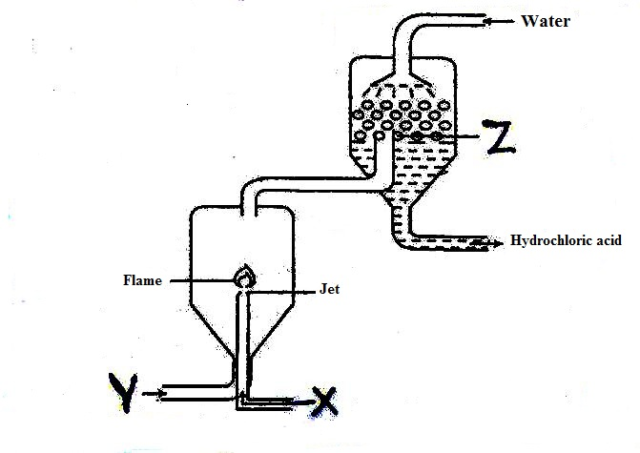
- Give two sources of substance X (1 mark)
__________________________________________________________________________________________________________________________________________________________________________
- State the role of the substance labeled Z. (1 mark)
__________________________________________________________________________________________________________________________________________________________________________
- State two uses of dilute hydrochloric acid. (1 mark)
__________________________________________________________________________________________________________________________________________________________________________
- During laboratory preparation of oxygen reagent H is added to Sodium Peroxide.
- Name the equation for the reaction that takes place. (1 mark)
_____________________________________________________________________________________
- Write the equation for the reaction that takes place. (1 mark)
__________________________________________________________________________________________________________________________________________________________________________
- Name a gas that is mixed with oxygen to be used in welding. (1 mark)
_____________________________________________________________________________________
- The elements fluorine, Chlorine, Bromine and Iodine belong to group (VII). Select the element with lowest melting point, Give a reason. (2 marks)
________________________________________________________________________________________________________________________________________________________________________________________________________________________________________________________________________________________________________________________________
- Starting with magnesium granules, describe how you can suitably obtain magnesium hydroxide solid. (3 marks)
______________________________________________________________________________________________________________________________________________________________________________________________________________________________________________________________________________________________________________________________________
- Aqueous Copper (II) Sulphate was electrolyzed using graphite electrodes.
- How does PH of the electrolyte change during electrolysis? (1 mark)
__________________________________________________________________________________________________________________________________________________________________________
- Write the cathode equation. (1 mark)
__________________________________________________________________________________________________________________________________________________________________________
- The experiment was repeated using copper electrodes. Write the anode equation. (1 mark)
__________________________________________________________________________________________________________________________________________________________________________

- In an experiment, dry hydrogen gas was passed Overheated magnesium oxide as shown in the diagram below.
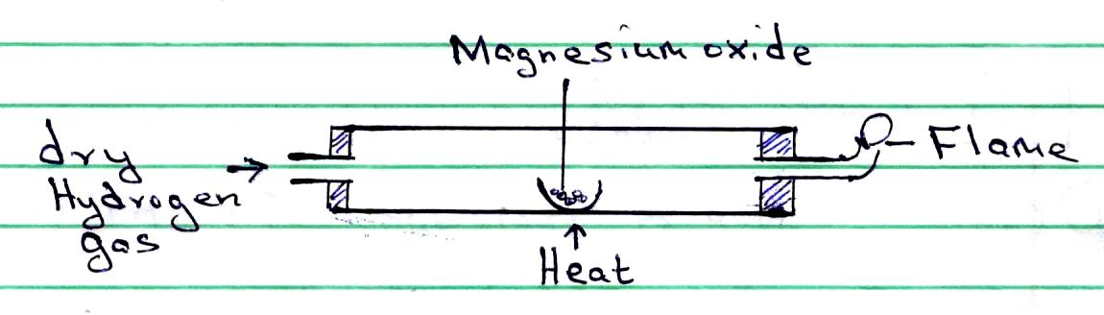
- State and explain the observations made in the combustion tube. (1 mark)
__________________________________________________________________________________________________________________________________________________________________________
- The experiment was repeated using Lead (II) oxide. State the observations made in the combustion tube. (1 mark)
__________________________________________________________________________________________________________________________________________________________________________
- Explain why an increase in temperature increases the rate of a reaction. (2 marks)
__________________________________________________________________________________________________________________________________________________________________________
- 10g of an oxide of Sodium contains 5.9g of sodium. Its molar mass is 78. Determine its molecular formula. (Na = 23, O = 16) (3 marks)
_________________________________________________________________________________________________________________________________________________________________________________________________________________________________________________________________________________________________________________________________________________________________________________________________________________________________________
- Study the flow chart below and answer the questions that follow:
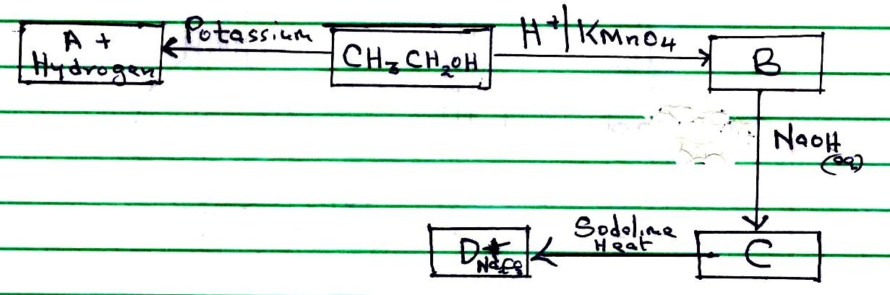

- Identify substance B and C (1 mark)
____________________________________________________________________________________________________________________________________________________________
- Name and draw the structure of substance A (1 mark)
__________________________________________________________________________________________________________________________________________________________________________________________________________________________________________
- Write the equation for the reaction that occur when D react with excess Bromine gas in presence of sunlight. (1 mark)
____________________________________________________________________________________________________________________________________________________________
- A piece of sodium metal was placed in a beaker containing pure water.
- Write the equation for the reaction that occurs. (1 mark)
______________________________________________________________________________
- Using oxidation numbers show that the reaction in (a) above is redox. (2 marks)
________________________________________________________________________________________________________________________________________________________________________________________________________________________________________________________________________________________________________________________
- (a) The set up in the figure below can be used to prepare dry nitrogen (iv) oxide. Use it to answer the questions that follow.
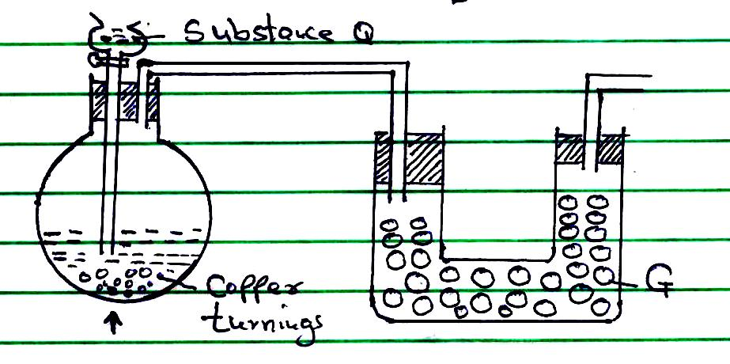
- Name the substance G and Q (1 mark)
____________________________________________________________________________________________________________________________________________________________
- Complete the set up to show how nitrogen (iv) oxide is exposed to air. (1 mark)

(b) State the observation made when a gas jar containing nitrogen (II) oxide is exposed to air. (1 mark)
________________________________________________________________________________________________________________________________________________
- The table below shows ammeter readings recorded when 2M potassium hydroxide and 2M aqueous ammonia were tested separately.
Electrolyte | Current (A)
2M Potassium Hydroxide | 8.1
2M Ammonia | 2.5
Explain the difference in the ammeter readings. (2 marks)
________________________________________________________________________________________________________________________________________________________________________________________________________________________________________________________________________________________________
- Compound H has the following structure
O

CH₃ – CH₂ – CH₂ – C – O – CH₃
- Give the name of the compound H. (1 mark)
______________________________________________________________________________
- In which group of compounds does H belong? (1 mark)
______________________________________________________________________________
- Name the reagents that were used to prepare compound H. (1 mark)
____________________________________________________________________________________________________________________________________________________________
- (a) State Boyle’s law. (1 mark)
____________________________________________________________________________________________________________________________________________________________________
(b) Study the set up below and answer the questions that follow.
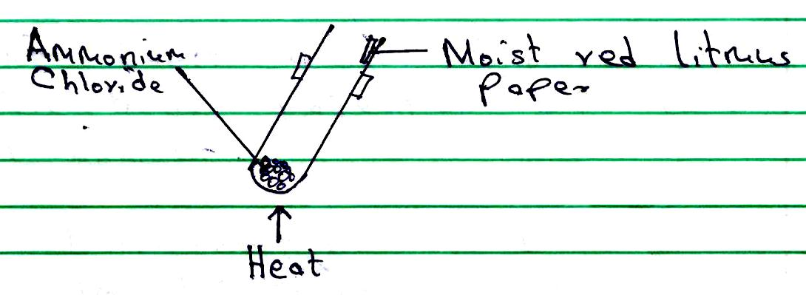
State and explain the observations made. (2 marks)
______________________________________________________________________________________________________________________________________________________
- Draw a well labeled diagram that can be used to electroplate iron spoon with silver. (3 marks)

- 2g of sodium hydroxide is added to 40cm³ of 1M sulphuric (vi) acid. What volume of 0.1M potassium hydroxide solution will be needed to neutralize the excess acid?
(Na = 23.0 O = 16.0 H = 1.0) (3 marks)

- (a) Explain why it is not advisable to prepare a sample of carbon (iv) oxide using calcium carbonate and dilute sulphuric (vi) acid. (2 marks)
______________________________________________________________________________________________________________________________________________________________________________________________________________________________________________________

(b) Give one use of coke. (1 mark)
___________________________________________________________________________

- The table below shows the standard electrode potentials of the elements P and Q.

Half reactions E^{ɵ}V
P²⁺_{(aq)} + 2e P_{(s)} -0.44
Q²⁺_{(aq)} + 2e Q_{(s)} -2.37
Use the information to predict whether the reaction represented below can take place. (2 marks)
P_{(s)} + Q²⁺_{(aq)} P²⁺_{(aq)} + Q_{(s)}

- The table below shows the atomic numbers and electron affinities of three elements. The letters are not actual chemical symbols. Use it to answer the questions that follow.
Element | Atomic number | Electron Affinity kJ/mol
A | 17 | -349 kJ/mol
B | 35 | -325 kJ/mol
C | 53 | -295kJ?mol

- What is electron affinity? (1 mark)

- Explain the trend in electron affinity from A to C. (2 marks)
________________________________________________________________________________________________________________________________________________________________________________________________________________________________________________________________________________________________________________________________________
- A sample of herbicide in solution form is suspected to contain Lead (II) ions. Describe how the presence of Lead (II) ions can be established. (2 marks)
________________________________________________________________________________________________________________________________________________________________________________________________________________________________________________________________________________________________________________________________________
- A monomer has the following structure.
H

H – C ꞊ C– H

COOCH₃
- Draw the structure of the polymer that contain three monomers. (1 mark)

- A sample of the polymer formed from the monomer has a molecular mass of 7740. Determine the number of monomers that formed the polymer.
(C = 12.0 H = 1.0 O = 16.0) 2 marks)

- (a) The figure below is an incomplete diagram that can be used to illustrate how alpha, beta and gamma radiations can be distinguished from each other
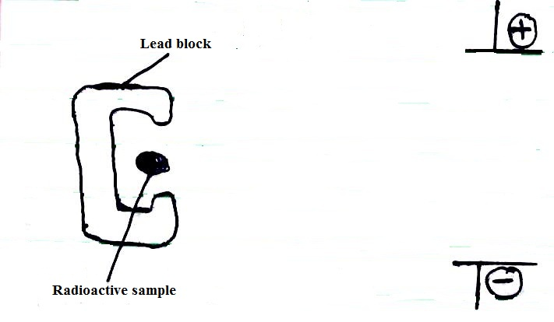
Complete the diagram above (1½ marks)
(b) Radioactive decay of ${}_{82}^{212}{Pb}$ gives ${}_{83}^{212}{Bi,}$ gamma radiations and X.
- Identify X. (½ mark)
____________________________________________________________________________________________________________________________________________________________
- Write a nuclear equation for the decay. (1 mark)

- A small amount of sulphur was burnt in a deflagrating spoon. The burning sulphur was then lowered into a gas jar full of oxygen.
- The product formed is dissolved in water. Suggest the PH of the resulting solution. Give a reason. (1 mark)
____________________________________________________________________________________________________________________________________________________________
- Explain the observation made when pink flower is immediately dropped in the solution obtained in (a) above. (2 marks)
________________________________________________________________________________________________________________________________________________________________________________________________________________________________________________________________________________________________________________________
- The table below gives three experiment on the reaction of excess dilute hydrochloric acid and 0.5g of zinc done under different conditions. In each the change in mass of the reactant was recorded at different time intervals.
Experiment | Forms od Zinc | Hydrochloric acid
I | Powder | 0.6M
II | Granules | 0.6M
III | Powder | 1M

On the axis below, draw and label the three curves that could be obtained from such results. (3 marks)
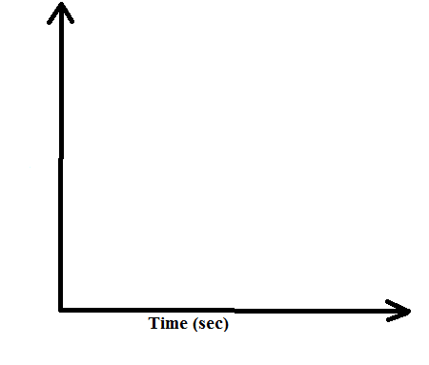
Mass of zinc in grams

- The relative atomic mass of an element is 10.28, it has two isotopes ¹⁰R and ¹¹R. Calculate the relative abundance of each isotope. (2 marks)

- (a) Define the standard enthalpy of formation of a substance. (1 mark)
____________________________________________________________________________________________________________________________________________________________________
(b) Use the thermochemical equations below to answer the questions that follow.

H_{2(g)} + ½ O_{2(g)} H₂O₍₁₎ ΔH = -286kJ/mol
C_{s)} + ½ O_{2(g)} C O_{2(g)} ΔH = -393kJ/mol
C₄ H_{10(g)} + 9/2 O_{2(g)} 4CO₂ + 5H₂O₍₁₎ ΔH = -2877kJ/mol

- Draw an energy cycle diagram linking the heat of formation of butane with its heat of combustion of its constituent elements. (2 marks)

- Calculate the heat of formation of butane. (1 mark)

- Name an appropriate apparatus that can be used to measure 29.3cm³ of 0.1M sodium hydroxide solution in the laboratory. (1 mark)
______________________________________________________________________________
- Copper is mostly extracted from copper pyrite.
- Give the chemical formula of copper pyrite. (1 mark)
______________________________________________________________________________
- State the role of silica that is added during extraction of copper from copper pyrite. (1 mark)
____________________________________________________________________________________________________________________________________________________________

