MARKING SCHEME
233/1
CHEMISTRY

TRIAL 1 EXAMS - AUGUST/SEPTEMBER – 2022.

- (a) 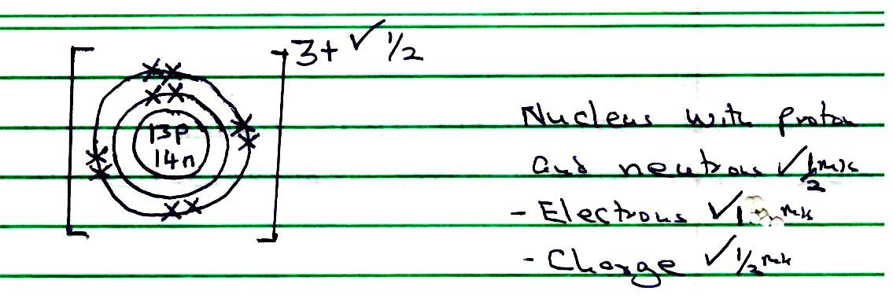
(b) The number of Protons and electrons in an atom are equal.$√$

- It contains hot glowing Carbon Particles ✓1 which on cooling form soot ✓1

- (a) Cracking of long chain alkanes.
- Electrolysis of brine.
- Reacting natural gas with steam
- (Mark the first two)

(b) Increases the Surface area over which hydrogen chloride gas dissolves ✓1
(c) - Removing rust from metal
- Sewage treatment / Treatment of water
- Making dyes, drugs and photographic material
- PH control and neutralization in industries
(mark the first two for ½ mark each)

- (a) Water ✓1
(b) 2 Na₂ O₂ + 2H₂O₍₁₎, 4 NaOH_{(aq) +} O_{2(g)}$√$
Penalize ½mark for missing or wromg state symbols
(c) Ethyne / Acetylene
-Hydrogen OR $√$ Penalize fully if not balanced.

- Flourine ✓1
It has the smallest molecular size ✓½ hence weakest intermolecular forces✓½ / few van der weal forces.

- Add excess Magnesium granules✓½ to dilute HCl/HNO₃/H₂SO₄,✓½ Stir and Filter,✓½ to the filtrate add Sodium hydroxide/Potassium hydroxide/Ammonia solution,✓½ filter✓½ and dry the residue between filter papers

- (a) PH of the electrolyte decreases,✓ there is accumulation of Hydrogen ions (H+)✓ since Copper (II) ions are discharged at the cathode.

(b) Cu$\begin{matrix}2+ \\ (aq)\end{matrix}$+ 2e Cu_{(s)} ✓ (1 mark)

(c) Cu_{(s)} Cu$\begin{matrix}2+ \\ (aq)\end{matrix}$+ 2e ✓ (1 mark)

- (a) White magnesium oxide remains white✓½/ same Magnesium is very high the reactivity series hence hydrogen cannot reduce✓½ magnesium oxide.

(b) Orange/yellow Lead (II) oxide changes to yellow grey lead

- Increase in temperature increases the kinetic energy✓½ of the reacting particle, this results in increase in number of successful✓1 collision / effective collision hence increases rate of reaction✓½

- 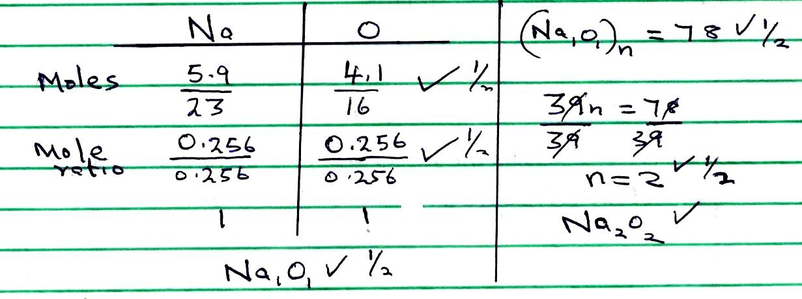

- 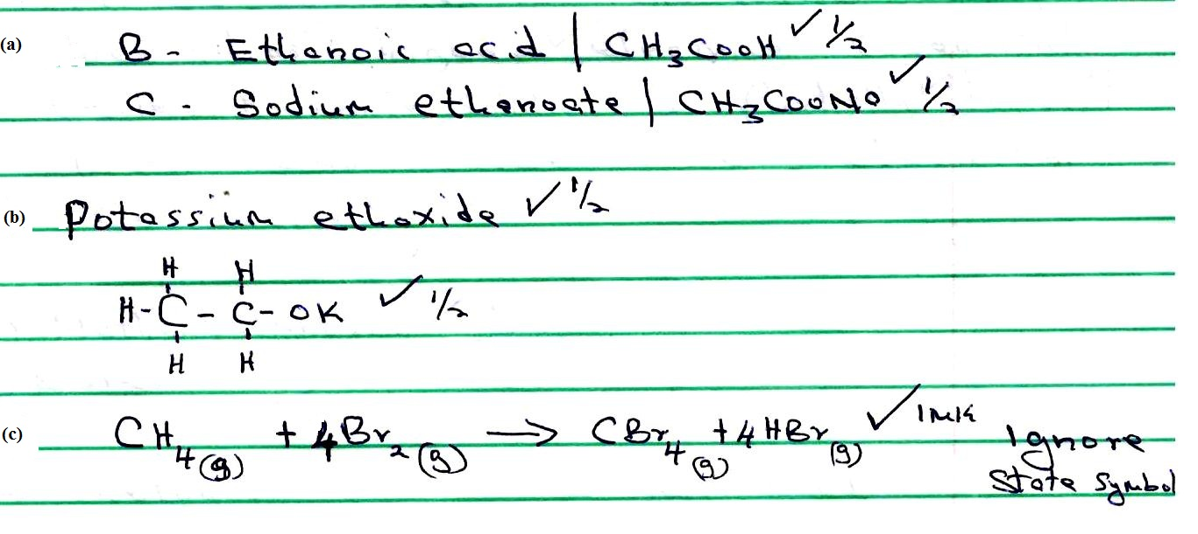
- (a) 2Na_{(s)} + 2H₂O_{(l)} 2NaOH_{(aq)} + H_{2(g)} ✓ (1 mark)

(b) The oxidation number of Sodium metal increases from 0 to +1, it is oxidized
Oxidation number of Hydrogen in water decreases of +1 to 0✓ it is reduced

- (a) (i) G - Anhydrous Calcium Chloride✓½ do not accept calcium oxide Q - Concentrated nitric (V) acid

(ii)
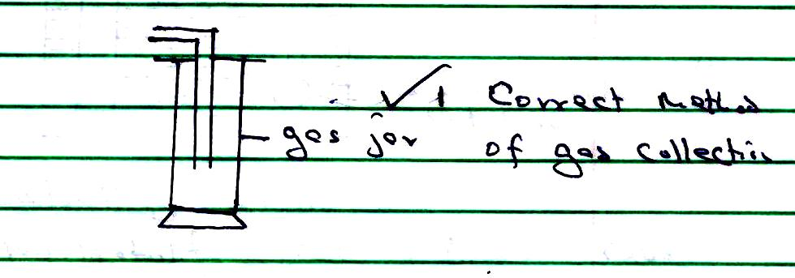
(b) Red - brown fumes produced✓½ nitrogen (11) oxide is oxidized✓½ to nitrogen (IV) oxide by air.

- Potassium hydroxide is fully ionized✓½/ strong base hence has higher$√1/2$ electrical conductivity, while Ammonia solution is partially✓½ ionized / weak base hence lower $√1/2$electrical conductivity

- (a) Methylbutanoate ✓1
(b) Esters ✓1
(c) Methanol✓½ Not tied
Butanoic acid ✓½
- (a) The volume of a fixed mass of inversely proportional to its pressure AT A constant temperature✓½

(b) Moist red litmus paper turns blue✓½ then red✓½ Ammonium chloride dissociate when heated into Ammonia gas and Hydrogen Chloride gas.✓½ Ammonia diffuses faster than hydrogen chloride gas

- 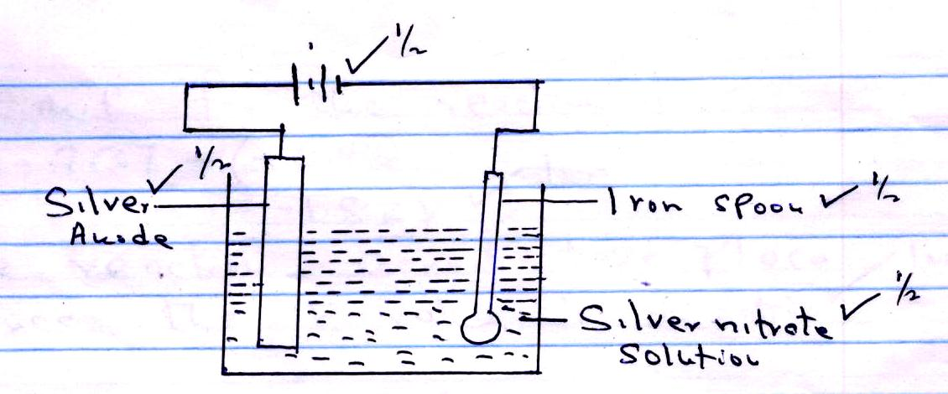
Labeling 2 marks
Workability 1mark.
Anode must be Silver and electrolyte must have silver ions.

- 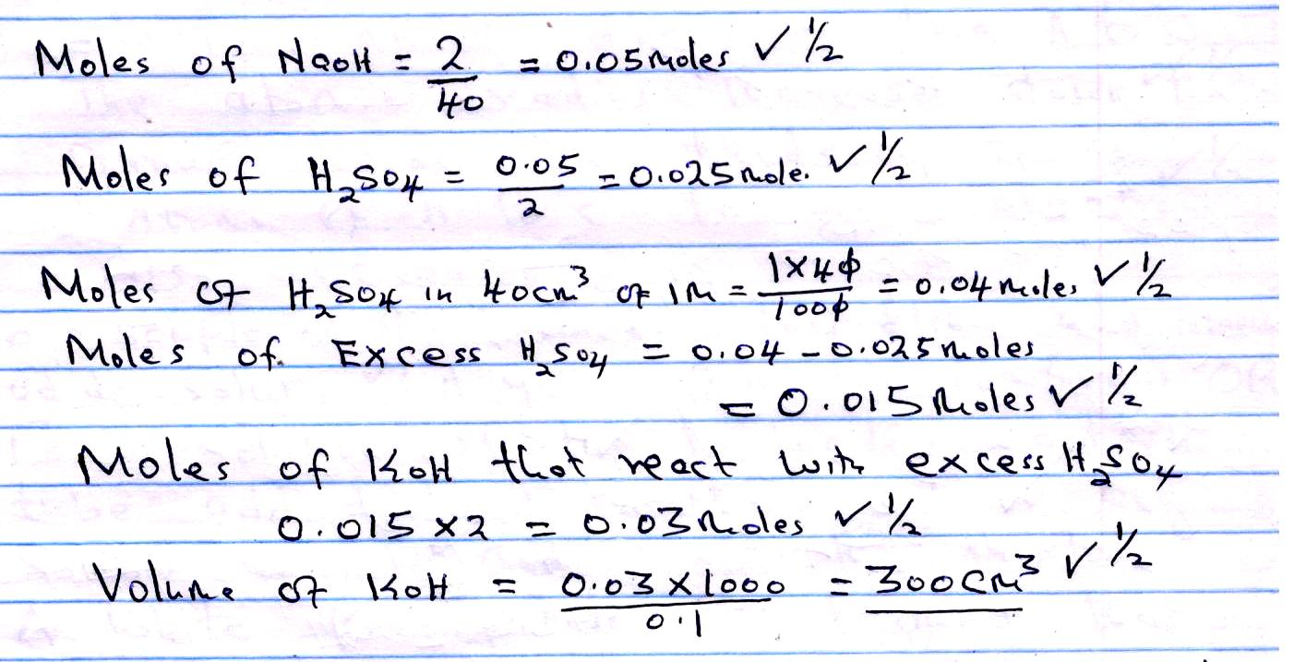
- (a) Calcium Carbonate react with dilute sulphuric (vi) acid to form Calcium sulphate that is insoluble✓ and forms a coating and stops further reaction
(Accept equation for 1 mark)
(b) (i) Used as a reducing agent in extraction of metals (ii) Used as fuel
(Mark the first one for 1 mark).
- The e.m.f for the reaction is
= -2.37 - (-0.44)
= -1.83V✓ 1 mark
The reaction cannot take place
since the E value is negative. ✓1 mark

- (a) Electron affinity. It is the amount of energy released when an atom gain election(s)

(b) Electron affinity decreases from A to C.✓1 The atomic radius increases down ✓½ the group hence the tendency of ✓½ Atoms of A to C to gain electrons also decreases.

- To a sample of the herbicide in test tube, add Potassium Iodide solution,✓1 A yellow precipitate is formed$√1$ OR To a solution of the herbicide in a test tube add dilute hydrochloric acid or any soluble Chloride✓½ , and warm✓½ the mixture. A white precipitate is formed✓½ that is soluble on warming. ✓½

- (a)
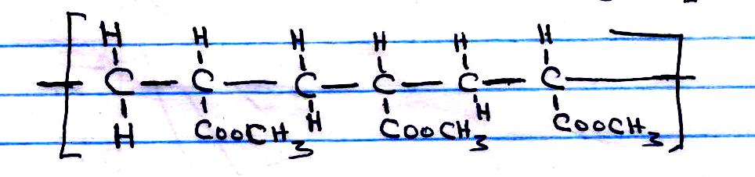
(b) Molecular mass of monomer = 48 + 32 + 6 = 86✓½
Number of Monomers = $\frac{7740}{86}$ ✓1 = 90✓½

- (a)
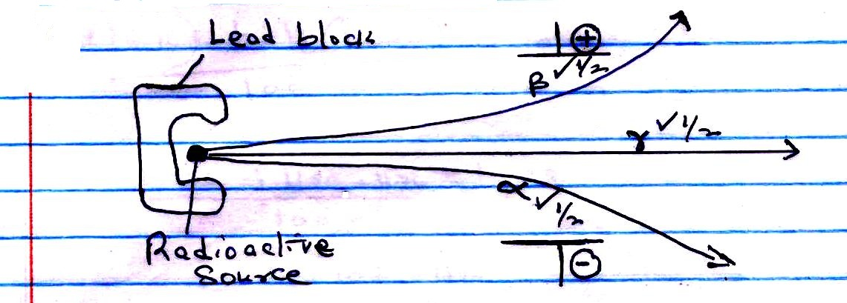

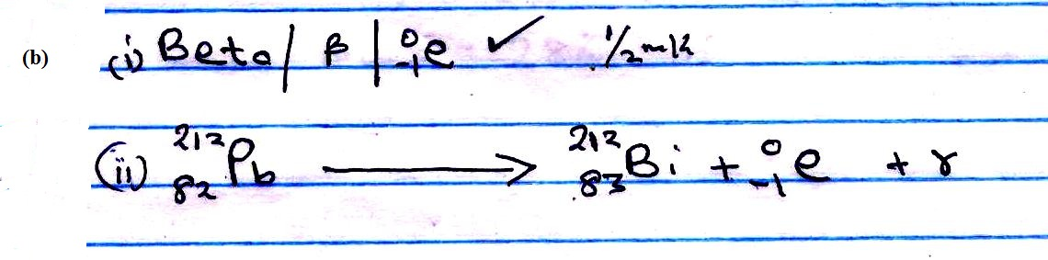

- a) PH values ranging from 4.5 - 6 ✓½ NB State one value within the range penalize if range is given
Sulphur (IV) oxide dissolves in water forming Sulphuric (IV) acid✓½ which is a weak acid.

(b) Pink flower is bleached! ✓1
Sulphuric (IV) acid removes oxygen✓1 atom in the dye, and form Sulphuric (VI) acid/Sulphuric (IV) acid bleaches by reduction.

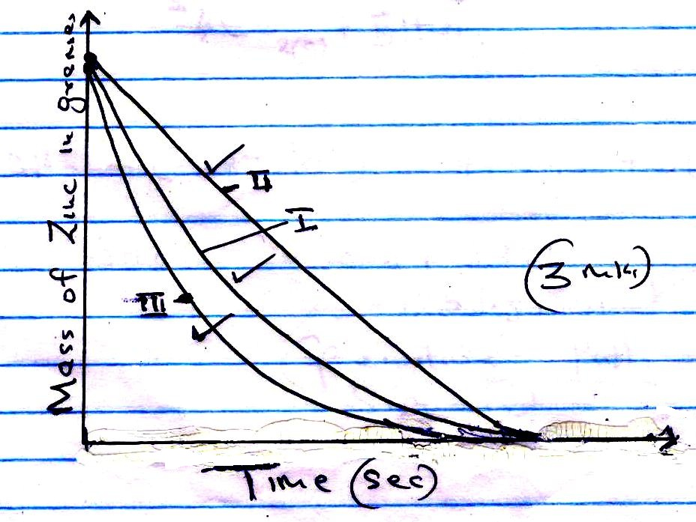

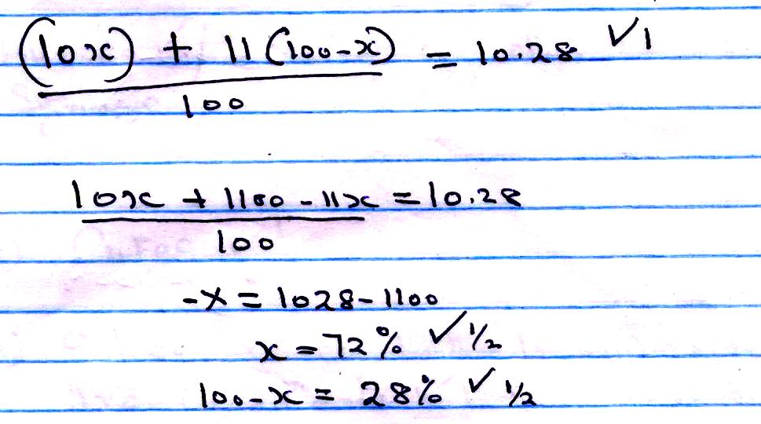
- (a) It is the enthalpy change that occurs when a substance is formed from its constituent elements under standard conditions.
1. ✓½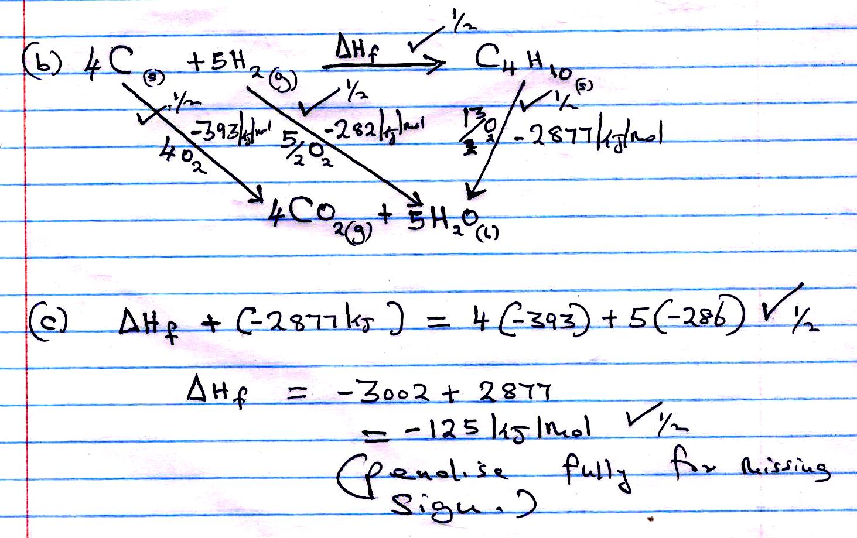
- Burette✓1/reject any other
OR
Syringe

- (a) CuFeS₂ ✓1
(b) Silica react with Iron (11) oxide to form Iron (II) silicate which is a major component of slag.

