CHEMISTRY OPENER FORM 3 NAME: ………………………………
TERM 1 2023. CLASS: …………………
TIME: 1HR 30MIN
- (a) State the Graham’s law. (1 mark)
………………………………………………………………………………………………………
………………………………………………………………………………………………………
(b) A 100 cm³ of Carbon (IV) oxide gas diffused through a porous partition in 30seconds.
How long would it take 150 cm³ of Nitrogen (IV) oxide to diffuse through the same
partition under the same conditions?) (C = 12.0, N = 14.0, O = 16.0) (2 marks)
………………………………………………………………………………………………………
………………………………………………………………………………………………………………………………………………………………………………………………………………
………………………………………………………………………………………………………
- A gas occupies 0.4dm³ at 20⁰c and 1.0 x 10³Pascals what will be the temperature of the gas when the volume and pressure of the gas when the volume and pressure of the gas is
0.1dm³ and 1.0 x 10³Pascals respectively. (3mks)
………………………………………………………………………………………………………
………………………………………………………………………………………………………………………………………………………………………………………………………………
------------------------------------------------------------------------------------------------------------------------------------------------------------------------------------------------------------------------------------------
- Study the table below and answer the question that follow. The letters do not represent
the actual symbols of the element.
Formula of ion Electron configuration
W²⁺ 2
V²⁻ 2.8
X³⁺ 2.8
U²⁺ 2.8
Y⁻ 2.8.8
a) Select elements found in;
i) the same group ……………………………………………………… (1mk)
ii) period three …………………………………………………… (1mk)
b) What is the family name given the group members to which element Y belongs (1mk)
………………………………………………………………………………………………………

4. Study the table below and answer the questions that follow
Substance | A | B | C | D | E | F
Melting Point (°C) | 801 | 113or 119 | -39 | 5 | -101 | 1356
Boiling Point (°C) | 1410 | 445 | 457 | 54 | -36 | 2860
Electrical solid | Poor | Poor | Good | Poor | Poor | Poor
Conducting Liquid | Good | Poor | Good | Poor | Poor | Poor
Identify with reasons the substances that
- Have a metallic structure ……………………………………………………….. (1mk)
- Have a molecular structure ……………………………………………………… (1mk)
- Suggest a reason why substance B has two melting points (1mk)
……………………………………………………………………………………………………………………………………………………………………………………………
5 A student lowered burning magnesium in a gas jar of carbon (IV) oxide as shown in the
diagram.
Magnessium
ribbon
Gas jar
CO₂

(a) State and explain the observation made in the gas jar (2 Marks)
…………………………………………………………………………………………………
…………………………………………………………………………………………………
…………………………………………………………………………………………………
(b) Write the equation of the reaction that takes place in the gas jar (1 Mark)
……………………………………………………………………………………………….
6. (a) Using a dot (•) and cross (x) to represent the outer most electrons, draw diagrams to
show the bonding in magnesium sulphide. (Mg =12 S =16 ) (2 Marks)
………………………………………………………………………………………………………
………………………………………………………………………………………………………………………………………………………………………………………………………………
………………………………………………………………………………………………………
………………………………………………………………………………………………………………………………………………………………………………………………………………
(b) State the structure of the above compound. ( 1 Mark)
………………………………………………………………………………………………………
(c) Give two properties of substances with the above structure (2 Mark)
…………………………………………………………………………………………………
…………………………………………………………………………………………………
7. Given sodium carbonate solid, lead (II) nitrate solid and water, explain how you can obtain
a solid sample of Lead (II) carbonate. (3 Marks)
………………………………………………………………………………………………………
………………………………………………………………………………………………………………………………………………………………………………………………………………
………………………………………………………………………………………………………
………………………………………………………………………………………………………
8. The diagram below shows part of Solvay process.
K
J
L
Brine
with ammonia

Carbon (IV) Oxide

NH₄Cl_{(aq)}

NaHCO₃ _{(s)}

Solid x

Solid Y

- Name solid X ……………………………………………………………… (1 Mark)
- State the process taking place in chamber L (1 Mark)
…………………………………………………………………………………………………State two uses of sodium carbonate (1 Mark)
……………………………………………………………………………………………………………………………………………………………………………………………………..
9 (a) Define electrolysis. (1mk)
…………………………………………………………………………………………………………………..…………………………………………………………………………………….........
(b) During the electrolysis of molten aluminium oxide, write the equations at the;
Anode - …………………………………………………………………………. (1mk)
Cathode - …………………………………………………………………………. (1mk)
…………………………………………………………………………………………
10. In an experiment to determine the percentage purity of Sodium carbonate produced in the Solvay process , 2.15g of the sample reacted with exactly 40.0cm³ of 0.5M Sulphuric(VI)acid. Determine the percentage purity of sodium carbonate in the sample. (3marks)

11. Below is a structure of an element X. Use it to answer the questions that follow.
+
+
+

+
+
+

a) Name the chemical family to which element X belongs. Give a reason. (2mks)
………………………………………………………………………………………………………
b Define covalent bond. (1mk)
………………………………………………………………………………………………………………………………………………………………………………………………………………12. A colourless liquid was suspected to be water. State two ways to confirm.
- Purity of the water. (1mk)
………………………………………………………………………………………………………………………………………………………………………………………………
- That the liquid was water. (2mks)
………………………………………………………………………………………….………………………………………………………………………………………………………………
13. The grid below is part of the periodic table. The elements are not represented by their actual symbols. Use the information to answer the questions that follow

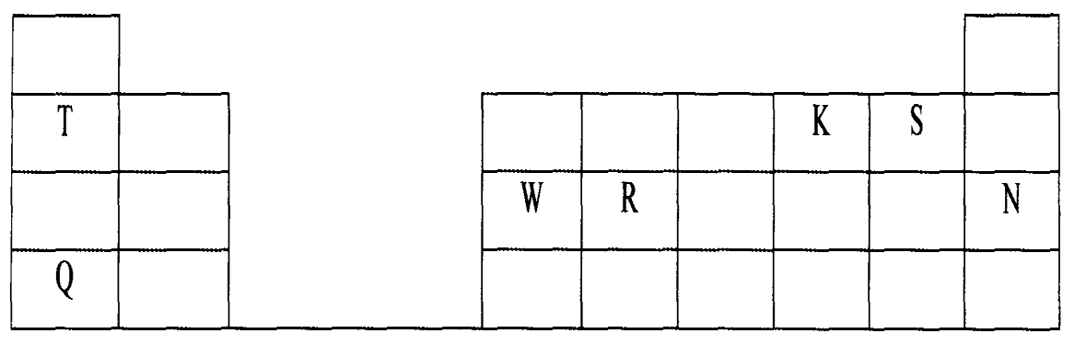

(i) Which is the most reactive
(I) Non — metal? (2mks).
………………………………………………………………………………………………………
Explain
………………………………………………………………………………………………………………………………………………………………………………………………………………
(II) Metal? (2mks)
……………………………………………………………………………………………………
Explain
………………………………………………………………………………………………………………………………………………………………………………………………………………
- Name the family to which elements T and Q belongs.(1mk)
………………………………………………………………………………………………………………………………………………………………………………………………………………
- Write the formula of the compound formed when W reacts with S. (1mk)

………………………………………………………………………………………………………
- Explain why element N doesn’t form compounds with other elements. (2mks)

……………………………………………………………………………………………………………………………………………………………………………………………………………………………………………………………………………………………………………………………………………………………………………………………………………………………….
- Compare the atomic radii of T and Q. Explain.(2mks)
…………………………………………………………………………………………………………………………………………………………………………………………………………………………………………………………………………………………………………………
(v) Compare the atomic radii of T and S. Explain. (2mks)
…………………………………………………………………………………………………………………………………………………………………………………………………………………………………………………………………………………………………….......................

