**CHEMISTRY OPENER FORM 4 NAME: …………………………………………………………**

**TERM 1 2023 CLASS: …………………………………………………..**

**TIME: 1HR 30MIN ADM NO. ………………………………………**

1. Name the following compounds using the IUPAC system. (3mks)

(i) CH3 CH2 CH2 CH2 C = CH

Br CH3

............................................................................................................................................................

(ii) CH3CH2CH2COOCH2CH2CH3

......................................................................................................................................................................................................................................

CH3

(iii) CH3CHCHCHCH3

Cl Cl

............................................................................................................................................................

. 2 (a) State Charles law. (1mk)

………………………………………………………………………………………………………………………………………………………………………………………………………………………………………………………………………………………………………

(b) A gas occupies 450cm3 at 270C. What volume would the gas occupy at 1770C if its pressure remains constant? (2mks)

……………………………………………………………………………………………………………………………………………………………………………………………………………………………………………………………………………………………………………………..………………………………………………………………………………………………………………………………………………………………………………………………………………

3. The following is an organic compound represented as CH3CH2COOCH2CH3

(i) Name the alkanoic acid and alkanol used in making the compound. (2mks)

Organic acid

Alkanol

(ii) Write an equation for the reaction that would take place when the alkanol in (i) above

is reacted with Potassium. (2mks)

4. The diagram below illustrates the contact process for the manufacture of sulphuric (VI) acid.

Study it and answer the questions that follow.



a) Name **three** possible identities of solid A. (3 marks)

................................................................................................................................................

................................................................................................................................................

................................................................................................................................................

  b) i) Name **two** impurities removed by the purifier. (1 mark)

  ..............................................................................................................................................

  ................................................................................................................................................

ii) Why is it necessary to remove the impurities? 1 mark)

................................................................................................................................................

c) Write down the equation for the reaction that takes place in the catalytic converter.

(1 mark)

................................................................................................................................................

d) i) Name **two** catalysts that can be used in the converter. (2 marks)

  ................................................................................................................................................

  ................................................................................................................................................

ii) Which of the **two** catalysts is most commonly used and why? (1 mark) ................................................................................................................................................

  ................................................................................................................................................

e) Why is sulphur (VI) oxide not absorbed directly into water? (1 mark) ................................................................................................................................................

f) Give the equation for the reaction that takes place in the absorption chamber.(1 mark)

  ................................................................................................................................................

g) Name the main pollutant in the contact process. (1 mark)

................................................................................................................................................

h) Name **one** method by which the pollution is controlled in the contact process.(1 mark)

................................................................................................................................................

 5.The scheme below shows a series of reactions starting with ethanol. Study it and answer the questions that follow.



 a) Give the type of reaction, the reagent(s) and the condition(s) necessary for step 1 to take place. (1 mark)

............................................................................................................................................................

b) Write the equation for the reaction that takes place in step L. (1 mark)

............................................................................................................................................................

c) Name product V and give the equation responsible for its formation. (2 marks)

............................................................................................................................................................

............................................................................................................................................................

d) Give the reagent(s) and condition(s) necessary for step W to take place. (1 mark)

..........................................................................................................................................................

............................................................................................................................................................

e) Give the IUPAC name and structural formula of compound X. (1 mark)

..................................................................................................................................................................................................................................................................................................................................................................................................................................................................................

f) Name compound K and state the type of reaction involved in its formation. (2 marks)

............................................................................................................................................................

............................................................................................................................................................

g) If the relative molecular mass of K is 44800, determine the value of n. (*C = 12, H = 1)* (2 marks)

..........................................................................................................................................................

............................................................................................................................................................

............................................................................................................................................................

1. The diagram below illustrates an experiment setup used for the preparation of dry chlorine in the laboratory

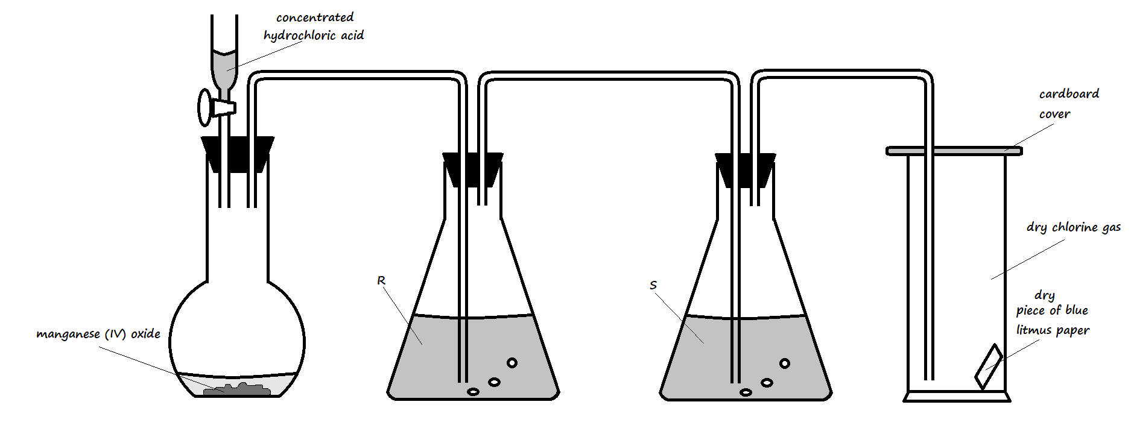

1. State **one** mistake that is in the setup (1 Mark)

________________________________________________________________________

1. Write an equation for the reaction that would occur in the flask (1 Mark)

________________________________________________________________________

1. What is the role of manganese (IV) oxide in the setup? (1 Mark)

_______________________________________________________________________

1. State the identity and roles of the following in the setup:
2. Solution **R** (2 Marks)

________________________________________________________________________

1. Solution **S** (2 Marks)

_______________________________________________________________________

1. State and explain one important precaution that should be observed when carrying out this experiment (2 Marks)

________________________________________________________________________

________________________________________________________________________

1. State and explain the observation made on the blue litmus paper in the gas jar (2 Marks)

________________________________________________________________________

________________________________________________________________________

1. State **three** uses of chlorine gas (3 Marks)

________________________________________________________________________

________________________________________________________________________

________________________________________________________________________

7. The grid given below represents part of the periodic table. Study it and answer the questions that follow. The letters are not the actual symbols of the elements.

|  |  |  |  |  |  |  |  |  |
| --- | --- | --- | --- | --- | --- | --- | --- | --- |
|  |  |  |  | | | | | A |
| B |  |  | G |  | H | E |  |
|  | J | I | L |  |  |  | C |
| D |  |  |  |  |  | M |  |
| Y |  |  |  |  |  |  |  |
|  |  |  |  |  |  |  |  |

(i) What name is given to the family of elements to which A and C belong? (1 mark)

(ii) Write the chemical formula of the sulphate of element D. (1 mark)

(iii ) Which letter represents the most reactive ( 1 mark )

1. Metal
2. Non-metal

(iv) Name the bond formed when B and H react. Explain your answer. (1 mark)

(v) Select one element that belong to period 4. (1 mark)

(vi) Ionic radius of element E is bigger than the atomic radius. Explain.

(1 mark)