CHEMISTRY FORM 4 MARKING SCHEME
- a) M 1/ 2mk and R1/ 2mk.
The ionic radius is larger 1mk than the atomic radius implying they gain electrons.

b) I Q=2 1mk R=3 1mk II QM2 1mk III Metallic (1mk

c) The oxide of P is ionic (1mk) with a giant ionic structure that requires a lot of energy to break, the oxide of R is molecular. 1mk

d) M and K 1mk M is a non-metal with the smallest (½mk) atomic radius hence most electronegative K is a metal with the largest atomic radius (½mk) hence most electropositive.

e) Has high melting point (1mk) and good conductor (1mk) of heat being a metal

2. a)
i. To remove carbon(iv) oxide. (1mk)

ii. To dry the air (1mk)

b) i. Turn from red brown to black (1mk) Copper is oxidized to copper (ii) oxide (1mk)

ii. 80-63.2cm3 = 16 .8 cm3 (1mk) 16.8 80 𝑥 100 21% (1mk)

iii. Nitrogen. (1mk)
iv. Impure (1mk) it contains noble gases like Argon. (1mk)
c) Hissing sound/ Melts into a silvery ball/ floats/ darts on the surface
3.a) (i)downward delivery method (1mk)

(ii) L- iron II Sulphide (1mk)
K- dilute HCl (1mk)

III )black solid dissolves forming a green solution

b) Fe3+ is reduced or Fe2+ (1mk)
H2S is oxidized to sulphur. (1mk)
c) (i) Vanadium V oxide (1mk)
ii) its cheaper , its less susceptible to poisonous
iii) the reaction is highly exothermic producing fumes of H2SO4 which are dangerous. (1mk)
4. Study the flow chart below then answer the questions that follow.
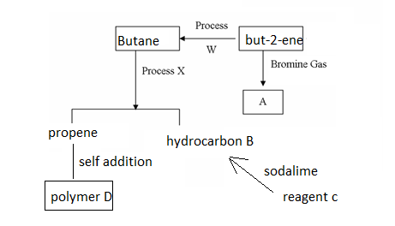
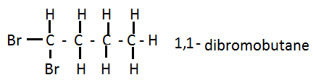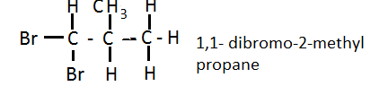
others 1,2- dibromobutane , 1,3- dibromobutane 1,4- dibromobutane, 2,2- dibromobutane
2,3- dibromobutane, 1,2 dibromo- 2 methyl propane..
- (3mks)
  - process W hydrogenation
  - process X cracking
  - Reagent C sodium ethanoate
`
b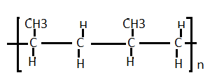
ci)Calcium carbide and water
ii)butyne
iii)
test | C2H4 | C2H6
BURN | Yellow sooty flame | Blue flame
Acidi. Kmno4 | Purple to colourless | Purple colour retained
Bromine water | Yellow to colourless | Yellow colour retained

5. (a) X/Y –Nitrogen obtained from air
- Fractional distillation of liquid oil fractional
X/Y – hydrogen conversion of natural gas a by product of cracking crude oil fraction
(b) Finely divided iron ½
Impregnated with aluminium oxide ½

(c) A copper metal ½ don’t accept symbols
B nitrogen gas ½
C nitric (V) acid ½
E oxygen _{1/2}

(d) (i) 4NO_{2(g)} + 2H₂O_{(l)} + O_{2(g)} 4HNO_{3(l)}1
(ii) Cu_{(s)} + 4HNO_{3(aq)} Cu(NO₃)_{(aq)} + 2NO_{2(g)} + 2H₂O_{(l)}1

(e) It relights/rekindles a glowing splint 1mk

(f) (i) As a nitrogen fertilizer1
(ii) Temperature of 400 – 500⁰C ½
Pressure of about 500 atm ½

6. . (a) (i) P- concentrated hydrochloric acid1
M - Water1
(ii) To dry chlorine gas1
(iii) Anhydrous calcium oxide
(iv) To absorb unreacted Cl_{2(g)} ½
(v) When heated, aluminium chloride sublimes hence it is formed in vapour form and solidifies at cooler parts of apparatus ½
(vi) Moles of aluminium used = $\frac{0.645}{27}$= 0.023889moles ½
Moles chlorine used 1800 = 0.075moles ½
2400
Mole ratio 0.023889: 0.075
0.023889 0.023889
1 : 3.1395 ½
1 : 3

E.f = AlCl₃ ½
Mf = (E.f mass) x n
Mass 267 = (27 + 35.5 x 3)n ½
267 = 133.5n
n = 267
133.5n
n = 2 mf: Al₂Cl₆ ½

7.a) A substance formed when some or all of the replaceable hydrogen atoms of an acid are wholly or partially replaced by a metal or an ammonia radical. 1mks

b) (i)Efflorescence. 1mks
ii)Deliquescence. 1mks
c)(i) 2KNO_{3(s)}→2KNO_{2(S)}+O_{2(g)}
(ii) NH₄Cl_{(aq)}→NH_{3(g)}+HCl_{(l)}
(iii) CuCO_{3(s)}→CuO_{(S)}+CO2(g)
d)React excess lead oxide with dilute nitric (v) acid to form lead nitrate solution.Add water to potassium sulphate to form a solution.react lead nitrate with the potassium sulphate , Filter, rinse the residue with distilled water and dry between filter papers.(3mks)
8. a) (i)Yellow/orange lead (ii) oxide turns grey. 1mk
Lead (ii) oxide was reduced by hydrogen to lead.
(ii)Copper (ii) oxide/Fe₃O_{4.}
b) PbO_{(s)}+H_{2(g)}→Pb_{(s)}+H₂O_{(L)} .1mks
c)Add anhydrous copper (ii) sulphate ,it will turn from white to blue.1mks OR
Add anhydrous cobalt (ii) chloride ,it will change from blue to pink.1mks
d) (i) No reaction, Magnesium is more reactive than hydogen.1_{1/2}mks
(ii)Hissing sound, ½mks
Darts on the surface,
Floats on the surface,
Melts into a silvery ball
e) Manufacture of ammonia/HCl WTTE

