CHEMESTRY
FORM FOUR
233/2
END OF TERM II 2022
CEKENAS END OF TERM TWO EXAM-2022
Kenya Certificate of Secondary Education. (K.C.S.E)
MAKING SCHEME

- (a) Study the table below and answer the questions that follows. The symbols are not the actual symbols of the elements

Element | A | B | C | D | E | F
Electronic configuration of the ion | 2.8 | 2.8.8 | 2.8 | 2.8.8.8 | 2.8 | 2.8.8
Valency and type of ion | Divalent cation | Divalent anion | Monovalent cation | Monovalent anion | Trivalent  cation | Trivalent  anion

- Arrange the elements A,B,C,D,E and F in terms of increasing atomic sizes (1mk)
- D, B,F,E,A,C
- Name the period of the periodic table to which these elements belongs? (1mk)
- Period 3
- Write an equation for the reaction between elements C and D (1mk)
- 2C_{(s)} + D_{2(g)} 2CD _{(aq)}
- Compare the electrical conductivity of elements A and E. Explain (2mks)
- E is better conductor than A. E has 3 delocalized electrons per atom compared to A which has one delocalized electron per atom
- Compare the first ionization energies of elements A and C. Explain (2mks)
- A has lower first ionization energy than C A has a bigger/ lager atomic radius than C
- vi) Which element sit re strongest oxidizing agent (1mk)

Element D
b.) Study the information below and answer the question that follow
Formula of oxide | NaCL | MgCl₂ | AlCl₃ | SiCl₄ | PCl₃ | SCl₂
Melting point ºC | 801 | 714 | _ | -70 | -91 | -80
Formula of oxide | Na₂O | MgO | AlO₃ | SiO₂ | P₄O₁₀ | SO₂
Melting point ºC | 1190 | 3080 | 2050 | 1730 | 560 | -73

- Aluminum chloride(AlCl₃ ) has an unexpected body type and structure
- State the type of bonding and the structure in AlCl₃ (1mk)
- Covalent, simple molecule structure
- What type of bonding would AlCl₃ be expected to have? Give a reason (1mk)
- Ionic bond, compound of a metal and a non-metal

- What is melting point of AlCl₃ not indicted in the table above (1mk)
- Sublimes when heated

- Silicon (iv) chloride get hydrolysed by water. Write a balanced equation for this reaction(1mk)
- SiCl_{4 (l)} + 4H₂ O _{(l)} SiO₂ _{(s)} + 4HCl _{(aq)}

2.) The following chart is an illustration of the extraction of aluminum from its ores
Residue S
Process T
Grinders
Bauxite

Filtration containing Al(OH)_{4 (aq)} /SiO@
Aluminum hydroxide
Aluminum oxide
Molten Aluminum Oxide

Gas
Molten
Process V

- Give the formula of bauxite (1mk)
- Al₂ O_{3 .} 2H₂ O
ii.) Name the two impurities in bauxite
- Iron (III) oxide
- Silicon (iv) oxide
iii.) Write the chemical equation for the reaction taking place during process cost – effective (1mk)
Al (OH) ⁻_{4 (aq)} Al(OH)₃ Al(OH)_{3 (s)} + OH⁻ _{(aq)}
_{OR}
[Al (OH)₄ ]⁻ _{(aq)} + CO_{2 (g)} 2Al(OH)₃ + CO₃²⁻ _{(aq)} + H₂O _{(l)}
(iv) The melting point of aluminum oxide is quite high. Explain what is done to make the process (1mk)
- Adding cryolite (Na₃ ALF₆ ) which lowers the melting point of aluminium, oxide from 2015 to 800º C
(v) Name residue S
Residue S – Iron (III) Oxide
Gas R – Oxygen
(vi) Write down the half equations for the reaction at the
I, Anode : 6O ²⁻ (l) 3O₂ (g) + 12e⁻
II,Cathode : 4Al ³⁺ (l) + 12e⁻ 4Al (s)
(vii) In the electrolysis stage the graphite electrode used at the anode is periodically replaced anode at regular intervals (1mk)
- The oxygen evolved at the anode reacts carbon electrode to form carbon (iv) oxide. This corrodeS the carbon anode hence the need to replace from time to time
(viii) Give two properties that makes aluminum and alloys suitable for making aircraft bodies (2mks)
- Lighter
- Stronger
- More resistant to corrosion
- Higher tensile strength
(3a.) A form four students carried out an experiment to extract oil from sim sim seeds. (1mk)
i.) Name two apparatus he used to crush the simsim seeds (1mk)
- Mortar and pestle
ii.) Name suitable solvent used (1mk)
- Propanone
iii.) Name the class or organ compounds in which vegetable oil belongs to (1mk)
- Esters
(iv) Describe the process of preparing soapy detergents using vegetable oil (3mks)
- Place vegetable oil in a beaker
- Add NaoH to the oil and stir
- Boil the mixture while stirring
- Add Nacl/sodium chloride solution to the mixture to precipitate soap
- Filter the mixture to obtain soap as residue
b.) Study the flow chaert below and answer the question that follow
- State the conditions for the reaction in step 1 to occur (1mk)
- 400 º C – 700 º C, Nickel catalyst
- Identify substance H (1mk)
- Ethane
- Give one disadvantage of the continued use of substances such as J (1mk)
- Non – biodegradable hence pollutes the environment
- The relative molecular mass of J is 16800. Calculate the number of monomers that make up J (2mks)
- $\frac{16800}{28}$ = 600
4. Study the standard electrode potentials of the half – cells given below and answer the questions that follow. The letters do not represent the actual symbols of the elements)
E^{Ɵ} Volts
N⁺ _{(aq)} + e⁻ N _{(s)} - 2.92
J^{+ (aq)} + e⁻ J _{(S)} + 0.52 K^{+ (aq)} + e⁻ ½ K_{(S)} 0.00
G^{+ (aq)} + e⁻ G_{2(S)} + 0.30
M^{2+ (aq)} + e⁻ M _{(S)} ₊ 0.44
- Identify the strongest oxidizing agent. Give a reason for your answer (2mks)
- G⁺ has the highest positive electrode potential/Greatest tendency to gain electrons
- Which two half- cells would produce the highest potential difference when combined (1mk)
- N⁺ _{(aq)} + e ⁻ N _{(s)} , G⁺_{(aq)} + e ⁻ G_{(s)}

- Draw an electron cell for the above. Show on the diagram flow of electrons (3mks)
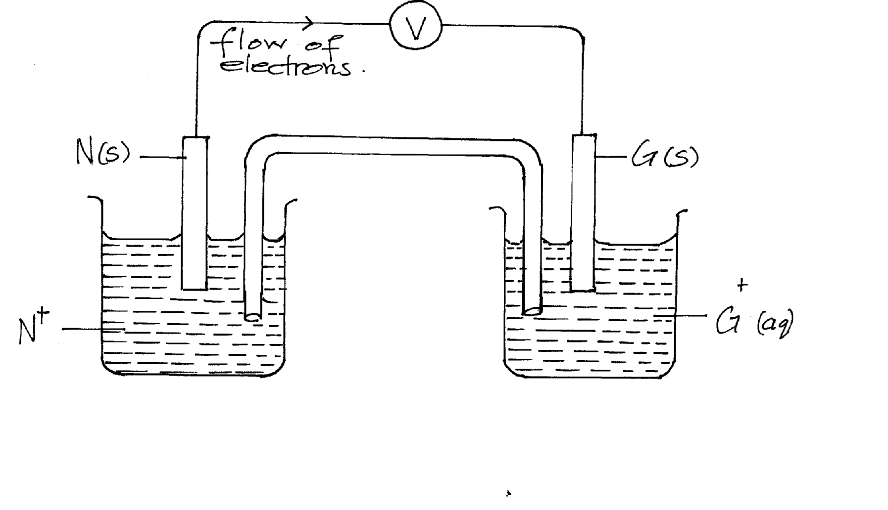
- Write three cell notation representation for the above cell (1mk)

- N _{(s)/} N⁺ _{(aq)//} G + _{(aq)/} G_{(s)}

- Calculate the e.m.f of the cell above (1mk)

- E^{Ɵ} = 0.8- -2.92 = + 3.72V

- Give two functions of the salt bridge (2mks)
- Complete the circuit by making contact between the electrolytes
- Maintain balance o charges / ions on both half cells
(vii) Determine the oxidation number of the halogens in 10₄ ⁻ (1mk)
- x + -8 = -1
x = +7
- Give on use f electrolysis (1mk)
- Electroplating
- Extraction of reactive metals
- Manufacture of pure substance
- Purification of metals
5. The table below shows the observations made when aqueous ammonia and sodium hydroxide solutions were added to cations of A,B,C and D
Cation of | Sodium hydroxide in excess | Ammonia solution in excess
A | White precipitate | Blue precipitate dissolved to form a deep blue solution
B | White precipitate dissolve to form a colorless solution | White precipitate dissolve to form a colourless solutuion
C | White precipitate dissolved to form a colourless solution | White precipitate
D

- Identify the cations present in (2mks)
- B- Zn ²⁺
- C- Pb ²⁺ and Al³⁺
- Write the formula of the complex ion present in the deep blue solution of cation (1mk)
- [ Cu (NH₃ ) ₄ ]²⁺
iii.) Given that the cation of D ore Na + ions complete the table above (1mk)
- No white precipitate
- No white precipitate

iv.) State any one use of complex ions (1mk)
- Softening hard water
- Extraction of reactive metals e.g. Al from its ore

Step 3
Excess NaOH (aq)
Step1
NC(OH)
5b.)
Colourless Solution M

White ppt
White precipitate T
Solution K
BaCL₂
White ppt
Excess NH3(aq)
Colourless solution
Step 2 Dil HCl

i.)Name precipitate L (1mk)
- Aluminum hydroxide
ii.) Write the ionic equation for the formation of L (1mk)
- Al ³⁺ _{(aq)} + 3OH⁻ _{(aq)} Al (OH) _{3 (s)}
iii.) Name the type of reaction in step 2 (1mk)
- Neutralisation
iv.) Name any other solution that can be used in step 2 above (1mk)
- Al (OH) _{3 (s)} + 3 HCl _{(aq)} AlCl _{3 (aq}) + 3H₂ O_{(l)}
v.) Name any other solution that can be used in step 2 above (1mk)
- Dil sulphuric (VI) acid/ Nitric (v) acid
6. The diagram below was used to prepare hydrogen chloride gas which was passed over heated iron powder
a.i.) State a pair of reagents that will produce hydrogen chloride gas in flask A (1mk)
- Sodium chloride and concentrated sulphuric (vi) acid
ii.) Name the substances in flask B (1mk)
- Concentrated sulphuric (VI) acid
iii.) State the observations made in the combustion tube (2mk)
- Grey iron powder turns green
iv.) Write the equation for the reaction in the combustion tube (1mk)
- Fe _{(s)} + 2HCl _{(g)} FeCl_{2(s)} + H _{2 (g)}
v.) Describe a chemical test for hydrogen chloride gas (2mks)
- Dip a glass rod in concentrated ammonia solution and expose it to HCl_{(g)}
- White dense fumes are produced
b i.) Identify the gas that burns at the jet (1mk)
- Hydrogen/ H₂
ii.) Explain why the gas in (b) is burnt (1mk)
- Avoid explosion because its mixture with oxygen burns explosively when ignited
c.) Another experiment was carried out where hydrogen chloride gas was bubbled through methylbenzene and water in separate beakers the resulting solutions were tested with blue litmus paper and marble chips
(2mks)
Solution of hydrogen chloride gas | Blue litmus paper | Marble chips
Water | - Turns red ½ | - Effervescence ½
Methylbenzene | - Remains blue ½ | - No effervescence

7. The thermodynamic equation for the formation of ammonia in the harber process is as follows.
N_{2(g)} + 3H_{2(g)} 2NH _{3 (aq)} H = -92KJ/mol
- If the system is allowed to attain equilibrium. State and explain how the following factors would affect the yield of ammonia
a.) Increase in temperature (1mk)
- The reaction is exothermic : increase in temperature will favor an endothermic reaction/ backward reaction
b.)Increase in pressure (1mk)
- Increase : increase in pressure favors the side with fewer number of molecules / moles / volumes hence more NH₃ will be produced
c.) Using a more efficient catalyst (1mk)
- No effect
ii.) In an experiment to study the rate of reaction 1g of Magnesium ribbon was reacted with excess 2M hydrochloric acid. The results obtained were recorded as shown in the table below.
Time(s) | 0 | 20 | 40 | 60 | 80 | 100 | 120 | 140 | 160 | 180
Volume of gas produced (cm³) | 0 | 11 | 20 | 26 | 31 | 35 | 38 | 39 | 40 | 40

- Give a reason why Magnesium ribbon is normally cleaned with sand paper before being put into the acid (1mk)
- Remove the oxide layer
b.) Write a balanced chemical equation for the reaction (1mk)
- Mg _{(s)} + 2 HCl _{(aq)} Mg Cl₂ _{(aq)} + H₂ _{(g)}
c.)On the grid provided plot a graph of volume of the gas produced against the time taken (3mk)
i)
- Graph
$\frac{30-7.5}{60-10}$ = 0.45 cm ³/ s
ii.)$\frac{45-36}{190-100}$ = 0.1 cm ³/ s

iii.) From the graph determine the rate of reaction at
- 30 seconds
- At 120 seconds
- Give a reason for the difference between the two values
- Rae of reaction at 30 s higher than at 120s
- The concentration of reactants decreases as the reaction continues

