END TERM 1-2023
CHEMISTRY PAPER 2 (233/2)
FORM FOUR (4)
TIME: 2 HOURS

Name …………………………………………….……… Adm. Number…………………………..
Candidate’s Signature ………………….…...……….. Date……………………………………
Instructions
- Write your name and index number in the spaces provided above.
- Sign and write the date of examination in the spaces provided above.
- Answer all the questions in the spaces provided
- Silent electronic calculators may be used.
- All working must be clearly shown where necessary.
- This paper consists of 12 printed pages.
- Candidates should check the question paper to ensure that all the pages are printed as indicated and that no questions are missing.

For Examiner’s use only
Question | Maximum Score | Candidate’s Score
1 | 13
2 | 12
3 | 12
4 | 10
5 | 11
6 | 10
7 | 12
Total Score | 80

- The grid below shows part of the periodic table. Study it and answer the questions that follow. The letters are not the actual symbols of the elements.

 |  |  | A |  |  | B | C | D
E | F
 |  |  |  |  |  |  | G
H

- Give the name of the family to which element F belongs. (1mk)

- Identify an element which forms a stable divalent anion (1mk)

- Give the formula of:
- The compound formed between A and B (½mk)

- The sulphate of H (½mk)

- Using dot(.) and cross(x) diagram, show the bonding in the compound formed between E and C. (2mks)

- Compare the atomic radii of elements C and D. Explain. (2mks)

- Select the element that has the lowest ionization energy. Explain. (1mk)

- 0.081g of element A reacts with 20cm³ of dilute hydrochloric acid. Calculate the molarity of the hydrochloric acid. (R.A.M = 27) (3mks)

- The graph below shows the trend of the melting points and the boiling points of the family to which element G belongs. Explain the trend in the melting points. (2mks)

- (a) (i) What is a fuel? (1 mk)

(ii) Calculate the heating value of propane, C₃H₈, given that its molar enthalpy of
combustion is 2200 kJ mol⁻¹. . (2 mks)
(C=12, H=1)

(b) (i) Define molar enthalpy of combustion. (1 mk)

(ii) Use the information provided by the thermochemical equations below to calculate the
molar enthalpy of combustion of ethyne. (3 mks)
C(s) + O₂(g) CO₂(g) ∆H= -394 kJ mol⁻¹
H₂(g) + ½O₂(g) H₂O(g) ∆H= -286 kJ mol⁻¹
2C(s) + H₂(g) C₂H₂(g) ∆H= +226 kJ mol⁻¹

(c) Study the data given below and answer the questions that follow.
Substance/ion | Enthalpy change
CaCl₂(s) | Lattice energy = -2237 kJ mol⁻¹
Ca²⁺(g) | Hydration energy = -1650 kJ mol⁻¹
Cl⁻(g) | Hydration energy = -364 kJ mol⁻¹

- Determine the molar enthalpy of solution of calcium chloride in water. (2 mks)

- Draw an energy level diagram for the dissolution of calcium chloride in water. (3 mks)

- (a) The diagram below shows the preparation of an oxide of nitrogen. Study the diagram and answer the questions that follow.
Gas jar
Flask M
Heat
Mixture of ammonium sulphate and solid D
Oxide of nitrogen
(Gas L)

- Name the solid D. (1mk)

- Write the equation for the reaction in the flask M (1mk)

- Burning magnesium ribbon was lowered into the gas jar containing gas L. State and explain the observations made. (2mks)

- Write the two equations for the reactions taking place in (iii) above. (2mks)
I.

II.

- A drop of water was added to the product formed in (iii) above. A colourless gas K with a choking smell was produced. Write the chemical equation for the production of gas K (1mk)

- (i) Give two uses for nitric (V) acid. (2mks)

(ii) A factory uses nitric (V) acid and ammonia gas as the only reactants for the preparation of ammonium nitrate. If the daily production of the ammonium nitrate is 4800kg, calculate the mass of ammonia gas used daily in kg. (N=14.0, O = 16.0 H= 1.0) (3 mks)

4. A group of form four students of Cockelbet Secondary School carried out an experiment to determine the solubility of potassium chlorate. The table below shows the results obtained.
Total volume of water added(cm³) | 10.0 | 20.0 | 30.0 | 40.0 | 50.0
Mass of KClO₃(g) | 5.0 | 5.0 | 5.0 | 5.0 | 5.0
Temperature at which crystals appear(⁰C) | 80.0 | 65.0 | 55.0 | 45.0 | 30.0
Solubility of KClO₃(g/100gH₂O)
- Complete the table to show the solubility of KClO₃ at different temperatures. (3mks)
- Plot a graph of mass of KClO₃ per 100g water against temperature at which crystals form.
(3mks)

- From the graph, determine ;
- The solubility of KClO₃ at 40ºC. (1mk)

- The temperature at which the solubility of KClO₃ is 35g/100g water. (1mk)

- Explain the shape of the graph. (1mk)

- State one application of solubility and solubility curves. (1mk)

5. (a) Use the standard reduction potentials for elements P, Q, R, S and T given below to answer the questions that follow. (The letters do not represent the actual symbols of the elements).
E^{θ} (Volts)
P²⁺ (aq) + 2e P (s) - 2.90
Q²⁺(aq) + 2e Q (s) -2.36
R⁺ (aq) + e ½R₂ (g) 0.00
S²⁺ (aq) + 2e S (s) + 0.33
½ T₂ (g) + e T⁻ (aq) +2.86
- Which element is likely to be hydrogen? Give a reason for your answer.
(1½mks)

- What is the E^{θ} value of the strongest reducing agent? (1mk)

- A form four student chose S²⁺_{(aq)} / S_{(s)} as the reference half-cell. Use the space at the right side of E^{θ} Volts) to rewrite the E^{θ} values of the above half-cells. (2½mks)

- In the space provided below draw a labeled diagram of the electrochemical cell that would be obtained when half-cells of elements Q and S are combined. (3mks)

(b) An iron spoon is placed in an electrochemical cell with AuCl₃ solution to be gold plated. How long must the spoon be in the electrolytic cell if the spoon is to be plated with 0.293 g of Au and the current of the cell is 1.03A. ( RAM of Au =197; 1F = 96,485 C). (3mks)

6 The diagram below represents a blast furnace used for the extraction of iron.
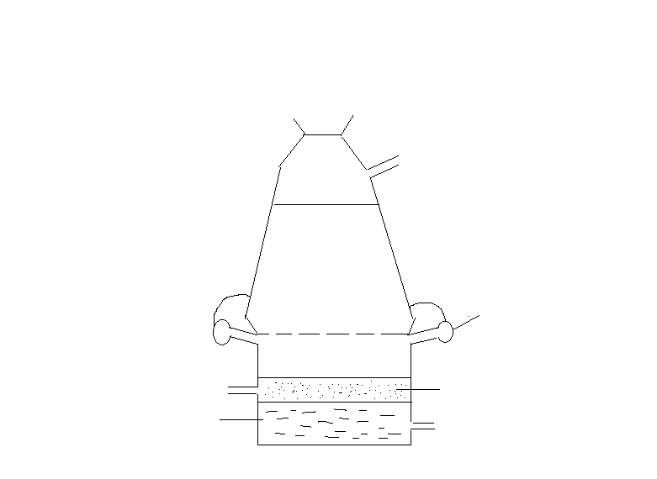
Charge mixture
Tuyeres
A
B
J
K
L
- Name three substances contained in the charge mixture. (1½mks)

- Name the substances labeled A and B. (2mks)

A…………………………………………………………………………………………….

B…………………………………………………………………………………………….

- Arrange regions J, K and L in order of decreasing temperature. (1mk)

- Write an equation for the reaction that occurs in region L. (1mk)

- What is the function of the tuyeres? (1mk)

- Distinguish between cast iron and wrought iron. (1mk)

- Write an equation for the reaction between heated iron and chlorine. (1mk)

- Iron-60 is a radioisotope of iron (half-life 2.6 x 10⁶ years). Its ultimate decay product is nickel-60. Write a nuclear equation for this process.
(Atomic numbers: Fe= 26, Ni= 28) (1mk)

- State one use of stainless steel. (½mks)

- (a) Draw and name all the isomers of C₄H₆ (2mks)

(b) The following monomers react to form a polymer:
Draw and name the structure of the polymer (2mks)

(c) Chlorofluorocarbons have a wide range of uses. However they have been linked to depletion of ozone.
(i) Explain the problem caused by depletion of ozone layer. (1mk)

(ii) Give one other environmental problem caused by chlorofluorocarbons. (1mk)

(d) Study the flow chart below and use it to answer the questions that follow.
Heat
NaOH_{(s)}
NaOH_{(aq)}
Process W
Heat
Conc. H₃PO₄
Propanol
Gas A
Propanoic acid
B
C

(i) Name:
I: Process W (½mk)

II: Substances A, B and C (1½mks)
A:
B:
C:
(ii) Write an equation for the combustion of substance C (1mk)

(iii) Give one use of gas A (1mk)

(e) Explain how a sample of propan-1-ol could be distinguished from a sample of propanoic acid by means of a chemical reaction (2mks)

THIS IS THE LAST PAGE PRINTED.

