END TERM 1-2023
CHEMISTRY PAPER 1(233/1)
FORM THREE (3)
TIME: 2 HOURS

Name …………………………………………….……… Adm. Number…………………………..
Candidate’s Signature ………………….…...……….. Date……………………………………

Instructions to candidates
- Write your name, stream, and admission number in the spaces provided above.
- Answer ALL the questions in the spaces provided, and working MUST be clearly shown
- This paper consists of 9 printed pages; Candidates should check the question paper to ascertain that all the pages are printed as indicated, and that no question is missing.

FOR EXAMINERS’ USE ONLY
QUESTION | MAXIMUM SCORE | CANDIDATE’S SCORE
1 – 28 | 80

- Chewing chalk has been used for many years to reduce excess acid in the stomach. The indigestion tablet often contains magnesium carbonate.
- Write a chemical equation to show the reaction that occurs in the stomach when the tablet is taken (1 mark)
___________________________________________________________________________
- Give two other applications of acid-base reactions (2 marks)
___________________________________________________________________________
___________________________________________________________________________
- A luminous flame of a Bunsen burner is bright yellow in colour. Explain this phenomenon (1 mark)
______________________________________________________________________________
______________________________________________________________________________
- Differentiate between a mixture and a compound. (2 marks)
______________________________________________________________________________
______________________________________________________________________________
______________________________________________________________________________
- Complete the table below. (3 marks)
Representation | Atomic number | Number of neutrons | Mass number | Electron configuration
$\begin{matrix}39 \\ 19\end{matrix}$M |  | 20
$\begin{matrix}_ \\ _\end{matrix}$W |  |  | 31 | 2.8.5

- The chart below represents a reaction scheme. Study it and use it to answer the questions that follow
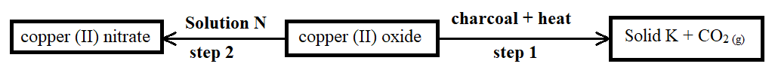
- Identify solution N and solid K. (1 mark)
Solution N __________________________________________________________________
Solid K ____________________________________________________________________
- State an expected observation made in step 1 (1 mark)
___________________________________________________________________________
- Name the type of chemical reaction in step 2 (1 mark)
___________________________________________________________________________
- 20cm³ sulphuric (VI) acid sample required 25cm³ of 0.16M potassium hydroxide solution for complete neutralization. Determine the molar concentration of the acid. (3 marks)
______________________________________________________________________________
______________________________________________________________________________
______________________________________________________________________________
- The diagram below represents part of a setup arranged for the collection of hydrogen gas in the laboratory. Study it and answer the questions that follow.
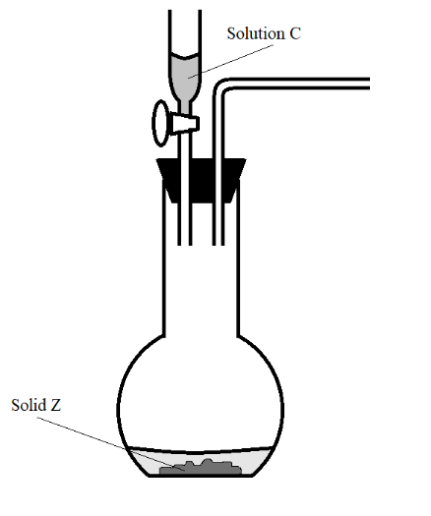
- Complete the diagram to show how a dry sample of hydrogen can be collected. (3 marks)
- Give the most suitable identity of solid Z. (1 mark)
___________________________________________________________________________
- State and explain how the conductivities of sodium and potassium compare. (2 marks)
______________________________________________________________________________
______________________________________________________________________________
______________________________________________________________________________
- State two applications of the effect of impurities on the melting point of a substance (2 marks)
______________________________________________________________________________
______________________________________________________________________________
- An element has two isotopes Q and V with mass numbers 28 and 29 respectively.
- What are isotopes? (1 mark)
___________________________________________________________________________
___________________________________________________________________________
- Determine the percentage abundance of Q and V given that the relative atomic mass of the element is 28.09 (3 marks)
___________________________________________________________________________
___________________________________________________________________________
- Below, is a table of the first ionization energies of some metallic elements. The letters do not represent actual symbols of elements.
Metal | A | B | C | D
First ionization energy (kJ/mole) | 494 | 418 | 519 | 376
- Arrange the metals in their order of decreasing reactivity. (1 mark)
___________________________________________________________________________
- Identify the metal with the highest melting point. (1 mark)
___________________________________________________________________________
- State one factor that affects the magnitude of ionization energy. (1 mark)
___________________________________________________________________________

- State Graham’s Law of diffusion. (1 mark)
___________________________________________________________________________
___________________________________________________________________________
- On the axes provided below, sketch the curve that verifies Boyle’s Law. (2 marks)

- State two laboratory apparatus that are used to measure fixed volumes. (2 marks)
___________________________________________________________________________
___________________________________________________________________________
- State the use of a desiccator in the laboratory. (1 mark)
___________________________________________________________________________
- Excess samples of magnesium and copper were burnt in separate vessels with equal and fixed volumes of air. Explain the difference in volume of air used in the two vessels at the end of the experiment. (3 marks)
______________________________________________________________________________
______________________________________________________________________________
______________________________________________________________________________
______________________________________________________________________________
- Study the table below and use it to answer the questions that follow. The letters do not represent actual elements.
Element | G | H | I | J
Atomic number | 11 | 12 | 16 | 18
- Compare the atomic sizes of elements H and I. Explain. (2 mark)
___________________________________________________________________________
___________________________________________________________________________
___________________________________________________________________________
- Identify an element that forms an oxide with acidic properties. (1 mark)
___________________________________________________________________________
- The statements below are attributes of hydrogen gas. Give reasons for the properties mentioned.
- An advantage of inflating aeroplane tyres with hydrogen gas. (1 mark)
___________________________________________________________________________
- A disadvantage of inflating aeroplane tyres with hydrogen gas. (1 mark)
___________________________________________________________________________
- List two industrial uses of hydrogen. (2 marks)
___________________________________________________________________________
___________________________________________________________________________

- A measuring cylinder was used for investigating a certain property of concentrated sulphuric (VI) acid. The setup was left open in the fume chamber for two days without interference. Figure 1 illustrates the initial condition of the acid in the measuring cylinder.
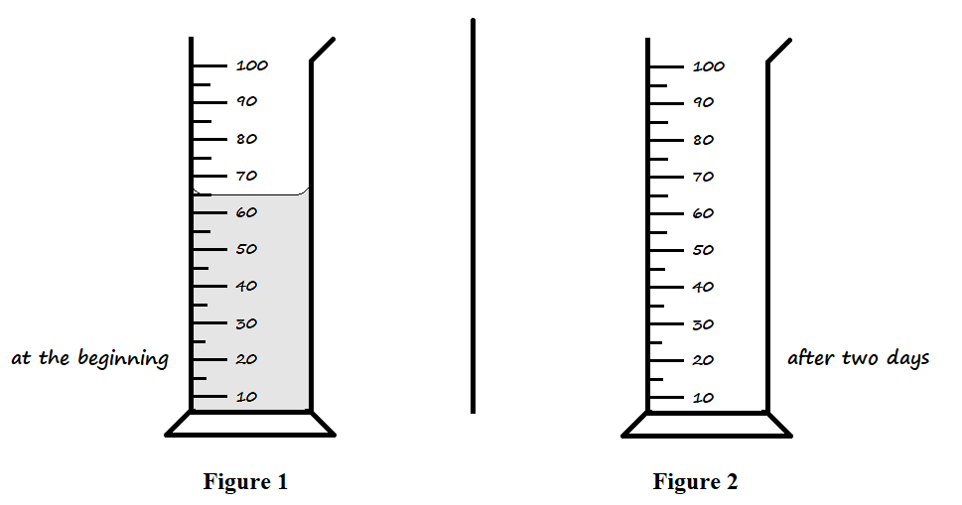
- Draw the expected level of the acid in Figure 2 after being left in the fume chamber for two days. (1 mark)
- Explain your illustration in the setup above. (2 marks)
___________________________________________________________________________
___________________________________________________________________________
- Describe how the following reagents may be used to prepare a pure sample of lead (II) chloride in the laboratory: Distilled water, sodium chloride crystals, lead metal, dilute nitric (V) acid. (3 marks)
______________________________________________________________________________
______________________________________________________________________________
______________________________________________________________________________
______________________________________________________________________________
- Rust affects the strength of iron structures. State two ways by which coating iron with a thin coat of aluminium paint prevents rusting. (2 marks)
______________________________________________________________________________
______________________________________________________________________________
- Use dot (•) and cross (×) diagrams to represent electron bonding in the following substances.
- Carbon (II) oxide, CO (1½ marks)

- Magnesium fluoride, MgF₂ (1½ marks)

- The diagrams below represent setups that were used to study properties of some halogens. Study them and answer the questions that follow.
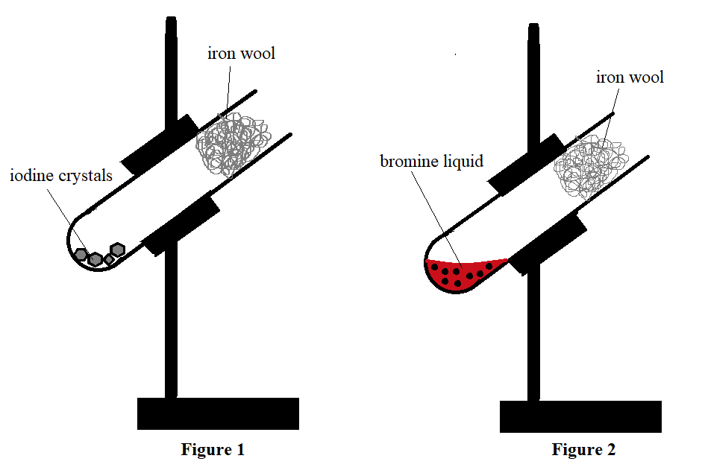
- State the observation made on the iron wool in Figure 2 during the experiment. (1 mark)
___________________________________________________________________________
- Name the compound formed in Figure 1. (1 mark)
___________________________________________________________________________
- State one precaution that should be observed when conducting the experiment above. (1 mark)
___________________________________________________________________________
___________________________________________________________________________
- 120cm³ of helium diffuses through a porous plug in 30 seconds. Determine the time required by 70cm³ of nitrogen (IV) oxide to diffuse across the same plug (2 marks)
(He = 4, N = 14, O = 16)
______________________________________________________________________________
______________________________________________________________________________
______________________________________________________________________________
- When carrying out titration, indicators are used to determine the endpoint.
- What is an endpoint? (1 mark)
___________________________________________________________________________
- List two acid-base indicators that are suitable for use in titration in the laboratory. (2 marks)
___________________________________________________________________________
___________________________________________________________________________

- The halogen compounds, hydrogen fluoride and hydrogen chloride have boiling points of 19.5ºC and -85.05ºC respectively.
- State the expected physical state of hydrogen fluoride at s.t.p. (1 mark)
___________________________________________________________________________
- Explain the differences in boiling points between the two compounds. (2 marks)
___________________________________________________________________________
___________________________________________________________________________
___________________________________________________________________________
- The table below shows pH values of solutions F, G, Y and Z.
Solution | pH value
F | 8.0
G | 2.0
Y | 12.0
Z | 7.0
- Which solution would react explosively with sodium metal? (1 mark)
___________________________________________________________________________
- State the expected colour of litmus solution in solution Y. (1 mark)
___________________________________________________________________________
- Describe how the pH value of solution F can be determined. (2 marks)
___________________________________________________________________________
___________________________________________________________________________
___________________________________________________________________________
- A compound of carbon, hydrogen and oxygen contains 55% carbon, 9.01% hydrogen, and the rest oxygen. Determine the molecular formula of the compound, given that its relative molecular mass is 88. (3 marks)
______________________________________________________________________________
______________________________________________________________________________
______________________________________________________________________________
______________________________________________________________________________

- The diagram below represents a burning jiko.
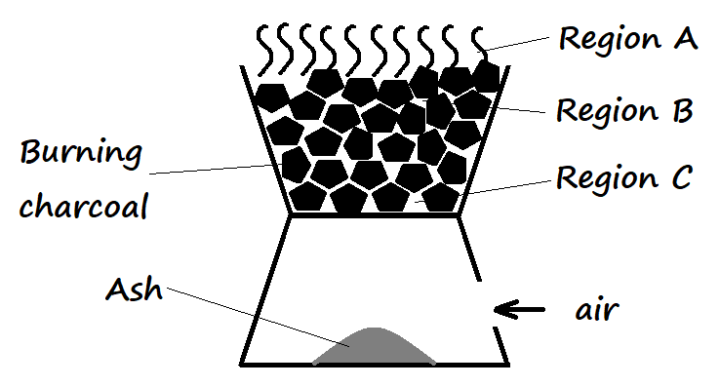
- Write the equation for the reactions that occur in regions A and B. (2 marks)
A _________________________________________________________________________
B _________________________________________________________________________
- It is not advisable to leave a burning jiko overnight in a poorly ventilated room. Explain. (1 mark)
___________________________________________________________________________
___________________________________________________________________________
- The following table shows the products formed when nitrates of metals J, Y, and W are heated strongly.
Nitrate of | Products formed
J | Metal oxide + Nitrogen (IV) oxide + Oxygen
Y | Metal + Nitrogen (IV) oxide + Oxygen
W | Metal nitrite + Oxygen
- Arrange the metals in their order of decreasing reactivity. (1 mark)
___________________________________________________________________________
- Which metal forms a soluble carbonate? (½ mark)
___________________________________________________________________________
- Give an example of nitrate Y. (½ mark)
___________________________________________________________________________

