END TERM 1-2023
CHEMISTRY (233)
FORM TWO (2)
TIME: 2 HOURS

Name …………………………………………….……… Adm. Number…………………………..
Candidate’s Signature ………………….…...……….. Date……………………………………

INSTRUCTIONS TO THE CANDIDATES:-

- Write your Name and Admission number in the spaces provided.
- Answer all the questions in the spaces provided.
- All working MUST be clearly shown where necessary.

For Examiner’s Use Only
Question | Maximum score | Candidate’s score
1-20 | 80
This paper consists of 15 printed pages. Candidates should check to ascertain that all pages are printed as indicated and that no questions are missing
- The diagram below shows the set up used to prepare dry hydrogen gas in laboratory. Study and answer questions that follow.
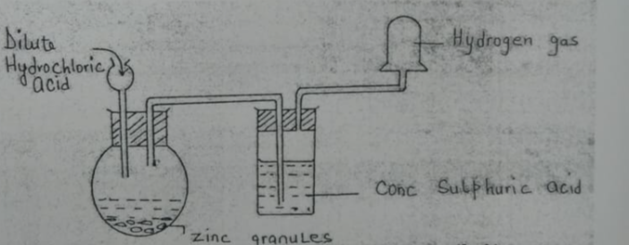
- State one mistake in the set-up (1mk)
______________________________________________________________________________________________________________________________________________________________
- Which property of hydrogen that enable it to be collected as shown in the diagram? (1mk)
______________________________________________________________________________________________________________________________________________________________
- Write a chemical equation for the reaction taking place in the flask. (1mk)
______________________________________________________________________________________________________________________________________________________________
- The diagrams below represent two iron nails with some parts covered tightly with zinc and tin respectively. What observations would be made at the exposed points R and Z if the wrapped nails are left in the open for several days? Explain.

2mks
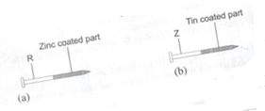
_____________________________________________________________________________________________________________________________________________________________________________________________________________________________________________
- The Diagram below is set-up for the laboratory preparation of oxygen gas.
Hydrogen peroxide
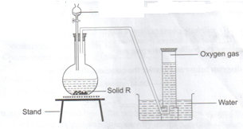

- Name solid R 1mk
______________________________________________________________________________________________________________________________________________________________
- Write an equation for the reaction that takes place in the flask. (2mks)
______________________________________________________________________________________________________________________________________________________________

- Give two commercial use of oxygen. (2mk)
______________________________________________________________________________________________________________________________________________________________
- An element y has an electron arrangement of 2.8.5
- State the period and group which the element belongs. (2mks)
______________________________________________________________________________________________________________________________________________________________

- Write the formula of the most stable ion formed when the element Y ionizes (1mk)
______________________________________________________________________________________________________________________________________________________________
- Explain the difference between the atomic radius of element Y and its ionic radius (2mks)
______________________________________________________________________________________________________________________________________________________________

- Lithium has two isotopes with mass numbers 6 and 7. If the R.A.M (relative atomic mass) of Lithium is 6.94, determine the percentage abundance of such isotope. 2mks
______________________________________________________________________________________________________________________________________________________________

- Other than their location in the atom, name two other differences between an electron and a proton. (2mks)
______________________________________________________________________________________________________________________________________________________________
- The diagram below was used to separate a mixture of methanol and propanol. Study it and answer the questions that follows
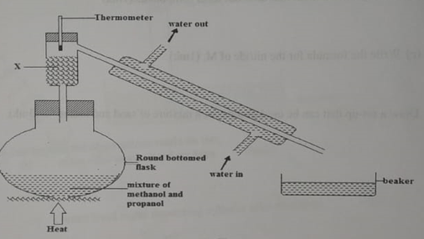
a) State the function of X 1mk
______________________________________________________________________________________________________________________________________________________________
b) Which liquid will collect first in the beaker? Give reason 2mks
______________________________________________________________________________________________________________________________________________________________

c) What would happen if water in and water out directions are reversed? Explain (2mk)
______________________________________________________________________________________________________________________________________________________________

- Briefly explain the following observations.
- Noble gases are generally unreactive. (1mk)
______________________________________________________________________________________________________________________________________________________________

- Alkaline earth metals are generally less reactive than alkali metals in the same period. 2mks
______________________________________________________________________________________________________________________________________________________________

- Given below are pH values of different solutions P, Q and S. Study it and answer the questions that follow.
Solution pH
P 1
Q 7
S 14
a) Which two solutions would react together to give a solution with a pH of 7.0? (2mk)
_____________________________________________________________________________________________________________________________________________________________________________________________________________________________________________
b) Which solution can be considered to be an oxide of hydrogen? (1mk)
______________________________________________________________________________________________________________________________________________________________
10. Nitrogen, oxygen and argon are obtained from the air using fractional distillation of air. Dust, carbon (IV) oxide and water vapour are removed from the air before fractional distillation is carried out.

(i)Name the compound used to absorb carbon (IV) oxide gas from the air (1mk)
______________________________________________________________________________________________________________________________________________________________
(ii)Explain how water vapour is removed from the air (2mks)
_____________________________________________________________________________________________________________________________________________________________________________________________________________________________________________

(iii)At what temperature are the gases liquefied? (1mk)
______________________________________________________________________________________________________________________________________________________________
(iv)The boiling points of nitrogen, oxygen and argon are -196, -183 and -186 respectively. State the order in which the three are distilled off starting with the first to be distilled off. (1mk)

11. Study the diagram shown below to answer the questions that follow. The curve shows the heating curve of water in the laboratory.

A
B
C
D

E
108⁰C
100⁰C
Temp ⁰C
Time (Min)

(i) At what temperature does the water boil? (1mk)
______________________________________________________________________________________________________________________________________________________________
(ii) Is the curve for a pure water or impure water? Give a reason for your answer 2mks

(iii) Give two effects of impurities on the boiling point of water 2mks
_______________________________________________________________________________
______________________________________________________________________________________________________________________________________________________________
(iii) Give two effects of impurities on the melting point of ice 2mks _____________________________________________________________________________________________________________________________________________________________________________________________________________________________________________

12. Excess magnesium ribbon sample was heated in equal volumes of:-
(i) Pure oxygen gas
(ii) Air
(a) Why was the mass of the resulting product in (ii) more than in (i)? 2mks _____________________________________________________________________________________________________________________________________________________________________________________________________________________________________________

(b) Write the chemical equations for the reactions in part (ii) 2mks
_____________________________________________________________________________________________________________________________________________________________________________________________________________________________________________

13. Excess iron fillings were allowed to rust in 1000cm³ of moist air and the volume of the remaining air was measured each day as shown in the table below
Day | 0 | 1 | 2 | 3 | 4 | 5 | 6 | 7 | 8
Volume of air cm³ | 1000 | 950 | 900 | 860 | 840 | 820 | 800 | 800 | 800

- Why did the volume of air remain constant from day six? 2mks
_____________________________________________________________________________________________________________________________________________________________________________________________________________________________________________
- Determine the percentage of oxygen in air using the data given in the table. 2mks
_____________________________________________________________________________________________________________________________________________________________________________________________________________________________________________

- Give two reasons why air is a mixture but not a compound. 2mks
____________________________________________________________________________________________________________________________________________________________________________________________________________________________________________
- The table below shows some properties and electronic arrangements of common ions of elements represented by letters P to X. Study the information in the table and answer the questions that follow
Element | Ion | Electron arrangement | Atomic radius | Ionic radius
P | P²⁺ | 2,8,8 | 0.197 | 0.099
Q | Q⁻ | 2,8 | 0.072 | 0.136
R | R⁺ | 2,8,8 | 0.231 | 0.133
S | S³⁺ | 2,8 | 0.143 | 0.050
T | T²⁺ | 2,8,8 | 0.133 | 0.074
U | U²⁺ | 2,8 | 0.160 | 0.065
V | V⁺ | 2,8 | 0.186 | 0.095
W | W⁺ | 2 | 0.152 | 0.060
X | X⁻ | 2,8,8 | 0.099 | 0.181

- Give the atomic numbers of the elements P and Q 2mks
P -

Q –

- Select the most reactive metallic element (1mk)
________________________________________________________________________________________________________________________________________

- Select one element that would react with cold water to evolve hydrogen gas (1mk)
________________________________________________________________________________________________________________________________________

- Why is the ionic radius of element X larger than its atomic radius? (1mk)
__________________________________________________________________________________________________________________________________________________________
- Observe the equation below
Fe₂O_{3(s)} + CO_{(g)} 🡪 Fe_{(s)} + CO_{2(g)}
- Balance the equation (1mk)
_____________________________________________________________________________________________________________________________________________________________________________________________________________________________________________

- Select the following from the above equation
Oxidizing agent (1mk)
______________________________________________________________________________________________________________________________________________________________

Reducing agent (1mk)
______________________________________________________________________________________________________________________________________________________________
- State two situations where redox reactions are applied in industry (2mks)

- Carbon (IV) sublimes at -78ºC. It is called dry ice
- Why is it called dry ice? (1mk)
______________________________________________________________________________________________________________________________________________________________
- It is used for keeping ice cream cold. Why is it preferred to ordinary ice? (2mks)
______________________________________________________________________________________________________________________________________________________________
- Name two other substances that behave as dry ice (1mks)
________________________________________________________________________________________________________________________________________________________
- Give an industrial application of sublimation (1mks)
______________________________________________________________________________________________________________________________________________________________

- a) Element X has two isotopes. Two thirds of ³³₁₆X and one-third ³⁰₁₆X. What is the relative mass of element X? (2mks)
______________________________________________________________________________________________________________________________________________________________

- An element, A, has 30 protons and 35 neutrons. What is;

- The mass number of element A? 1mk
______________________________________________________________________________________________________________________________________________________________

- What is the atomic number of element A? 1mk
____________________________________________________________________________________________________________________________________________

- A piece of sodium metal was placed in a trough half filled with cold water. State the observations that were made. (3mrks)
_____________________________________________________________________________________________________________________________________________________________________________________________________________________________________________
20. The grid below shows part of the periodic table. Use it to answer the questions that follow.
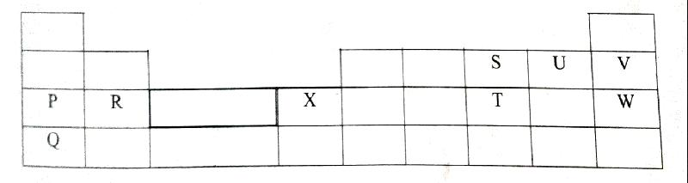
- Which of the elements has the largest atomic radius? Explain (2mrks)
_____________________________________________________________________________________________________________________________________________________________________________________________________________________________________________b) Identify the most reactive metal. Explain (2mrks)
_____________________________________________________________________________________________________________________________________________________________________________________________________________________________________________

