**LONDIANI SUBCOUNTY JOINT EXAMINATIONS**

**CHEMISTRY PAPER 2(THEORY)**

**TIME 2 HOURS**

**INSTRUCTIONS TO CANDIDATES**

1. *Write your name and index no in the spaces provided above.*
2. *Sign and write the date of exam in the spaces provided above.*
3. *Answer all the questions in the spaces provided after each.*
4. *Mathematical tables and silent electronic calculators may be used.*
5. *All working must be clearly shown where necessary.*
6. *This paper consists of 12 printed pages. Candidates should check to ensure that all pages are printed as indicated and that no questions are missing.*
7. *All answers should be written in English.*

**FOR EXAMINER’S USE ONLY**

|  |  |  |
| --- | --- | --- |
| **Question** | **Maximum score** | **Candidate’s score** |
| 1 |  | 10 |
| 2 |  | 12 |
| 3 |  | 14 |
| 4 |  | 11 |
| 5 |  | 12 |
| 6 |  | 09 |
| 7 |  | **12** |
| **Total** |  | **80** |

1. The table below shows the positions of some elements in the periodic table. The letters are not the actual symbols of the elements.

|  |  |  |  |  |  |  |  |  |
| --- | --- | --- | --- | --- | --- | --- | --- | --- |
|  |  |  |  |  |  |  |  |  |
|  |  |  |  |  |  | A |  |  |
|  | B |  | C |  | D |  | E |  |
| F | G |  |  |  |  |  |  |  |
|  |  |  |  |  |  |  | H |  |

a) Select an element that can form an ion with a charge of +2. Explain your answer (2mks)

b) What type of structure would the oxide of C have? Explain your answer. (2mks)

c) How does the reactivity of H compare with that of E? Explain your answer. (2mks)

d) Explain how you would expect the following to compare.

(i) Atomic radii of F and G. (1mk)

(ii) The pH values of aqueous solution of the oxide of B and D. (1mk)

e) Draw a diagram to represent an ion of element D. (2mks)

2. The diagram below shows a set up for the determination of enthalpy of displacement for the reaction between zinc metal and copper (II) sulphate solution



1. Define molar heat of displacement (1 mark)
2. Write an ionic equation for the reaction that takes place in this experiment (1 mark)

(c) What is the function of the saw dust in the set up (1 mark)

(d) State and explain two observations made at the end of this experiment other than rise in temperature (3 marks)

(e) 4 g of the zinc powder were added to 50cm3 of 0.25M copper (II) sulphate solution. The mixture was stirred with the thermometer and the highest temperature recorded.

Final temperature = 34.5oC

Initial temperature = 22.0oC

Calculate the molar heat of displacement of copper by zinc (Zn=65) (4marks)

(f) Sketch an energy level diagram for the above reaction (2 marks)

3.(a)Study the given reduction potentials and answer the questions that follow. The letters do not represent actual symbols of elements. Eθ(V)

X2+(aq) + 2e- X(s) -2.90

Y2+(aq) + 2e- Y(s) -2.38

Z2+(aq) + 2e- Z(s) 0.00

½ A2(g) + e- A(aq) +2.87

(i) Which element is likely to be hydrogen? (1mk)

(ii) Draw an electrochemical cell when Y and A are combined. Show the direction of flow of electrons (2mks)

(iii) Draw a diagram to show how a spoon made of iron can be coated with silver metal (2mks)

(b) The set – up below was used during the electrolysis of a solution of magnesium sulphate using inert electrodes.

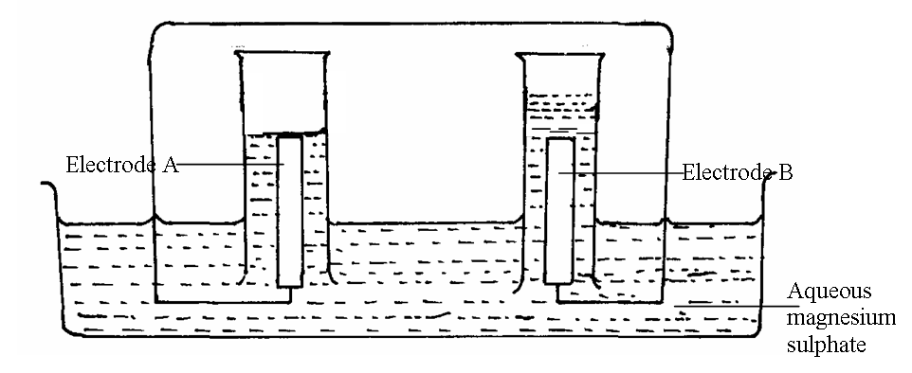

(i) Identify the ions present in the electrolyte (1mk)

(ii) Write half equations at the anode and at the cathode:

Cathode: (1mk)

Anode (1mk)

(iii) Which electrode is the cathode? Explain (2mks)

(c) Explain the pH changes of the electrolyte during the experiment (2mks)

d) Calculate the quantity of electricity (in coulombs) that would liberate 1.2dm3 of oxygen gas at R.T.P (take 1 mole of gas at r.t.p = 24dm3, 1F = 96500C) (2mks)

4.(a) Crude oil is a source of many compounds that contain carbon and hydrogen only.

(i) Name the process used to separate the components of crude oil. (1mk)

(ii) On what basis does separation occur (1mk)

(b) Under certain conditions, hexane can be converted to two products, one of them being butane.

Write the formula of the other product (1mk)

(ii) Describe a simple chemical test to show the differences between the two products formed in (b) above. (2mks)

c) Ethyne is another compound found in crude oil. One mole of hydrogen chloride gas

reacted with one mole of ethyne and a product P was formed. P was then reacted with excess hydrogen gas to form product Q.

Draw the structure of P and Q (2mks)

(d) Ethyne may be collected over water during preparation. Explain why this is possible. (1mk)

(e) (i) When one mole of ethyne is reacted with one mole of hydrogen, the product formed may undergo addition polymerization under suitable conditions. Write an equation for addition polymerization of the product. (1mk)

(ii) Give one disadvantage of the polymer in e(i) above (1mk)

(f) State one commercial use of ethyne (1mk)

5. In the experiment, steam was passed over heated iron wool as shown in the diagram below.The gas produced was then dried and passed through heated copper (ii) oxide

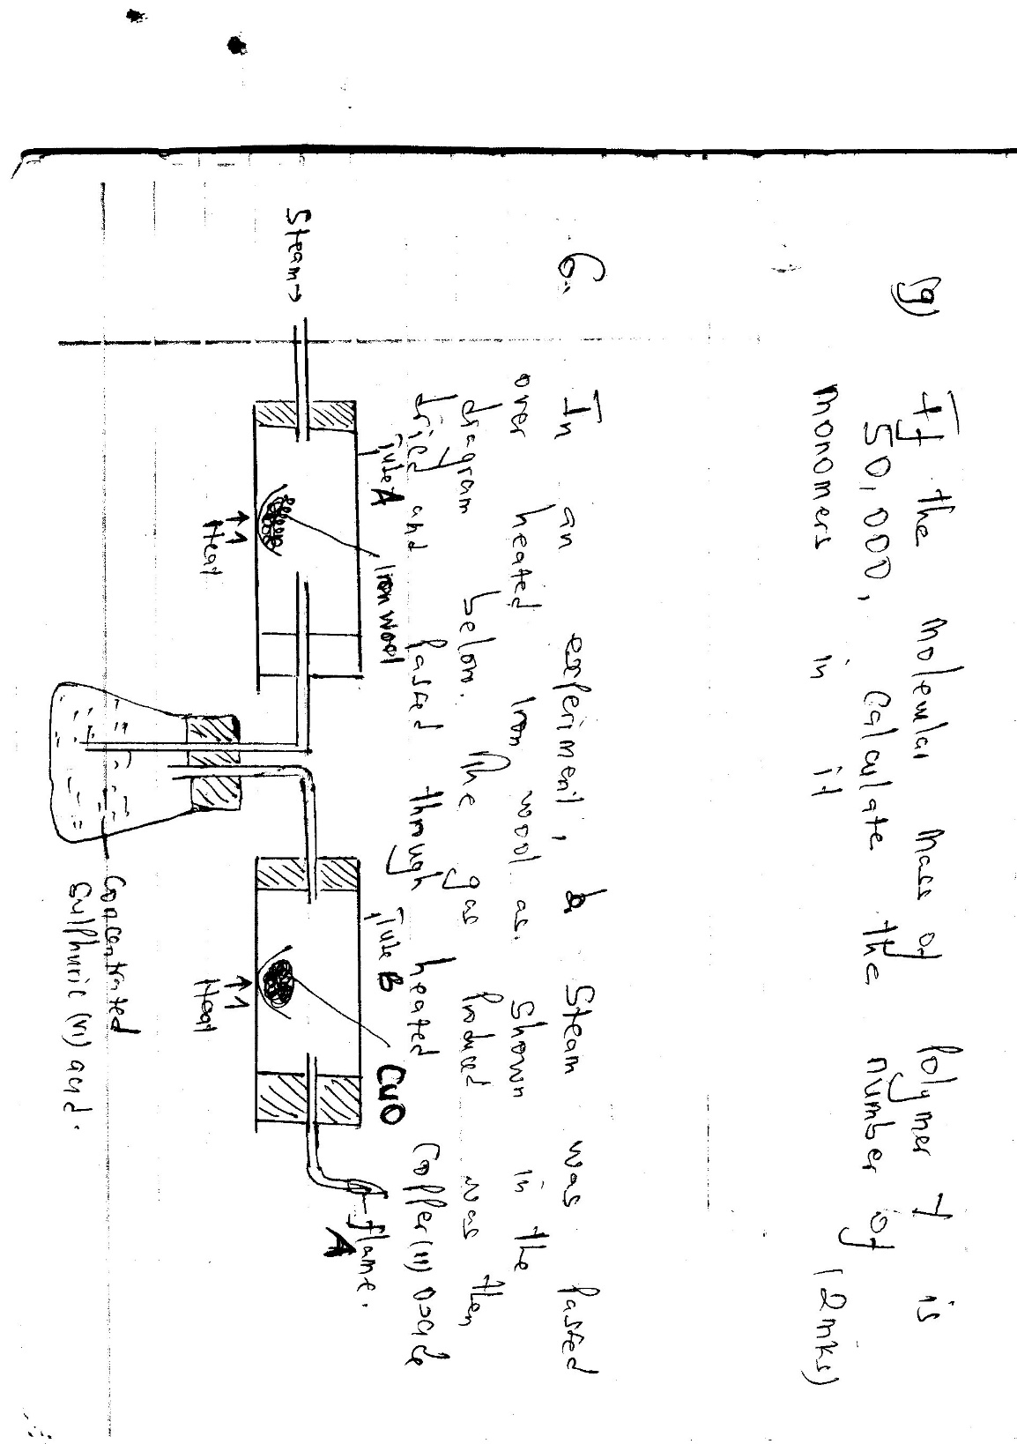

1. Write an equation for the reaction between steam and iron 1mk
2. What observation would be made in tube B at the end of reaction? Explain 2mks
3. What precaution should be taken into consideration before lighting the gas at A 1mk
4. What type of reaction takes place in the tube B 1mk
5. Give two uses that are for both carbon(ii) oxide and hydrogen gases 2mks
6. i)Give the name of the process described below 3mks

|  |  |  |
| --- | --- | --- |
| Substance | condition | Name of the process |
| Iron(ii) sulphate heptahydrate | Exposed to air ,changes from crystalline to powder form |  |
| Concentrated sulphuric(vi) acid | Exposd to air, volume of the acid increases |  |
| Zinc nitrate | Exposed to air changes in solution |  |

ii) Name another substance that can undergo the same process as zinc nitrate above 1mk

iii) Write the formula of copper (ii) sulphate crystals 1mk

6 3.06g of Manganese (IV) oxide was placed in a flask and 25cm3 of hydrogen peroxide added.

The volume of oxygen gas produced was recorded after every 10 seconds. The results obtained were recorded in the table below.

Plot a graph of volume (cm3) against time (sec). (3mks)



* 1. From the graph, determine the volume of oxygen gas produced.(1mk)
  2. The experiment was repeated using more concentrated hydrogen peroxide.

On the same axis; sketch the curve that was obtained. (1mk)

* 1. Write an equation for catalytic decomposition of hydrogen peroxide.(1mk)
  2. Give the test for oxygen gas.(1 mk)

* 1. State two commercial uses of oxygen gas. (2 mks)

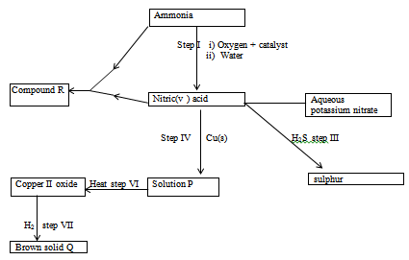7 The scheme below shows various reactions starting with ammonia. Study it and answer the questions that follow.

a) Name:

i) Compound R (1mk)

ii) Solid Q (1mk)

iii) Catalyst used in step I (1mk)

iv) Process taking place in step II (1mk)

b) i) What property of nitric (V) acid is demonstrated in step III (1mk)

ii) State the precaution to be taken when carrying out reaction in step III? Give a reason (2mks)

c) Write an equation for the reaction in step VII (1mk)

d) i) Give one use of compound R (1mk)

ii) Calculate the percentage of nitrogen by mass in compound R (N=14, H=1, 0= 16 (2mks)

e) State one commercial use of Nitric (V) acid apart from making nitrogenous fertilizers (1mk)