KENYA CERTIFICATE OF SECONDARY SCHOOL
233/1
CHEMISTRY PAPER 1
Time: 2 Hours

Name…………………………………………Index no……………………. 2HOURS 80MKS

Instructions

- Answer ALL questions in the spaces provided
- Show your working clearly.
- Electronic calculators and Mathematical tables may be used.
- All answers must be written in English language

QUESTIONS | TOTAL  SCORE | STUDENT’S  SCORE
1 –25 | 80

This paper consists of 12 printed Pages
Candidates should check the question paper to ensure that all the pages are printed as indicated and no questions are missing

- Below is a table showing the solubility of salts Q and R at different temperatures.

Temperature ºC |  | 0 | 10 | 20 | 30 | 40 | 50
Solubility in grams per 100g of water | Salt Q | 3.0 | 5.0 | 7.4 | 10.0 | 14.0 | 19.0
 | Salt R | 15.0 | 17.0 | 20.7 | 25.7 | 28.7 | 33.0

- Define the term “Solubility of salt” (1mk)

- If both salts Q and R are present in 100cm³ of saturated solution at 50ºC, what willbe the total mass of crystals formed if the solution was cooled to 20ºC? (2mks)

- Name two areas where knowledge of solubility curves is applied (2mks)

- Two samples of hard water C and D were boiled. When tested with drops of soap, sample D formed lather easily while C did not:-
- Name the possible salt that caused hardness in sample D(1mk)

- Explain how distillation can remove hardness in sample C (1mk)

(c) Give two advantages of hard water (1mk)

- You are provided with a mixture of Lead (II) Chloride, ammonium chloride and sodium chloride. Explain how you would separate all the three solids (3mks)

- Sodium Carbonate Decahydrate crystals were left exposed on a watch glass for two days.
- State the observations made on the crystals after two days.(1mk)

b) Name the property of salts investigated in the above experiment (1mk)

- When water reacts with potassium metal the hydrogen produced ignites explosively on the surface of water.
- What causes this ignition?(1mk)

- Write an equation to show how this ignition occurs (1mk)

- How does the pH value of 0.25M KOH _{(aq)} compare with that of 0.25M ammonia solution? Explain (2mks)

- i. State Gay Lussac’s law. (1mk)

ii. 10cm³ of methane (CH₄) gas is exploded with 150cm³ of air containing 20% oxygen and 80% nitrogen. The products were allowed to cool to room temperature. What will be the total volume of the gases at the end of the reaction (3mks)

- The formulae below represents active ingredients of two cleansing agents A and B
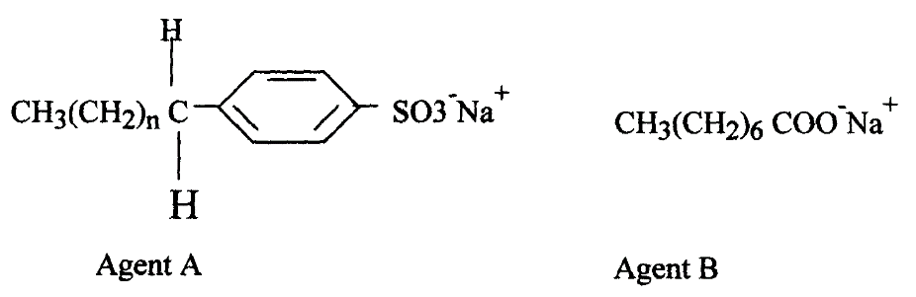

- Name the class to which each of the cleansing agent belongs(2mks)

- Which one of the cleaning agent above is not environmental friendly? Explain (2mk)

- Which one of the cleansing agent would be suitable to be used in water containing magnesium hydrogen carbonate? Explain (2mks)

- During Saponification process, a small amount of Sodium Chloride is added Give a reason (1mk)

- (a) Write an equation showing how ammonium nitrate may be prepared starting with ammonia gas (1mk)

(b) Calculate the maximum mass of ammonium nitrate that can be prepared using 5.3kg of ammonia (H=1, N=14, O=16) (2mks)

10. Plastics and rubber are extensively used to cover electrical wires.
(a) What Name is used to describe plastic and rubbers used in this way? (1mk)

(b) Explain why plastics and rubbers are used for this purpose (1mk)

11. G grams of a radioactive isotope take 120days to decay to 3.5grams. The half-life period of the isotope is 20days

(a) Find the initial mass of the isotope (2mks)

(b) Give two applications of radioactivity in medicine (2mks)

(c) Uranium -238 disintegrates by emitting an alpha particle to form substance Y.
Nuclide Y emits a beta particle to form substance Z. Write down nuclear equations to show how
substance Y and Z are formed (U=92) (2mks)

12. Study the flow chart below and answer the questions that follow:
Copper Pyrites
CuFeS₂
Step (I)
Froth floatation,
Air
Gas Q
Gas Q
Step (II)
Cu₂S_{(s)}
Cu₂O
Cu_{(s)}
Pure Copper
Air
Step (III)
Cu₂S
Step (IV)
FeO
Step (V)

- Name gas Q(1mk)

- With the help of diagram, describe how step (V) is carried out (3mks)

- During purification of copper by electrolysis, 1.48g of copper were deposited when a Current was passed through aqueous copper (II) sulphate for 2 ½ hours. Calculate the amount of current passed (Cu = 63.5 1Faraday = 96500C) (3mks)

- What is meant by the term Froth Floatation(2mks)

- Name two impurities present in the ore of copper (1mk)

13. State two properties of Duralumin that make it suitable for use in making aircraft parts?(1mk)

14. The flow chart below shows a sequence of chemical reactions starting with Zinc. Study it and answer the questions that follow:-
Zn_{(s)}
Step 1
Zn²⁺_{(aq)}
Step 2

NaOH_{(aq)}
Zn(OH)_{2(s)}
Step 3

Heat
Zn_{(s})
Zn²⁺_{(aq)}
Step 5

Metal T
Step 4 H₂SO_{4(aq)}
ZnO_{(s)}
Dilute hydrochloric acid

- In step 1, excess 3M hydrochloric acid was added to 0.5g of Zinc powder

- State one observation which were made when the reaction was in progress ( ½ mks)

- Explain why hydrogen gas is not liberated when dilute nitric acid is used in step 1 (1mk)

- a) Write an ionic equation for the reaction that took place in step 1 (1mk)

- Calculate the volume of 3M hydrochloric acid that was needed to react completely with0.5g of Zinc powder (Zn = 65.0) (2mks)

15. Briefly describe how a pure sample of lead ii iodide can be prepared in the lab given Distilled water, solid lead ii nitrate and solid Potassium iodide (3mks)

16. Use equations only to explain how slag is formed in the Blast furnace during the extraction of iron (2mk)

17. Using dots and crosses to represent electrons draw the structure Phosphorous chloride (PCl₃) (1mk)

19. Study the information in the table below and answer the questions that follow:
(The letters do not represent the actual symbols of the elements)
Element | Electronic configuration | Ionization energy KJmol⁻¹
P | 2:1 | 519
Q | 2:8:1 | 494
R | 2:8:8:1 | 418

- What is meant by ionization energy? (1mk)

- Element R has the lowest ionization energy. Explain. (1mk)

- When a piece of element Q is placed on water it melts and a hissing sound is produced as it moves on the water surface. Explain these observations. (1 ¹/₂mks)

- Write the equation for the reaction between element Q and water.(1mk)

20. Chlorine has a higher boiling point than Argon. Give a reason (1mk)

21.i) State Graham’s Law of diffusion (1mk)

ii) Gas B takes 110 seconds to diffuse through a porous pot, how long will it take for the
Same amount of ammonia to diffuse under the same conditions of temperature and pressure?
(RMM of B = 34 RMM of ammonia = 17) (2mks)

22.The setup below was used to carry out the electrolysis of Magnesium sulphate solution using
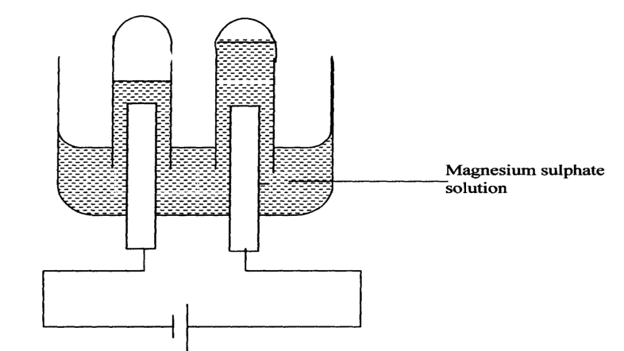 Inert electrodes

- Name a suitable pair of electrode that can be used in the above process. ( ½ mk)

- State and explain the changes on the concentration of magnesium sulphate solution as the process proceeds. (1mk)

- Label on the diagram the Cathode and anode(1mk)

23.i. Bond energies for some bonds are tabulated below:-
BOND | BOND ENERGY KJ/mol
H – H | 436
C = C | 610
C- H | 410
C - C | 345

Use the bond energies to estimate the enthalpy for the reaction
C₂H_{4(g)} + H_{2(g)} C₂H_{6(g)} (2mks)

ii. Study the diagram below and answer the questions that follow:
NH₄⁺_{(g)} +Cl⁻_{(g)}
NH₄g +
∆H₂
NH₄⁺_{(g)} +Cl⁻_{(g)}

NH₄⁺(_{aq}) + Cl⁻(_{aq})
∆H₃
∆H₁
NH₄Cl(_{s})
Energy
Reaction Co-ordinate

a) What do ∆H₁ and ∆H₂ represent? (1mk)
∆H₁
∆H₂
- Write an expression to show the relationship between ∆H₁, ∆H₂ and ∆H₃.(1mk)

24. (a)Name one substance that is added to Aluminium oxide during electrolysis in the manufacture of Aluminium metal ( ½ mk)

(b ) Give a reason why the substance named above is added (1mk)

25.a) State Le Chatelier’sPrinciple (1mk)

- An equilibrium exists in the Haber process as shown in the equation below
N_{2(g)} + 3H_{2(g)}2NH_{3(g)}ΔH = -92kJ

State and explain the effect of the following factors on the yield of Ammonia

- Increase in Pressure (1 ½mks)

- Increase in Temperature (1 ½ mks)

