Term 1 – 2023 OPENER EXAM
CHEMISTRY
PAPER 1 (233/1)
FORM FOUR (4)
Time: 2 Hours

Name: …………………………………………………………. Adm No: ……………….
School: ……………………………………………………….. Class: …………………..
Signature: …………………………………………………….. Date: …………………...
Instructions to candidates
- Write your name, admission number, index number, and stream in the spaces provided above.
- Sign and write the date of the examination in the spaces provided
- Answer ALL the questions in the spaces provided.
- Candidates MUST answer all questions in English.
- KNEC mathematical tables and silent non-programmable electronic calculators may be used.
- This paper consists of 8 printed pages
- Candidates should check the question paper to ascertain that ALL the pages are printed as indicated and that NO QUESTIONS ARE MISSING

FOR EXAMINER’S USE ONLY.
QUESTION | MAXIMUM SCORE | CANDIDATE’S SCORE
1 – 26 | 80

- The table below shows the number of valence electrons in atoms of elements W, X, and Y.
Element | W | X | Y
No. of valence electrons | 1 | 5 | 2
- Elements W and Y cannot combine to form a compound. Explain (1 mark)
___________________________________________________________________________
___________________________________________________________________________
- The carbonate of W was heated in a test tube, using a Bunsen burner flame. State and explain the observations made. (2 marks)
___________________________________________________________________________
___________________________________________________________________________
___________________________________________________________________________
- One mole of ethyne reacted with one mole of hydrogen chloride gas:
- Draw the structure and give the name of the compound formed (2 marks)
Structure

Name: _____________________________________________________________________
- Excess hydrogen was bubbled through the product in the presence of nickel catalyst. Three drops of acidified potassium manganate (VII) were then added to the product of reaction. State the observation made when this oxidising agent was added. (1 mark)
___________________________________________________________________________
___________________________________________________________________________
- A certain carbonate has the formula WCO₃. If 1g of the carbonate reacts completely with 20cm³ of 1M hydrochloric acid, calculate the relative atomic mass of W (3 marks)
(O =16, C = 12)
_____________________________________________________________________________
_____________________________________________________________________________
- Starting with aqueous magnesium sulphate, describe how you would obtain a sample of magnesium oxide. (3 marks)
______________________________________________________________________________
______________________________________________________________________________
______________________________________________________________________________
- Under certain conditions, ethanol and butanoic acid react to form a compound with a pleasant smell.
- State the conditions necessary for the reaction to occur (1 mark)
___________________________________________________________________________
- Name the process that forms the pleasant-smelling compound (1 mark)
___________________________________________________________________________
- Name the compound formed in the reaction above. (1 mark)
___________________________________________________________________________
- Iron wool was heated in the presence of hydrogen chloride gas as shown in the diagram below
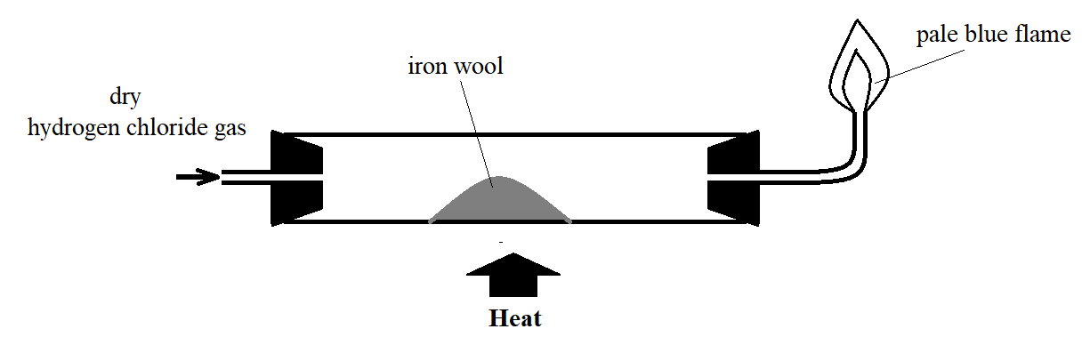
- State the observation that was made in the combustion tube (1 mark)
___________________________________________________________________________
___________________________________________________________________________
- The flame at the nozzle burns quietly. Explain this observation (1 mark)
___________________________________________________________________________
___________________________________________________________________________
- Write an equation for the formation of the flame at the nozzle (1 mark)
___________________________________________________________________________

- At room temperature and pressure hydrogen fluoride is a volatile liquid, while hydrogen chloride is a gas. Explain (2 marks)
______________________________________________________________________________
______________________________________________________________________________
- Name the group of compounds to which hydrogen fluoride and hydrogen chloride belong. (1 mark)
___________________________________________________________________________
- Sodium chloride and aluminium chloride are chlorides of metals found in period 3 of the Periodic table. State and explain the observations made on methyl orange indicator when the compounds were added to separate samples of water in test tubes. (3 marks)
______________________________________________________________________________
______________________________________________________________________________
______________________________________________________________________________
- Concentrated sulphuric (VI) acid was added to a sample of table sugar.
- State and explain the observation made. (2 marks)
___________________________________________________________________________
___________________________________________________________________________
- Give an example of application of the reaction in a) above (1 mark)
___________________________________________________________________________
___________________________________________________________________________
- Manganese (IV) oxide is mixed with hydrogen peroxide to form oxygen gas and mixed with concentrated hydrochloric acid to form chlorine gas in the laboratory.
- State the role of manganese (IV) oxide in
- Preparation of Chorine (1 mark)
________________________________________________________________________
________________________________________________________________________
- Preparation of Oxygen (1 mark)
________________________________________________________________________
________________________________________________________________________
- Write chemical equations for the reactions that lead to:
- Production of Oxygen (1 mark)
________________________________________________________________________
- Production of Chlorine (1 mark)
________________________________________________________________________
- A white powder J was heated. A colourless gas was formed, and fumes of a brown gas observed along with a yellow residue V which cooled to form a white substance. When sodium hydroxide solution was added to cold residue V, a white precipitate which dissolved in excess sodium hydroxide to form a colourless solution X was observed.
- Identify
- Powder J _________________________________________________________(½ mark)
- Residue V _______________________________________________________ (½ mark)

- Why does residue V react with sodium hydroxide? (1 mark)
___________________________________________________________________________
___________________________________________________________________________
- Write an equation that leads to the formation of the colourless solution X (2 marks)
___________________________________________________________________________
- Hydrogen sulphide gas is considered more poisonous than carbon (II) oxide. However, carbon (II) oxide poisoning accounts for more fatalities than hydrogen sulphide gas. Explain this observation (2 marks)
______________________________________________________________________________
______________________________________________________________________________
- The melting point of halogens increases down the group, while that of the alkali metals decreases down the group. Explain this observation. (3 marks)
______________________________________________________________________________
______________________________________________________________________________
______________________________________________________________________________
- Dry chlorine gas is bubbled through a solution of sodium sulphite. Describe a test that shows a chemical change took place. (3 marks)
______________________________________________________________________________
______________________________________________________________________________
______________________________________________________________________________
- The sequence below shows how air can be used as a raw material for obtaining ammonia.
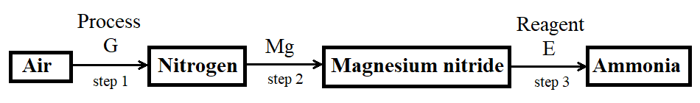
- Name Process G (1 mark)
___________________________________________________________________________
- Name Reagent E (1 mark)
___________________________________________________________________________
- Write a balanced chemical equation for the reaction in step 2 (1 mark)
___________________________________________________________________________

- If 280cm³ of nitrogen gas diffuses through a porous membrane in 70 seconds. How long will 400cm³ of carbon (IV) oxide diffuse through the same membrane? (3 marks)
(C = 12, O = 16, N = 14)
______________________________________________________________________________
______________________________________________________________________________
______________________________________________________________________________
- The following results were obtained from an experiment to determine the quantity of water of crystallization in the crystals of ZnSO₄•XH₂O:
Mass of crucible 21.30g
Mass of crucible + crystals 27.04g
Mass of crucible + residue 24.52g
Determine the value of X (3 marks)
(Zn = 65, S = 32, O = 16, H = 1)
______________________________________________________________________________
______________________________________________________________________________
______________________________________________________________________________
- Determine the volume of hydrogen gas, at room temperature and pressure, produced in a class experiment when 4.333g zinc granules react completely with excess dilute sulphuric (VI) acid. (3 marks)
(Zn = 65, Molar Gas Volume at R.T.P. = 24dm³)
______________________________________________________________________________
______________________________________________________________________________
______________________________________________________________________________
- The graph below shows the atomic radii of some elements in groups I and II plotted against their atomic numbers.
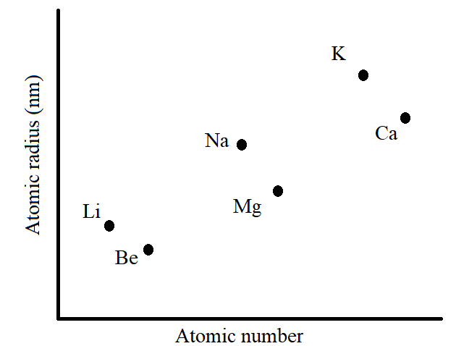
Explain:
- The trend shown by Li, Na, and K. (1 mark)
___________________________________________________________________________
___________________________________________________________________________
- Why the atomic radii of elements Be, Mg, and Ca are lower than those of Li, Na, and K (2 marks)
___________________________________________________________________________
__________________________________________________________________________
___________________________________________________________________________
- An element Y forms an ion Y³⁻. This ion contains 18 electrons.
- State the group and period of this element. Explain (2 marks)
___________________________________________________________________________
___________________________________________________________________________
- Write the formula of the compound which would be formed if Y reacts with chlorine. (1 mark)
___________________________________________________________________________

- State Gay-Lussac’s law. (1 mark)
___________________________________________________________________________
___________________________________________________________________________
- When 30cm³ of a gaseous hydrocarbon reacted completely with 90cm³ of oxygen, 60cm³ of carbon (IV) oxide was produced. If all volumes of the gases were measured at room temperature, determine the formula of this hydrocarbon. (2 marks)
___________________________________________________________________________
___________________________________________________________________________
___________________________________________________________________________
- The oxide of an element G contains 47.06% oxygen by mass. Determine the empirical formula of the oxide (G = 27, O = 16) (2 marks)
______________________________________________________________________________
______________________________________________________________________________

- Name and draw two structural isomers of pentyne (4 marks)
Name | Name
Structure | Structure
- Sulphur is soluble in ethanol but not in water. Sodium chloride is soluble in water but not in ethanol. Sand is insoluble in both ethanol and water. Describe how to obtain sand from a mixture of sand, sodium chloride, and sulphur. (2 marks)
______________________________________________________________________________
______________________________________________________________________________
______________________________________________________________________________
- Ammonium chloride reacts with calcium hydroxide in the Solvay Process to generate ammonia gas.
- Write a chemical equation for the reaction (1 mark)
___________________________________________________________________________
- Calculate the volume of ammonia produced, at room temperature, when 2.14g of ammonium chloride reacts with calcium hydroxide. (2 marks)
(N =14, H = 1, Cl = 35.5, Molar Gas Volume = 24dm³)
___________________________________________________________________________
___________________________________________________________________________
___________________________________________________________________________
- Calcium oxide is used as a drying agent in the laboratory.
- Calcium oxide is not suitable for drying hydrogen chloride gas. Explain (2 marks)
___________________________________________________________________________
___________________________________________________________________________
- Name one suitable drying agent for hydrogen chloride gas. (1 mark)
___________________________________________________________________________
- In terms of structure and bonding, why is graphite used as a lubricant? (2 marks)
___________________________________________________________________________
___________________________________________________________________________

