Term 1 – 2023 OPENER EXAM
CHEMISTRY
PAPER 1 (233/1)
FORM FOUR (4)
Time: 2 Hours
MARKING SCHEME

Instructions to candidates
- Write your name, admission number, index number, and stream in the spaces provided above.
- Sign and write the date of the examination in the spaces provided
- Answer ALL the questions in the spaces provided.
- Candidates MUST answer all questions in English.
- KNEC mathematical tables and silent non-programmable electronic calculators may be used.
- This paper consists of 8 printed pages
- Candidates should check the question paper to ascertain that ALL the pages are printed as indicated and that NO QUESTIONS ARE MISSING

FOR EXAMINER’S USE ONLY.
QUESTION | MAXIMUM SCORE | CANDIDATE’S SCORE
1 – 26 | 80

- The table below shows the number of valence electrons in atoms of elements W, X, and Y.
Element | W | X | Y
No. of valence electrons | 1 | 5 | 2
- Elements W and Y cannot combine to form a compound. Explain (1 mark)
They both react by losing electrons
- The carbonate of W was heated in a test tube, using a Bunsen burner flame. State and explain the observations made. (2 marks)
No production of a colourless gas that forms a white precipitate in calcium hydroxide solution. Carbonates of group I elements do not decompose on heating.
- One mole of ethyne reacted with one mole of hydrogen chloride gas:
- Draw the structure and give the name of the compound formed (2 marks)
Structure
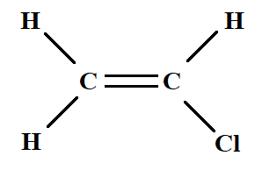
Name: 1-chloroethene
- Excess hydrogen was bubbled through the product in the presence of nickel catalyst. Three drops of acidified potassium manganate (VII) were then added to the product of reaction. State the observation made when this oxidising agent was added. (1 mark)
Purple acidified potassium manganate (VII) remains purple
- A certain carbonate has the formula WCO₃. If 1g of the carbonate reacts completely with 20cm³ of 1M hydrochloric acid, calculate the relative atomic mass of W (3 marks)
(O =16, C = 12)
Moles HCl | Moles WCO₃ | R.F.M. WCO₃
$$\frac{20 ×1}{1000}$$  = 0.02 moles | HCl : WCO₃  2 : 1  = $\frac{0.02 ×1}{2}$  = 0.01 moles | 0.01 moles $≡$ 1g  1 mole $≡$ $\frac{1 ×1}{0.01}$  = 100  W + 12 + 3(O) = 100  W = 100 – 12 – 3(16) = 40

- Starting with aqueous magnesium sulphate, describe how you would obtain a sample of magnesium oxide. (3 marks)
Add some sodium carbonate and stir to form magnesium carbonate. Filter the mixture to retrieve the magnesium carbonate as the residue. Heat the residue until no further change in mass occurs to obtain Magnesium oxide.
- Under certain conditions, ethanol and butanoic acid react to form a compound with a pleasant smell.
- State the conditions necessary for the reaction to occur (1 mark)
A few drops of concentrated sulphuric (VI) acid and warming
- Name the process that forms the pleasant-smelling compound (1 mark)
Esterification
- Name the compound formed in the reaction above. (1 mark)
Ethylbutanoate
- Iron wool was heated in the presence of hydrogen chloride gas as shown in the diagram below
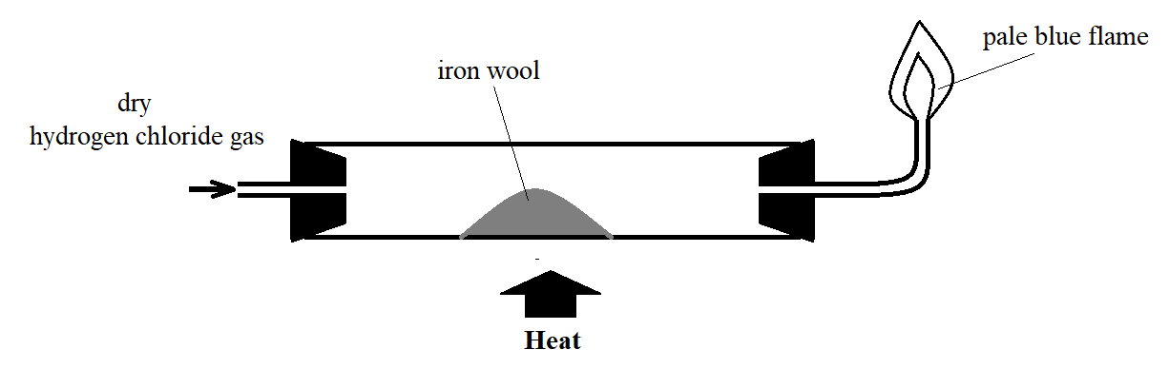
- State the observation that was made in the combustion tube (1 mark)
Grey iron wool changes to pale green crystals.
- The flame at the nozzle burns quietly. Explain this observation (1 mark)
Pure hydrogen burns quietly
- Write an equation for the formation of the flame at the nozzle (1 mark)
2H_{2 (g)} + O_{2 (g)} 2H₂O _{(l)}

- At room temperature and pressure hydrogen fluoride is a volatile liquid, while hydrogen chloride is a gas. Explain (2 marks)
In addition to weak Van der Waal’s forces of attraction, hydrogen fluoride experiences hydrogen bonding due to the higher electronegativity of fluorine while hydrogen chloride does not experience hydrogen bonding due to the lower electronegativity of its chlorine atom.
- Name the group of compounds to which hydrogen fluoride and hydrogen chloride belong. (1 mark)
Hydrogen halides
- Sodium chloride and aluminium chloride are chlorides of metals found in period 3 of the Periodic table. State and explain the observations made on methyl orange indicator when the compounds were added to separate samples of water in test tubes. (3 marks)
Orange methyl orange remains orange in the solution of sodium chloride, while the orange methyl orange changes to pink in a solution of aluminium chloride. Sodium chloride only dissolves in water to form a neutral solution while aluminium chloride hydrolyses in water to form hydrochloric acid solution.
- Concentrated sulphuric (VI) acid was added to a sample of table sugar.
- State and explain the observation made. (2 marks)
White crystals change to a frothy black solid. Concentrated sulphuric (VI) acid removes the elements of water from sugar to form black carbon.
- Give an example of application of the reaction in a) above (1 mark)
- making ethene from ethanol
- drying acidic or neutral gases in the laboratory
- preparing carbon (II) oxide from ethanedioic acid in the laboratory
- Manganese (IV) oxide is mixed with hydrogen peroxide to form oxygen gas and mixed with concentrated hydrochloric acid to form chlorine gas in the laboratory.
- State the role of manganese (IV) oxide in
- Preparation of Chorine (1 mark)
It oxidises concentrated hydrochloric acid to chlorine gas

- Preparation of Oxygen (1 mark)
It catalyses the decomposition of hydrogen peroxide to form oxygen
- Write chemical equations for the reactions that lead to:
- Production of Oxygen (1 mark)
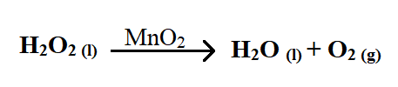
- Production of Chlorine (1 mark)
MnO_{2 (s)} + 4HCl _{(aq)} MnCl_{2 (aq)} + Cl_{2 (g)} + 2H₂O _{(l)}
- A white powder J was heated. A colourless gas was formed, and fumes of a brown gas observed along with a yellow residue V which cooled to form a white substance. When sodium hydroxide solution was added to cold residue V, a white precipitate which dissolved in excess sodium hydroxide to form a colourless solution X was observed.
- Identify
- Powder J Zinc nitrate (½ mark)
- Residue V Zinc oxide (½ mark)

- Why does residue V react with sodium hydroxide? (1 mark)
It is amphoteric
- Write an equation that leads to the formation of the colourless solution X (2 marks)
Zn(OH)_{2 (s)} + 2NaOH_{(aq)} [Zn(OH)₄]²⁻_{(aq)} + 2Na⁺_{(aq)}
- Hydrogen sulphide gas is considered more poisonous than carbon (II) oxide. However, carbon (II) oxide poisoning accounts for more fatalities than hydrogen sulphide gas. Explain this observation (2 marks)
Hydrogen sulphide gas has a characteristic smell of rotten eggs that makes it easy to detect, while carbon (II) oxide is colourless and odourless, making it difficult to detect.
- The melting point of halogens increases down the group, while that of the alkali metals decreases down the group. Explain this observation. (3 marks)
An increase in molecular size down the group of halogens leads to an increase in strength of Van der Waal’s forces hence increase in melting point, while an increase in atomic size for metals leads to a decrease in effective nuclear force of attraction, hence a decrease in strength of metallic bond.

- Dry chlorine gas is bubbled through a solution of sodium sulphite. Describe a test that shows a chemical change took place. (3 marks)
When barium nitrate/barium chloride is added to a solution of sodium sulphite, a white precipitate is formed which dissolves to form a colourless solution on addition of dilute hydrochloric acid/dilute nitric acid. When barium chloride/barium nitrate is added to the solution after chlorine is bubbled, the white precipitate persists on addition of dilute acid.
- The sequence below shows how air can be used as a raw material for obtaining ammonia.
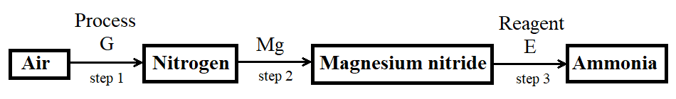
- Name Process G (1 mark)
Fractional distillation [of liquid air].
- Name Reagent E (1 mark)
Water
- Write a balanced chemical equation for the reaction in step 2 (1 mark)
3Mg _{(s)} + N_{2 (g)} Mg₃N₂ _{(s)}

- If 280cm³ of nitrogen gas diffuses through a porous membrane in 70 seconds. How long will 400cm³ of carbon (IV) oxide diffuse through the same membrane? (3 marks)
(C = 12, O = 16, N = 14)

$\frac{RN2}{RCO2}$ = $\sqrt{\frac{M.CO2}{M.N2}}$  R_{N2} = $\frac{280}{70}$ = 4cm³/s  M_{N2} = 2(14) = 28  M_{CO2} = 12 + 2(16) = 44 | $\frac{4}{R.CO2}$ = $\sqrt{\frac{44}{28}}$  R_{CO2} = 3.191  Since R_{CO2 =} $\frac{V.CO2}{T.CO2}$ | T_{CO2 =} $\frac{400}{3.191}$  T_{CO2} = 125.36 seconds

OR  $\frac{T.N2}{T.CO2}$ = $\sqrt{\frac{M.N2}{M.CO2}}$  If 280cm³ 70 seconds  Then 400cm³ $\frac{400 ×70}{280}$  = 100 seconds | $\frac{100}{T.CO2}$ = $\sqrt{\frac{28}{44}}$  T_{CO2} = 125.36

- The following results were obtained from an experiment to determine the quantity of water of crystallization in the crystals of ZnSO₄•XH₂O:
Mass of crucible 21.30g
Mass of crucible + crystals 27.04g
Mass of crucible + residue 24.52g
Determine the value of X (3 marks)
(Zn = 65, S = 32, O = 16, H = 1)
 | ZnSO₄ | H₂O
Mass (g) | 27.04 – 21.30 = 5.74 | 27.04 – 24.52 = 2.52
R.F.M. | 65 + 32 + 4(16) = 161 | 2(1) + 16 = 18
Moles | ${5.74}/{161}$ = 0.03565 | ${2.52}/{18}$ = 0.14
Ratio | $\frac{0.03565}{0.03565}$ = 1 | $\frac{0.14}{0.03565}$ =3.927 $≈$ 4
X = 4
- Determine the volume of hydrogen gas, at room temperature and pressure, produced in a class experiment when 4.333g zinc granules react completely with excess dilute sulphuric (VI) acid. (3 marks)
(Zn = 65, Molar Gas Volume at R.T.P. = 24dm³)
Moles Zn  65g 1 mole  4.333g $\frac{4.333 ×1}{65}$ = 0.06667 moles  Zn : H₂  1 : 1 | Moles H₂ = moles Zn = 0.06667 moles  If 1 mole = 24dm³  0.06667 moles = 0.06667 × 24  = 1.60dm³
- The graph below shows the atomic radii of some elements in groups I and II plotted against their atomic numbers.
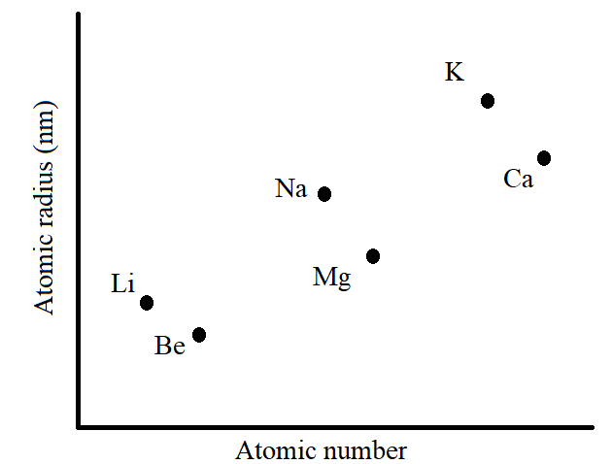
Explain:
- The trend shown by Li, Na, and K. (1 mark)
Atomic radius increases with an increase in atomic number. This is due to an increase in the number of occupied energy levels.
- Why the atomic radii of elements Be, Mg, and Ca are lower than those of Li, Na, and K (2 marks)
They have more protons compared to the corresponding alkali metals. This increases the effective nuclear force of attraction acting in the atom.
- An element Y forms an ion Y³⁻. This ion contains 18 electrons.
- State the group and period of this element. Explain (2 marks)
Group V, Period 3. An atom of the element has an electron configuration of 2.8.5 hence 5 valence electrons and 3 occupied energy levels.
- Write the formula of the compound which would be formed if Y reacts with chlorine. (1 mark)
YCl₅

- State Gay-Lussac’s law. (1 mark)
At constant temperature and pressure, gases react in volumes that bear simple ratios to one another and to the volume of the product(s) if gaseous.
- When 30cm³ of a gaseous hydrocarbon reacted completely with 90cm³ of oxygen, 60cm³ of carbon (IV) oxide was produced. If all volumes of the gases were measured at room temperature, determine the formula of this hydrocarbon. (2 marks)
C_{x}H_{y} + O₂ CO₂ + H₂O
30 90 60 y
3 9 6
3C_{x}H_{y} + 9O₂ 6CO₂ + yH₂O
3C_{x} = 6C  X = 2 | 9O₂ = 6O₂ + Yo  18 O = 12 O + Y O  Y = 6

- The oxide of an element G contains 47.06% oxygen by mass. Determine the empirical formula of the oxide (G = 27, O = 16) (2 marks)
 | G | O
% mass | 100 – 47.06 = 52.94 | 47.06
R.A.M. | 27 | 16
Moles | ${52.94}/{27}$ = 1.961 | ${47.06}/{16}$ = 2.941
Ratio | ${1.961}/{1.961}$ = 1 | ${2.941}/{1.961}$ = 1.49997 $≈$ 1.5
2(1 : 1.5)
2 : 3
E.F. | G₂O₃

- Name and draw two structural isomers of pentyne (4 marks)
Name Pent-1-yne | Name 3-methylbut-1-yne
Structure | Structure
- Sulphur is soluble in ethanol but not in water. Sodium chloride is soluble in water but not in ethanol. Sand is insoluble in both ethanol and water. Describe how to obtain sand from a mixture of sand, sodium chloride, and sulphur. (2 marks)
Add water to the mixture to dissolve sodium chloride and filter to obtain a residue of sand and sulphur. Add ethanol to the residue to dissolve sulphur and filter to obtain sand as a residue.
OR
Add ethanol to the mixture to dissolve sand and filter to obtain a residue of sand and sodium chloride. Add water to the residue to dissolve sodium chloride and filter the mixture to obtain sand as a residue.
- Ammonium chloride reacts with calcium hydroxide in the Solvay Process to generate ammonia gas.
- Write a chemical equation for the reaction (1 mark)
Ca(OH)_{2 (aq)} + 2NH₄Cl _{(aq)} CaCl_{2 (aq)} + 2NH_{3 (g)} + 2H₂O _{(l)}
- Calculate the volume of ammonia produced, at room temperature, when 2.14g of ammonium chloride reacts with calcium hydroxide. (2 marks)
(N =14, H = 1, Cl = 35.5, Molar Gas Volume = 24dm³)

Moles NH₄Cl  R.F.M. = 14 + 4(1) + 35.5 = 53.5  Moles = ${2.14}/{53.5}$ = 0.04 moles  NH₄Cl : NH₃  2 : 2 | Moles NH₃ = Moles NH₄Cl = 0.04 moles  If 1 mole = 24dm³  Then 0.04 moles = 0.04 × 24  = 0.96dm³

- Calcium oxide is used as a drying agent in the laboratory.
- Calcium oxide is not suitable for drying hydrogen chloride gas. Explain (2 marks)
Calcium oxide is basic while hydrogen chloride is acidic. Calcium oxide will therefore react with the hydrogen chloride gas, rather than dry it.
- Name one suitable drying agent for hydrogen chloride gas. (1 mark)
Concentrated sulphuric (VI) acid
- In terms of structure and bonding, why is graphite used as a lubricant? (2 marks)
It is arranged in hexagonal layers that slide over each other to give the lubricating property.

