SUKELLEMO JOINT EXAMINATION
CHEMISTRY PAPER 1
JUNE 2022- 2 HOURS
Marking Scheme
Name------------------------------------ School-------------------------
Class--------------------------------------Index number------------------
Instructions to candidates
- Answer all the questions in the spaces provided on the question paper.
- Non programmable silent electronic calculators and KNEC mathematical tables may be used.
- All working must be clearly shown where necessary.

For examiners use only

Question | Maximum Score | Candidate’s score
1-31 | 80

- The element Y is represented by ²⁷₁₃ Y.
- What does letter Y represent? (1 mark)
Chemical Symbol of the element

- What name and symbol is given to the superscript and what does it represent? (1 mark)
Mass number , A ½ mk
Represents sum of protons and neutrons ½ mk

- Element W (not the actual symbol) belongs to period 3 and group VI of the periodic table. Write the formula of its most stable ion. (1 mark)
W²⁻

- An alkanol has the following composition by mass: Hydrogen 13.5%, Oxygen 21.6% and Carbon 64.9%)
  - Determine the empirical formula of the alkanol. (C=12, H=1, O=16) (2 marks)
C H O
% 64.9. 13.5. 21.6
moles 64.9/12 13.5/1 21.6/16
5.40833. 13.5 1.35
5.40833/1.35. 13.5/1.35. 1.35/1.35
ratio 4. 10. 1
C₄H₁₀O

  - Given that the empirical formula and the molecular formula of the alkanol are the same, draw the structure of the alkanol. (1 mark)
H H H H
H-C-C-C-C-O-H
H H H H

- With the help of an equation, show how chlorine water bleaches (1 mark)

HOCl_{(aq)} + dye HCl _{(aq)} + (dye +O)

- The table below gives the ionization energies of group I elements.
Element | I | II | III | IV
Ionization energy (kJ/mole) | 94 | 418 | 519 | 576

Arrange the elements in order of reactivity starting with the most reactive ( 1 mark )
I II III IV

- Oxygen and Sulphur belong to group VI of the periodic table. Explain why there is a big difference in their melting points (melting point of Oxygen is -216ºC while that of Sulphur is 114ºC) (2 marks)
Oxygen is a diatomic molecule while Sulphur exists as S₈ rings. 1mk
S₈ rings has a higher molecular mass ½ mk, hence stronger Van Der Waals
forces ½ mk compared to oxygen molecule.

- Heated iron can react with both Chlorine gas and hydrogen chloride gas. Write an equation for each reaction (2 marks)

2Fe_{(s)} + 3Cl_{2(g)} 2FeCl_{3(s)}

Fe(s) + 2HCl FeCl_{2(s)} + H_{2(g)}

- Distinguish between a covalent bond and a co-ordinate bond (2 marks)
Covalent bond – the sharing of a pair of electrons where each atom forming the bond contributes one electron. 1mk
Coordinate bond- the sharing of a pair of electrons which are contributed by only one of the atoms forming the bond. 1mk

- Draw a dot (.) and cross (X) diagram of an Oxygen molecule (O₂) given that oxygen has an atomic number of 8. (2 marks)
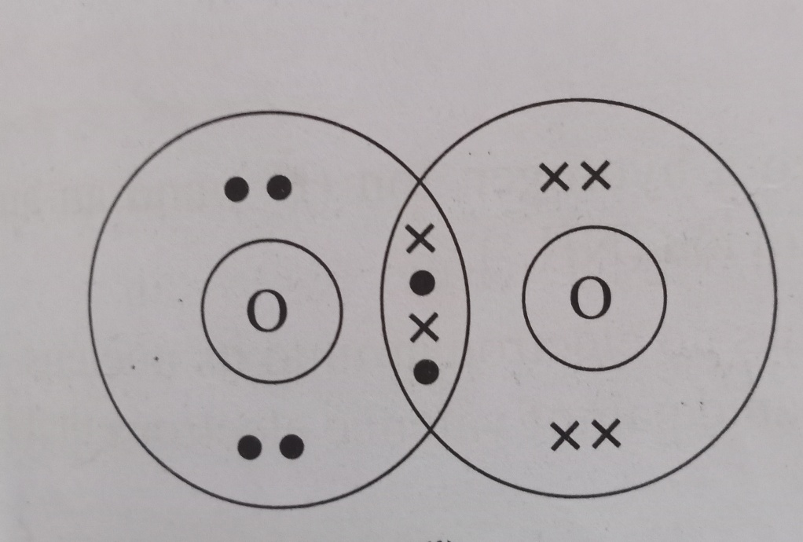

- a) Differentiate between a strong acid and a concentrated acid ( 2 marks)
A strong acid ionizes completely
A concentrated acid contains many moles of acid per litre of solution

b). Identify the acid in the forward reaction given by the equation below. Explain ( 2 marks)
HSO₄⁻_{(aq)} + H₂O_{(i)} H₂SO_{4 (aq)} + OH⁻_{(aq)}
Acid H₂O

Reason It has donated a proton

- Describe how a sample of Lead (II) chloride can be prepared in the laboratory starting with Lead metal. ( 3 marks )

Add excess lead to dilute nitric V acid to form lead II nitrate. 1 mk

Filter off the excess lead ½ mk

Add sodium chloride solution to the lead II nitrate solution ½ mk
Filter the mixture, lead II chloride is obtained as the residue. ½ mk

Wash the residue with distilled water and dry between filter papers. ½ mk

- The table below gives information on four elements represented by the letters K, L, M and N. Study it and answer the questions that follow. The letters do not represent the actual symbol of the elements.

Element | Electron Arrangement | Atomic Radius (nm) | Ionic Radius
K | 2.8.2 | 0.136 | 0.065
L | 2.8.7 | 0.099 | 0.181
M | 2.8.8.1 | 0.203 | 0.133
N | 2.8.8.2 | 0.174 | 0.099

- Which two elements have similar chemical properties? Explain (2 marks)
K and N
They have equal number of electrons in the outermost energy level

- What is the most likely formula of the oxide of L? (1 mark)
L₂O , L₂O₇
- Which element is a non-metal? (1 mark)
L

- a) Define a binary electrolyte. (1 mark)
An electrolyte that contains two ions, one cation and one anion 1mk

- Solid Lead (II) Iodide does not conduct electricity, but fused Lead (II) Iodide does. Explain. (2 marks)
In solid state the ions are in fixed positions hence cannot conduct electricity 1mk
In molten state the ions are mobile therefore will conduct electricity 1mk

- Write a half equation for what is formed at the cathode in the reaction above. (1 mark)

Pb²⁺_{(l)} + 2e Pb_{(s)}
- The diagram below shows a setup that can be used to obtain nitrogen gas in an experiment.

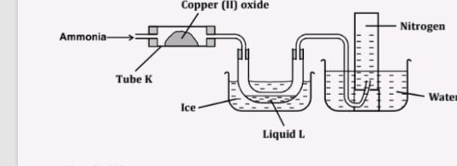

- Name liquid L (1 mark)
Water

- What observation would be made in tube K after heating for some time?
(1 mark)

Black solid changed to brown

- Write an equation for the reaction that took place in tube K
(1 mark)

2NH_{3(g)} + 3CuO_{(s)} Cu_{(s)} + 3H₂O_{(l)} + N_{2(g)}

- 60cm³ of Oxygen gas diffused through a porous partition in 50 seconds. How long would it take 60cm³ of Sulphur (IV) Oxide gas to diffuse through the same partition under the same conditions?
(S=32, O=16)
(2 marks)
Rate of O₂ = 60/50 = 1.2cm³/second

Rate of SO₂ ₌ 60/t
1.2/rate of SO₂ ₌ (64/32)^{1/2} =1.41421
Rate of SO₂ = 1.2/1.41421=0.84853
60/t = 0.84853
t = 70.71seconds

- 30cm³ of 0.06M Sodium Hydroxide reacted with 25cm³ of a dibasic acid HOOC(CH₂)_{x}COOH containing 4g/litre. Calculate the value of X .
( C=12, H=1 O=16, Na=23). (3 marks)

Moles of NaOH
30/1000 *0.06 = 0.0018
Moles of acid = 0.0018 / 2= =0. 0009
Molarity of acid = 1000 * 0.0009/25 = 0.036M
RFM of acid = 4/0.036 = 111.11
HOOC(CH₂)_{x}COOH = 111.11
90 +( CH₂)_{x} = 111.11
14x =111.11 -90
14x = 21.11
X =21.11/14
=1.5079

- Water from a town in Kenya is suspected to contain sulphate. Describe how the presence of sulphate ions in the water can be tested. (2 marks)

Transfer 2cm³ of the water to a test tube then add two drops of acidified barium chloride solution 1mk. A white precipitate is formed 1mk

- The figure below was set up by a student to investigate the reaction between chlorine gas and hydrogen sulphide gas.

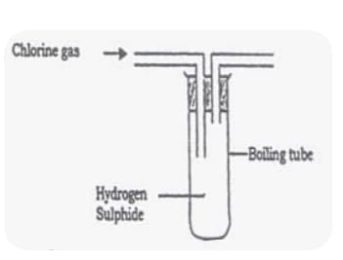

- Write an equation for the reaction that took place in the flask. (1mark
Cl_{2(g)} + H₂S_{(g)} S_{(s)} + 2HCl_{(g)}

- What observation was made in the flask? (1 mark)

A yellow solid is formed

- What precaution should be taken when carrying out the experiment? ( 1 mark)
The experiment should be carried out in a fume cupboard ½ mk both chlorine and hydrogen sulphide are poisonous gases ½ mk

- Describe how Sulphur is extracted by the frasch process (2 marks)
Has three concentric pipes ½ mk
Superheated water at 170⁰Cand 10atm is pumped through the outermost pipe ½ mk
Hot compressed air at 15atm is passed through the innermost pipe ½ mk
Molten Sulphur passes through the middle pipe to the surface ½ mk

- a) State Gay Lussac’s law (1 mark)
When gases react, they do so in volumes that bear a simple ratio to one another and to the volume of the products if gaseous, temperature and pressure remaining constant.

b)200cm³ of Ammonia reacted with 300cm³ of Oxygen gas to form 200cm³ of Nitrogen (II) Oxide and 300cm³ of steam. 50cm³ of Oxygen remained unreacted. Determine the equation for the reaction. (2 marks)
NH₃ + O₂ NO + H₂O
200/50 250/50 200/50 300/50 1mk
4 5 4 6 ½ mk
4NH_{3(g)} + 5O_{2(g)} 4NO_{(g)} 6H₂O_{(g)} ½ mk

- Wooden splints F and G were placed in different zones of a Bunsen burner flame. The diagram below gives the observations that were made.
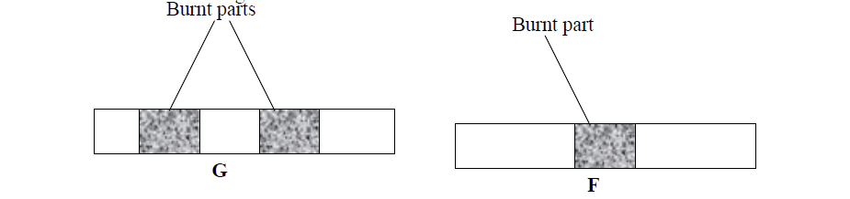

- Explain the difference between F and G. (2 marks)
G. Not burnt uniformly. Burnt part was in contact with the blue part of the
flame, the unburnt part was inContact with the almost colourless region

F. Burnt uniformly. Was placed at the top part (blue) region of the flame

- Name the type of flame that was used in the above experiment. (1 mark)
Non luminous flame

- 1g of potassium carbonate was placed in two different tubes. 2M sulphuric (VI) acid was added into one test of the tubes and in the other test tube 2M ethanoic acid was added. Explain the observations that were made. ( 3 marks).
More bubbles/effervescence observed in the test tube with 2M Sulphuric VI compared to that containing 2M ethanoic acid. 1mk
Sulphuric VI acid is a strong acid, it ionizes completely, producing many hydrogen ions which react with potassium carbonate liberating a lot of carbon IV oxide. 1mk
Ethanoic acid is a weak acid is a weak acid, it ionizes partially giving few hydrogen ions which react with potassium carbonate producing little carbon IV oxide 1mk

- Draw a set up of apparatus to show how dry sulphur (IV) oxide can be prepared in the laboratory starting with dilute hydrochloric acid. ( 3 marks)

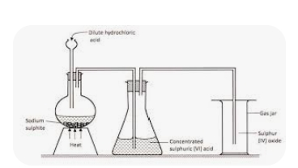
Heat ½ mk
Sodium sulphite ½ mk
Drying ½ mk
Collection ½ mk
Workability 1mk
- Give the formula of the polymer formed from the following monomers.
- H₂N – R – NH₂ and HOOC – R – COOH (1 mark)
-HN-R-NH-CO-R-CO-

- Name the type of polymerization shown in (i) above (1 mark)
Condensation polymerisation
- What substance is lost during the polymerization named above? (1 mark)

Water
- Study the diagram below and answer the questions that follow.
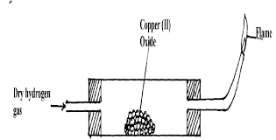

- Why is it necessary to pass hydrogen through the tube before lighting the hydrogen gas?(1 mark)

To drive out air from the apparatus because a mixture of hydrogen and oxygen is explosive when ignited

- After reduction is complete, the apparatus is allowed to cool while hydrogen is still passed over the reduced oxide. Explain (1 mark)

To prevent re oxidation of the hot copper metal

- Name another gas that can be used to reduce the metal oxide other than hydrogen. (1 mark)
Carbon II oxide
Ammonia Any one

- The table below shows solubility of two salts A and B at different temperatures.
Temp (⁰C) | Salt | 0 | 10 | 20 | 30 | 40 | 50
Solubility (g/100g H₂O) | A | 3.0 | 5.0 | 7.4 | 10.0 | 14.0 | 19.0
 | B | 15.0 | 17.0 | 20.7 | 28.7 | 29.9 | 33.3

- If both A and B were present in 100 cm³ of a saturated solution at 50⁰ C. What would be the total mass of crystals formed if the solution is cooled to 20⁰ C. (2 marks)

A 19.0-7.4 =10.6g ½ mk
B 33.3-20.7=12.6g ½ mk
Total mass = 23.2g 1mk

- Solubility of gases decreases as the temperature increases. Explain. (1 mark)
As the temperature rises, the kinetic energy of the gaseous solute increases, its
molecules break from the attraction of solvent molecules and return to the gas
phase

- A certain salt C dissolves with absorption of heat from the surroundings. How would its solubility change with an increase in temperature? Explain.(2 marks)
The solubility will increase.
Increase in temperature provides heat required to break the lattice hence dissolves faster

- The scheme below was used to prepare a cleansing agent. Study it and answer the questions that follow:
Solution of cleansing agent and an alcohol
NaoH(step 1)

Step 2
fat

Solid cleansing agent

- Name the category of cleansing agent prepared by the method above.(1 mark)
Soapy detergent
- Name one chemical substance added in step 2.(1 mark)

Sodium chloride
- What is the purpose of adding the chemical substance named in ii) above (1 mark)
Precipitates the soap
- Name another suitable substance to be used in step 1. (1 mark)

Potassium hydroxide
- Melting and boiling points of Hexanoic acid is higher than hexan-1-ol. Explain. (1 mark Hexanoic acid forms more hydrogen bonds than hexan -1-ol therefore higher higher melting and boiling point.

- Classify the following processes as chemical changes or physical changes.
- Neutralization
Chemical
- Sublimation

Physical
- Fractional distillation
Physical
- Displacement
Chemical (2 marks)
- Study the heating curve below and answer the questions that follow:
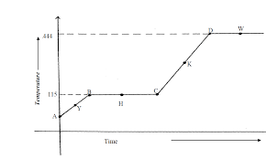

- What physical changes occur at H and W? ( 1 mark )
H. Melting
W Evaporation

- Explain what happens to the melting point if sodium chloride is added to this substance.( 1 mark)
The melting point will be lowered ½ mk and will melt over a range of temperatures ½ mk

- Give the names of the intermolecular forces of attraction in the segments: (1 mark)
- AB hydrogen bonds

- CD. Hydrogen bonds

