233/1 Marking Guide

- Below is a table showing the solubility of salts Q and R at different temperatures.

Temperature ºC |  | 0 | 10 | 20 | 30 | 40 | 50
Solubility in grams per 100g of water | Salt Q | 3.0 | 5.0 | 7.4 | 10.0 | 14.0 | 19.0
 | Salt R | 15.0 | 17.0 | 20.7 | 25.7 | 28.7 | 33.0

- Define the term “Solubility of salt” (1mk)
- The maximum mass of solute required to saturate 100g of solvent at a given temperature;

- If both salts Q and R are present in 100cm³ of saturated solution at 50ºC, what will be the total mass of crystals formed if the solution was cooled to 20ºC? (2mks)
Q 19.0 - 7.4 = 11.6
R 33.3 – 20.7 = 12.6
Total mass= 24.2

- Name two areas where knowledge of solubility curves is applied (2mks)
- Extraction of Trona and Sodium Chloride on Lake Magadi
- Separation of Soda ash and Ammonium Chloride in the Solvay process

- Two samples of hard water C and D were boiled. When tested with drops of soap, sample D formed lather easily while C did not:-
- Name the possible salt that caused hardness in sample D (1mk)
    - Magnesium hydrogen carbonate
    - Calcium hydrogen Carbonate
- Explain how distillation can remove hardness in sample C (1mk)

- When water is heated to boil, it evaporates and the vapour is condensed, distilled water free of Calcium and Magnesium ions is obtained.

(c) Give two advantage of hard water (1mk)
- Calcium ions are necessary for strong bones and teeth
- Good for beer brewing

- You are provided with a mixture of Lead (II) Chloride, ammonium chloride and sodium chloride. Explain how you would separate all the three solids (3mks)
- Heat the mixture in a beaker covered with a watch glass containing ice cold water
- Ammonium chloride sublimes and is deposited as a sublimate
- Add water and stir to dissolve Sodium chloride
- Filter, Lead ii chloride as residue, sodium chloride as filtrate
- Heat to saturate the filtrate, Cool to crystallize
- Dry the sodium chloride crystals between filter papers

- Sodium Carbonate Decahydrate crystals were left exposed on a watch glass for two days.
- State the observations made on the crystals after two days.(1mk)
- Dry/loses their water of crystallization
b) Name the property of salts investigated in the above experiment (1mk)
- Efflorescence

- When a small piece of potassium metal is dropped in cold water, it bursts into a flame on the surface of water.
- What causes this ignition?(1mk)
- Heat produced ignites the hydrogen gas being produced

- Write an equation to show how this ignition occurs (1mk)

- 2H_{2(g)} + O_{2(g)} 2H₂O_{(g)}

- What is the colour of the flame (1mk)
- Lilac

- How does the pH value of 0.25M KOH _{(aq)} compare with that of 0.25M ammonia solution? Explain (2mks)
- pH of 0.25M KOH is Higher
- KOH is a strong base/ completely or fully Dissociates/ionizes in water to produce more hydroxide ions

- (i) State Gay Lussac’s law. (1mk)
- When gases combine, they do so in volumes which bear simple ratios to one another and to the product if gaseous

(ii) 10cm³ of methane (CH₄) gas is exploded with 150cm³ of air containing 20% oxygen and 80% nitrogen. The products were allowed to cool to room temperature. What will be the total volume of the gases at the end of the reaction (3mks)
CH_{4 (g)} + 2O_{2 (g)} CO_{2(g)} + 2H₂O_{(l)}

- Vol ratios 1 2 1 2
- Total volume of oxygen in air 20/100 *150 = 30cm³
- Volume of O₂ that reacted with methane 2/1*10 =20cm³
Unreacted O₂ 30-20 =10cm³
- Volume of CO₂ formed 1/1*10= 10cm³
- Volume of N₂ 150-30= 120cm³
- Volume of gases mixture at end 120+10+10=140cm³

- The formulae below represents active ingredients of two cleansing agents A and B
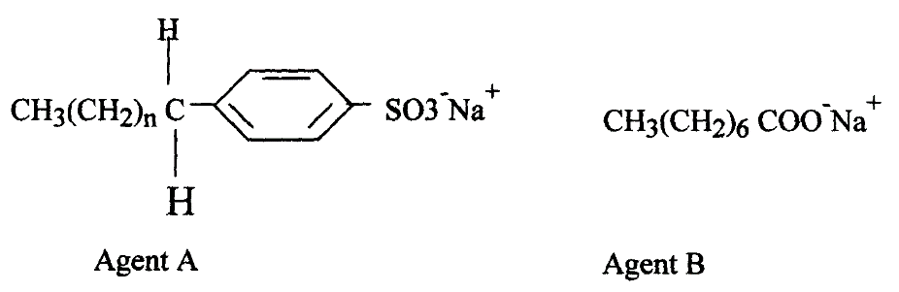

- Name the class to which each of the cleansing agent belongs(2mks)
- A Soapless detergent/detergent
- B Soapy detergent/soap

- Which one of the cleaning agent above is not environmental friendly? Explain (2mk)
- B

- Which one of the cleansing agent would be suitable to be used in water containing magnesium hydrogen carbonate? Explain (2mks)
- A
- During Saponification process, a small amount of Sodium Chloride is added Give a reason (1mk)
- To help precipitate the soap/reduce its solubility in glycerol

- (a) Write an equation showing how ammonium nitrate may be prepared starting with ammonia gas (1mk)
- NH_{3(g)} + HNO_{3(aq)} NH₄NO_{3(aq}
(b) Calculate the maximum mass of ammonium nitrate that can be prepared using 5.3kg of ammonia (H=1, N=14, O=16) (2mks) (accept direct method)
- Moles of Ammonia 5300/17 = 311.76471 ½ mk
- Moles of Ammonium nitrate 1/1*311.76471=311.76471 ½ mk
- Mass Ammonium nitrate 311.76471*96=29929.4112g/ 29.929kg 1mk
10. Plastics and rubber are extensively used to cover electrical wires.
(a) What Name is used to describe plastic and rubbers used in this way? (1mk)
- Insulators
(b) Explain why plastics and rubbers are used for this purpose (1mk)
- They are Non conductor

- G grams of a radioactive isotope take 120days to decay to 3.5grams. The half-life period of the isotope is 20days

(a) Find the initial mass of the isotope (2mks)
- No of half lifes 120/20 =6 ½ mk
1 2 3 4 5 6
3.5 7 14 28 56 112 224g 1 ½ mks
Or Remaining mass = (½) ^{n} *Original mass ½ mk
3.5=(½)⁶*Om
Om=3.5/(½)⁶ ½ mk
=224g ½ mk
(b) Give two applications of radioactivity in medicine (2mks)
- Gamma rays are used to detect bone fractures and healing(any 2 correct, with correct example)
- Gamma rays are used to sterilize surgical equipment
- Iodine 331 treatment of hyperthyroidism
- Cancer treatment/Radiotherapy/kll malignant tumors- gamma radiation
(c) Uranium -238 disintegrates by emitting an alpha particle to form substance Y. Nuclide Y emits a beta particle to form substance Z. Write down nuclear equations to show how substance Y and Z are formed (U=92) (2mks)
- ²³⁸ ₉₂U ²³⁴ ₉₀ Y + ⁴ ₂ He (accept the greek symbols of the particles)

- ²³⁴ ₉₀ Y ²³⁴ ₉₁Z + ⁰₋₁e
12. Study the flow chart below and answer the questions that follow:
Copper Pyrites
CuFeS₂
Step (I)
Froth floatation,
Air
Gas Q
Gas Q
Step (II)
Cu₂S_{(s)}
Cu₂O
Cu_{(s)}
Pure Copper
Air
Step (III)
Cu₂S
Step (IV)
FeO
Step (V)

- Name gas Q (1mk)
- Sulphur iv oxide

- With the help of diagram, describe how step (V) is carried out (3mks)
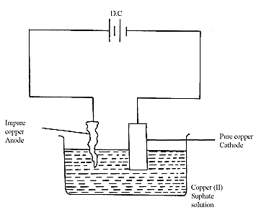
- Workable diagram 1mk
- Labels 1mk
Impure copper is the Anode while pure copper is cathode. During electrolysis copper ions migrate/attracted to the cathode where they are discharged as pure copper 1mk (accept equation)
Cu²⁺ + 2e Cu(s)

- During purification of copper by electrolysis, 1.48g of copper were deposited when a Current was passed through aqueous copper (II) sulphate for 2 ½ hours. Calculate the amount of current passed (Cu = 63.5 1Faraday = 96500C) (3mks)
63.5g= (96500*2) C ½ mk
1.48= (96500*2*1.48)/63.5 ½ mk
=4498.267C ½ mk
I=Q/t
4498.267/(2.5*60*60) ½ mk =0.4998A 1mk
Or
Moles of copper deposited 1.48/63.5 = 0.02331moles ½ mk
Quantity of charge used 193000 (½ mk )*0.02331 = 4498.83C ½ mk
I=Q/t
4498.83/ (2.5*60*60) ½ mk =0.4998A 1mk

- What is meant by the term Froth Floatation(2mks)
Involves crushing the ore into fine powder, ( ½ mk) dissolving the powder in a suitable solvent such as oil, water or detergent solution,( ½ mk) then air is blown into the mixture (½ mk)A froth which is a more concentrated ore floats on the surface and is separated. ( ½ mk)

- Name two impurities present in the ore of copper (1mks)
- Gold
- Silver
13. State two properties of Duralumin that make it suitable for use in making aircraft parts? (1mk)
- Low density/light (any two ½ mk each)
- High tensile strength/tough
- Resistant to corrosion
- Malleable and ductile
14. The flow chart below shows a sequence of chemical reactions starting with Zinc. Study it and answer the questions that follow:-
Zn_{(s)}
Step 1
Zn²⁺_{(aq)}
Step 2

NaOH_{(aq)}
Zn(OH)_{2(s)}
Step 3

Heat
Zn_{(s})
Zn²⁺_{(aq)}
Step 5

Metal T
Step 4 H₂SO_{4(aq)}
ZnO_{(s)}
Dilute hydrochloric acid

- In step 1, excess 3M hydrochloric acid was added to 0.5g of Zinc powder

- State one observation which were made when the reaction was in progress (1mk)
- Effervescence

- Explain why hydrogen gas is not liberated when dilute nitric acid is used in step 1 (1mk)
- Hydrogen produced is oxidized to water
- a) Write an ionic equation for the reaction that took place in step 1 (1mk)

- Zn _{(s)} + 2H⁺ _{(aq)} Zn²⁺_{(aq)} +H_{2(g)}

- Calculate the volume of 3M hydrochloric acid that was needed to react completely with0.5g of Zinc powder (Zn = 65.0) (2mks

Moles of Zinc 0.5/65 =0.007692 moles ½ mks

Moles of HCl 2* 0.007692 = 0.015385moles ½ mks

Volume of HCl (1000*0.015385)/3 (½ mks)
=5.1cm³ ½ mks
15. Briefly describe how a pure sample of lead ii iodide can be prepared in the lab given Distilled water, solid lead ii nitrate and solid Potassium iodide (3mks)
- Add water to the two solids ½ mk
- Mix the two solutions to form a yellow precipitate of lead ii iodide ½ mk
- Filter to obtain the precipitate ½ mk
- Wash the precipitate with distilled water 1mk
- Dry the precipitate between filter papers ½ mk
16. Using equations explain how slag is formed in the extraction of iron (2mks)
- CaO_{(s)} + SiO_{2(s)} CaSiO₃ _{(l)}

- CaO(s) + Al₂O₃(s) Ca Al₂O₄ _{(l)}

17. Using dots and crosses to represent electrons draw the structure of Phosphorous chloride (PCl₃) (1mk)

19. Study the information in the table below and answer the questions that follow:
(The letters do not represent the actual symbols of the elements)
Element | Electronic configuration | Ionization energy KJmol⁻¹
P | 2:1 | 519
Q | 2:8:1 | 494
R | 2:8:8:1 | 418

- What is meant by ionization energy? (1mk)
Minimum amount of energy required to completely remove a loosely held electron from an atom in gaseous state

- Element R has the lowest ionization energy. Explain. (1mk)
Largest atomic size/radius/ valence Electron far away/greatest distance from nucleus ( ½ mk) hence its loosely held/require least energy to be removed/experiences weak nuclear force of attraction ( ½ mk)

- When a piece of element Q is placed on water it melts and a hissing sound is produced as it darts on the water surface. Explain these observations. (1 ¹/₂mks)
- Melts – exothermic/ heat is produced
- Hissing sound- production of hydrogen gas
- Darts on water surface- less dense than water

- Write the equation for the reaction between element Q and water.(1mk)

- 2Q _{(s)} + 2H2O_{(l)} 2QOH_{(aq)} + H2 _{(g)}
20. Chlorine has a higher boiling point than Argon. Give a reason (1mk)
- Chlorine gas has larger Diatomic molecules which experience stronger intermolecular forcesmthan the smaller monoatomic molecules of Argon
21. i) State Graham’s Law of diffusion (1mk)
- Under similar conditions of temperature and pressure, the rate of diffusion of a gas is inversely proportional to the square root of Its density
ii) Gas B takes 110 seconds to diffuse through a porous pot, how long will it take for the
Same amount of ammonia to diffuse under the same conditions of temperature and pressure?
(RMM of B = 34 RMM of ammonia = 17) (2mks)
T _{NH3}/T_{B} = M_{NH3}/M_{B}
T _{NH3} = M_{NH3}/M_{B} * T_{B} formula ½ mk, subt= ½ mk
= 0.70710*110
=77.78seconds 1mk
22. The setup below was used to carry out the electrolysis of Magnesium sulphate solution using
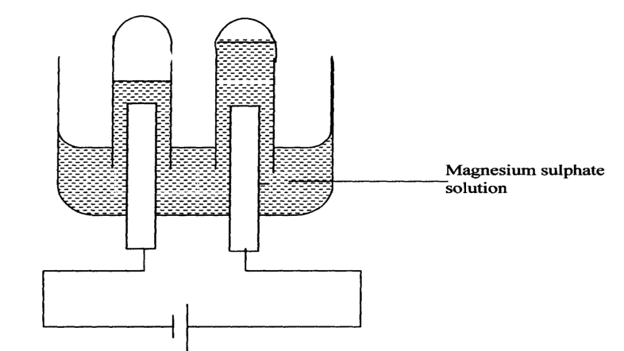
Inert electrodes
Cathode ½ mk Anode ½ mk

- Name a suitable pair of electrode that can be used in the above process. ( ½ mk)
- Platinum/Carbon/Graphite

- State and explain the changes on the concentration of magnesium sulphate solution as the process proceeds. (1mk)
- Increases- H⁺ and OH⁻ ions of water are being discharged

- Label on the diagram the Cathode and anode(1mk
23. i. Bond energies for some bonds are tabulated below:-
BOND | BOND ENERGY KJ/mol
H – H | 436
C = C | 610
C- H | 410
C - C | 345

Use the bond energies to estimate the enthalpy for the reaction
C₂H_{4(g)} + H_{2(g)} C₂H_{6(g)} (2mks)
- 2686 ( ½ mk) - 2805 ( ½ mk) = -119 kJ (1mk)

ii. Study the diagram below and answer the questions that follow:
NH₄⁺_{(g)} +Cl⁻_{(g)}
NH₄g +
∆H₂
NH₄⁺_{(g)} +Cl⁻_{(g)}

NH₄⁺(_{aq}) + Cl⁻(_{aq})
∆H₃
∆H₁
NH₄Cl(_{s})
Energy

Reaction Co-ordinate

a) What do ∆H₁ and ∆H₂ represent? (1mk)
∆H₁ Lattice ½ mk
∆H₂ Hydration ½ mk
- Write an expression to show the relationship between ∆H₁, ∆H₂ and ∆H₃. (1mk)

- ∆H₁ + ∆H₂= ∆H₃
24. (a)Name one substance that is added to Aluminium oxide during electrolysis in the manufacture of Aluminium metal ( ½ mk)
- cryolite /sodium hexafluoroaluminate

- Give a reason why the substance named above is added (1mk)
Lower the melting point from 2015 ºC to about 800ºC (½ mk)to save on the electrical energy needed( ½ mk)
25. a) State Le Chatelier’s Principle (1mk)

if a stress/change is applied to a system in dynamic equilibrium, the system readjust/shift/move/behave so as to remove/ reduce/ counteract/ oppose the stress/change

- An equilibrium exists in the Haber process as shown in the equation below
N_{2(g)} + 3H₂ _{(g)} 2NH₃ _{(g)} ΔH = -92kJ
State and explain the effect of the following factors on the yield of Ammonia

- Increase in Pressure (1 ½ mks)

shift the equilibrium forward/to the right ½ mk where there is less volume/molecules ( ½ mk) More/higher yield of ammonia is attained ( ½ mk)

- Increase in Temperature (1 ½ mks)

shift the equilibrium to the left/favours reverse reaction ½mk because forward reaction is exothermic(ΔH = -92kJ) ½ mk . Ammonia formed decomposes back to Nitrogen and Hydrogen/ a less yield of ammonia is formed ½ mk

Last page

