Term 2 - 2022
CHEMISTRY (233/2)
PAPER 2
FORM FOUR (4)
Time: 2 Hours
MARKING SCHEME

Instructions to candidates
- Write your name, stream, and admission number in the spaces provided above.
- Answer ALL the questions in the spaces provided, and working MUST be clearly shown
- This paper consists of 12 printed pages; Candidates should check the question paper to ascertain that all the pages are printed as indicated, and that no question is missing.

FOR EXAMINERS’ USE ONLY
QUESTION | MAXIMUM SCORE | CANDIDATE’S SCORE
1 – 6 | 80

- The grid below represents part of the periodic table. Study it and answer the questions that follow. The letters do not represent actual symbols of the elements
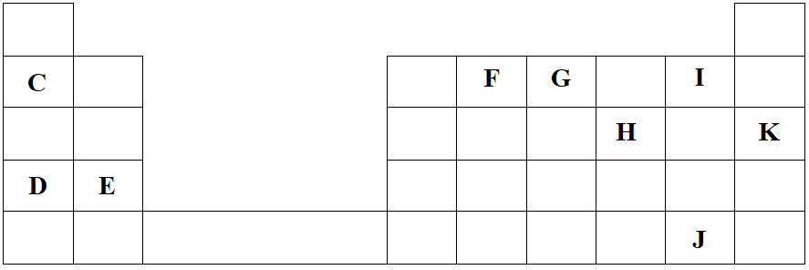
- Identify the most reactive non-metal. Explain (2 Marks)
Element I. It has the smallest atom with the highest effective nuclear force of attraction.
[1 mk statement; 1 mk explanation]
- What is the name given to the family of elements to which I and J belong? (1 Mark)
Halogens Reject: Group VII
- Using dots (•) and crosses (×) to represent electrons, show bonding in the compound formed between C and H. (2 Marks)
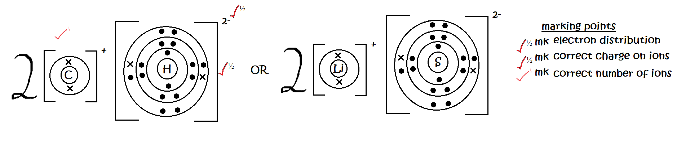
- How does the atomic radius of F compare with that of I? Explain. (2 Marks)
F is larger than I. F experiences a lower effective nuclear force of attraction on its energy levels hence more loosely held // F has fewer protons for the same number of energy levels as I hence its energy levels are more loosely held.

- Study the table below and answer the questions that follow.
Substance | M | N | O | P | Q | R
Melting Point (ºC) | 801 | 1356 | -101 | 26 | -39 | 113
Boiling Point (ºC) | 1410 | 2850 | -36 | 154 | 457 | 445
Electrical conductivity in solid state | Poor | Poor | Poor | Poor | Good | Poor
Electrical conductivity in molten state | Good | Poor | Poor | Poor | Good | Poor

- Explain why substance M is a good conductor of electricity in the molten state but not in the solid state. (2 Marks)
It has a giant ionic structure. Its ions are held by strong ionic bonds in the solid state but these are weakened in the molten state to allow their movement.
- What is the most likely structure and bond in substance N? Explain. (2 Marks)
Structure Giant covalent//Giant atomic Bond Covalent
It has high melting point and boiling point and does not conduct electricity in the solid and in the molten state
[½mk each for structure and bond; 1mk for explanation]
- Identify, with a reason, a substance that exists as a liquid at room temperature. (2 Marks)
Q. Its melting point is below room temperature and its boiling point above room temperature.

- What name is given to different forms of an element which exist in the same physical state? (1 Mark)
Allotropes
- Name two crystalline forms of carbon (1 Mark)
Diamond Graphite

- The figure below is part of a setup used to prepare and collect dry carbon (II) oxide from carbon (IV) oxide.
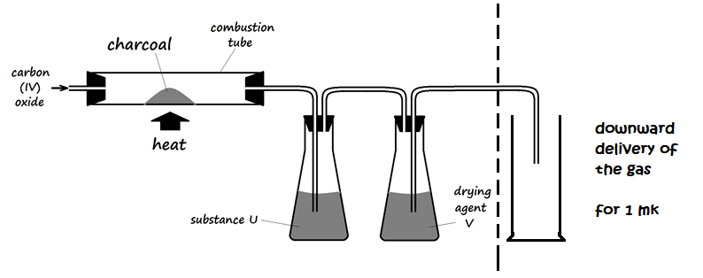
- Complete the diagram to show how dry carbon (II) oxide gas is collected. (1 Mark)

- Identify:
- Substance U and state its use
Concentrated sodium hydroxide solution // Concentrated potassium hydroxide solution
- Drying agent Y
Concentrated sulphuric (VI) acid
- Write a chemical equation for the reaction which takes place in the combustion tube (1 Mark)
CO_{2 (g)} + C _{(s)} 2CO _{(g)}
- Carbon (II) oxide is a major environmental pollutant.
- Give one major source of carbon (II) oxide in the atmosphere (1 Mark)
Automobile exhaust fumes // Industrial emissions
- Explain how carbon (II) oxide causes poisoning (1 Mark)
It forms stable carboxyhaemoglobin that prevents oxygen from reaching body cells to result in suffocation
- State one use of carbon (II) oxide (1 Mark)
Used as a reducing agent in the extraction of metals from their ores
Used in the industrial production of methanol
A mixture of carbon (II) oxide and hydrogen is used as a fuel (water gas)
[the candidate’s first answer for 1 mk]
- Write an equation for the formation of water gas. (1 Mark)
C _{(s)} + H₂O _{(g)} CO _{(g)} + H_{2 (g)}
[rules for writing chemical equations apply]
- Explain why sodium hydroxide solution is not used in testing for carbon (IV) oxide gas, while calcium hydroxide is preferably used. (2 Marks)
Sodium hydroxide reacts with carbon (IV) oxide to form soluble sodium carbonate hence no change in physical appearance; while calcium hydroxide reacts with carbon (IV) oxide to form a white precipitate which can be used to detect the reaction.

- Study the following energy cycle diagram and then answer the questions that follow.
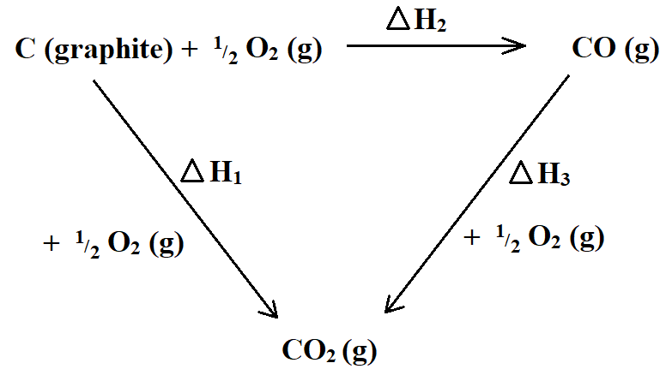
- Name the enthalpy change represented by ∆H₂. (1 Mark)
Heat of formation of carbon (II) oxide
- Use the following information to calculate the value of ∆H₁ for 144g of graphite. (2 Marks)
∆H₂ = -110 kJ/mole ∆H₃ = -283kJ/mole
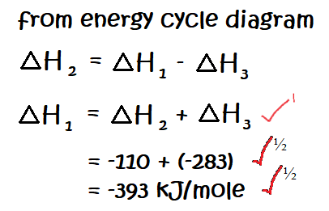

- The following are thermochemical equations for molar enthalpies of combustion for some substances. Study them and answer the questions that follow.
C₄H₁₀ (g) + $\frac{13}{2}$O₂ (g) 4CO₂ (g) + 5H₂O ∆H^{θ}_{c} = -2877kJ/mole
C (s) + O₂ (g) CO₂ (g) ∆H^{θ}_{c} = -399kJ/mole
H₂ (g) + ½O₂ (g) H₂O (l) ∆H^{θ}_{c} = -286kJ/mole

- What is molar enthalpy of combustion of a substance? (1 Mark)
This is the enthalpy change that occurs when one mole of a substance is completely burnt in oxygen.
- Calculate the molar enthalpy of formation of butane (C₄H₁₀) using the information given above. (3 Marks)
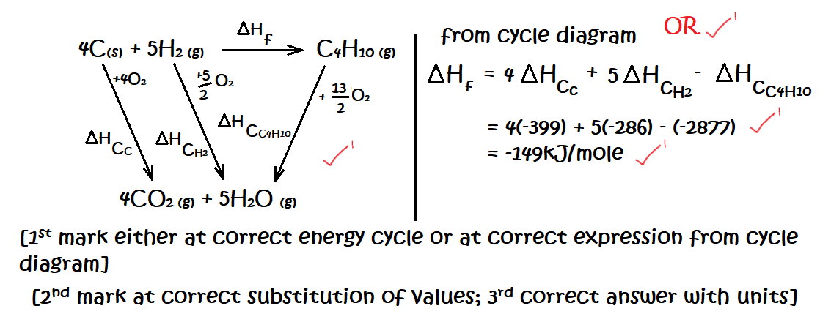
- The following results were obtained in an experiment, to determine the heat of neutralization of 25cm³ of 2M sodium hydroxide solution, using 25cm³ of hydrochloric acid:
Initial temperature of acid = 25.0ºC
Initial temperature of alkali = 26.0ºC
Final temperature of mixture of acid + alkali = 38.5ºC
Density of solution =1g/cm³
Specific heat capacity of solution =4.2 J/g/K

- Define molar heat of neutralization (1 Mark)
This is the enthalpy change that occurs when an acid and a base react to form one mole of water.

- Write an ionic equation for the neutralization reaction involving hydrochloric acid and sodium hydroxide solution. (1 Mark)
H⁺_{(aq)} + OH⁻_{(aq)} H₂O _{(l)}
- Calculate:
- The enthalpy change during this experiment. (2 Marks)
∆T = 38.5 – ($\frac{25+26}{2}$) = 13 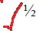 mass = volume = 25 + 25 = 50g
∆H = mc∆T = 50g x 4.2 J/g/K x 13K = -2730J

- The molar enthalpy of neutralization for this reaction (2 Marks)
Moles H₂O
Moles H₂O = moles NaOH
If 1000cm³ base contains 2 moles
Then 25cm³ base contains $\frac{25 ×2}{1000}$ = 0.05 moles

Molar heat of neutral
Since 0.05 moles of base evolves -2730 J
1 mole of base evolves = $\frac{1 × -2730}{0.05}$ = - 54600J/mole = 54.6kJ/mole

- Below is a simplified diagram of the Down’s Cell, used for the manufacture of sodium. Study it and answer the questions that follow.
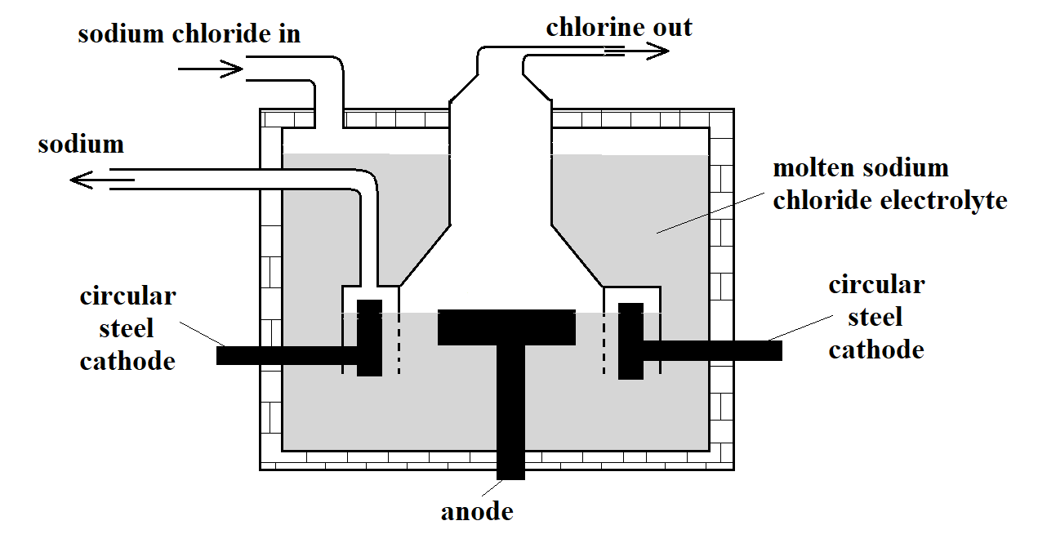
- What material is the anode made of? Give the reason why that material is used. (2 Marks)
Carbon. It is inert and will therefore not react with the chlorine.
[1mk statement; 1mk explanation]
- What precaution is taken to prevent chlorine and sodium from re-combining? (1 Mark)
The anode is surrounded by wire meshing to prevent chlorine from coming in contact with the hot sodium metal.
- Write an ionic equation for the reaction in which chlorine gas is formed (1 Mark)
2Cl _{(l)} Cl_{2 (g)} + 2e⁻
- In the Downs process, (used for manufacture of sodium), a certain salt is added to lower the melting point of sodium chloride from about 800ºC to about 600ºC.
- Name the salt that is added. (1 Mark)
Magnesium chloride
- State why it is necessary to lower the temperature in b) above (1 Mark)
To lower the amount of energy required to maintain the electrolyte in the molten state [hence lower production cost].
- Explain why aqueous sodium chloride is not suitable as an electrolyte for the manufacture of sodium in the Down’s Process. (2 Marks)
H⁺ is preferentially discharged, and not Na⁺ at the anode since Na⁺ _{(aq)} requires a high potential.
The Na formed will also react explosively with water.
- Sodium metal reacts with air to form two oxides. Give the formulae of the two oxides (1 Mark)
Na₂O Na₂O₂ Reject: Na₃N Reject names written in words.
- State two uses of sodium (2 Marks)
The yellow glow of sodium is used in making fog-lights and street lamps
Sodium chloride is used as a food additive
It is used as a reducing agent in the extraction of titanium from its ore
[1st two of the candidate’s answers]

- The diagram below shows part of the Frasch process, used for the extraction of sulphur. Use it to answer the questions that follow.
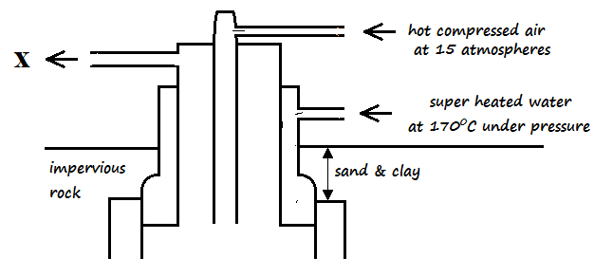
- Identify X molten sulphur and water (1 Mark)
- Why is it necessary to use superheated water and hot compressed air in this process? (2 Marks)
Superheated water melts the sulphur deposits while hot compressed air increases pressure in the sulphur deposit to push the molten sulphur up the middle concentric pipe.
- State two physical properties of sulphur that makes it possible for it to be extracted by this method. (2 Marks)
It does not does not dissolve in water
It has a low melting point // It melts easily
- The diagram below shows part of the process in the manufacture of sulphuric (VI) acid. Study it and use it to answer the questions that follow.
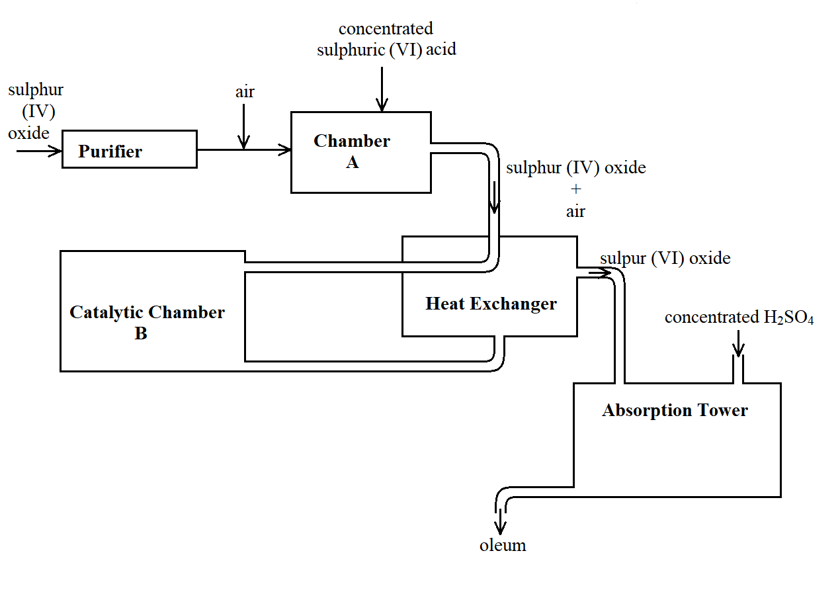
- Give two reasons why air is referred to as a mixture (2 Marks)
Its components can be separated by physical means
It does not have a specific melting and boiling point.

- What is the role of concentrated sulphuric (VI) acid in Chamber A? (1 Mark)
It dries the gas produced // It acts as a drying agent.
- Name two catalysts that can be used in the Catalytic Chamber B. (2 Marks)
Vanadium (V) oxide
Platinum
- State two roles of the heat exchanger (2 Marks)
It preheats the mixture of sulphur (IV) oxide and air before being taken to the catalytic chamber
It coo ls down the sulphur (VI) oxide prepared in the catalytic chamber
- Describe the test for sulphite anion, SO₃²⁻ (2 Marks)
Add a few drops of barium nitrate solution to a small of the test substance. Add 1cm³ of hydrochloric acid to the resultant mixture. If a white precipitate that dissolves on addition of hydrochloric acid is observed, it indicates that sulphite ions are present.
[marking points are underlined, each scores ½ mark]
- Explain the observation made when a few drops of concentrated sulphuric (VI) acid are added to crystals of hydrated copper (II) sulphate. Explain your answer. (2 Marks)
The blue crystals turn to white. Blue hydrated copper (II) sulphate loses its water of crystallization and changes to white powder.
- Study the reaction scheme below and answer the questions the follow:
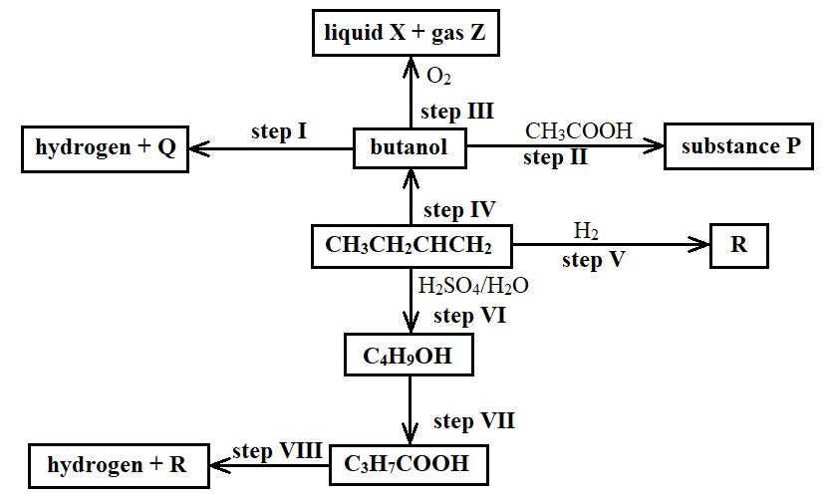
- What is the distinguishing physical property of Substance P? (1 Mark)
It has a pleasant smell Reject: It has a sweet smell
- Identify a suitable reagent that can be used in Step I. (1 Mark)
Sodium metal // Potassium metal
- Describe a chemical test on how C₃H₇COOH can be distinguished from C₄H₉OH. (2 Marks)
Put samples of the C₃H₇COOH and C₄H₉OH in separate test tubes. Add a spatula of sodium carbonate in both test tubes. Effervescence of a colourless gas is observed in the test tube containing C₃H₇COOH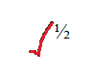 while no effervescence is observed in the test tube containing C₄H₉OH.
- Write an equation for the reaction that takes place in Step III (1 Mark)
C₄H₇OH _{(l)} + 6O_{2 (g)} 4CO_{2 (g)} + 4H₂O _{(l)}
[rules for writing chemical equations apply; state symbols may only be ignored if they have not been put completely; if one is stated the all MUST be included]
- Name the types of reaction that occur in steps II, III, V, and VII (2 Marks)
II addition reaction III combustion reaction
V addition reaction VII oxidation
[hydrogenation, esterification etc are considered as processes and NOT types of reaction hence cannot answer the question of ‘type of reaction’]
- If 7.4g of butanol completely underwent Step III, determine the volume of gas Z produced at s.t.p. (MGV = 22.4 litres, C = 12, H = 1, O = 16) (3 Marks)
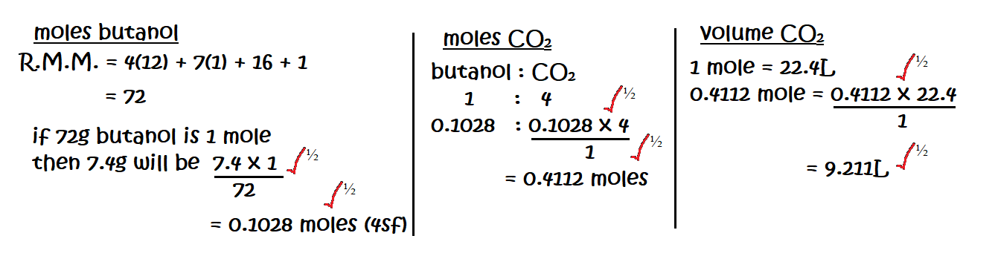

- Write an equation for the reaction between R and one mole of fluorine gas (1 Mark)
C₄H_{10 (g)} + F_{2 (g)} C₄H₉F _{(g)} + HF _{(g)}
- Describe a chemical test for liquid X (2 Marks)
Add a few drops of liquid X to white anhydrous copper (II) sulphate powder. The white powder turns to blue crystals
OR
Add a few drops of liquid X to blue anhydrous cobalt (II) chloride powder. The blue powder turns to pink crystals.

