Term 2 - 2022
CHEMISTRY (233/1)
PAPER 1
FORM FOUR (4)
Time: 2 Hours

Name: …………………………………………………………. Adm No: ……………….
School: ……………………………………………………….. Class: …………………..
Signature: …………………………………………………….. Date: …………………...
Instructions to candidates
- Write your name, stream, and admission number in the spaces provided above.
- Answer ALL the questions in the spaces provided, and working MUST be clearly shown
- This paper consists of 11 printed pages; Candidates should check the question paper to ascertain that all the pages are printed as indicated, and that no question is missing.

FOR EXAMINERS’ USE ONLY
QUESTIONS | MAXIMUM SCORE | CANDIDATE’S SCORE
1 – 28 | 80

- A magnesium ribbon sample was heated in separate volumes of pure oxygen and air.
- In which sample was the mass of the product higher? Explain. (2 Marks)
___________________________________________________________________________
___________________________________________________________________________
- Write the equations for the reactions in the sample with air. (2 Marks)
___________________________________________________________________________
- Give the systematic name of the following compound and draw the structure of the polymer it forms: CH₂CHCl
Name __________________________________________________________________(1 Mark)
Structure (1 Mark)
______________________________________________________________________________
______________________________________________________________________________
______________________________________________________________________________
- When aqueous sodium hydroxide solution was added to freshly prepared acidified iron (II) sulphate solution, a green precipitate was formed. When hydrogen peroxide was first added to iron (II) sulphate solution followed by sodium hydroxide solution, a brown precipitate was formed. Explain these observations. (3 Marks)
______________________________________________________________________________
______________________________________________________________________________
______________________________________________________________________________
______________________________________________________________________________
- Study the following nuclear reaction and complete it by giving the values of m and n
$\begin{matrix}232 \\ 92\end{matrix}$ X $\begin{matrix}m \\ n\end{matrix}$ Y + 2 $\begin{matrix}0 \\ -1\end{matrix}$ e⁻ + $\begin{matrix}4 \\ 2\end{matrix}$ He
m _____________________________ (1 Mark) n _______________________ (1 Mark)

- State Charles’ Law (1 Mark)
___________________________________________________________________________
___________________________________________________________________________
- A certain mass of carbon (IV) oxide gas occupied 200cm³ as 25ºC and 750mmHg pressure. Calculate the volume occupied by the same mass of gas if pressure is lowered to 300mmHg and the temperature raised to 30ºC. (2 Marks)
___________________________________________________________________________
___________________________________________________________________________
- Chlorine gas was bubbled into as solution of hydrogen sulphide as shown in the diagram below.
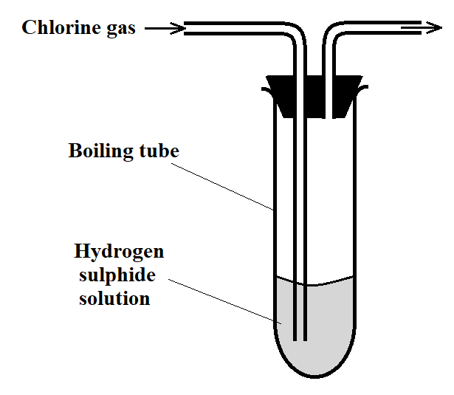
- Explain the observation made in the boiling tube (2 Marks)
___________________________________________________________________________
___________________________________________________________________________
- What precaution should be taken in this experiment? (1 Mark)
___________________________________________________________________________
___________________________________________________________________________
- Distinguish between the bleaching action of chlorine and that of sulphur (IV) oxide. (1 Mark)
___________________________________________________________________________
___________________________________________________________________________
- Concentrated sulphuric (VI) acid was left exposed in air for a few days. It was found that the level of the acid had risen.
- Why did the level of the acid in the container rise? (1 Mark)
___________________________________________________________________________
___________________________________________________________________________
- How is this property useful in the laboratory? (1 Mark)
___________________________________________________________________________
___________________________________________________________________________

- The setup below can be used to dry and collect ammonia gas. Use it to answer the questions that follow.
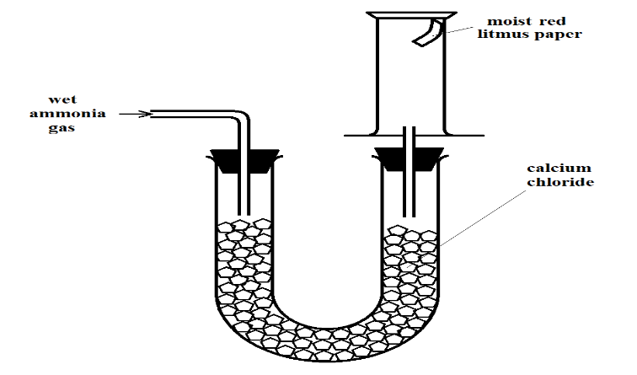
- The wet red litmus paper remained red. Explain. (1 Mark)
___________________________________________________________________________
___________________________________________________________________________
- Name the method used when collecting ammonia gas. (1 Mark)
___________________________________________________________________________
- 400cm³ of gas D diffuses from a porous plug in 50 seconds while 600cm³ of oxygen gas diffuses from the same apparatus in 30 seconds. Calculate the relative molecular mass of gas D. (3 Marks)
______________________________________________________________________________
______________________________________________________________________________
______________________________________________________________________________
- Use the information in the table below on solubility to answer the questions that follow.
Salt | Solubility at
 | 70ºC | 35ºC
CuSO₄ | 38 | 28
Pb(NO₃)₂ | 78 | 79

A mixture containing 38g copper (II) sulphate and 78g of lead (II) nitrate in 100g of water at 70ºC is cooled to 35ºC.
- Which of the two salts will crystallize? (1 Mark)
___________________________________________________________________________
- Calculate the mass of crystals formed. (1 Mark)
___________________________________________________________________________
___________________________________________________________________________
- State the salt that will be unsaturated at 35ºC (1 Mark)
___________________________________________________________________________
- How much of the salt in c) above would be required to make a saturated solution at 35ºC? (1 Mark)
___________________________________________________________________________
___________________________________________________________________________

- Methane burns in oxygen as shown by the equation below.
CH₄ (g) + 2O₂ (g) CO₂ (g) + 2H₂O (g)
Given the following bond energies:
Bond | Bond Energy (kJ/mole)
C – H | 413
O = O | 497
C = O | 740
O – H | 463
- Calculate the heat change for the reaction. (2 Marks)
___________________________________________________________________________
___________________________________________________________________________
___________________________________________________________________________
- Define molar heat of combustion. (1 Mark)
___________________________________________________________________________
___________________________________________________________________________
___________________________________________________________________________
- Given solid sodium carbonate, lead (II) nitrate crystals and water, explain how you can obtain a solid sample of lead (II) carbonate. (3 Marks)
______________________________________________________________________________
______________________________________________________________________________
______________________________________________________________________________
______________________________________________________________________________
______________________________________________________________________________
- Calculate the volume of oxygen produced when 10g of silver nitrate was completely decomposed by heating at s.t.p. (Ag = 108, N = 14, O = 16, MGV at s.t.p. = 22.4dm³) (3 Marks)
______________________________________________________________________________
______________________________________________________________________________
______________________________________________________________________________
______________________________________________________________________________

- A solution of hydrogen chloride gas in water conducts an electrical current, while that of hydrogen chloride in methylbenzene does not conduct. Explain. (2 Marks)
______________________________________________________________________________
______________________________________________________________________________
______________________________________________________________________________
- The scheme below shows some reactions, starting with ethyne. Study it and answer the questions that follow.
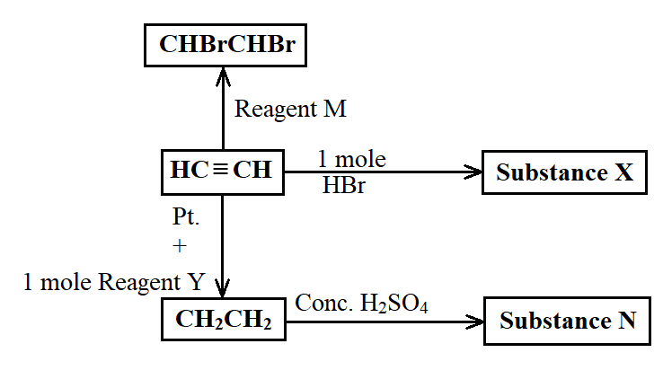
- Name substance
- X ______________________________________________________________ (½ Mark)
- N ______________________________________________________________ (½ Mark)
- M ______________________________________________________________ (½ Mark)
- Ethene undergoes polymerization to form a polymer. Give an equation for the reaction and name the product. (1½ Marks)
___________________________________________________________________________
___________________________________________________________________________
- When 16g of ammonium nitrate was dissolved in 100cm³ of water at 25ºC, the temperature of the solution drops to 19ºC.
- Calculate the molar enthalpy of solution of ammonium nitrate (3 Marks)
(N = 14, O = 16, H = 1, Specific Heat Capacity for Water = 4.2kJ/kg/k)
___________________________________________________________________________
___________________________________________________________________________
___________________________________________________________________________
___________________________________________________________________________
- Is the enthalpy change endothermic or exothermic? Give a reason (1 Mark)
___________________________________________________________________________
___________________________________________________________________________
___________________________________________________________________________
- The curves below represent the volume of carbon (IV) oxide gas evolved when 2M hydrochloric acid was reacted with 100g of powdered calcium carbonate and when 1M hydrochloric acid was reacted with the same quantity of calcium carbonate.
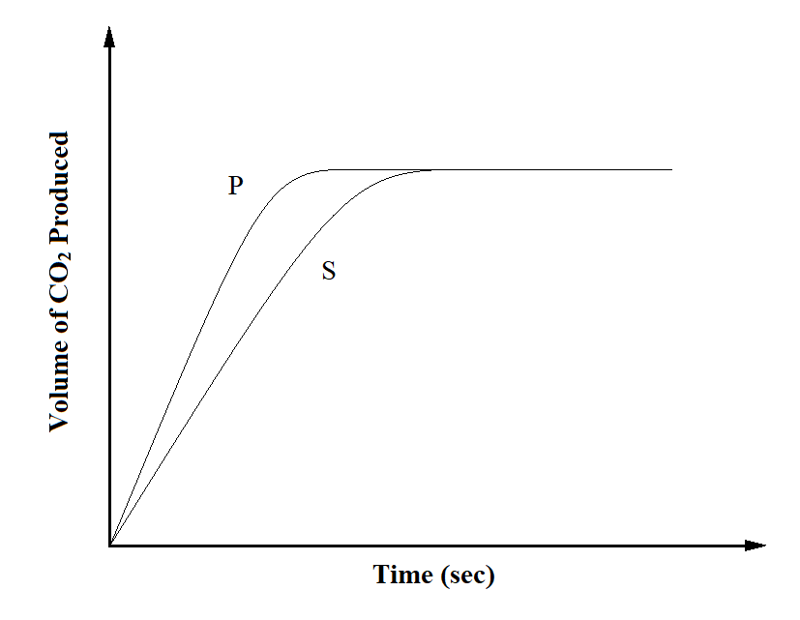
- Which of the two curves represents the reaction of 2M concentrated hydrochloric acid? Explain. (2 Marks)
___________________________________________________________________________
___________________________________________________________________________
___________________________________________________________________________
- Why do the two curves flatten at the same level of production of CO₂? (1 Mark)
___________________________________________________________________________
___________________________________________________________________________
- The electron arrangement of ions X³⁺ and Y²⁻ are 2.8, and 2.8.8 respectively.
- In which groups do X and Y belong? (1 Mark)
X___________________________ Y_____________________________________
- State the formula of the compound that would be formed between X and Y (1 Mark)
___________________________________________________________________________

- State two ores from which sodium metal can be extracted. (1 Mark)
___________________________________________________________________________
___________________________________________________________________________
- During the extraction, calcium chloride solid is added into the sodium chloride solid. Why is calcium chloride added to the sodium chloride? (1 Mark)
___________________________________________________________________________
___________________________________________________________________________
- State two uses of sodium metal. (2 Marks)
___________________________________________________________________________
___________________________________________________________________________
- Using and energy cycle diagram, calculate the enthalpy change of formation of carbon disulphide, given: (3 Marks)
S (s) + O₂ (g) SO₂ (g) ∆H = -294kJ/mole
CS₂ (g) + 3O₂ (g) CO₂ (g) + 2SO₂ (g) ∆H = - 1072kj/mole
C (s) + O₂ (g) CO₂ (g) ∆H = -393kJ/mole
______________________________________________________________________________
______________________________________________________________________________
______________________________________________________________________________

- The table below shows tests carried out in a sample of water and the results obtained.
Sample | Results | observations
A | Addition of sodium hydroxide dropwise until excess | Whit precipitate which dissolves in excess
B | Addition of excess ammonia solution | White precipitate
C | Addition of dilute nitric (V) acid followed by barium chloride | White precipitate
- Identify the anion present in the water sample (1 Mark)
___________________________________________________________________________

- Write an ionic equation for the reaction in C (1 Mark)
___________________________________________________________________________
- Use the following information to answer the questions that follow:
Sn²⁺ (aq) + 2e⁻ Sn (s) E^{θ} = -0.14V
Cu²⁺ (aq) + 2e⁻ Cu (s) E^{θ} = +0.34V
- Write the cell representation for the cell made up of the two half cells (1 Mark)
___________________________________________________________________________
- Identify the reducing species (1 Mark)
___________________________________________________________________________
- Calculate the E^{θ} value for the cell (1 Mark)
___________________________________________________________________________
___________________________________________________________________________

- The following is a reaction of an equilibrium mixture:
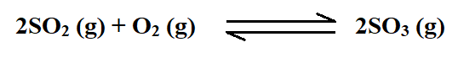
The percentage of sulphur (VI) oxide in the equilibrium mixture varies with temperature as illustrated in the sketch graph below
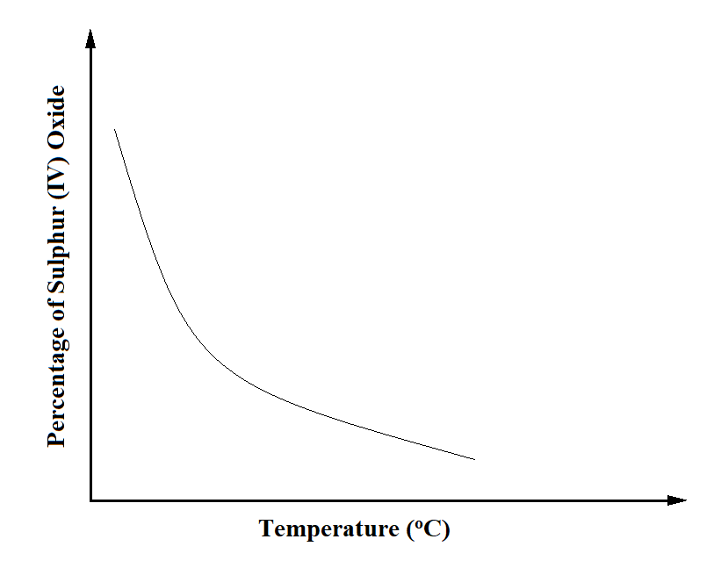
- How does the percentage of sulphur (VI) oxide in the equilibrium mixture vary as the temperature increases? Explain. (1½ Mark)
___________________________________________________________________________
___________________________________________________________________________
___________________________________________________________________________
- Is the forward reaction in the equilibrium exothermic or endothermic? Give a reason for your answer. (1½ Mark)
___________________________________________________________________________
___________________________________________________________________________
- Radioactive polonium (Po) with a mass number of 212 and atomic number of 84 was detected in a sample of water. The water had an activity of 1000 counts per second.
- If the water is boiled, explain whether the activity would be affected or not. (1 Mark)
___________________________________________________________________________
___________________________________________________________________________

- Given that polonium resulted from bitumen (B) following emission of a beta (β) particle, write a nuclear equation for the decay. (1 Mark)
___________________________________________________________________________
- State one medical application of radioactivity. (1 Mark)
___________________________________________________________________________

- Name and give the formula of:
- The chief ore from which zinc is extracted (1 Mark)
___________________________________________________________________________
- The main impurity in the ore. (1 Mark)
___________________________________________________________________________
- The ore is concentrated by froth floatation. What is froth floatation? (1 Mark)
___________________________________________________________________________
___________________________________________________________________________
- The atomic number of sulphur is 16. Write the electron arrangement of sulphur in the following compounds
- H₂S _______________________________________________________________ (1 Mark)
- SO₃²⁻ _______________________________________________________________(1 Mark)
- For the reaction: Cl₂ (g) + 2I⁻ (aq) 2Cl⁻ (aq) + I₂ (s)
Using oxidation numbers, state and explain the reducing species. (2 Marks)
______________________________________________________________________________
______________________________________________________________________________

- The setup below was used to investigate the effect of carbon (II) oxide on zinc oxide.
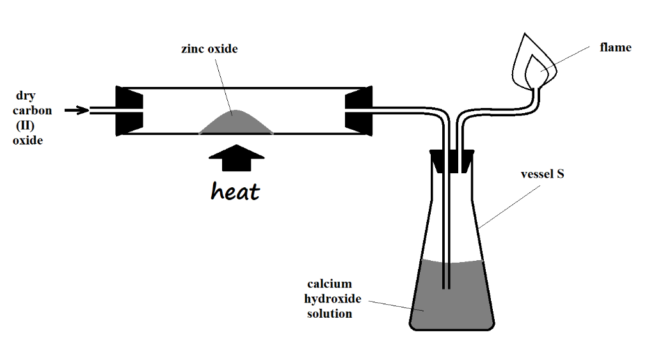

- State the observations made on the setup. (2 Marks)
___________________________________________________________________________
___________________________________________________________________________
- Write equations for the reactions that took place. (2 Marks)
___________________________________________________________________________
___________________________________________________________________________

