END TERM 1-2023
CHEMISTRY PAPER 1(233/1)
FORM THREE (3)
TIME: 2 HOURS
MARKING SCHEME

Instructions to candidates
- Write your name, stream, and admission number in the spaces provided above.
- Answer ALL the questions in the spaces provided, and working MUST be clearly shown
- This paper consists of 9 printed pages; Candidates should check the question paper to ascertain that all the pages are printed as indicated, and that no question is missing.

FOR EXAMINERS’ USE ONLY
QUESTION | MAXIMUM SCORE | CANDIDATE’S SCORE
1 – 28 | 80

- Chewing chalk has been used for many years to reduce excess acid in the stomach. The indigestion tablet often contains magnesium carbonate.
- Write a chemical equation to show the reaction that occurs in the stomach when the tablet is taken (1 mark)
MgCO_{3 (s)} + 2HCl _{(aq)} MgCl_{2 (s)} + CO_{2 (g)} + H₂O _{(l)}
½ mark for correctly balanced equation
½ mark for correct state symbols
Penalize fully if not balanced.
- Give two other applications of acid-base reactions (2 marks)
Use of alkaline toothpaste to neutralize mouth acidity to prevent tooth decay
Adding lime to acidic soil to raise the soil pH
Rubbing bases such as sodium hydrogen carbonate on stings by insects
[award the first two responses of the candidate]
- A luminous flame of a Bunsen burner is bright yellow in colour. Explain this phenomenon (1 mark)
The carbon particles in the laboratory gas do not burn completely, they only heat up and glow giving yellow light.
½ mark for each of the two marking points (underlined phrases)
- Differentiate between a mixture and a compound. (2 marks)
A mixture constitutes substances that are only physically combined//substances that retain their physical and chemical properties while a compound constitutes substances that come together to form a new substance, i.e., they no longer retain their unique physical and chemical properties. [Words to that effect]
Award 1 mark for each marking point. The double slash (//) indicates an alternative phrase.
- Complete the table below. (3 marks)
Representation | Atomic number | Number of neutrons | Mass number | Electron configuration
$\begin{matrix}39 \\ 19\end{matrix}$M | 19  (½ mark) | 20 | 39  (½ mark) | 2.8.8.1  Accept  2,8,8,1  Reject  2:8:8:1  (½ mark)
$\begin{matrix}_31 \\ _15\end{matrix}$W  (½ mark) | 15  ((½ mark) | 16  (½ mark) | 31 | 2.8.5
Award ½ mark for each correct entry in the table
- The chart below represents a reaction scheme. Study it and use it to answer the questions that follow
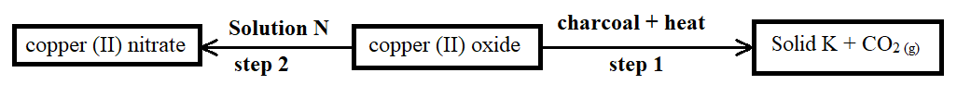
- Identify solution N and solid K. (1 mark)
Solution N Dilute nitric (V) acid. [Accept: nitric acid], HNO₃
Solid K copper metal//Cu
Award ½ mark for each correct answer
- State an expected observation made in step 1 (1 mark)
Black copper (II) oxide changes to a brown substance
- Name the type of chemical reaction in step 2 (1 mark)
Neutralization reaction
- 20cm³ sulphuric (VI) acid sample required 25cm³ of 0.16M potassium hydroxide solution for complete neutralization. Determine the molar concentration of the acid. (3 marks)
H₂SO_{4 (aq)} + 2KOH _{(aq)} K₂SO_{4 (aq)} + 2H₂O _{(l)} OR mole ratio acid to base = 1:2
Moles KOH: If 1000cm³ contains 0.16 moles
Then 25cm³ contains $\frac{25 ×0.16}{1000}$ ½ mark
= 0.004 moles ½ mark
Moles H₂SO₄: Since mole ratio KOH : H₂SO₄
2 : 1
Then 0.004 : $\frac{0.004 ×1}{2}$ ½ mark
= 0.002 moles H₂SO₄ ½ mark
Concentration H₂SO₄: If 20cm³ contains 0.002 moles
Then 1000cm³ will contain $\frac{1000 ×0.002}{20}$ ½ mark
= 0.1 moles per litre ½ mark
- The diagram below represents part of a setup arranged for the collection of hydrogen gas in the laboratory. Study it and answer the questions that follow.
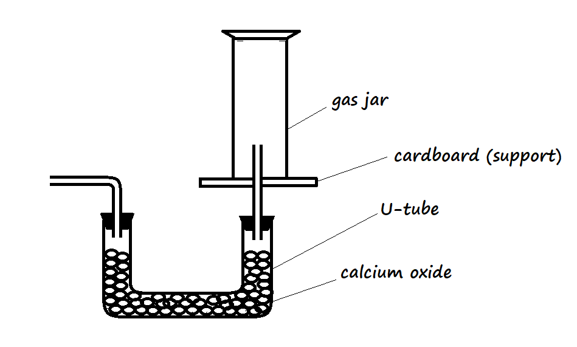
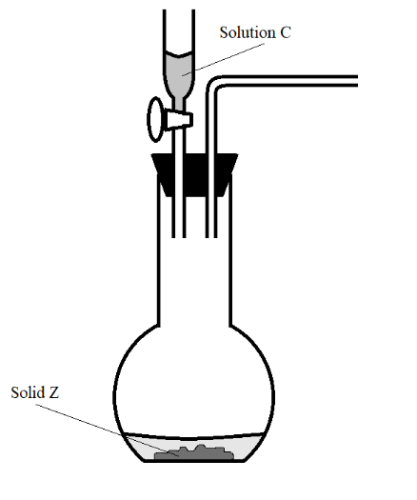
1 mark for workability of the setup, i.e., correct connection of delivery tubes and corks correctly fitted
1 mark for drying agent
1 mark for downward displacement of air
- Complete the diagram to show how a dry sample of hydrogen can be collected. (3 marks)
- Give the most suitable identity of solid Z. (1 mark)
Zinc metal
- State and explain how the conductivities of sodium and potassium compare. (2 marks)
Potassium has a higher electrical conductivity than sodium. Electrons in potassium experience a lower effective nuclear force of attraction because potassium has a larger atomic radius than sodium making electrons in sodium more loosely held.
- State two applications of the effect of impurities on the melting point of a substance (2 marks)
Removing ice from roads in temperate countries
- An element has two isotopes Q and V with mass numbers 28 and 29 respectively.
- What are isotopes? (1 mark)
These are atoms of the same element that have different mass numbers//Are atoms with the same atomic number but different mass numbers
- Determine the percentage abundance of Q and V given that the relative atomic mass of the element is 28.09 (3 marks)
R.A.M. = $\frac{\left(RAQ\right)MQ + \left(RAV\right)MV}{100}$
28.09 = $\frac{28RAQ+29RAV}{100}$ 1st ½ mark for correct substitution
2809 = 28RA_{Q} + 29RA_{V}
But RA_{Q} + RA_{V} = 100
So RA_{Q} = 100 – RA_{V} 2nd ½ mark
2809 = 28(100 – RA_{V}) + 29RA_{V} 3rd ½ mark for correct substitution
2809 = 2800 – 28RA_{V} + 29RA_{V} 4th ½ mark
RA_{V} = 9 5th ½ mark
RA_{Q} = 100 – 9 = 91 6th ½ mark
- Below, is a table of the first ionization energies of some metallic elements. The letters do not represent actual symbols of elements.
Metal | A | B | C | D
First ionization energy (kJ/mole) | 494 | 418 | 519 | 376
- Arrange the metals in their order of decreasing reactivity. (1 mark)
D B A C
[award ½ mark for 1st two correct, and another ½ mark for the 2nd two correct]
- Identify the metal with the highest melting point. (1 mark)
C
- State one factor that affects the magnitude of ionization energy. (1 mark)
Number of occupied energy levels
Effective nuclear force of attraction
Stability of the atom
[award the candidate’s 1st answer – if multiple answers are given]

- State Graham’s Law of diffusion. (1 mark)
The rate of diffusion of a gas is inversely proportional to the square root of its density.
- On the axes provided below, sketch the curve that verifies Boyle’s Law. (2 marks)
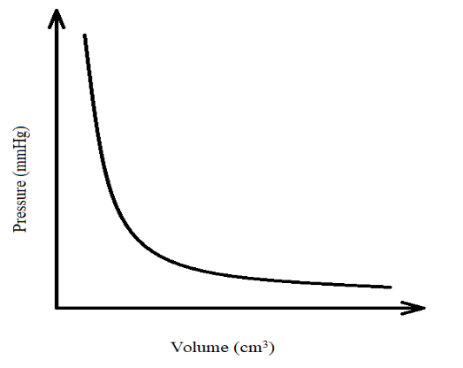
A smooth curve that does not touch the x or y axes [1 mark]
Axes labelled [1 mark]

- State two laboratory apparatus that are used to measure fixed volumes. (2 marks)
Pipette
Volumetric flask
- State the use of a desiccator in the laboratory. (1 mark)
To keep laboratory reagents dry
- Excess samples of magnesium and copper were burnt in separate vessels with equal and fixed volumes of air. Explain the difference in volume of air used in the two vessels at the end of the experiment. (3 marks)
There is a higher volume in the vessel with copper [1st mark]
OR There is a lower volume in the vessel with magnesium (reject high volume or low volume since a comparison is being made)
Magnesium used the oxygen and nitrogen components of air [2nd mark]
…while copper only used the oxygen component of air [3rd mark]
- Study the table below and use it to answer the questions that follow. The letters do not represent actual elements.
Element | G | H | I | J
Atomic number | 11 | 12 | 16 | 18
- Compare the atomic sizes of elements H and I. Explain. (2 mark)
H has a larger atomic radius than I [1st mark]
OR I has a smaller/shorter atomic radius than H
H a weaker effective nuclear force of attraction compared to I [2nd mark]
OR H has fewer protons for the same number of occupied energy levels compared to I
- Identify an element that forms an oxide with acidic properties. (1 mark)
I
- The statements below are attributes of hydrogen gas. Give reasons for the properties mentioned.
- An advantage of inflating aeroplane tyres with hydrogen gas. (1 mark)
Hydrogen gas is light
- A disadvantage of inflating aeroplane tyres with hydrogen gas. (1 mark)
Hydrogen explodes when exposed to heat [during landing]
- List two industrial uses of hydrogen. (2 marks)
Used as rocket fuel
Used in filling weather balloons
Used to harden oils to fats [during manufacture of margarine]
[award the first two of the candidate’s answers if more than two are listed]
- A measuring cylinder was used for investigating a certain property of concentrated sulphuric (VI) acid. The setup was left open in the fume chamber for two days without interference. Figure 1 illustrates the initial condition of the acid in the measuring cylinder.
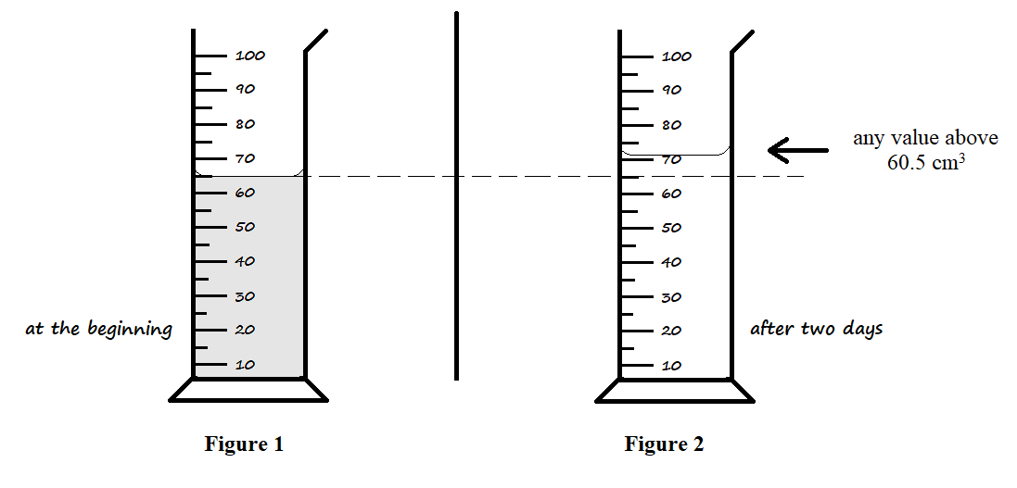
- Draw the expected level of the acid in Figure 2 after being left in the fume chamber for two days. (1 mark)
- Explain your illustration in the setup above. (2 marks)
Concentrated sulphuric (VI) acid is hygroscopic and absorbs atmospheric moisture to increase its volume.
[award 1 mark for each underlined marking point]
- Describe how the following reagents may be used to prepare a pure sample of lead (II) chloride in the laboratory: Distilled water, sodium chloride crystals, lead metal, dilute nitric (V) acid. (3 marks)
Heat a sample of lead metal in air to form lead (II) oxide. Add dilute nitric (V) acid to excess lead (II) oxide to form lead (II) nitrate solution. Filter the mixture to remove excess lead (II) oxide as a residue. Add sodium chloride crystals to the filtrate to form lead (II) chloride as a precipitate, and sodium nitrate solution. Filter the mixture to obtain lead (II) chloride as a residue. Dry the residue between two filter papers.
[award ½ mark for each underlined marking point. Penalize fully from the point a contradiction is presented]
- Rust affects the strength of iron structures. State two ways by which coating iron with a thin coat of aluminium paint prevents rusting. (2 marks)
Aluminium paint covers the iron surface to prevent its contact with air and moisture
Aluminium is more reactive than iron; air and moisture react with it instead of reacting with iron – leaving the iron protected.
- Use dot (•) and cross (×) diagrams to represent electron bonding in the following substances.
- Carbon (II) oxide, CO (1½ marks)
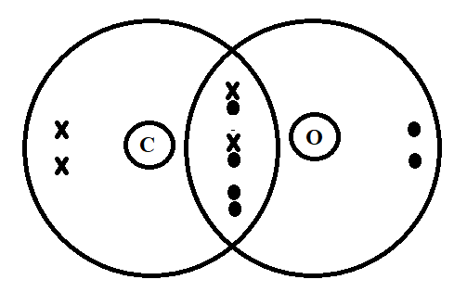
Correct labelling of elements 1st half mark
One pair of electrons denoted using either both dots or both crosses to indicate dative bonding 2nd half mark
Correct total number of electrons in both atoms 3rd half mark

- Magnesium fluoride, MgF₂ (1½ marks)
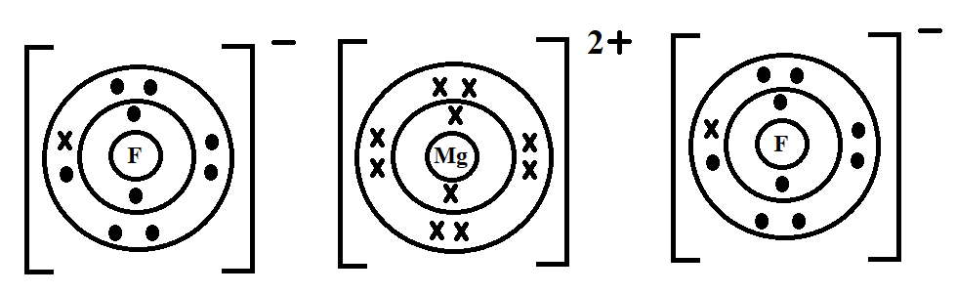 OR 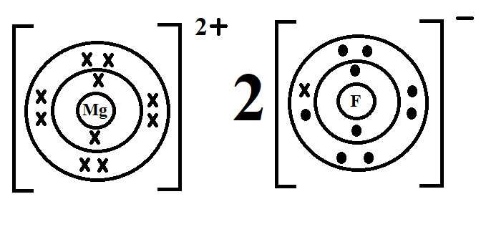
Award 1st ½ mark for showing two fluoride ions and 1 magnesium ion otherwise penalize fully
Award 2nd ½ mark for indicating all occupied energy levels in both the magnesium ion and fluoride ion, otherwise penalize fully
Award 3rd ½ mark for indicating that the fluoride ion gained one electron from magnesium, i.e., one electron in the fluoride ion having the same notation as those in magnesium.
- The diagrams below represent setups that were used to study properties of some halogens. Study them and answer the questions that follow.
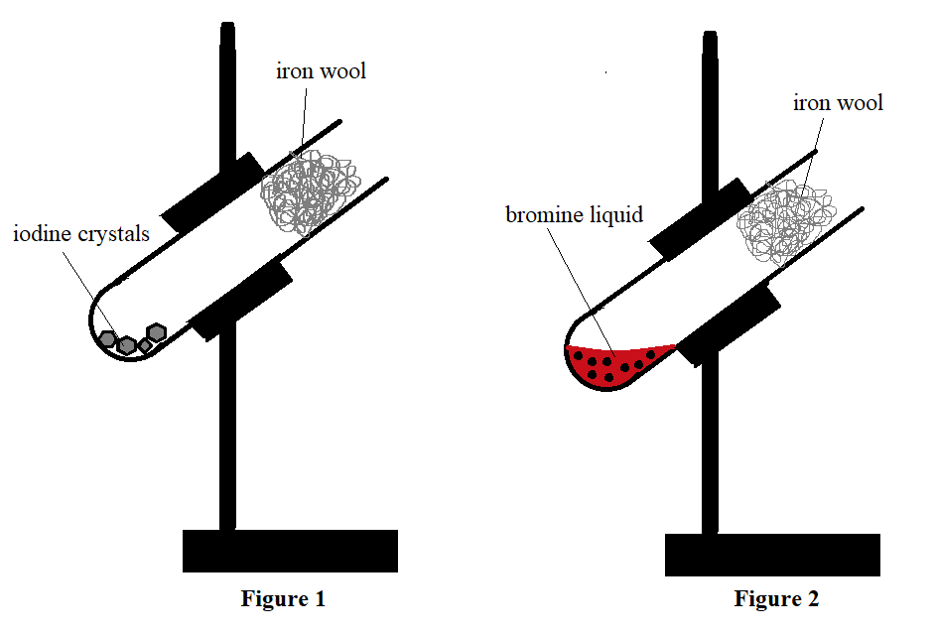
- State the observation made on the iron wool in Figure 2 during the experiment. (1 mark)
The iron wool glows and changes from grey to a red solid.
- Name the compound formed in Figure 1. (1 mark)
Iron (II) iodide Reject: Iron (III) iodide
- State one precaution that should be observed when conducting the experiment above. (1 mark)
The experiment should be done in a fume chamber
The experiment should be done in the open air
- 120cm³ of helium diffuses through a porous plug in 30 seconds. Determine the time required by 70cm³ of nitrogen (IV) oxide to diffuse across the same plug (2 marks)
(He = 4, N = 14, O = 16)
R_{He} = $\frac{120}{30}$ = 4cm³/s ½ mark
M_{NO2} = 14 + 2(16) = 46
R_{NO2} = R_{He} ×$\sqrt{\frac{MHe}{MNO2}}$
R_{NO2} = 4 × $\sqrt{\frac{4}{46}}$
= 1.1795 ½ mark
T_{NO2} = $\frac{VNO2}{RNO2}$ = $\frac{70}{1.1795}$ ½ mark
T_{NO2} = 59.35 seconds ½ mark
OR
Alternative Method

If 120cm³ He takes 30 seconds
Then 70cm³ He takes $\frac{70 ×30}{120}$ = 17.5 s ½ mark
T_{NO2} = T_{He} × $\sqrt{\frac{MNO2}{MHe}}$
T_{NO2} = 17.5 × $\sqrt{\frac{46}{4}}$ 1 mark
= 59.35 seconds ½ mark
- When carrying out titration, indicators are used to determine the endpoint.
- What is an endpoint? (1 mark)
This is the volume at which an acid has reacted with the exact volume of base to neutralize it.
- List two acid-base indicators that are suitable for use in titration in the laboratory. (2 marks)
Phenolphthalein indicator
Methyl orange indicator
Reject: Litmus paper (mentioned on its own or as red and blue), litmus solution, universal indicator, bromothymol blue indicators.
- The halogen compounds, hydrogen fluoride and hydrogen chloride have boiling points of 19.5ºC and -85.05ºC respectively.
- State the expected physical state of hydrogen fluoride at s.t.p. (1 mark)
Gaseous state Accept: Gas
- Explain the differences in boiling points between the two compounds. (2 marks)
Both compounds have a simple molecular structure with weak Van der Waal’s forces of attraction [1st mark]
However, hydrogen fluoride has hydrogen bonding in addition to the weak Van der Waal’s forces hence a higher boiling point than hydrogen chloride [2nd mark]
[marking points are the underlined for 1 mark each]

- The table below shows pH values of solutions F, G, Y and Z.

Solution | pH value
F | 8.0
G | 2.0
Y | 12.0
Z | 7.0
- Which solution would react explosively with sodium metal? (1 mark)
Solution G
- State the expected colour of litmus solution in solution Y. (1 mark)
Blue
- Describe how the pH value of solution F can be determined. (2 marks)
Add 3 drops of universal indicator to the solution [1st mark]. Match the colour of the resultant solution to the colours of a pH chart [2nd mark]. The colour on the pH chart corresponding to the colour of the solution gives the pH value of the solution
- A compound of carbon, hydrogen and oxygen contains 55% carbon, 9.01% hydrogen, and the rest oxygen. Determine the molecular formula of the compound, given that its relative molecular mass is 88. (3 marks)
% Oxygen = 100 – (55+9.01) = 35.99% ½ mark
Elements | C | H | O
% Composition | 55 | 9.01 | 35.99
R.A.M. | 12 | 1 | 16
Moles | $$\frac{55}{12}$$  = 4.583 | $$\frac{9.01}{1}$$  = 9.01 | $$\frac{35.99}{16}$$  = 2.249 | ½ mark
Ratio | $$\frac{4.583}{2.249}$$  = 2 | $$\frac{9.01}{2.249}$$  = 4 | $$\frac{2.249}{2.249}$$  = 1
Empirical formula (EF) | C₂H₄O |  |  | ½ mark

…mass of M.F. = (mass E.F.)_{n}
88 = [2(12) + 4(1) + 16]_{n}
88 = (44)_{n} ½ mark
…n = $\frac{88}{44}$ = 2 ½ mark
M.F. = (C₂H₄O)₂
= C₄H₈O₂ ½ mark
- The diagram below represents a burning jiko.
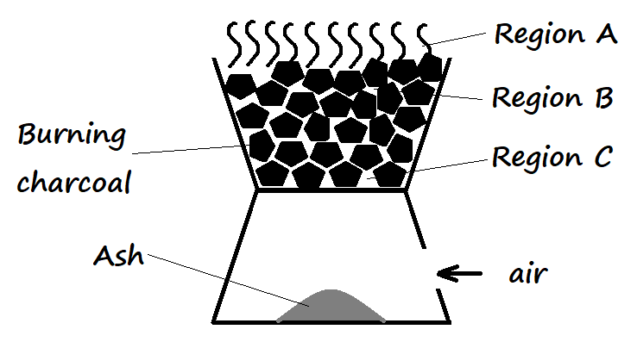
- Write the equation for the reactions that occur in regions A and B. (2 marks)
A 2CO _{(g)} + O_{2 (g)} 2CO_{2 (g)}
B CO_{2 (g)} + C _{(s)} 2CO _{(g)}
For each equation, award the 1st half mark for a balanced equation then the 2nd half mark for the correct state symbols.
Penalize fully for an equation that is not balanced.
- It is not advisable to leave a burning jiko overnight in a poorly ventilated room. Explain. (1 mark)
The carbon (II) oxide produced in the middle region is not oxidised to carbon (IV) oxide and may cause suffocation.
- The following table shows the products formed when nitrates of metals J, Y, and W are heated strongly.
Nitrate of | Products formed
J | Metal oxide + Nitrogen (IV) oxide + Oxygen
Y | Metal + Nitrogen (IV) oxide + Oxygen
W | Metal nitrite + Oxygen
- Arrange the metals in their order of decreasing reactivity. (1 mark)
W J Y
- Which metal forms a soluble carbonate? (½ mark)
W
- Give an example of nitrate Y. (½ mark)
Silver nitrate (AgNO₃) or mercury nitrate [Hg(NO₃)₂]
Award 1 mark for one nitrate mentioned: Reject if element only e.g., Reject Ag or Hg
Where the candidate writes the formula of the nitrate, the formula MUST be correct for it to score.

