Term 2 - 2022
FORM 4
CHEMISTRY PAPER 2 (233/2)
MARKING SCHEME

Question |  | Answer | Marks
 |  | Nuclear fission is the splitting process a heavy nuclide undergoes when bombarded by a fast moving neutron. | 1 mark
 |  | In both cases a large quantity of energy is released.  Both processes results in chain reactions. | 1 mark  1 mark
 | - (i) | Scale:  Curve:  Plotting:  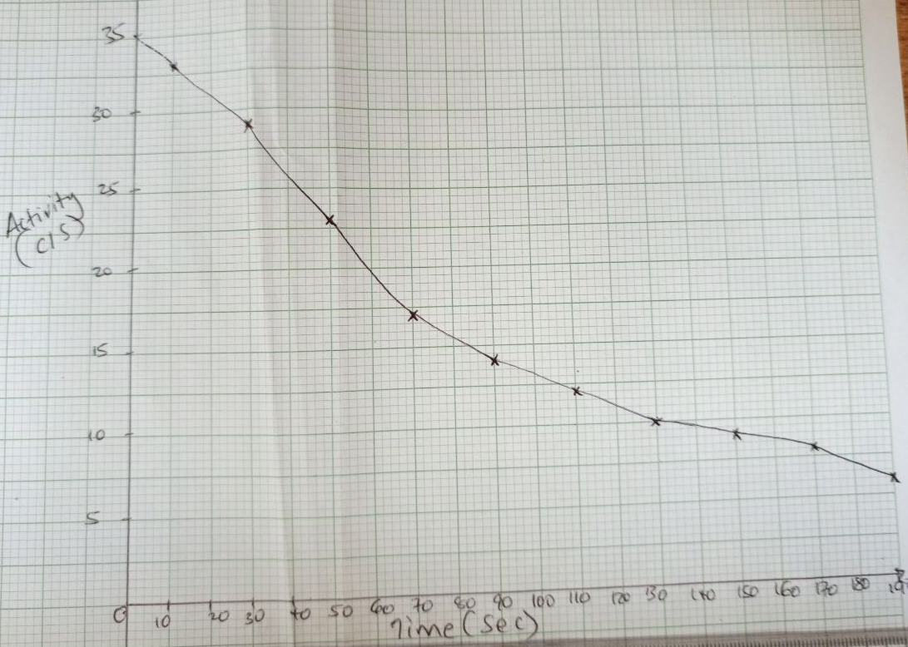 | 1 mark  1 mark  1 mark
 | (ii)I | 35
 | II | 24.5
 |  | Testing of nuclear weapons in the oceans also causes environmental pollution since plants and other living organisms may take in the radioactive materials released in the water.  When not put into proper use, radioisotopes can be used as weapons of mass destruction | 1 mark  1 mark
Total |  |  | 10 marks
 | - (i) | 3 units
 | (ii) |  | 1 mark
 | (iii) | They do not decompose easily, i.e., are non-biodegradable. This results in environmental pollution.  Some synthetic polymers give off poisonous gases when they burn, e.g., polythene gives off hydrogen cyanide and carbon(IV) oxide. | 2 marks
 |  | Tetraoxophosphate  Enzymes | 1 mark  1 mark
 |  | C₂H₄ + H₂O → C₂H₅OH  Molecular mass of ethene 12 x 2 + 1 x 4 = 28  Moles of ethene 56 ÷ 28 = 2 moles  Mole ratio 1 : 1  Moles of ethanol 2 moles  Molecular mass of ethanol  12 x 2 + 1 x 6 + 16 = 46  Mass of ethanol 2 x 46 = 92g | ¹/₂ mark  ¹/₂ mark  ¹/₂ mark  ¹/₂ mark
 | - (i) | Alkanols | 1 mark
 | (ii) | 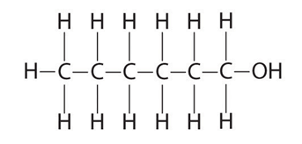 | 1 mark
 | (iii) | (C₃H₆O)n = 116  (3 x12 + 1 x 6 + 16)n= 116  58n=116  n=2  C₅H₁₁COOH/C₆H₁₂O₂  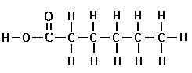 | ¹/₂ mark  ¹/₂ mark  1 mark
 | (iv) | Put 2 cm³ of Q in a test tube.  Add 1 cm³ of sulphuric (VI) acid.  Add an alkanol-any to the test tube and warm.  A pleasant smell is produced. | ¹/₂ mark  ¹/₂ mark  ¹/₂ mark  ¹/₂ mark
Total |  |  | 14 marks
 |  | Electricity charge 2 x 4 x 60 x 60=28,800C  28,800C x 24,000cm³  (96,500 x 4) =1,790.67 cm³ | 1 mark  1 mark
 | - (i)(I) | +1.23V/half-cellXI | ¹/₂ mark
 | (II) | -2.71V/ half-cell IV | ¹/₂ mark
 | (ii) | 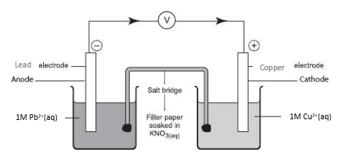 | 3 marks
 | (iii) | Pb(s) + Cu²⁺(aq) → Pb²⁺(aq) + Cu(s)  +0.34 +0.13=+0.47V | 2 marks
 | (iv) | Formation of insoluble PbSO₄. This reduces the concentration of ions in the electrolyte/reduces the effectiveness of the cell. | 1 mark
 | (v) | Pb(s)|Pb²⁺(aq) || Cu²⁺(aq)|Cu(s) E^{θ} = +0.47V | 1 mark
 | (vi) | 2Fe(s) → 2Fe²⁺(aq) + 4e⁻ +0.44V  O₂(g) + 2H₂O (l) + 4e⁻ → 4OH⁻(aq)+0.40V  2Fe(s) + ³/₂O₂(g) + 2H₂O (l) → Fe₂O₃.2H₂O(s)+0.84V | 1 mark  1 mark
 | (vii) | Improve appearance.  Prevent corrosion. | 1 mark  1 mark
Total |  |  | 14 marks
 |  | B | 1 mark
 |  | I | 1 mark
 |  | Alkaline Earth Metals | 1 mark
 |  | √ indicated on the diagram. | 1 mark
 |  | D has more protons which increases the effective nuclear charge attracting the valence electrons firmly to the nucleus. | 1 mark
 |  | The incoming electrons experiences repulsion from the existing electrons.  The energy level expand to accommodate the incoming electrons. | 1 mark  1 mark
 |  | C
 |  | Chloride of E has ionic bonds throughout its giant ionic structure while chloride of E is a molecule with weak van der waals forces of attraction throughout its simple molecular structure. | 1 mark
Total |  |  | 10 marks
 |  | Weigh about 1g clean magnesium ribbon in a crucible.  Heat the crucible, occasionally lifting the lid to let air in.  Do not allow any contents to escape from the crucible.  When all the magnesium has burned, allow the crucible to cool.  Weigh the cool crucible and its contents again.  Determine the change in Mass by (Mass of crucible + Magnesium before burning) -  (Mass of crucible + contents after burning) | ¹/₂ mark  ¹/₂ mark  ¹/₂ mark  ¹/₂ mark  ¹/₂ mark  ¹/₂ mark
 | - (i) | Step 2 Zn²⁺ and Al³⁺  Step 5 CO₃²⁻ and SO₃²⁻ | 1 mark  1 mark
 | (ii) | 2H⁺(aq) + CO₃²⁻(aq) →H₂O(l) + CO₂(g)/  2H⁺(aq) + SO₃²⁻(aq) →H₂O(l) + SO₂(g) | 1 mark
 | (iii) I | Formations of a colorless solution  Brown solid deposited  Effervescence | 1 mark  1 mark
 | II | Zinc | 1 mark
 | III | Zn²⁺(aq) + 2OH⁻(aq) → Zn(OH)₂(s)  Zn(OH)₂(s) + 2OH⁻(aq) →[Zn(OH)₄]²⁻(aq) | 1 mark  1 mark
Total |  |  | 11 marks
 | - (i) | Solidification | 1 mark
 | (ii) | A Sulphorous acid/sulphuric (IV) acid  B Potassium sulphite  CSulphur  DWater | ¹/₂ mark  ¹/₂ mark  ¹/₂ mark  ¹/₂ mark
 | (iii) | Oxidizing | 1 mark
 | - (i) | Burning magnesium produces a lot of heat.  That decomposes carbon (IV) oxide to carbon and oxygen.  Oxygen is used to continue burning forming a white solid of magnesium oxide. | 1 mark  1 mark  1 mark
 | (ii) I | Carbon (II) oxide | 1 mark
 | II | CO(g) + CuO(s) → Cu(s) + CO(g) | 1 mark
 | III | Black solid changes to brown. | 1 mark
Total |  |  | 11 marks
 | - (i) | Galena/lead (II) sulphide/Cerussite | 1 mark
 | (ii) | A Sulphur (IV) oxide gas  B Iron  C Slag | 1 mark  1 mark  1 mark
 |  | SiO_{2(s)} + CaO_{(s)} →CaSiO_{3(l)} | 1 mark
 |  | Zinc blende/Silica | 1 mark
 |  | Froth flotation | 1 mark
 |  | 2PbS_{(s)} + 3O_{2(g)} →2PbO_{(s)} + 2SO_{2(g)} /  PbCO_{3(s)} →PbO_{(s)} + CO_{2(g)} | 1 mark
 |  | Used in lead acid accumulators as lead plates | 1 mark
 |  | Emission of Sulphur (IV) oxide forms acid rain which corrodes stone buildings and metallic structures. | 1 mark
Total |  |  | 10 marks
 |  |  | 80 marks

