Term 2 - 2022
CHEMISTRY (233/2)
PAPER 2
FORM FOUR (4)
Time: 2 Hours

Name: …………………………………………………………. Adm No: ……………….
School: ……………………………………………………….. Class: …………………..
Signature: …………………………………………………….. Date: …………………...
Instructions to candidates
- Write your name, stream, and admission number in the spaces provided above.
- Answer ALL the questions in the spaces provided, and working MUST be clearly shown
- This paper consists of 11 printed pages; Candidates should check the question paper to ascertain that all the pages are printed as indicated, and that no question is missing.

FOR EXAMINERS’ USE ONLY
QUESTION | MAXIMUM SCORE | CANDIDATE’S SCORE
1 – 6 | 80

- The grid below represents part of the periodic table. Study it and answer the questions that follow. The letters do not represent actual symbols of the elements
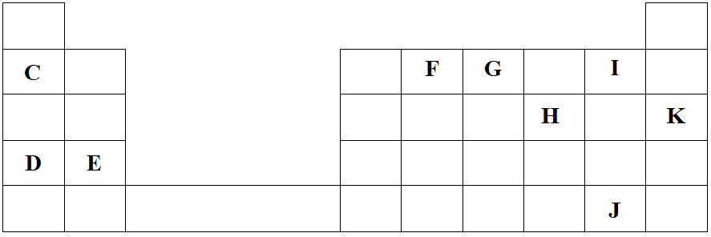
- Identify the most reactive non-metal. Explain (2 Marks)
___________________________________________________________________________
___________________________________________________________________________
___________________________________________________________________________
- What is the name given to the family of elements to which I and J belong? (1 Mark)
___________________________________________________________________________
- Using dots (•) and crosses (×) to represent electrons, show bonding in the compound formed between C and H. (2 Marks)

- How does the atomic radius of F compare with that of I? Explain. (2 Marks)
___________________________________________________________________________
___________________________________________________________________________
___________________________________________________________________________
- Study the table below and answer the questions that follow.
Substance | M | N | O | P | Q | R
Melting Point (ºC) | 801 | 1356 | -101 | 26 | -39 | 113
Boiling Point (ºC) | 1410 | 2850 | -36 | 154 | 457 | 445
Electrical conductivity in solid state | Poor | Poor | Poor | Poor | Good | Poor
Electrical conductivity in molten state | Good | Poor | Poor | Poor | Good | Poor

- Explain why substance M is a good conductor of electricity in the molten state but not in the solid state. (2 Marks)
___________________________________________________________________________
___________________________________________________________________________
___________________________________________________________________________
- What is the most likely structure and bond in substance N? Explain. (2 Marks)
Structure ____________________________ Bond ___________________________
__________________________________________________________________________
__________________________________________________________________________
- Identify, with a reason, a substance that exists as a liquid at room temperature. (2 Marks)
___________________________________________________________________________
___________________________________________________________________________
___________________________________________________________________________

- What name is given to different forms of an element which exist in the same physical state? (1 Mark)
___________________________________________________________________________
- Name two crystalline forms of carbon (1 Mark)
__________________________________ _________________________________
- The figure below is part of a setup used to prepare and collect dry carbon (II) oxide from carbon (IV) oxide.
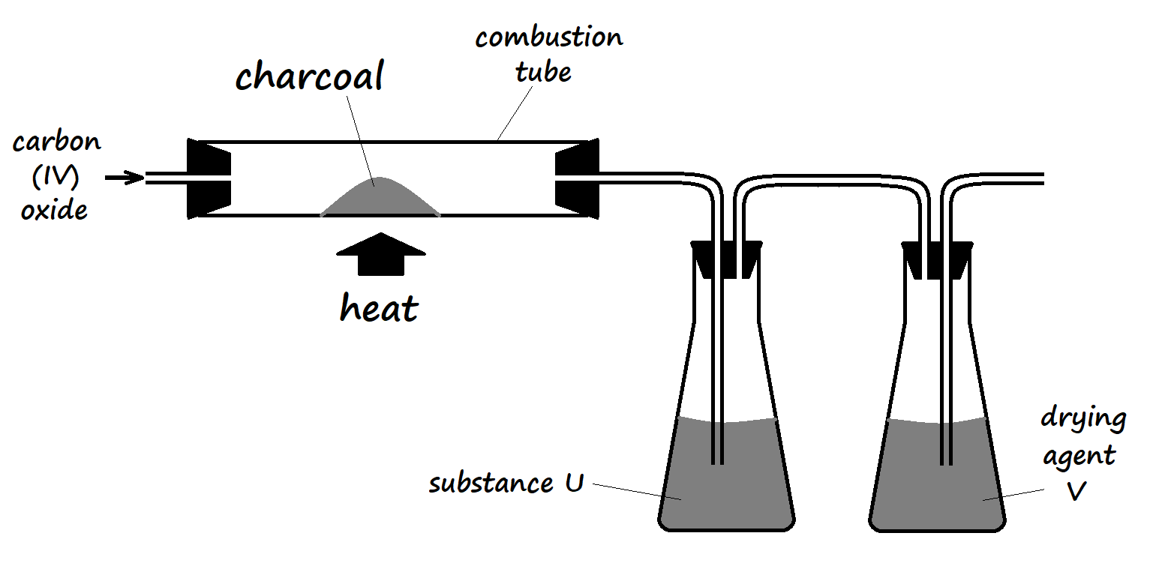
- Complete the diagram to show how dry carbon (II) oxide gas is collected. (1 Mark)
- Identify:
- Substance U and state its use
_____________________________________________________________________
_____________________________________________________________________
- Drying agent Y
_____________________________________________________________________
- Write a chemical equation for the reaction which takes place in the combustion tube (1 Mark)
___________________________________________________________________________
- Carbon (II) oxide is a major environmental pollutant.
- Give one major source of carbon (II) oxide in the atmosphere (1 Mark)
_____________________________________________________________________
- Explain how carbon (II) oxide causes poisoning (1 Mark)
_____________________________________________________________________
_____________________________________________________________________
- State one use of carbon (II) oxide (1 Mark)
___________________________________________________________________________
- Write an equation for the formation of water gas. (1 Mark)
___________________________________________________________________________
- Explain why sodium hydroxide solution is not used in testing for carbon (IV) oxide gas, while calcium hydroxide is preferably used. (2 Marks)
___________________________________________________________________________
___________________________________________________________________________
___________________________________________________________________________

- Study the following energy cycle diagram and then answer the questions that follow.
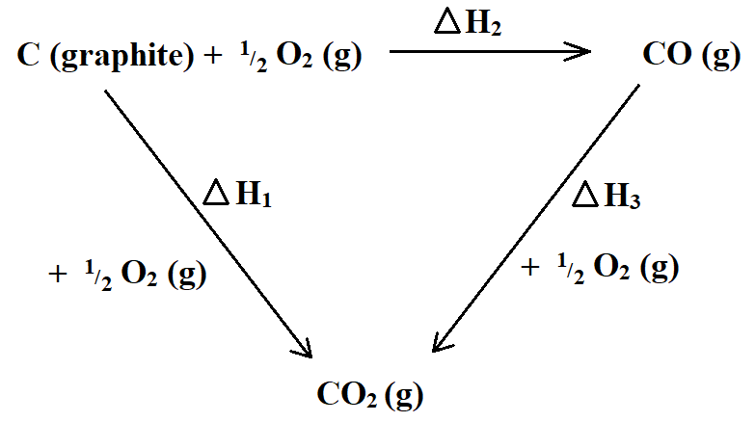
- Name the enthalpy change represented by ∆H₂. (1 Mark)
___________________________________________________________________________
- Use the following information to calculate the value of ∆H₁ for 144g of graphite. (2 Marks)
∆H₂ = -110 kJ/mole ∆H₃ = -283kJ/mole
___________________________________________________________________________
___________________________________________________________________________
___________________________________________________________________________
___________________________________________________________________________
- The following are thermochemical equations for molar enthalpies of combustion for some substances. Study them and answer the questions that follow.
C₄H₁₀ (g) + $\frac{13}{2}$O₂ (g) 4CO₂ (g) + 5H₂O ∆H^{θ}_{c} = -2877kJ/mole
C (s) + O₂ (g) CO₂ (g) ∆H^{θ}_{c} = -399kJ/mole
H₂ (g) + ½O₂ (g) H₂O (l) ∆H^{θ}_{c} = -286kJ/mole

- What is molar enthalpy of combustion of a substance? (1 Mark)
___________________________________________________________________________
___________________________________________________________________________
- Calculate the molar enthalpy of formation of butane (C₄H₁₀) using the information given above. (3 Marks)
___________________________________________________________________________
___________________________________________________________________________
___________________________________________________________________________
- The following results were obtained in an experiment, to determine the heat of neutralization of 25cm³ of 2M sodium hydroxide solution, using 25cm³ of hydrochloric acid:
Initial temperature of acid = 25.0ºC
Initial temperature of alkali = 26.0ºC
Final temperature of mixture of acid + alkali = 38.5ºC
Density of solution =1g/cm³
Specific heat capacity of solution =4.2 J/g/K

- Define molar heat of neutralization (1 Mark)
___________________________________________________________________________
___________________________________________________________________________
- Write an ionic equation for the neutralization reaction involving hydrochloric acid and sodium hydroxide solution. (1 Mark)
___________________________________________________________________________
- Calculate:
- The enthalpy change during this experiment. (2 Marks)
_____________________________________________________________________
_____________________________________________________________________
_____________________________________________________________________
_____________________________________________________________________
- The molar enthalpy of neutralization for this reaction (2 Marks)
_____________________________________________________________________
_____________________________________________________________________
_____________________________________________________________________
_____________________________________________________________________

- Below is a simplified diagram of the Down’s Cell, used for the manufacture of sodium. Study it and answer the questions that follow.
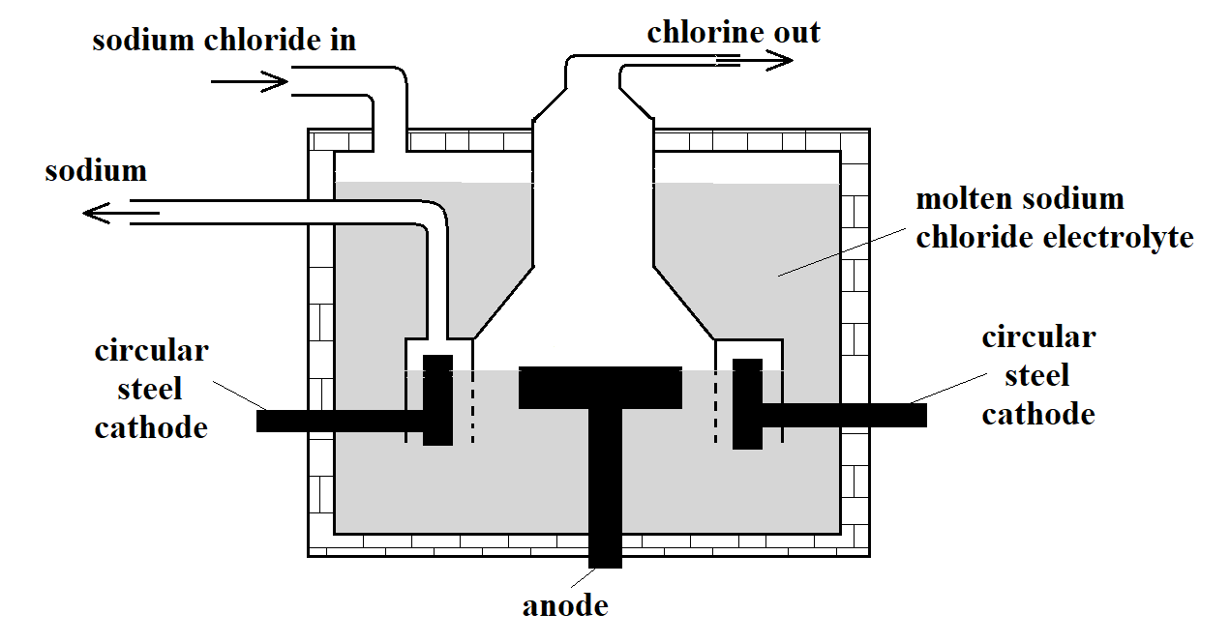
- What material is the anode made of? Give the reason why that material is used. (2 Marks)
___________________________________________________________________________
___________________________________________________________________________

- What precaution is taken to prevent chlorine and sodium from re-combining? (1 Mark)
___________________________________________________________________________
___________________________________________________________________________
- Write an ionic equation for the reaction in which chlorine gas is formed (1 Mark)
___________________________________________________________________________
- In the Downs process, (used for manufacture of sodium), a certain salt is added to lower the melting point of sodium chloride from about 800ºC to about 600ºC.
- Name the salt that is added. (1 Mark)
___________________________________________________________________________
- State why it is necessary to lower the temperature in b) above (1 Mark)
___________________________________________________________________________
___________________________________________________________________________
- Explain why aqueous sodium chloride is not suitable as an electrolyte for the manufacture of sodium in the Down’s Process. (2 Marks)
___________________________________________________________________________
___________________________________________________________________________
- Sodium metal reacts with air to form two oxides. Give the formulae of the two oxides (1 Mark)
_____________________________ _______________________________________

- State two uses of sodium (2 Marks)
___________________________________________________________________________
___________________________________________________________________________
___________________________________________________________________________

- The diagram below shows part of the Frasch process, used for the extraction of sulphur. Use it to answer the questions that follow.
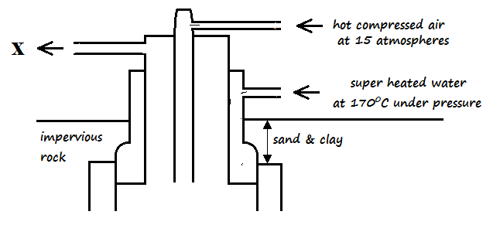
- Identify X ________________________________________________________(1 Mark)
- Why is it necessary to use superheated water and hot compressed air in this process? (2 Marks)
___________________________________________________________________________
___________________________________________________________________________
___________________________________________________________________________
- State two physical properties of sulphur that makes it possible for it to be extracted by this method. (2 Marks)
___________________________________________________________________________
___________________________________________________________________________

- The diagram below shows part of the process in the manufacture of sulphuric (VI) acid. Study it and use it to answer the questions that follow.
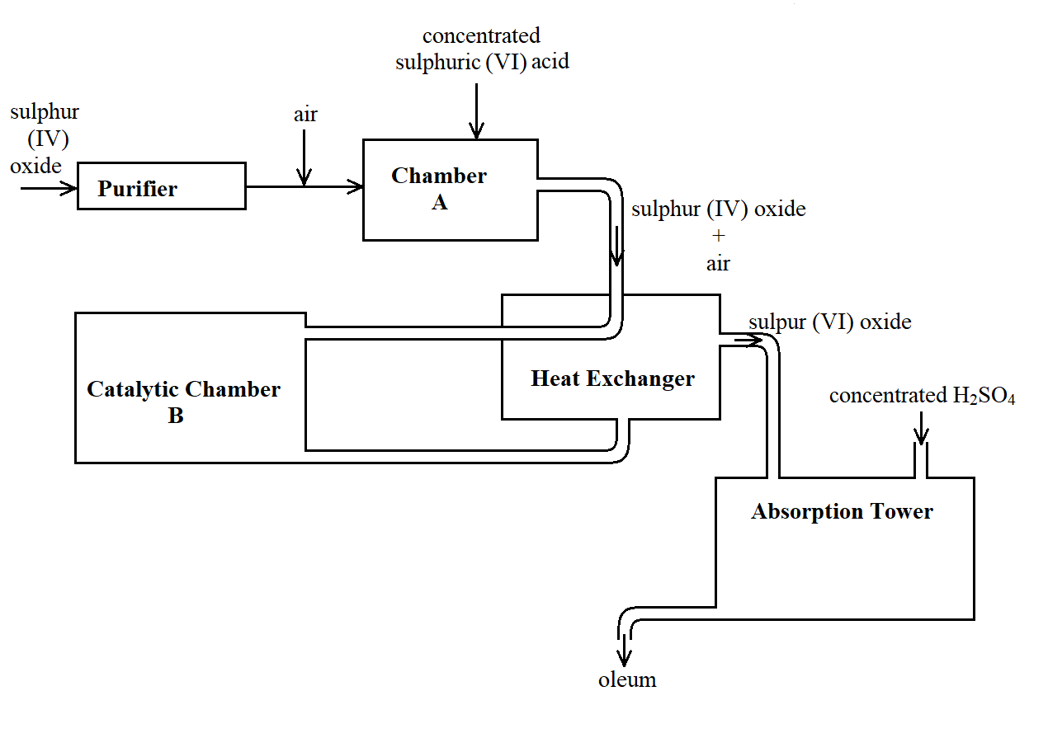
- Give two reasons why air is referred to as a mixture (2 Marks)
___________________________________________________________________________
___________________________________________________________________________
- What is the role of concentrated sulphuric (VI) acid in Chamber A? (1 Mark)
___________________________________________________________________________
___________________________________________________________________________
- Name two catalysts that can be used in the Catalytic Chamber B. (2 Marks)
___________________________________________________________________________
___________________________________________________________________________
- State two roles of the heat exchanger (2 Marks)
___________________________________________________________________________
___________________________________________________________________________
- Describe the test for sulphite anion, SO₃²⁻ (2 Marks)
___________________________________________________________________________
___________________________________________________________________________
___________________________________________________________________________

- Explain the observation made when a few drops of concentrated sulphuric (VI) acid are added to crystals of hydrated copper (II) sulphate. Explain your answer. (2 Marks)
___________________________________________________________________________
___________________________________________________________________________
___________________________________________________________________________
- Study the reaction scheme below and answer the questions the follow:
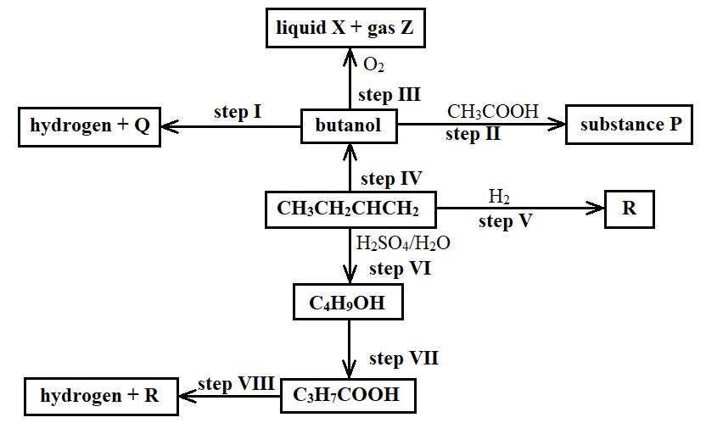
- What is the distinguishing physical property of Substance P? (1 Mark)
___________________________________________________________________________
___________________________________________________________________________
- Identify a suitable reagent that can be used in Step I. (1 Mark)
___________________________________________________________________________
- Describe a chemical test on how C₃H₇COOH can be distinguished from C₄H₉OH. (2 Marks)
___________________________________________________________________________
___________________________________________________________________________
___________________________________________________________________________
- Write an equation for the reaction that takes place in Step III (1 Mark)
___________________________________________________________________________
- Name the types of reaction that occur in steps II, III, V, and VII (2 Marks)
II ___________________________ III ______________________________
V ___________________________ VII _____________________________

- If 7.4g of butanol completely underwent Step III, determine the volume of gas Z produced at s.t.p. (MGV = 22.4 litres, C = 12, H = 1, O = 16) (3 Marks)
___________________________________________________________________________
___________________________________________________________________________
___________________________________________________________________________
___________________________________________________________________________
- Write an equation for the reaction between R and one mole of fluorine gas (1 Mark)
___________________________________________________________________________
- Describe a chemical test for liquid X (2 Marks)
___________________________________________________________________________
___________________________________________________________________________
___________________________________________________________________________

