Name ………………………………….…………………………………….. Index number ….…………
School …………………………………………….………………………….. Candidate’s sign….………
233/2
CHEMISTRY
PAPER 2
SEPT 2021
TIME: 2 HOURS

EAGLE EXAM 2021
Kenya Certificate of Secondary Education (K.C.S.E

INSTRUCTIONS TO THE CANDIDATES:
- Write your name and index number in the spaces provided above
- Sign and write the date of examination in the spaces provided.
- Answer all the questions in the spaces provided.
- All working must be clearly shown where necessary.
- Mathematical tables and electronic calculators can be used.

For Examiners Use Only
Question | Maximum score | Candidate’s score
1 | 09
2 | 08
3 | 10
4 | 08
5 | 07
6 | 11
7 | 13
8 | 14
Total | 80

- Use the table below to answer the questions that follow. (The letters do not represent the actual symbols of the elements).
Element | Atomic number | Melting point ºC
A  B  C  D  E | 11  13  14  17  19 | 97.8  660  1410  -101  63.7

- Write the electronic arrangement for the ions formed by element B and D. [2mks]
………………………………………………………………………………………………………………………………………………………………………………………………………………………………………………………………………………………………………
- Select an element which is:
- A non-conductor of electricity [1mk]
…………………………………………………………………………………………
- The most reactive non-metal [1mk]
…………………………………………………………………………………………

- To which period of the periodic table does element E belong? [1mk]
……………………………………………………………………………………………………………………………………………………………………………………………………
- Element E losses its outermost electron more readily than A. Explain. [1mk]
………………………………………………………………………………………………………………………………………………………………………………………………………………………………………………………………………………………………………
- Use dots (.) and crosses (x) to represent the valence electrons and show the bonding in the compound formed between element C and D. [1mk]
………………………………………………………………………………………………………………………………………………………………………………………………………………………………………………………………………………………………………

- Explain why the melting point of element B is higher than that of element A [1mk]
………………………………………………………………………………………………………………………………………………………………………………………………………………………………………………………………………………………………………
- Write an equation for the reaction that takes place between element A and water. [1mk]
……………………………………………………………………………………………………………………………………………………………………………………………………

- (a) The set-up below was used to collect gas F, produced by the reaction between water and calcium metal.
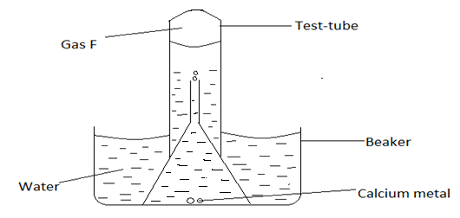

- Name gas F [1mk]
…………………………………………………………………………………………
- At the end of the experiment the solution in the beaker was found to be a weak base. Explain why the solution is a weak base. [1mk]
………………………………………………………………………………………………………………………………………………………………………………………………………………………………………………………………………………
- Give one laboratory use of the solution formed in the beaker. [1mk]
…………………………………………………………………………………………

b) The scheme below shows some reaction starting with calcium oxide. Study it and answer the questions that follow.
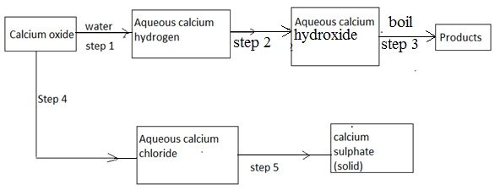
- Name the reagent used in step 2 and 4 [1mk]
Step 2 ___________________________________
Step 4 ___________________________________

- Write an equation for the reaction in step 3 [1mk]
………………………………………………………………………………………………………………………………………………………………………………………………………………………………………………………………………………………
- Describe how a solid sample of anhydrous calcium sulphate is obtained in step 5 [3mks]
……………………………………………………………………………………………………………………………………………………………………………………………………………………………………………………………………………………………………………………………………………………………………………………
- The figure below is a flow chart showing the process that occurs in the manufacture of nitric (V) acid.
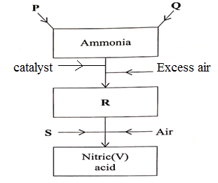

(a) Name substance P, Q, R and S.
- P …………………………………………….. …………………………………… (1mk)
- Q …………………………………………………………………………..……….(1mk)
- R ………………………………………………………………………………….. (1mk)
- S …………………………………………………………………………………… (1mk)
​(b) To obtain substance R, ammonia is heated at 900⁰C in the presence of air and a catalyst.
The product is then cooled in the heat exchanger and mixed with more air.
(i) Name the catalyst for the reaction (1mk)
……………………………………………………………………………………………………
(ii) Write the equation for the reaction described (1mk)
……………………………………………………………………………………………………..
(c) When ammonia is reacted with nitric (V) acid, it produces a nitrogenous fertilizer.
(i) Calculate the percentage of nitrogen in the fertilizer obtained. (N=14,H=1,O=16) (2mks)

(ii) State one problem associated with the use of nitrogenous fertilizers. (1mk)
………………………………………………………………………………………………………………………………………………………………………………………………………….

- The diagram in Figure below was used to prepare hydrogen chloride gas which was then passed over heated iron powder.
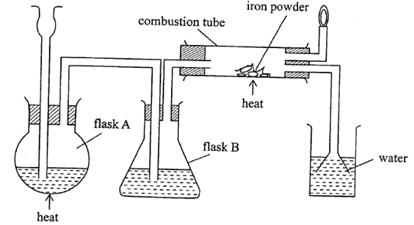

- Give a pair of reagents that will produce hydrogen chloride gas in flask A. (2mks)
………………………………………………………………………………………………………………………………………………………………………………………………………………………………………………………………………………

- Name the substance in flask B. (1mk)
…………………………………………………………………………………………………………………………………………………………………………………..

- State the observation made in the combustion tube after the reaction is complete. (1mk)
………………………………………………………………………………………………………………………………………………………………………………………………………………………………………………………………………………

- Write an equation for the reaction in the combustion tube. (1mk)
…………………………………………………………………………………………

- Describe a chemical test for hydrogen chloride gas. (1mk)
……………………………………………………………………………………………………………………………………………………………………………………

- Identify the gas that burns at the jet and explain why the gas is burned.
(1mk)
………………………………………………………………………………………………………………………………………………………………………………………………………………………………………………………………………………

- Give reasons why excess hydrogen chloride gas is dissolved using the funnel arrangement. (1mk)
………………………………………………………………………………………………………………………………………………………………………………………………………………………………………………………………………………

- Define the following:
- Empirical formula. (1mk)
………………………………………………………………………………………………………………………………………………………………………………….

- Molecular formula. (1mk)
………………………………………………………………………………………………………………………………………………………………………………
- A major textile dye manufacturer developed a new yellow dye. The dye has a percent composition of 75.95% Carbon, 17.72% Nitrogen, and 6.33% Hydrogen by mass. Determine;
- The empirical formula of the dye. (C=12, H=1, N=14) (3mks)
……………………………………………………………………………………………………………………………………………………………………………………………………………………………………………………………………………………………………………………………………………………………………………………
- The molecular formula of the dye, if it has a molar mass of about 237 g/mol. (C=12, H=1, N=14) (2mks)
………………………………………………………………………………………………………………………………………………………………………………………………………………………………………………………………………………

- (a) (i) Define the term fuel [1mk]
………………………………………………………………………………………………………………………………………………………………………………………….
(ii) Determine the heating value of ethanol
(C = 12, H = 1, O = 16) [2mks]
(ΔH_{c}(C₂H₅OH) = -1368KJ/mol)
……………………………………………………………………………………………………………………………………………………………………………………………………………………………………………………………………………………….
b) The diagram below represents a set-up that was used to determine the enthalpy of combustion of ethanol.
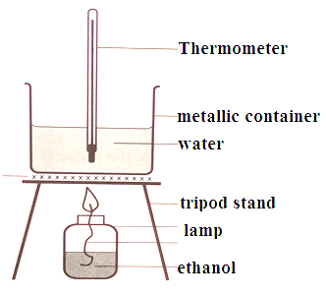
The following results were obtained:
Volume of water = 500cm³
Initial temperature of water = 25ºC
Final temperature of water = 38ºC
Mass of ethanol + lamp before heating = 120.5g
Mass of ethanol + lamp after heating = 119.5g

i) Calculate the heat evolved
(Specific heat capacity = 4.2jg⁻k⁻, density of water = 1g/cm³) [2mks]
……………………………………………………………………………………………………………………………………………………………………………………………………………………………………………………………………………………………………………………………………………………………………………………
ii) Determine the molar heat of combustion of ethanol (C = 12, H = 1, O = 16) [3mks]
………………………………………………………………………………………………………………………………………………………………………………………………………………………………………………………………………………………
iii) Write the thermochemical equation for the reaction. [1mk]
…………………………………………………………………………………………………………………………………………………………………………………............

iv) The theoretical value for the molar enthalpy of combustion of ethanol is -1368kJ/mol
Why is the value calculated from the experimental results different from this? [1mk]
…………………………………………………………………………………………………………………………………………………………………………………………

v) Define the term molar heat of combustion [1mk]
……………………………………………………………………………………………………………………………………………………………………………………………………

- (a) (i) Give the systematic name of the following compound.
CH₃CH₂COOCH₃ [1mk]
…………………………………………………………………………………………….

(ii) Draw the structure of 2-methyl but -1, 3-diene [1mk]

b) The scheme below shows the reactions of organic compounds, study it and answer the questions that follow.
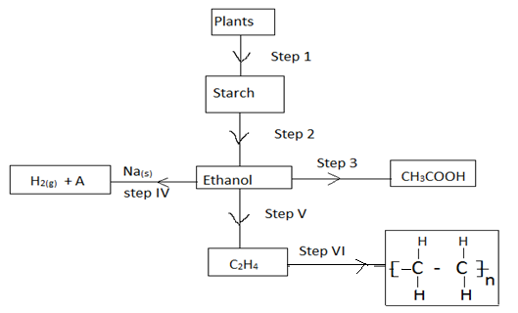
- Name the process in step 1 [1mk]
……………………………………………………………………………………
- State the condition for the process in step 2 [1mk]
…………………………………………………………………………………….
- Write the equation for the process in step 4 [1mk]
…………………………………………………………………………………….

- Name the process taking place in step 3 [1mk]
…………………………………………………………………………………….
- Name the organic compound A the product of step (IV) [1mk]
…………………………………………………………………………………….
- Given that the relative formula mass of the product of step (VI) is 56000. Determine the value of n. (C=12, H=1) [2mks]
…………………………………………………………………………………………………………………………………………………………………………

c) The flow chart below is a summary of the process involved during preparation of a
detergent.
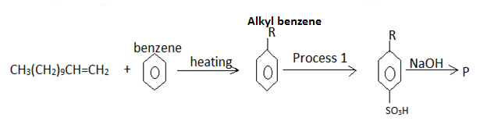
- Name the reagent in process 1 [1mk]
………………………………………………………………………………………..

- Draw the structure of P; Give its name [2mks]

- State one advantage of detergent P over COO⁻Na⁺
[1mk]
……………………………………………………………………………………………..

- (a) Define the term solubility [1mk]
………………………………………………………………………………………………………………………………………………………………………………………………………………………………………………………………………………………

b) Experiments were done to determine the solubility of two salts X and Y in water at different temperatures. The following results were obtained:
Temperature (ºC) | Solubility in g/100g of water
 | X | Y
0  10  20  30  40  50  60  70  80 | 14.0  17.5  21.0  25.0  28.5  33.0  40.0  47.0  55.0 | 25.0  27.0  30.0  32.5  35.0  37.5  40.0  42.5  45.0

- On the same axis plot the solubility corves for salts X and Y [5mks]

- Determine the solubility of salt Y at 45ºC [1mk]
…………………………………………………………………………………………………………………………………………………………………………………………
- At what temperature is the solubilities of the two salts equal [1mk]
…………………………………………………………………………………………………………………………………………………………………………………………
- 80g of a saturated solution of salt X was cooled from 75ºC to 15ºC, determine the mass of salt X that crystallized out [3mks]
………………………………………………………………………………………………………………………………………………………………………………………………………………………………………………………………..................................................................................................................................................................................
- A mixture containing 20g of X and 40g of Y in 100g of water at 80ºC was cooled to 30ºC. Identify the salt that crystallized out. Calculate the mass of the salt that crystallized. [3mks]
……………………………………………………………………………………………………………………………………………………………………………………………………………………………………………………………………………………………………………………………………………………………………………………

