CHEMISTRY PAPER 2 MARKING SCHEME
- (a) B – 2.8 √ D – 2.8.8√ (2mks)

b) (i) D √ (1mk) (ii) D√ (1mk)

c) Period 4√ (1mk)

d) E – has a bigger/greater/larger atomic radius√ hence loses its outermost electrons
easily. √ (1mk)

(e) (1mk)
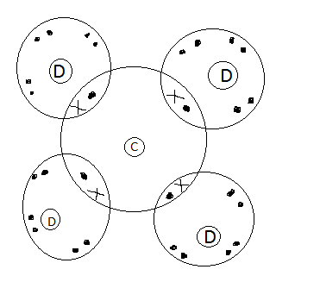√

f) B has more delocalized electrons√$\frac{1}{2}$ than A hence has stronger metallic bond. √$\frac{1}{2}$ (1mk)
OR B has smaller atomic radius√$\frac{1}{2}$ hence stronger metallic bond√$\frac{1}{2}$

g) 2A_{(s)} + H₂O_{(l)} 2AOH_{(aq)} + H2_{(g) (1mk)} √
(Accept if actual symbols used,
award 0 if not balanced,
penalize half mark for wrong state symbol)
- (a) (i) Hydrogen gas (1mk) (strictly the name)

(ii) Ca (OH)₂ slightly soluble in water, √ only few OH⁻ are produced√$\frac{1}{2}$ in
solution. (1mk)

(iii) It is used for testing presence of CO₂. √ (1mk)
- Prepare ammonia √ (any one)

(b) (i) Step 2 - carbon (IV) oxide√$\frac{1}{2}$ (1/2mk)
Step 4 – Dilute HCL√$\frac{1}{2}$ (1/2 mk)
(ii) Ca (HCO₃)_{2(aq)} CaCO_{3(s)} + CO_{2(g)} + H₂O_{(l)} (1mk)

(iii) Add an aqueous solution of sulphuric (VI) acid/Na₂SO₄/K₂SO₄ (1mk)

- Filter to obtain CaSO₄ √
- Wash with distilled water√ and dry between filter papers√

3.
(a) P Hydrogen/nitrogen 1mk
Q Nitrogen /hydrogen 1mk
R Nitrogen (IV) oxide 1mk
S Water 1mk

b)
- Platinum – rhodium 1mk
- 4NH₃(g) + 5O₂(g) 4NO(g) + 6H₂O(g) √
2NO(g) + O2(g) 2NO2(g) √

- (i) NH₄NO₃√$\frac{1}{2}$ (REM = 80) √$\frac{1}{2}$
$\frac{28}{80} x 100$ √$\frac{1}{2}$= 35% √$\frac{1}{2}$

  - (ii) Lowers soil Ph
    - Increase soil acidity
    - Causes euthrophication
    - Pollution of water
(any one)

4. (i) – solid sodium chloride/rock salt
- Concentrated Sulphur (VI) acid
- (ii) Concentrated Sulphur (VI) acid(penalize formula)
(iii) – Grey iron powder turns to green iron (II) chloride (acc. Green solid formed)
(iv) HCl_{(g)} + Fe_{(s)} FeCl_{2(s)} + H_{2(g)} 1mk
(v) When in contact with ammonia gas, dense white fumes of ammonium chloride are formed 1mk
(vi) hydrogen gas √$\frac{1}{2}$
Mixture of hydrogen and air burns explosively√$\frac{1}{2}$
(vii) – to prevent sucking back in increasing surface area for dissolution
- (i) formula showing the simplest whole ratio in which atoms combine to form compound
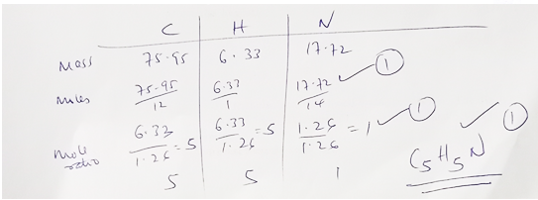
(ii) Formula showing the actual number of each kind of atoms present in molecule of the compound
b)
n(79)=237√$\frac{1}{2}$
237/79 = 3 √$\frac{1}{2}$
C₁₅H₁₅√1
6 (a) (i) A substance that burns in air to produce useful energy (1mk)

(ii) CH₃CH₂OH
RFM = 46√$\frac{1}{2}$

= $\frac{1368}{46} (√\frac{1}{2}) =29.74 kJ/g$ (√1mk)

(b) (i) ΔH = MCDJ

= 500 x 4.2 x 13 (1mk)
= 27,3005
= 27.3Kj 1mk
(penalize half mark for wrong units)

(ii) Mass of ethanol
120.5-119.5=1g (√ 1mk)
1g – 27.3kJ
46g – 46 x 27.3 ( √ 1mk)
1
= 1255 .8Jk
= -1255.8kJ/mol (1mk)(penalize half mark for missing –ve sign
Penalize fully for wrong units)

(iii) CH₃CH₂OH(g) + 3O₂₍g) 2CO₂g + 3H₂O ΔH = -1255.8 kJj/mol (√ 1mk)

(iv) heat loss to the surrounding (1mk)
- Error in measurements of volume and temperature (experiment errors)

(v) Heat change that occur when one mole of a substance burns completely in oxygen.
(√ 1mk)
7(a) (i) Methylpropanoate (√ 1mk)

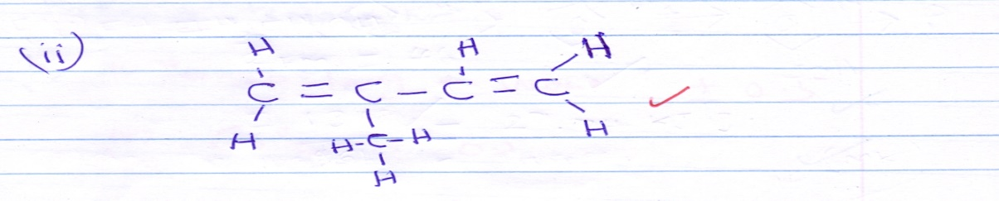

(b) (i) Photosynthesis (√ 1mk)

(ii) yeast (√ 1mk)

(iii) 2CH₃CH₂OH + 2Na 2CH₃CH₂ONa + H₂ (√ 1mk)

(iv) Oxidation (√ 1mk)

(v) sodium ethoxide (√ 1mk)

(vi) ? - (C₂H₄) = 56000
28n = 56000√
? = 2000√ (2mks)

(c) (i) concentrated sulphuric acid (√ 1mk)

(ii) 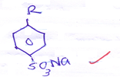(√ 1mk)

Sodium alkylbenzene sulphanoate (√ 1mk)

(iii) Does not form scum with hard water (√ 1mk)

- (a) The maximum mass of a solute that can dissolve in 100g of solvent (water) at a particular temperature to form saturated solution. (√ 1mk)

(b) (ii) 36.5g/100g of water $± 1$ (1mk)(Read from correct curve)

(iii) 60ºC $± 1$ (1mk)

(iv) 51.5 x 80 – 28.5 x 80 = 9.452g (√ 1mk)
151.5 (√ 1mk) 128.5 (√ 1mk)

(v) Solubility of g/100g of water at
Salt | 30ºC | 80ºC
X | 25 | 55
Y | 32.5 | 45

(√ 1mk)
(√ 1mk)

Crystal of y (√ 1mk)
40-32.5 = 7.5 (√ 1mk)

