Name: ………………………………………… Index No. …………………………………..
School: ……………………………………………. Candidate’s Sign. …………………………
Stream …………………………………… Date: ……………………………………….
233/1
CHEMISTRY
PAPER 1
AUGUST 2021
TIME: 2 HOURS

EAGLE JOINT EXAM

Kenya Certificate of Secondary Education (K.C.S.E.)

Chemistry
Paper 1

INSTRUCTIONS TO THE CANDIDATES:-

- Write your name and index number in the spaces provided.
- Answer all the questions in the spaces provided.
- Mathematical tables and electronic calculations may be used for calculators.
- All working must be clearly shown where necessary.

Questions | Maximum score | Candidates score
1- 28 | 80

This paper consists of 11 printed pages. Candidates should check to ascertain that all pages are printed as indicated and that no questions are missing.

1. Dry Carbon (II) oxide gas reacts with heated Copper (II) oxide as shown in the equation below:
CuO _{(s)} + CO _{(g)} Cu _{(s)} + CO_{2 (g)}
(a) State one observation made (1mk)
……………………………………………………………………………………………………
(b) Name the process undergone by Copper (II) oxide (1mk)
……………………………………………………………………………………………………
(c) Give a reason for your answer in (b) above (1mk)
……………………………………………………………………………………………………
2. Briefly explain why water is not used to put off oil fires. (2mks)
……………………………………………………………………………………………………
……………………………………………………………………………………………………
3. Form 3 students of Kipsigis Girls High school set up the apparatus shown below to investigate the action of sunlight on chlorine water.
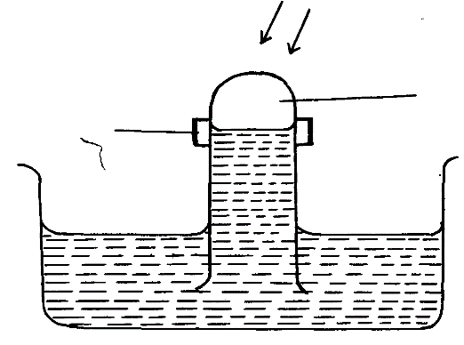
Chlorine water
Sunlight
Gas M
Clamp

(a) Identify gas M………………………………………………………………. (1mk)
(b) Write an equation to show how gas M is formed. (1mk)
……………………………………………………………………………………………………
(c) Heated iron can react with both chlorine gas and hydrogen chloride gas. Write equations for the reactions. (2mks)
……………………………………………………………………………………………………
……………………………………………………………………………………………………

4. The common drying agents such as concentrated Sulphuric (VI) acid are not used to dry ammonia gas;
(a) Explain why concentrated sulphuric (VI) acid is not a suitable drying agent. (2mks)
……………………………………………………………………………………………………
……………………………………………………………………………………………………
(b)Name a suitable drying agent for ammonia gas. (1mk)
……………………………………………………………………………………………………
5. Ethanol obtained from glucose can be converted to Ethene as shown below:-
C₆H₁₂O₆ C₂H₅OH C H₂ = CH₂
Step I Step II
Name the processes that take place in steps I and II (2mks)

Step I……………………………………………………………………………………….

Step II………………………………………………………………………………………
6. The diagrams below represent two allotropes of Sulphur. Study them and answer the questions which follow:-
Y
X

- Name the two allotropes labelled X and Y (2mks)
X……………………………………………………………………………………………

Y……………………………………………………………………………………………
(ii) Explain why a piece of burning magnesium continues to burn in a gas jar of Sulphur
(IV) Oxide (2mks)
……………………………………………………………………………………………………
……………………………………………………………………………………………………
……………………………………………………………………………………………………
……………………………………………………………………………………………………

7. The diagram below shows an experiment in which Copper (II) nitrate crystals are heated.
Study it and answer the questions that follow;
Gas W
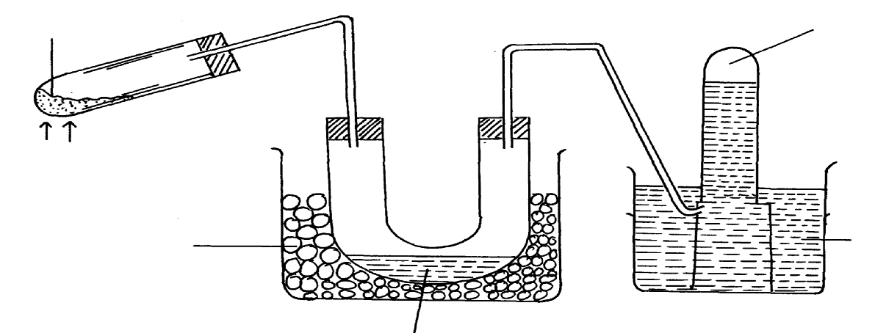
Powdered Copper (II) nitrate

Heat

Freezing
Mixture
Water

Liquid X

(a) Name liquid X and gas W (2mks)

Liquid X……….. ………………………………………………………………………….
Gas W……………………….……………………………………………………………...
(b) Write an equation for the reaction that takes place in the heated test tube. (1mk)
……………………………………………………………………………………………………
8. The diagram below shows a charcoal stove with different regions
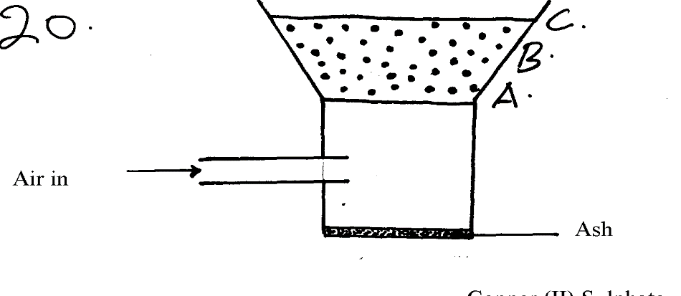

- Identify gas formed at region A (2mks)
……………………………………………………………………………………………………
- Write an equation for the formation of the product in region B (1mk)
……………………………………………………………………………………………………
- How would one avoid the production of the product at B? Give a reason for your answer (2mks)
………………………………………………………………………………………………………
9. Study the reaction below and answer the questions that follow
NH₃ _{(g)} + H₂O _{(l)} NH₄⁺ _{(aq)} + OH⁻_{(aq)}

- Define the term acid (1mk)

……………………………………………………………………………………………………
……………………………………………………………………………………………………
……………………………………………………………………………………………………

- Identify an acid in the above reaction, explain (2mks)

……………………………………………………………………………………………………
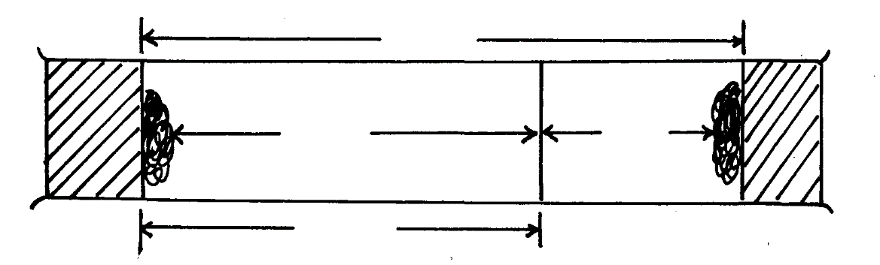
……………………………………………………………………………………………………
36cm
A
B
27cm
10. The figure below shows two gases A and B diffusing from two opposite ends 18 seconds after the experiment

- Which of the gases has a higher density? (1mk)

……………………………………………………………………………………………………

- Given that the molecular mass of gas A is 17, calculate the molecular mass of B (2mks)

……………………………………………………………………………………………………
……………………………………………………………………………………………………
……………………………………………………………………………………………………
……………………………………………………………………………………………………

11. Study the table below showing solubility of a salt;
Temperature ºC | Solubility g/100g water
0 | 28
30 | 38
70 | 48
100 | 60
What would happen if a sample of a saturated solution of the salt at 70ºC is cooled to 30ºC? Explain (2mks)
……………………………………………………………………………………………………………….…………………………………………………………………………………………...…………………….…………………………………………………………………………………...………………………………………………………………………………………………………
12. Lead (II) ions react with iodide ions according to the equation;
Pb²⁺_{(aq)} + 2I⁻_{(aq)} PbI_{2(s)}
300cm³ of a 0.1m solution of iodide ions was added to a solution containing excess lead II ions.
Calculate the mass in grams of lead II iodide formed (Pb = 207, I = 127) (3mks)

……………………………………………………………………………………………………………….…………………………………………………………………………………………...…………………….…………………………………………………………………………………...………………………………………………………………………………………………………
13. (a) Define efflorescence. (1mk)
……………………………………………………………………………………………………………….……………………………………………………………………………………………
(b) Give one substance which is efflorescence (1mk)
………………………………………………………………………………………………………
14. Sodium chloride dissolves in water to form a neutral solution while iron (III) chloride forms an acidic solution. Explain (2mks)
……………………………………………………………………………………………………………….……………………………………………………………………………………………..

15. Study the diagram below and use it to answer the questions that follow:-

Lead (II) bromide
A
B
Heat

(a) Show the flow of electrons on the diagram (1mk)
(b) Name the product formed at the anode (1mk)

……….……………………………………………………………………………………………..

- Write the electrode half equation of reaction at electrode A (1mk)
……….……………………………………………………………………………………………
16. Describe how you would prepare a dry sample of Lead Chloride in the laboratory starting with Lead Nitrate solid. (3mks)
……………………………………………………………………………………………………
……………………………………………………………………………………………………
……………………………………………………………………………………………………
……………………………………………………………………………………………………
……………………………………………………………………………………………………
……………………………………………………………………………………………………
17. 25cm³ of a solution of hydrochloric acid dissolved 3g of Magnesium ribbon. Calculate the concentration f hydrochloric acid in Moldm⁻³ (Mg = 24). (3mks)
……………………………………………………………………………………………………
……………………………………………………………………………………………………
……………………………………………………………………………………………………
……………………………………………………………………………………………………
………………………………………………………………………………………………………
18. Study the arrangement below and answer the questions that follow:
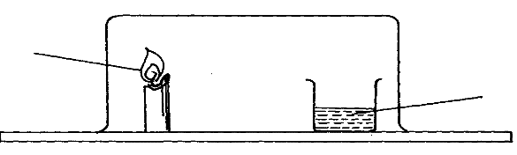
Calcium Hydroxide
Lighted candle

Explain what will be observed after sometime. (2mks)
……………………………………………………………………………………………………
……………………………………………………………………………………………………
……………………………………………………………………………………………………
23
11
22
11
19 . In a sample, the percentage of X is 60% and X is 40%.
(a) Calculate the relative atomic mass of X. (2mks)
……………………………………………………………………………………………………
……………………………………………………………………………………………………
……………………………………………………………………………………………………
20. Chlorine was bubbled through a solution of Potassium iodide.
(a) State the observation that would be made. (1mk)
………………………………………………………………………………………………………
(c)Write the ionic equation for the reaction that takes place. (1mk)
………………………………………………………………………………………………………
21. Four solutions A, B, C and D of pH 7, 2, 4.5 and 13 respectively were each reacted with Calcium carbonate. In which of the solutions would effervescence be observed. Explain each case. (3mks)
……………………………………………………………………………………………………
……………………………………………………………………………………………………
……………………………………………………………………………………………………
……………………………………………………………………………………………………

22. Cardboard X and Y were placed in different zones of a Bunsen burner flame.
Cardboard
Explain the difference between X and Y. (2mks)
………………………………………………………………………………………………………………………………………………………………………………………………………………
……………………………………………………………………………………………………………………………………………………………………………………………………………..
23. (a) What observation can be made when concentrated Sulphuric (VI) acid is added to the following substance:
(i) Sugar………………………………………………………………………… (1mk)
(ii) Copper metal ……………………………………………………………….. (1mk)
(b) Write the equation for the reaction of concentrated Sulphuric (VI) acid with copper metal. (1mk)
……………………………………………………………………………………………………

24. The table below shows the electrical conductivity of substance A, B and C
Substance | Solid state | Molten state | Aqueous solution
A | Conducts | Conducts | Not soluble
B | Doesn’t conduct | Conducts | Conducts
C | Doesn’t conduct | Doesn’t conduct | Not soluble

- Which one of the substance is likely to be diamond? (1mk)

……………………………………………………………………………………………………
(b) Which of the substances is likely to be sodium chloride? Explain (2mks)

……………………………………………………………………………………………………
……………………………………………………………………………………………………

25. Ammonium ion is formed when ammonia combines with hydrogen ion;
(a) Using dots (.) and cross (x) diagram, show how ammonium ion is formed. (N =7, H = 1). (2mks)
……………………………………………………………………………………………………
……………………………………………………………………………………………………
……………………………………………………………………………………………………
……………………………………………………………………………………………………
……………………………………………………………………………………………………
……………………………………………………………………………………………………
(b) State the types of bonds formed in (a) above. (1mk)
……………………………………………………………………………………………………
26. (a) Name the class to which the following cleansing agents belong:- (2mks)

(i) …………………………………………………………………………
R – COONa⁺

(ii) …………………………………………………………..
R – O-SO₃ Na
O

- Which cleaning agent above is not environmental friendly? Explain (2mks)

……………………………………………………………………………………………………

……………………………………………………………………………………………………

27. A solution of hydrogen chloride gas in methylbenzene has no effect on calcium carbonate. A solution of hydrogen chloride in water reacts with calcium carbonate to produce a gas. Explain (3mks)

……………………………………………………………………………………………………

……………………………………………………………………………………………………

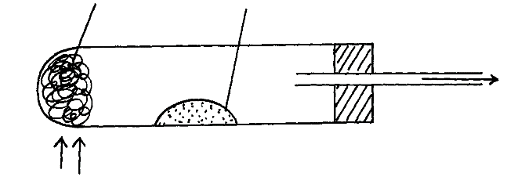
28. The diagram below represents set-up that was used to react Magnesium with steam. Study it answer the questions that follow;
Heat Heat
Wet sand
Magnesium
Gas

(a) Explain why it is advisable to heat first wet sand before heating magnesium (1mk)
……………………………………………………………………………………………………

……………………………………………………………………………………………………
(b) Write an equation for the reaction that takes place. (1mk)
……………………………………………………………………………………………………
(b) Why would it not be advisable to use Potassium in place of magnesium in the above set up? (1mk)
……………………………………………………………………………………………………

