FORM FOUR END OF TERM TWO EXAMINATION

233/2 CHEMISTRY PAPER 2
TIME: 2 Hours
Name: ………………………………………....…… Adm No: ……….……
Class: ………………Candidate’s Signature: …….……Date: …..…

INSTRUCTIONS TO CANDIDATES
- Write your name, class and admission number in the spaces provided above.
- Answer all the questions in the spaces provided in the questions paper.
- Mathematical tables and silent electronic calculators may be used.
- All working must be shown where necessary.

For Examiners Use Only
Question | Maximum score | Candidates score
1 | 10
2 | 11
3 | 14
4 | 10
5 | 12
6 | 11
7 | 12
TOTAL 80

This paper consists of 14 printed pages Check the Question paper to ensure that all pages are printed as indicated and no question are missing.

1. The figure below represents trends of some properties of period three elements. Study it answer the questions that follow.

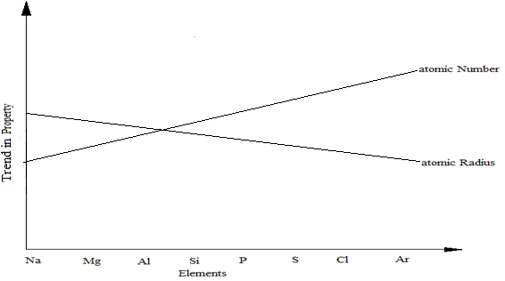

a). Explain the trends shown by the atomic numbers and the atomic radii
i). Atomic number (1 mark)
........................................................................................................................................................................................................................................................................................................................................................................
ii). Atomic radii (2 marks)
........................................................................................................................................................................................................................................................................................................................................................................
b). On the same axes, sketch the trend of reactivity across the period (1mark)

c). Write down the electronic configuration of phosphorous and sulphur in the following compounds
i). H₃PO₄ (P=15) (1 mark)
........................................................................................................................................................................................................................................................................................................................................................................

ii). Na₂S₂O₃ (S=16) (1 mark)
........................................................................................................................................................................................................................................................................................................................................................................
d). i). One of the elements given in the figure above is stored under water.
Identify the element and give a reason as to why it is stored under water (1 mark)
........................................................................................................................................................................................................................................................................................................................................................................
ii). State one use of aluminium that can be associated with its malleability.
(1mark)
........................................................................................................................................................................................................................................................................................................................................................................
e). Explain the observation that would be made if the chloride of Phosphorous is exposed to moist air. (2 marks)
............................................................................................................................................................................................................................................................................................................................................................................................................

2. a). Sulphur is extracted from sulphur beds below the earth’s surface. Super-heated
water is pumped down a pipe into the sulphur beds.

- What is super-heated water and how is it obtained? (2marks)

………………………………………………………………………………….

……………………………………………………………………………….....

………………………………………………………………………………….

- Why does the water used here have to be superheated, and not use boiling water? (1mark)

………………………………………………………………………………….

…………………………………………………………………………………..

- When molten sulphur is pumped to the surface, it solidifies. Which allotrope of sulphur forms first? (1mark)

……………………………………………………………………………………………………………………………………………………………………
- Name the form of sulphur obtained when liquid sulphur is poured into a beaker of cold water (1mark)

…………………………………………………………………………………..
…………………………………………………………………………………..
b) The diagram below represents a set up that can be used for electrolysis of aqueous
copper (II) sulphate. Use it to answer the questions that follow.

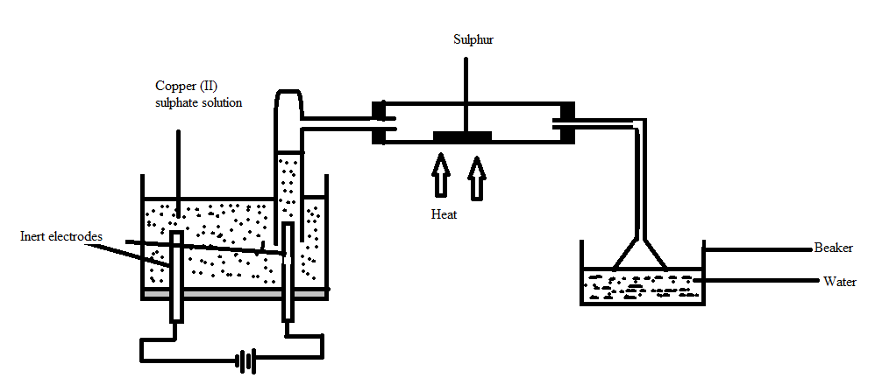

- What do you understand by the term inert electrode? (1mark)

…………………………………………………………………………………..

- What is the purpose of the filter funnel? (1mark)

…………………………………………………………………………………..

- Explain what happens to the pH of the:
- Water in the beaker. (1mark)
…………………………………………………………………………

…………………………………………………………………………..

- Copper (II) sulphate solution (1mark)
……………………………………………………………………………………………………………………………………………………
- Write ionic equation for the:
- Oxidation reaction (1mark)
…………………………………………………………………………..
…………………………………………………………………………..
- Reduction reaction, in above set up. (1mark)
…………………………………………………………………………..
…………………………………………………………………………..

3. a). (i) Define the term ‘molar enthalpy of formation of a compound;
(1mark)
………………………………………………………………………………………………………………………………………………………………

- Calculate the molar enthalpy of formation of ethane using the following information:

C₂H_{6(g)} + $\frac{ 7 }{2}$O_{2(g)} 2CO_{2(g)} + 3H₂O_{(l)}, ∆H_{f}^{ϴ} = -1561 kJ/mole

C_{(s)} + O_{2(g)} CO_{2(g)} , ∆H_{f}^{ϴ} = -394 kJ/mole

H_{2(g)} + $\frac{1}{2}$O_{2(g)} H₂O_{(l)} , ∆H_{f}^{ϴ}= -286 kJ/mole

…………………………………………………………………………………………

…………………………………………………………………………………………

…………………………………………………………………………………………

………………………………………………………………………………………….
(3marks)

b) Study the reactions below and answer the questions that follow:
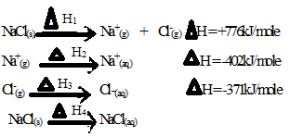

- State the name given to :

a) ∆H₁ ……………………………………………………….(1mark)

b) ∆H₂ ………………………………………………………(1mark)

- Draw an energy cycle diagram illustrating the reactions above.
(2marks)

- Determine the value of H₄ (2marks)

………………………………………………………………………………

………………………………………………………………………………

………………………………………………………………………………

- Joy placed 100cm³ of 0.1M CuSO_{4(aq)} in a plastic beaker , covered it with some cotton wool and recorded its initial temperature. She then added excess zinc powder to the solution and stirred it using a stirrer. She noted down the following data:
Initial temperature 20.5ºC
Final temperature 30.0ºC
Density of solution 1.0g/cm³
Specific heat capacity of water 4200J/kg/k

- Apart from the temperature rise, state one other observation made while she was stirring. (1mark)
………………………………………………………………………………………………………………………………………………
- Calculate the heat change for the reaction above (1mark)
………………………………………………………………………………………………………………………………………………
- Determine the number of moles of ions of copper reacting
(1mark)
………………………………………………………………………………………………………………………………………………
- Hence, determine the molar enthalpy of the reaction. (1mark)

………………………………………………………………………………………………………………………………………………

4. a) An experiment was set up to investigate the effect of temperature on the rate of
reaction between 1.0g calcium carbonate and excess hydrochloric acid. The temperature was varied from15⁰C, 20⁰C and 25⁰C; and data obtained for the 3 sets of reagents.

- Sketch a graph of volume of carbon (IV) oxide gas produced against time for each temperature on the axes below. Label each graph with corresponding temperature. Consider all gas volumes measured at same temperature and pressure. (2 marks)

ii) Explain the shape of graphs you’ve drawn in (a) above. (2marks)
………………………………………………………………………………………………………………………………………………………………………………………………………………………………………………

b) In an experiment, equal amounts of magnesium powder were placed into test tube 1 and 2 as shown below.
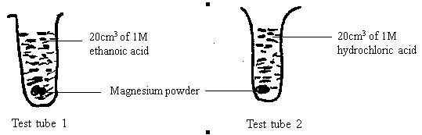

i) Explain why the magnesium powder in test tube 2 gets used up faster than
that in test tube 1. (3 marks)
………………………………………………………………………………………………………………………………………………………………………………………………………………………………………………………………………………………………………………………………
ii) Other than concentration, state one factor that affects the rate of a reaction. (1 mark)
………………………………………………………………………………………………………………………………………………………………………………………………………………………………………………

c) Consider the equilibrium of the reaction below

A(g) + B(g) D(I) + E(g); DH = -ve.

In which direction will the equilibrium position shift as a result of each of the following changes? Explain.

i) Raising the temperature (1 mark)
………………………………………………………………………………………………………………………………………………………………………………

ii) Reducing the volume of the container. (1mark)
……………………………………………………………………………………………………………………………………………………………………………………………………………………………………………………………………

5. (a) Work out the oxidation number of nitrogen in ${NO}_{3}^{-}$ ? (1 mark)

(b) Study the standard electrode potentials below and answer the questions that follow. (The letters do not represent the actual symbols of the elements.

${A^{+}}_{(aq)}+e^{-} A_{(s)} E^{ϑ}=-2.92V$
${B^{+}}_{(aq)}+e^{-} B_{(s)} E^{ϑ}=+0.52V$
${C^{+}}_{(aq)}+e^{-} \frac{1}{2}C_{2(g)} { E}^{ϑ}=0.00V$
$\frac{1}{2}D_{2(g)}+e^{- } {D^{-}}_{(aq)} E^{ϑ}=+1.36V$
${E^{2+}}_{(aq)}+{2e}^{-} E_{(s)} E^{ϑ}=-0.44V$
(i) With reasons, identify the;
I Strongest reducing agent. (1 mark)
……………………………………………………………………………………………………
II the reference electrode. (1 mark)
……………………………………………………………………………………………………
(ii) Write the overall equation for the reaction that will be obtained when half cells of B and E are connected. (1 mark)

…………………………………………………………………………………………………….
…………………………………………………………………………………………………..

(iv) Explain whether the reaction represented below can take place.
(2 marks)
${{2A}^{+}}_{(aq)}+E_{(s)} {2A}_{(s)}+{E^{2+}}_{(aq)}$

(v) Draw the cell diagram obtained when the half cells in (ii) are combined.
(2 marks)

(c) In an experiment to electroplate a copper spoon with silver, a current of 0.5A was passed for 18 minutes.

(i) Sketch a diagram to show how the experiment was carried out. (2 marks)

(ii) Calculate the amount of silver deposited on the spoon.
(IF = 96500C, Ag = 108) (2 marks)

- The process of extraction of Aluminium is summarized as below:

Ore X
Residue
Solution R
Aluminium Oxide
Molten Aluminium Oxide

Molten Aluminium

Step I
Substance
Q Step II Step III

Substance S

  - (i) Write the formula of the main Ore X which is used in extraction of
Aluminium. (1 mark)
- Name:
  - The main residue formed after filtration in step I. (1 mark)
………………………………………………………………………………………………………………………………………………
  - Substance Q. (1 mark)
………………………………………………………………………………………………………………………………………………

- How is the sodium Aluminate in Solution R separated from the impurity
silicon (iv) oxide. (2 marks) ………………………………………………………………………………………………

- What is the purpose of addition of substance S in step III. Explain. (2 marks)
………………………………………………………………………………………………………………………………………………………………………………………………………………………………………………

  - (i) Explain why the Anode in extraction of Aluminium is replaced
periodically. (2 marks)
………………………………………………………………………………………………………………………………………………
(ii) Write an equation for the formation of Aluminium at the cathode.
(1 mark)
…………………………………………………………………………………………………………………………………………………….

  - Explain why Duralum an alloy of Aluminium is used in construction of aircraft
parts and car window frames. (1 mark)
………………………………………………………………………………………………………………………………………………………………………………

7.(a) Study the flow chart below and answer the questions that follow.

A
Ethanol
CH₃CH₂OH
Long chain alkane

Step II H_{2(g)} Ni_{(s)} Step 1 Step VI
C
CH₂ = CH₂
Step V
Polymerize

Step III HCl_{(g)} Step IV
B
CO_{2(g)} + H₂O_{(l)}

- Name the process taking place in step (I). (1mark)
…………………………………………………………………………………………………
- Describe a chemical test that can be carried out to show the identity of organic compound A. (2marks)

…………………………………………………………………………………………………………………….……………………………………………………………………………………………………………………..………………………………………………………………………………………….…………………………..………………………………………………………………………………
- Give the name of the following: (2marks)
  - A:…………………………………………………………………………………

  - B:…………………………………………………………………………………
- Give the structural formulae of substance C. (1mark)
………………………………………………………………………………………………………………………………………………………………………………………………………………………………………………………………………………………………………………
- Name the type of reaction that occurs in:
  - Step IV (2marks)
……………………………………………………………………………………

  - Step VI:

……………………………………………………………………………………
- Give the reagent and the condition necessary for step VI. (2marks)

Reagent:…………………………………………………………………………………………

Condition:……………………………………………………………………………………
- Give the systematic names of the following compounds:
  - CH₂CHCHCH₂CH₃ (1mark)
…………………………………………………………………………………………
  - CH C CH₃ (1mark)
…………………………………………………………………………………………

This is the last printed page

