**233/2 END OF TERM II CHEMISTRY**

**TIME: 2 Hours**

**Name**: ………MARKING SCHEME…………………**ADM** **No**: ……….……

**Class**: ………………**Candidate’s** **Signature**: …….……**Date**: …..….

**INSTRUCTIONS TO CANDIDATES**

1. Write your name, class and admission number in the spaces provided above.
2. Answer all the questions in the spaces provided in the questions paper.
3. Mathematical tables and silent electronic calculators may be used.
4. All working must be shown where necessary.

**For Examiners Use Only**

|  |  |  |
| --- | --- | --- |
| **Question** | **Maximum score** | **Candidates score** |
| **1** | **10** |  |
| **2** | **11** |  |
| **3** | **14** |  |
| **4** | **10** |  |
| **5** | **14** |  |
| **6** | **10** |  |
| **7** | **11** |  |
| **TOTAL 80** | |  |

***.***

1. a) i) Atomic number increases ; number of protons increase

ii) Atomic radius decreases / reduces; due to the additional protons // increase

in nuclear charge hence energy levels are pulled closer to the nuclear

b)



c) i) 2.8

ii) 2.8.4

1. i) P/Phosphorous ; cut off air// Prevent reaction with air// smoulders when exposed

to air

ii) Manufacture of aluminium sheets //aircraft parts// Aluminium foil// Reject

manufacture of Iron sheets.

1. White fumes are formed. The Chloride of phosphorous hydrolyses in air to form hydrogen chloride

2. a). i) - Is water that boils above boiling point.

- It is achieved by raising pressure of water

1. - To melt the sulphur.

- Boiling water is at 100oC while sulphur melts at 113oC

1. Monoclinic sulphur (stable at temperatures above 96oC)
2. Plastic sulphur

b) i) Electrode that serves only as a source or sink for electrons without playing

a chemical role in the electrode reaction

ii) To increase the surface area for dissolving of the gas.

iii) I. The pH lowers as SO2(g) formed dissolves in water forming H2SO3

which is acidic

II pH lowers as concentration of H+ increases due to deposition of cu2+ leaving H+ ions in solution

iv) I. 4OH-(aq) 2H2O(l) + O2(g) + 4e-

II. 4H+(aq) + 4e- 2H2(g)

3. a. (i) It is the energy released or absorbed when one mole of a compound is

formed from its constituent elements in their standard states

(ii) $∆Hfθ$

2C(s) + 3H2(g) C2H6(g)

H1=2(-394) H3= -1560kJmole-1

H2 =3(-286)

2CO2(g) + 3H2O(g)

Hf + H3 = 2H1 + 3H2

Hf = [2(-394) + 3(-286)- (1560)] = -86kJ/mole

I a) ∆H1 Enthalpy of lattice for NaCl(s) (1mark)

1. ∆H2 Enthalpy of hydration of Na+(g) (1mark)

II.

NaCl(s) + (aq) ∆H1=+776kJ/mole Na+(g) + Cl-(g)

∆H4 = ? ∆H2 = -402 ∆H3 = -307kJ/mole

Na+(aq) + Cl-(aq

III ∆H4 = ∆H1 + ∆H2 + ∆H3

∆H4 = +776 + (-402 + -371) = +3 kJ/mole

IV (i) - Colour of solution changes from blue to colourless

* A brown solid was deposited , etc

(ii) ∆H = m x c x ∆T

∆H = cm3 x 1.0 x 4200 $\frac{J}{kgK}$ x (30.0 - 20.5) K

∆H = -3990J

(iii) Number of moles = $\frac{o.1mole x 100.0 dm3}{1000.0 dm3}$ = 0.01 m0les

(iv) ∆Hmolar = = -399 kJ/mole

4. a) i)

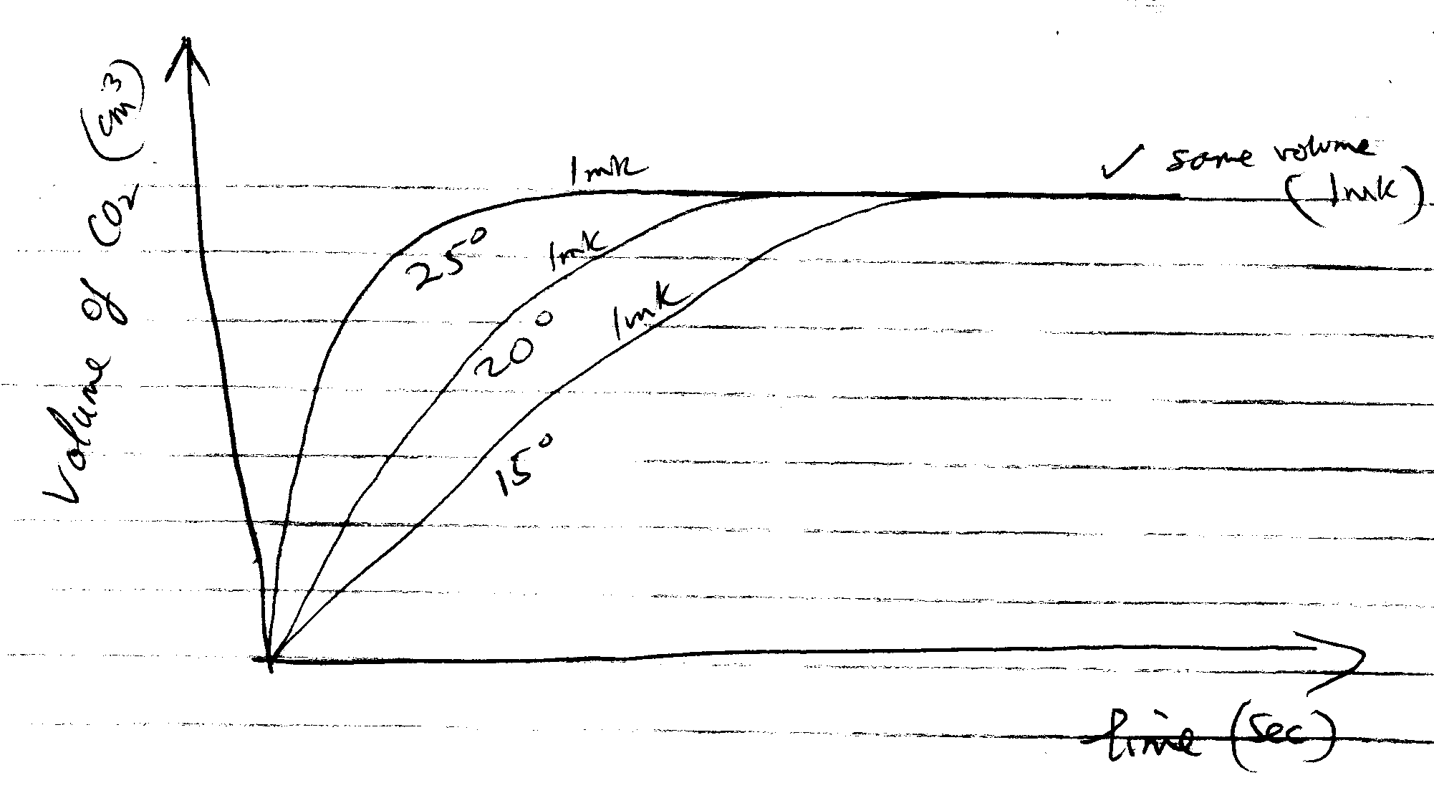

ii) Total volume of gas evolved is equal when excess acid was reacted with same mass of calcium carbonate – graph levels off in the end. (1mark)

The gradient of graph for 250C in greater showing greater rate of reaction at higher temperature. Increase in temperature increases the kinetic energy of particles causing more frequent and effective collisions w.t.t.e (1mark)

b) i) Hydrochloric acid completely dissociated in water producing a large

amount of H+ whereas ethanoic acid only partially dissociates in water releasing few H+ ions. In ethanoic acid solution there are few H+ available for displacement. W.t.t.e. (3marks)

ii) Temperature, pressure, surface area, catalyst, etc

*for any one – 1mark*

c) i) left/ backward

A(g) + B (g) D(I) + E(g) + heat

Increase in temperature means heat which is a product in this case. Equilibrium shift backwards to get rid of excess heat.

ii) Right / forward

The products formed occupy a smaller volume compared to reactants.

1. (a)X+-2(3)=-1

X=+6-1

X=+5

(b) (i) I A(s). can easily lose electrons/ most electropositive/most negative electrode potential.

IIC2. Has electrode potential of 0.00V

( ii) E(s) +2B+ 2B(s) +E2+ E= +0.96V

(iii) Reaction cannot take place. A is more reactive than E/ E cannot displace A.

Or has negative EMF.

(iv) 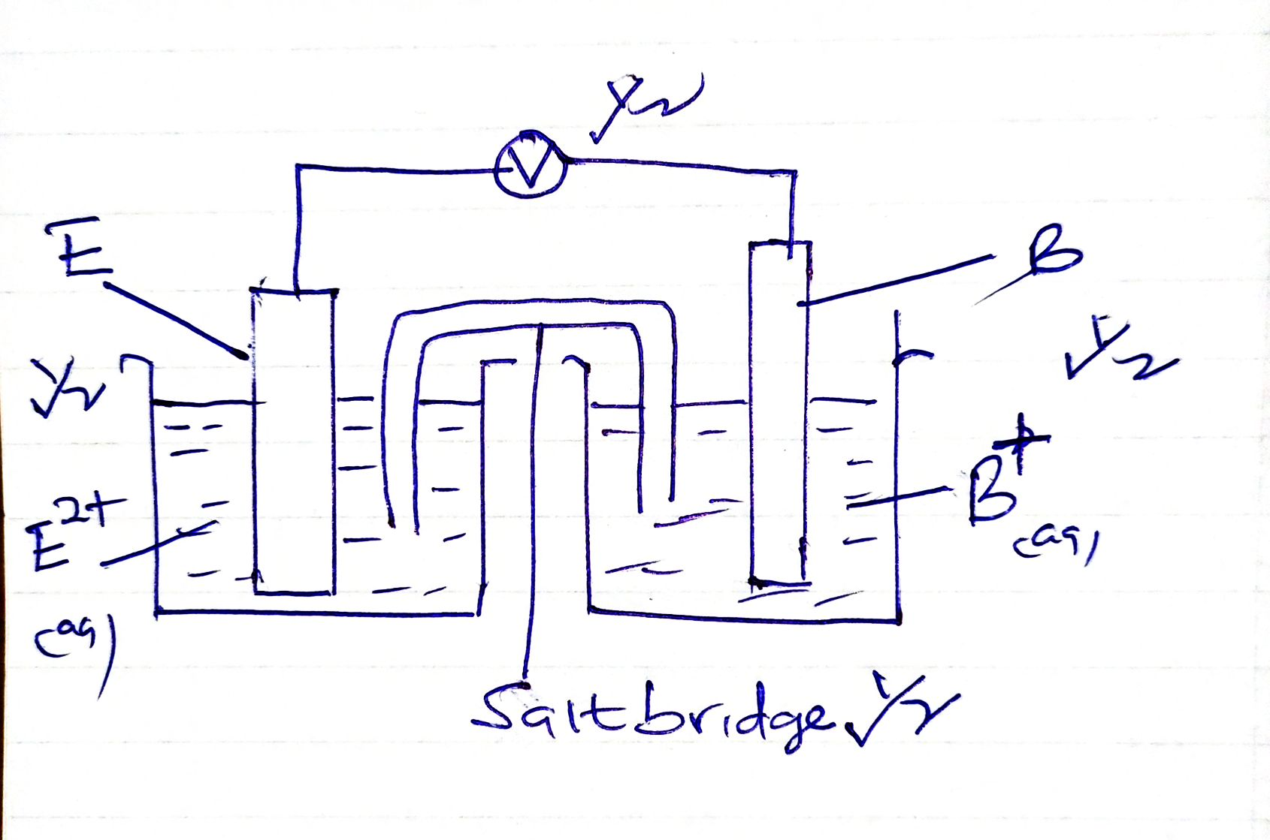

C*(i)*

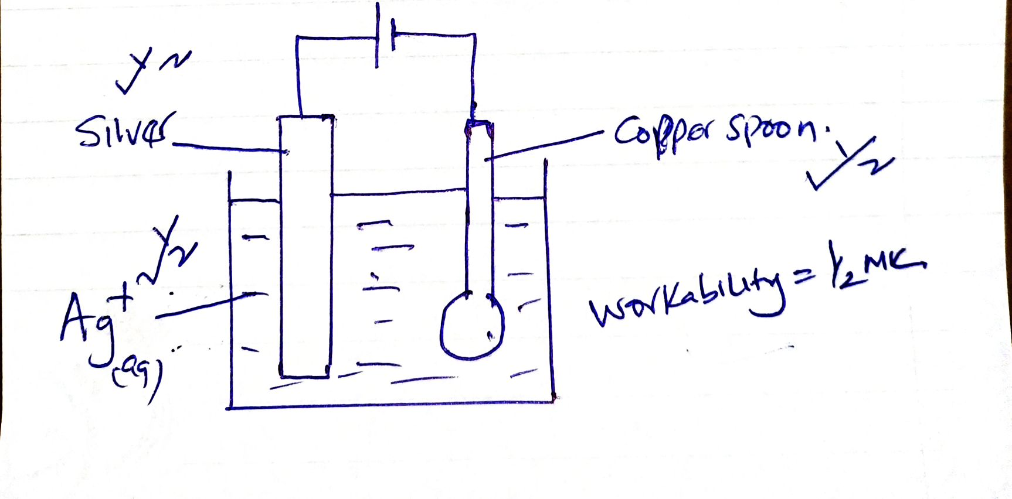

*8*

C(ii) 0.5× 18× 60=540C

96500C=108g

(108×540)÷ 96500= 0.644g

6. (a) (i) Al2O3. 2H2O√1 // Al2O3.H20

(ii) (a) Iron (iii) Oxide√1

(b) Concentrated Sodium√1 Hydroxide // (NaOH)

(iii) By bubbling carbon (iv) oxide gas through the filtrate to precipitate

Aluminum hydroxide which is the filtered off. √½

(iv) To lower M.p of Al2O3 from 20150C√1 to 8000C; which is economical√1

during electrolysis // to avoid Aluminium from vaporizing if electrolysis is

carried out at 20150C.

1. (i) Because the carbon anode is attacked√1 by oxygen liberated at high temperature

hence the anode gradually burns√1 away.

(ii) 4Al3+(l) + 12e- 4Al(s) √1

OR 4Al3+(l) + 3e- Al(s)

1. (i) It is light, √1 hard, strong and resistant to corrosion.

(ii) - making cooking vessels. √1

* + - * + Making overhead cables. √1
        + As a reducing agent in thermite process. (any 2x1 = 2mks)

7.(a) (i) Cracking√ 1

(ii) When the gas is burnt in air√ 1 it burns with a pale blue flame. √ 1

OR

Does not decolourize √ 1purple acidified potassium manganate (VII). √ 1

(iii) I. A. Ethane√ 1

II. B 1- Chloroethane√ 1

(iv)

H H

C C

H H n√ 1

(v) (i) Combustion√ 1

(ii) Dehydration√ 1

(vi) Conc. H2SO4√ 1

Temperature of 1700C. √ 1

(b) (i) Pent-2-ene√ 1

(ii) Prop-1-yne