BUNAMFAN CLUSTER EXAMINATION - 2022
Kenya Certificate of Secondary Education
446/1 – BUILDING CONSTRUCTION – Paper 1

June 2022 - 2 ½ hours
Name………………………………………Adm No……
Class…………… Date……………………………
INSTRUCTIONS TO CANDIDATES
(a) Write your and index number in the spaces provided above.
(b) Sign and write the date of examination in the spaces provided above.
©Candidates should have the following for this exam:.
- drawing paper size A3
- drawing instruments
-Scientific calculator
(d) This paper consists of two sections; A and B.
(e) Answer all questions in section A in the spaces provided.
(f) From section B, answer question 11 on A3 paper and any other three questions in the spaces provided.
(g) All dimensions are in millimeters unless otherwise stated.
(h) This paper consists of 11 printed pages.
(i) Candidates should check the question paper to ascertain that all the pages are printed as indicated and that no questions are missing.
(j) Candidates should answer the questions in English.
For Examiner’s Use Only
Section | Question | Maximum Score | Candidate’s Score
A | 1-10 | 40
B | 11 | 15
 | 12 | 15
 | 13 | 15
 | 14 | 15
 | 15 | 15
Total Score

SECTION A (40 marks)
Answer all the questions in this section in the spaces provided.
1. (a) Explain the term ‘peat ground’ (1 mark)
………………………………………………………………………………………………………………………………………………………………………………………………………………………………………………………………………. (b) Explain the meaning of “Building Construction.” (1 mark) ……………………………………………………………………………………………………………………………………………………………………………………………………………………………………………………………………...
2. (a) state the appropriate protective wear for each of the following parts of the body: (2 marks)
(i) Head
………………………………………………………………………………………
(ii) Feet
………………………………………………………………………………………
(iii) Eyes
………………………………………………………………………………………
(iv) Hands
………………………………………………………………………………………
(b) State three advantages of using PVC pipes for drainage works. (3 marks)
………………………………………………………………………………………………………………………………………………………………………………………………………………………………………………………………………
………………………………………………………………………………………
3. (a) State four factors that affect the type of trench support adopted. (2 marks)
………………………………………………………………………………………………………………………………………………………………………………………………………………………………………………………………………
……………………………………………………………………………………………………………………………………………………………………………………………………………………………………………………………………...

(b) Sketch and label a vertical section through a manhole. (4 marks)

4. (a) List four factors to consider before a system of painting is selected.(2 marks)
………………………………………………………………………………………………………………………………………………………………………………………………………………………………………………………………………
………………………………………………………………………………………………………………………………………………………………………………
(b) List four welfare services provided on a building site. (2 marks)
………………………………………………………………………………………………………………………………………………………………………………………………………………………………………………………………………
………………………………………………………………………………………
5. (a) List two methods of storing masonry tools. (1 mark)
………………………………………………………………………………………………………………………………………………………………………………

(b) Complete the following abbreviations as used in building. (2 marks)
(i) HC-………………………………………………………………………………………

(ii) DPM-………………………………………………………………………………………

(iii) RC- ………………………………………………………………………………………

(iv) GCI-………………………………………………………………………………………

6. (a) Name two occupational hazards that a mason may be exposed to. (2 marks) ………………………………………………………………………………………………………………………………………………………………………………
(b) State four regulations governing site investigation. (2 marks)
……………………………………………………………………………………………………………………………………………………………………………………………………………………………………………………………………...
………………………………………………………………………………………………………………………………………………………………………………
7. (a) State why sub-soil drainage is necessary in a building site (give 4).
(2 marks)

………………………………………………………………………………………………………………………………………………………………………………………………………………………………………………………………………
………………………………………………………………………………………………………………………………………………………………………………
(b) State two functions of a road kerb. (2 marks)
……………………………………………………………………………………………………………………………………………………………………………………………………………………………………………………………………….

8. (a) Briefly explain four methods of curing freshly laid concrete. (2 marks)
………………………………………………………………………………………………………………………………………………………………………………………………………………………………………………………………………
………………………………………………………………………………………………………………………………………………………………………………
(b) State two advantages of short bore pile foundation. (2 marks)
………………………………………………………………………………………………………………………………………………………………………………………………………………………………………………………………………
………………………………………………………………………………………
9. (a) State three steps in stone dressing. (2 marks)
………………………………………………………………………………………………………………………………………………………………………………………………………………………………………………………………………
………………………………………………………………………………………
(b) State four places where vertical damp-proof courses are used. (2marks)
……………………………………………………………………………………………………………………………………………………………………………………………………………………………………………………………………….
………………………………………………………………………………………………………………………………………………………………………………………………………………………………………………………………………
10. (a) State any two defaults of a ball-valve that would necessitate continuous flow of water. (2 marks)
……………………………………………………………………………………………………………………………………………………………………………………………………………………………………………………………………….
………………………………………………………………………………………

(b) ) State any four barriers to the trenches. (2 marks)

……………………………………………………………………………………………………………………………………………………………………………………………………………………………………………………………………….
………………………………………………………………………………………………………………………………………………………………………………
………………………………………………………………………………………………………………………………………………………………………………………………………………………………………………………………………
………………………………………………………………………………………

SECTION B (60 marks)
Answer question 11 on the A3 paper provided and any other three questions from this section in the space provided. Candidates are advised to spend not more than 25 minutes on question 11.
11. Figure 4 shows a pictorial drawing of a shaped block.
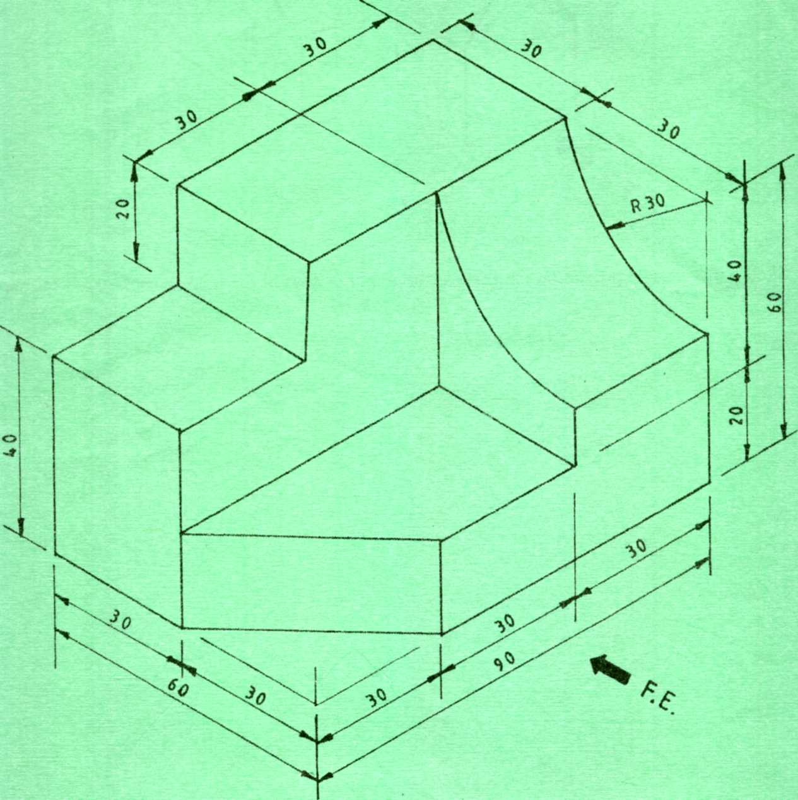Fig. 4
To a scale of 1:1, draw three orthographic views of the block in 3rd angle projection. Insert six
dimensions. (15 marks)

12. (a)Using a labeled vertical cross sectional sketch, show the damp proof details provided on a parapet wall and roof covered with iron sheets. (8 marks)

(b) State four factors to be considered when choosing a type of floor finish.
(4 marks)
………………………………………………………………………………………………………………………………………………………………………………………………………………………………………………………………………
………………………………………………………………………………………………………………………………………………………………………………………………………………………………………………………………………
(c) Outline three basic water treatment stages. (3 marks)
……………………………………………………………………………………………………………………………………………………………………………………………………………………………………………………………………...
………………………………………………………………………………………

13. (a) Outline the procedure of fixing tresses into position to form a roof.
(5 marks)
………………………………………………………………………………………………………………………………………………………………………………………………………………………………………………………………………
………………………………………………………………………………………………………………………………………………………………………………
(b) ) Sketch a putlog scaffold and explain how it is assembled. (10 marks)
………………………………………………………………………………………………………………………………………………………………………………………………………………………………………………………………………
……………………………………………………………………………………………………………………………………………………………………………………………………………………………………………………………………….
………………………………………………………………………………………………………………………………………………………………………………

14. (a) State five functional requirements of masonry walls in a building.(5 marks)
………………………………………………………………………………………………………………………………………………………………………………………………………………………………………………………………………
……………………………………………………………………………………………………………………………………………………………………………………………………………………………………………………………………….
(b) Outline the procedure for the construction of timber wall framing. (5 marks)
………………………………………………………………………………………………………………………………………………………………………………………………………………………………………………………………………
……………………………………………………………………………………………………………………………………………………………………………………………………………………………………………………………………...
………………………………………………………………………………………
(c) Sketch and label a raft foundation. (5 marks)

15. (a) . Sketch a longitudinal section through reinforced concrete lintel. (5 marks)

(b) State three properties (qualities) of good building mortar. (3 marks)
………………………………………………………………………………………………………………………………………………………………………………………………………………………………………………………………………
………………………………………………………………………………………
(c) Give four functional requirements of foundations. (4 marks)
……………………………………………………………………………………………………………………………………………………………………………………………………………………………………………………………………..
………………………………………………………………………………………………………………………………………………………………………………
(d) State three advantages of air seasoning. (3 marks)
………………………………………………………………………………………………………………………………………………………………………………………………………………………………………………………………………
………………………………………………………………………………………

THIS IS THE LAST PRINTED PAGE

