MARKING SCHEME

BUNAMFAN CLUSTER EXAM
BUILDING CONSTRUCTION
PAPER 1 446/1 2022
2 ½ Hours

INSTRUCTIONS TO CANDIDATES
(a) Write your and index number in the spaces provided above.
(b) Sign and write the date of examination in the spaces provided above.
©Candidates should have the following for this exam:.
- drawing paper size A3
- drawing instruments
-Scientific calculator
(d) This paper consists of two sections; A and B.
(e) Answer all questions in section A in the spaces provided.
(f) From section B, answer question 11 on A3 paper and any other three questions in the spaces provided.
(g) All dimensions are in millimeters unless otherwise stated.
(h) This paper consists of 11 printed pages.
(i) Candidates should check the question paper to ascertain that all the pages are printed as indicated and that no questions are missing.
(j) Candidates should answer the questions in English.
For Examiner’s Use Only
Section | Question | Maximum Score | Candidate’s Score
A | 1-10 | 40
B | 11 | 15
 | 12 | 15
 | 13 | 15
 | 14 | 15
 | 15 | 15
Total Score

SECTION A (40 marks)
Answer all the questions in this section in the spaces provided.
1. (a) Explain the term ‘peat ground’ (1 mark)
This is a type of ground that is made of decomposed vegetation.
(b) Explain the meaning of “Building Construction”
2. (a) state the appropriate protective wear for each of the following parts of the body: (2 marks)
(i) Head
(ii) Feet
(iii) Eyes
(iv) Hands
(Any 4 x ½ =2 marks)
(b) State three advantages of using PVC pipes for drainage works. (3 marks)
(3x 1 =3 marks)
3. (a) State four factors that affect the type of trench support adopted. (2 marks)
(i) Safety of the workers.
(ii) Type of work to be carried out.
(iii) Prevailing weather conditions.
(iv) Presence of ground water.
(v) Vibrations from traffic, railways.
(vi) Length of time trench is likely to remain open.
(vii) The nature of the ground – angle of repose

(Any 4 x ½ =2marks)

(b) Sketch and label a vertical section through a manhole. (4 marks)
Sketch=2marks
Labels 4x ½ =2marks
Total=4marks
4. (a) List four factors to consider before a system of painting is selected.(2 marks)
- Cost
- Type of surface to be painted
- Type of finish desired.
- Area to be painted (exposed or covered)
(Any 4x ½ = 2 marks)
(b) List four welfare services provided on a building site. (2 marks)
- Security
- Insurance
- First aid / medical /health
- Safety (personal)
- Transport
- Communication
(Any 4 x ½ = 2 marks)

5. (a) List two methods of storing masonry tools. (2marks)
(i) Use of tool crib
(ii) Use of tool store
(iii) Use of tool box
(b) Complete the following abbreviations as used in building. (2 marks)
(i) HC-hardcore
(ii) DPM-damp proof membrane
(iii) RC- reinforced concrete
(iv) GCI- galvanized corrugated iron
(Correct definition 4x ½ =2 marks)
6. (a) Name two occupational hazards that a mason may be exposed to. (2 marks)
(i) Inhaling of dust particles of both cement and lime.
(ii) Collapsing buildings.
(iii) Falling objects.
(iv) Scaling of high heights.
(Any 2 x 1 =2 marks)
(b) State four regulations governing site investigation. (2 marks)
(i) Position of building lines.
(ii) Provision of access roads.
(iii) Erection of hoarding.
(iv) Precautions while demolishing.
(v) Damage to streets.
(vi) Closing and obstruction of streets
(vii) Disposal of rain water from the site.
(Any 4 x ½ =2 marks)
7. (a) State why sub-soil drainage is necessary in a building site (give 4). (2marks)
(i) To avoid surface flooding.
(ii) To increase the stability of the ground.
(iii) To avoid dampness in basement.
(iv) To reduce humidity in the immediate vicinity of the building.
(v) To improve the workability of the soil for agricultural purposes.
(Any 4 x ½ =2 marks)

(b) State two functions of a road kerb. (2marks)
(i) To resist lateral thrust of the carriage way.
(ii) To define carriage way limits.
(iii) To direct the flow of surface water to gullies.
(iv) To support and protect footpaths and verges.
(Any 2 x ½ =1 mark)

8. (a) Briefly explain four methods of curing freshly laid concrete. (2 marks)
(i) Providing shades.
(ii) Covering the surface with hessian mats or gunny bags.
(iii) Sprinkling water on the surface.
(iv) Ponding
(v)Membrane curing
(vi) Steam curing
(vii) Chemical application (any 4x ½ = 2 marks)
(b) State two advantages of short bore pile foundation. (2 marks)
(i) Cleaning site owing to the reduced amount of spoil which is excavated.
(ii) Greater speed of construction especially if the holes bored by mechanical means.
(iii) Work can proceed when the weather makes it difficult for normal excavation of trenches.
(Any 2 x ½ =1mark)
9. a) State three steps in stone dressing. (2 marks)
(i) Selecting the stone with the correct measurements
(ii) Cutting the stone to the required size
(iii) Cutting the marginal draft
(iv) Dressing the stone to the required size and shape.

(b) State four places where vertical damp-proof courses are used. (2marks)
(i) Reveals or doors and window openings.
(ii) Retaining walls.
(iii) Internal faces of walls enclosing laundry and dry cleaning areas.
(iv) On tanking to basements.
(Any 4 x ½ = 2 marks)

10. (a) State any two defaults of a ball-valve that would necessitate continuous flow of water. (2 marks)
(i) Punctured ball.-lever arm off the valve.
(ii)Lever arm stuck in open position.
(iii) Lever arm.
(Any 2x 1=2 marks) (b) State any four barriers to the trenches. (2 marks)
(i) Making use of excavation soil
(ii) Close boarding
(iii) Continuous nails
(iv) Wooden face
(v) Empty drum
(vi) Timber nails
(Any 4 x ½ = 2marks)

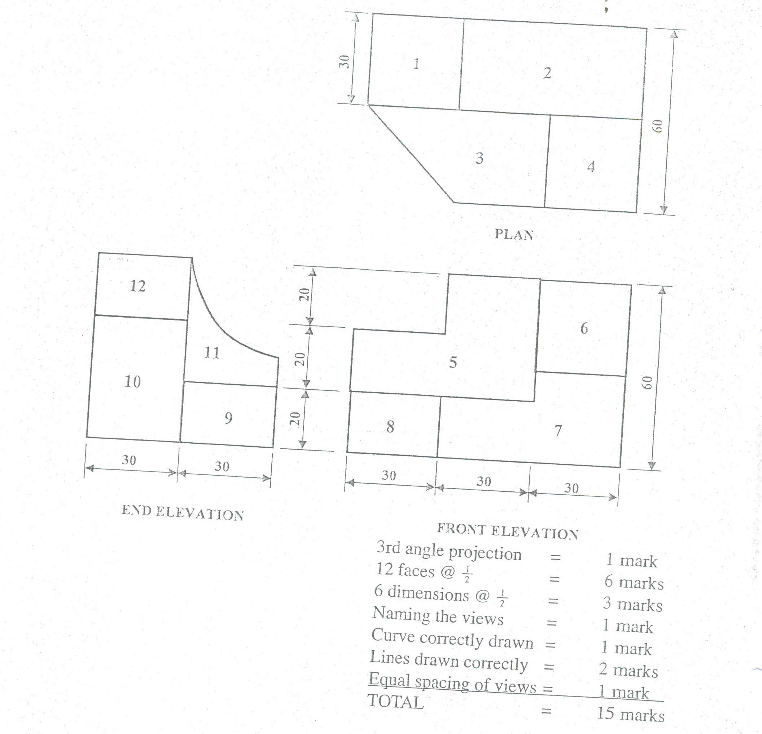
11.

12. (a)Using a labeled vertical cross sectional sketch, show the damp proof details provided on a parapet wall and roof covered with iron sheets. (8 marks)

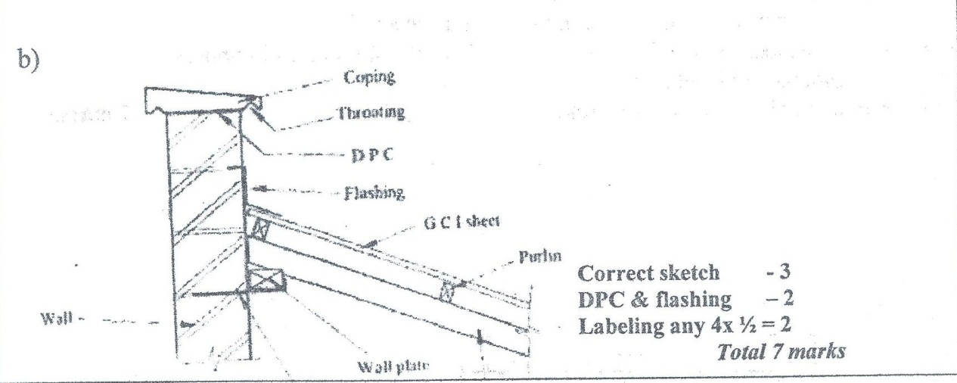

(b) State four factors to be considered when choosing a type of floor finish.
(4 marks)
(i) Use of floor area
(ii) Cleanliness required
(iii) Availability of materials
(iii) Cost of materials
(iv) Back ground
(v)Tear and ware
(vi) Surface protection
(vi) Repair and maintenance
(vii) Cost
(c) Outline three basic water treatment stages. (3 marks)
(i) Sedimentation
(ii) Filtration
(iii) Chlorination

13. (a) Outline the procedure of fixing tresses into position to form a roof.
(5 marks)
- Mark the position of the truss
- Place the trusses in the marked positions
- Fix the end trusses plumb
- Brace the trusses
- Tie the strings for alignment in order to align the remaining trusses into position
(vi) Fix the intermediate trusses into position with appropriate braces as you maintain the plumpness
(b) ) Sketch a putlog scaffold and explain how it is assembled (10 marks)
(i) The sole plate is placed on a relatively level ground.
(ii) Base plates are placed on top of the sole plate.
(iii) The standards are erected vertically on the top of the base plate.
(iv)The ledgers are fixed across the standard and secured tightly with strong ropes.
(v) Put logs are supported on ledgers at each standard on one end while the other supported by the wall.
(vii) Scaffold boards are placed on the put logs.
(viii) Fix a toe board.
(ix) Finally a guard rail is fixed at least 1m height.

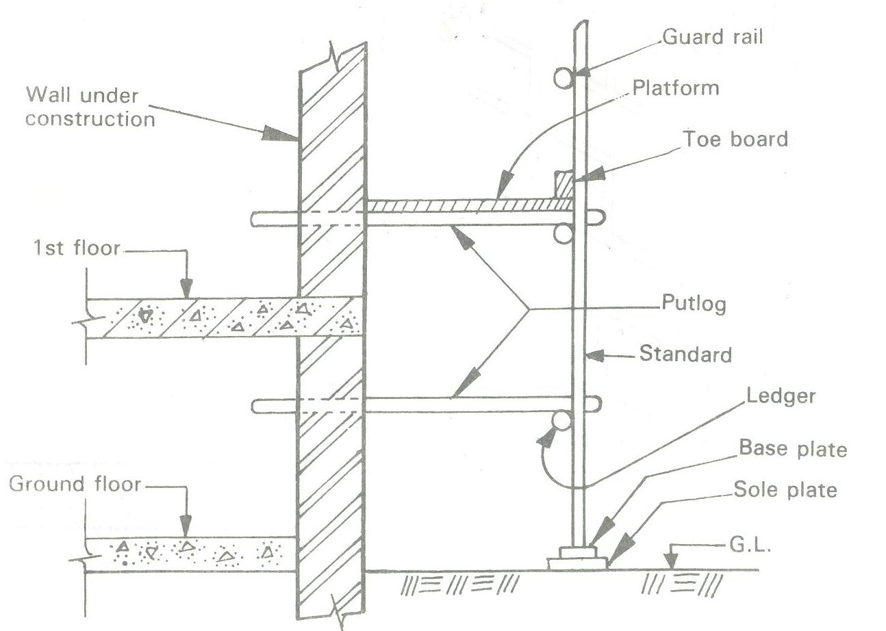

14. (a) State five functional requirements of masonry walls in a building.(5 marks)
- Safely transit imposed loads to the foundation
- Prevent penetration of moisture from outside
- Retain heat within
- Resistant to weather elements like wind
- Fire resistance
- Insulate against heat from outside
- Sound insulation
(Any 5 x 1 =5 marks)
(b) Outline the procedure for the construction of timber wall framing. (5 marks)
- Prepare cutting list
- Set anchor bolts and compact concrete around them.
- Cut and fix the sole plate.
- Mark and cut housing for starts and sole plate.
- Cut and fix studs to correct heights.
- Cut and fix wall plate.
- Cut and fix noggins.
- Cut and fix external cladding and internal facing.
(Any 5 x 1 =5 marks)

(c) Sketch and label a raft foundation. (5 marks)

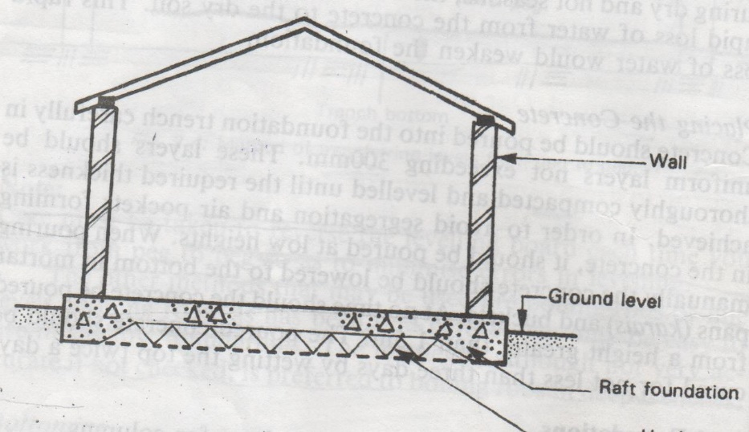

15. (a) . Sketch a longitudinal section through reinforced concrete lintel. (5marks)
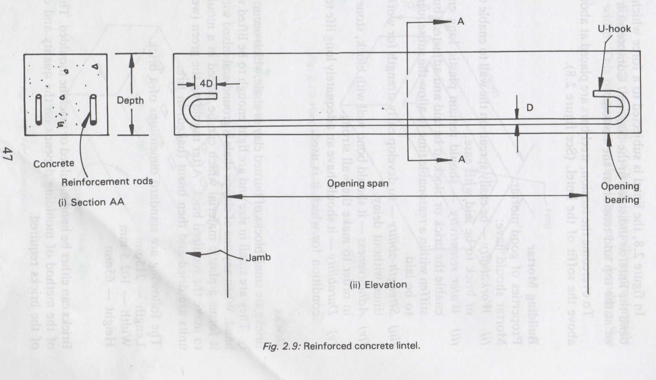

(b) State three properties (qualities) of good building mortar. (3 marks)
(i) Easy to spread
(ii) Able to retain water until the joints, plaster or screed gains adequate strength
(iii) Be able to bond with other materials
(Any 3x1=3marks)
(c) Give four functional requirements of foundations. (4 marks)
(i) It must not sunk or crack because the ground is not stable and firm.
(ii) It must not crack because of uneven settlement.
(iii) It must not break because it is based on loose soil.
(iv) Vegetable top soil must be removed.
(v) Must not crack because of tree roots.
(vi) The foundation itself must be strong enough to carry building load.
(vii) The ford must not sheep because it has not been laid level.
(viii) It must not be undermined by rain water because the site is not back graded; the foundation has not been laid deep enough.
(ix) The foundation must not disintegrate in the presence of water.
(Any 4x1=4marks)
(d) State three advantages of air seasoning. (3 marks)
- It is cheaper in small supplies
- Require little attention
- Can be done anywhere by any person (no skills needed)
- Fewer defects
(Any 3x1=3 marks)

