NAME…………………………………………………………………….ADM NO……………
SCHOOL……………………………………………………CANDIDATES SIGN ……………
DATE……………………… TEACHER..................................................................
231/3
BIOLOGY
PAPER 3
TIME: 1 ¾ HOURS
CEKENAS END OF TERM I EXAM-2022
FORM FOUR EXAM
Kenya Certificate of Secondary Education.(K.C.S.E)
BIOLOGY PRACTICAL
PAPER 3
INSTRUCTIONS TO CANDIDATES
- Write your name, admission number, date, and signature and school name in the spaces provided.
- Answer ALL the questions in the spaces provided in the question paper
- You are NOT allowed to start working with the apparatus for the first 15 minutes of the 1 ¾ hours allowed for this paper. This time is to enable you to read the question paper and make sure you have all the chemicals and apparatus that you may need.

For examiners use only
SECTION | QUESTION | MAXIMUM SCORE | CANDIDATES SCORE
 | 1 | 10
 | 2 | 18
 | 3 | 12
TOTAL SCORE |  | 40

1. You are provided with Irish potato tuber; dilute Hydrogen peroxide solution, washing up solution, solutions labelled K, PH 4, solution labelled L of PH 7, and solution labelled M of PH 9. You are also provided with 10mI measuring cylinder, white tile, glass rod, scalpel, stop watch, test tubes in a test tube rack.
Peel the potato tuber and cut a piece measuring lcm3. Crush it on a white tile using the glass rod to obtain a paste. Divide the paste into 3 portions and use them as follows.
i) Put 2cm³ of solution K into a 10ml measuring cylinder. Add one portion of the potato paste into the cylinder containing solution K. Read and record the volume of the mixture in the table below. Add one drop of the washing up solution. Add lcm³ of hydrogen peroxide solution into the mixture and immediately start a stop watch. At the end of 2minutes read the mark to which the foam rises and record in the table below. Clean and rinse the measuring cylinder with distilled water.
ii) Put 2cm³ of solution L into a 10ml measuring cylinder. Add the second portion of the potato paste into the cylinder containing solution L. Read and record the volume of the mixture in the table below. Add one drop of the washing up solution. Add lcm³ of hydrogen peroxide solution into the mixture and immediately start a stop watch. At the end of 2minutes read the mark to which the foam rises and record in the table below. Clean and rinse the measuring cylinder with distilled water.
iii) Put 2cm³ of solution M into a 10ml measuring cylinder. Add the third portion of the potato paste into the cylinder containing solution M. Read and record the volume of the mixture in the table below. Add one drop of the washing up solution. Add lcm³ of hydrogen peroxide solution into the mixture and immediately start a stop watch. At the end of 2minutes read the mark to which the foam rises and record in the table below.
a) Complete the table below by calculating the volume of the foam produced in each of the solutions using the data obtained in (i), (ii) and (iii)(3mks)
 | SOLUTION K | SOLUTION L | SOLUTION M
Volume of the solution + Potato portion
Volume of the solution + potato portion + foam
Volume of the foam

b) Explain the observation made when hydrogen peroxide was added to the mixture (2mks)
.........................................................................................................................................................................
.........................................................................................................................................................................
.........................................................................................................................................................................
.........................................................................................................................................................................
.........................................................................................................................................................................
.........................................................................................................................................................................
c) Account for the difference in the volume of the foam that was produced in solution K and solution M (2mks)
.........................................................................................................................................................................
.........................................................................................................................................................................
.........................................................................................................................................................................
.........................................................................................................................................................................
.........................................................................................................................................................................
d) Cut a piece of potato measuring lcm³ from the remaining potato .Use the reagent provided to test for the food substance (3mks)
Test | Procedure | Observation | Conclusion

2. You are provided with photographs of specimen Q and N together with actual specimens H, K and P. specimen H is a complete plant while K is a portion of a different plant. Observe the specimens and the photographs and use them to answer the questions that follows.
a) State two observable differences between the leaves of H and K. (2mks)
.........................................................................................................................................................................
.........................................................................................................................................................................
.........................................................................................................................................................................
b) Explain how the stem of specimen H adapts the plants to photosynthesis (2mks)
.........................................................................................................................................................................
.........................................................................................................................................................................
.........................................................................................................................................................................
.........................................................................................................................................................................
c) State the ecological importance of specimen H (1mk)
.........................................................................................................................................................................
d) Describe how specimen K is adapted to its habitat (2mks)
.........................................................................................................................................................................
.........................................................................................................................................................................
.........................................................................................................................................................................
.........................................................................................................................................................................
e) Explain the consequences of spilling common salt to the soil in which specimen H is growing. (2mks)
.........................................................................................................................................................................
.........................................................................................................................................................................
.........................................................................................................................................................................
.........................................................................................................................................................................
f) With a reason identify the subdivision from which specimen H and K belong (2mks)
.........................................................................................................................................................................
.........................................................................................................................................................................
.........................................................................................................................................................................
.........................................................................................................................................................................
g) Cut a longitudinal section of specimen P. using the observable features.
i) Identify the type of placentation (1mk)
.........................................................................................................................................................................
.........................................................................................................................................................................
ii) With a reason classify the type of fruit to which it belongs. (2mks)
.........................................................................................................................................................................
.........................................................................................................................................................................
.........................................................................................................................................................................
.........................................................................................................................................................................
.........................................................................................................................................................................
h) Use the photographs of Q and N to complete the table below (4 mks)
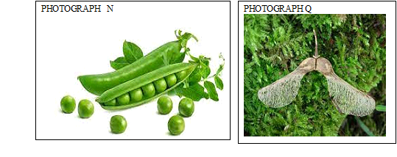
SPECIMEN | MODE OF DISPERSAL | ADAPTIVE FEATURE
Q
N

3. Below is a photograph of a dissected rat with abdominal organs spread out. Examine it
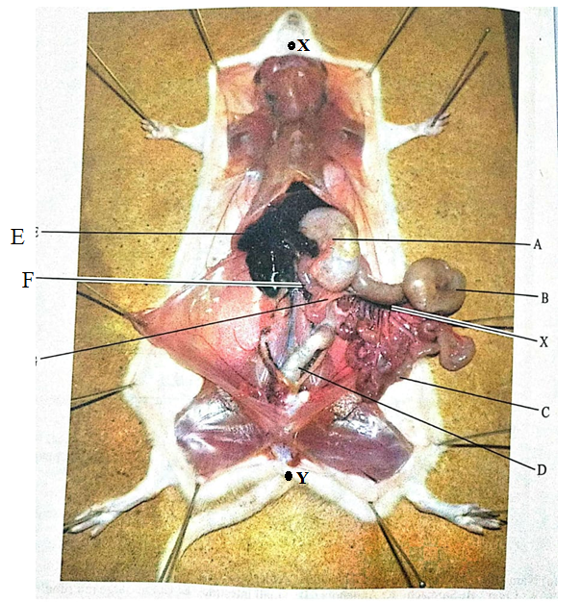

a) State two characteristics that distinguish the dissected animal into its taxonomic class. (2mks)
.........................................................................................................................................................................
.........................................................................................................................................................................
.........................................................................................................................................................................
b) Name the parts labelled (3mks)
i) B
.........................................................................................................................................................................
ii) C
.........................................................................................................................................................................
iii) F
.........................................................................................................................................................................
c) State
i) Two functions of part labelled A (2mks)
.........................................................................................................................................................................
.........................................................................................................................................................................
.........................................................................................................................................................................
ii) The function of D (1 mk)
.........................................................................................................................................................................
.........................................................................................................................................................................
.........................................................................................................................................................................
d) Other than homeostasis and excretion state two functions of structure E (2mks)
.........................................................................................................................................................................
.........................................................................................................................................................................
.........................................................................................................................................................................
.........................................................................................................................................................................

e) Given the magnification of the specimen in the photo as X 0.67, calculate the length of the rat from X to Y (2mks)

THIS IS THE LAST PRINTED PAGE!

