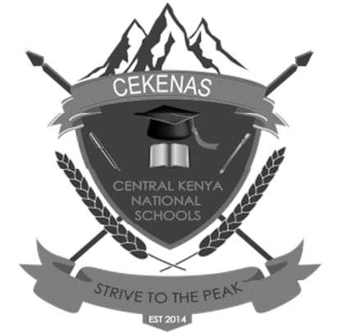
CEKENAS END OF TERM TWO EXAM-2022
FORM FOUR EXAM
Kenya Certificate of Secondary Education. (K.C.S.E)
Biology paper 3
231/3
Confidential
Each candidate requires:
- A mature Sodom apple’s flower (J)
- A mature lemon fruit labelled T
- Scalpel
- 3 test tubes
- Test tube holder
- 50 ml beaker
- Ruler
Access to:
- DCPIP solution
- Sodium hydrogen carbonate solution
- Dilute hydrochloric acid
- Benedict’s solution
- Sodium hydroxide solution
- Copper II sulphate solution
- Means of heating

