NAME…………………………………………………………………….ADM NO…………...…
SCHOOL……………………………………………………CANDIDATES SIGN …………..…
DATE……………………… CLASS........................................................................
231/2
BIOLOGY
PAPER 2
JUNE-2022
TIME: 2 HOURS
CEKENAS END OF TERM ONE EXAM-2022
FORM FOUR EXAM
Kenya Certificate of Secondary Education.(K.C.S.E)
BIOLOGY THEORY
PAPER 2
- Write your name class, and index number in the spaces provided above.
- Answer ALL the questions in the spaces provided.
- Answer all questions in Section A.
- In section B answer question 6 (compulsory) and either question 7 or 8 in the spaces provided after question 8.
- This paper consist of 12 printed pages.
- Students should check the question paper to ascertain that all the pages are printed as indicated
and that no questions are missing.

For examiner’s use only
Section | Question | Maximum score | Candidate’s score
A | 1  2  3  4  5 | 8  8  8  8  8
B | 6  7/8 | 20  20
 | Total score | 80

1. a) Digestive enzymes are made by different organs in the digestive system. Complete the table below by putting a tick () or a cross (X) in the boxes. The first has been done. (2mks)
Enzyme | Salivary glands | Stomach | Pancrease | Ileum
Amylase |  | X
lipase
Protease

b) Name the features that increase the surface area of small intestines. (2mks)
………………………………………………………………………………………………………………
………………………………………………………………………………………………………………
c) Name the vitamin which is associated with citrus fruits and green vegetables. (1mk)
………………………………………………………………………………………………………………
d) What food nutrient would be found in the villi of ileum few hours after a meal of boiled rice? (1mk)
………………………………………………………………………………………………………………
e) Caecum is poorly developed in humans. Name the group of mammals in which its well developed and outline its role. (2mk)
………………………………………………………………………………………………………………
………………………………………………………………………………………………………………
2. The diagram below shows the structure of a chromosome.
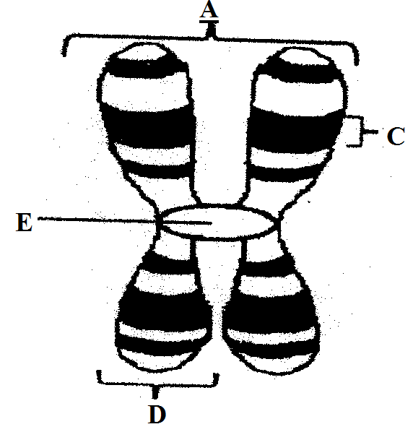
a) Identify the parts labelled D and E. (2mks)
D……………………………………………………………………………………………

E……………………………………………………………………………………………
b) Name:
i) Two organelles in an animal cell where DNA is found. (1mk)
………………………………………………………………………………………………………………
………………………………………………………………………………………………………………
ii) The process whereby DNA makes an identical copy of itself. (1mk) ………………………………………………………………………………………………………………
………………………………………………………………………………………………………………
c) Coat colour in cats is determined by a sex linked gene with two alleles, black and orange. When black cats are mated with orange cats, the female offspring are always tortoise shell, their coats show black and orange patches of various sizes, while the male offspring have the same coat colour as their mothers. Using symbols (B) for black and (O) for orange, draw a punnet square to account for a cross of tortoise shell female with an orange male. (4mks)

3. A form 2 student wanted to investigate the effect of temperatures on the rate of carbon (IV) oxide production by yeast. He set up the apparatus as shown below.
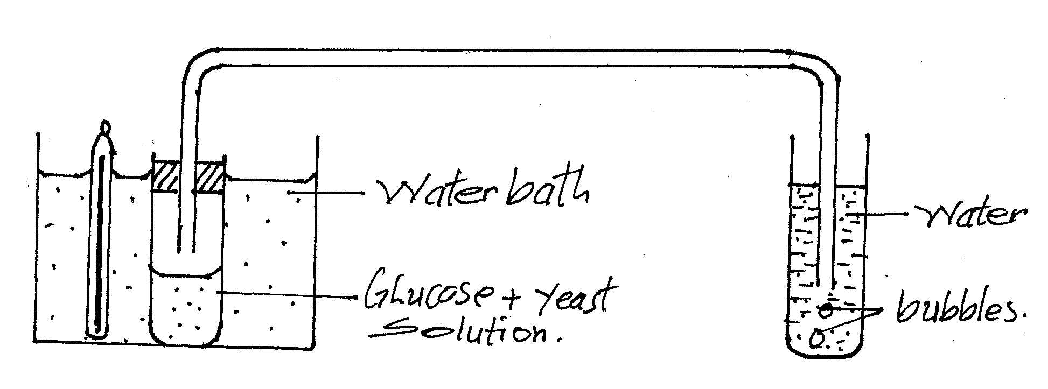
a) The student varied the temperatures of the water bath between 15⁰c – 65⁰c. He measured the rate of carbon (IV) oxide production by counting the number of bubbles per minute.

i) Sketch the shape of the graph that the student would obtain on the axes below. (3mks)
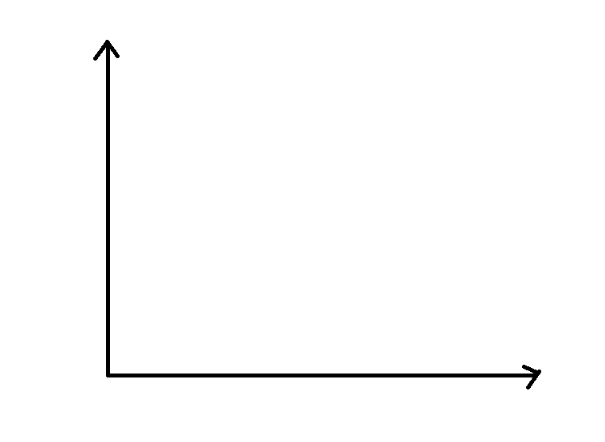
ii) Account for the shape of the graph. (1mk)
………………………………………………………………………………………………………………
………………………………………………………………………………………………………………
b) Give two variables that the student would need to keep at constant in his experiment. (2mks)
………………………………………………………………………………………………………………
………………………………………………………………………………………………………………
c) i) Yeast is used in production of beer. Write the equation for the respiration of yeast that occurs during production of beer. (1mk)
………………………………………………………………………………………………………………
ii) Suggest why lactic acid produced in the body is not highly excreted out of the body. (1mk)
………………………………………………………………………………………………………………
………………………………………………………………………………………………………………
4. The diagram below represents the relationship between the blood system of the foetus and that of the mother. The arrows indicate the direction of blood flow in the blood vessels.
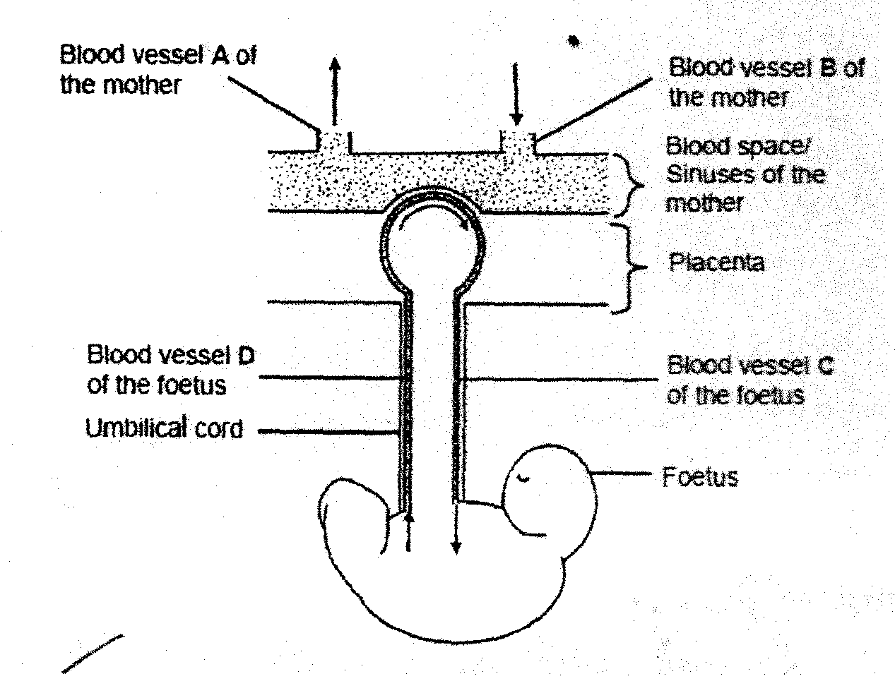
a) Apart from diffusion of substances from the mother’s blood to the foetus blood and vice versa, state two other functions of the placenta. (2mks)
………………………………………………………………………………………………………………
………………………………………………………………………………………………………………
………………………………………………………………………………………………………………
b) i) Name the blood vessels C and D. (2mks)
C……………………………………………………………………………………………………
D……………………………………………………………………………………………………
b) ii) State two differences between the composition of blood found in blood vessel C and blood found in blood vessel D. (2mks)
C | D
c) Explain one consequence for the foetus if blood vessel D becomes blocked preventing blood flow. (2mks)
………………………………………………………………………………………………………………
………………………………………………………………………………………………………………
………………………………………………………………………………………………………………
………………………………………………………………………………………………………………
5. The diagram below is of a mammalian nephron and associated structures.
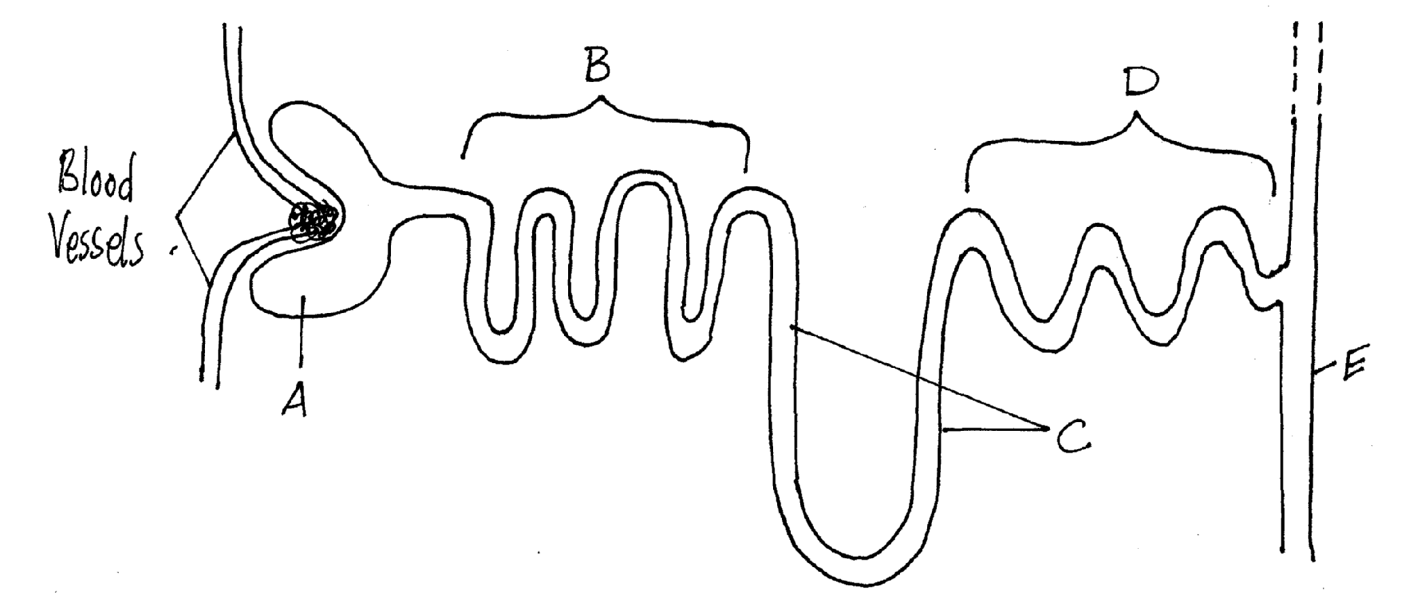

a) i) Identify the parts labelled D and E. (2mks)
D……………………………………………………………………………………………………………
E……………………………………………………………………………………………………………
ii) Reabsorbtion of substances takes place along the regions labelled B-E. Which two letters correspond to the regions in which most water is reabsorbed? (1mk)
………………………………………………………………………………………………………………
………………………………………………………………………………………………………………
b) The table below summarizes differences in the concentration of some substances in the blood plasma and the renal filtrate at the end of the proximal convoluted tubule.
Substances | Concentration in blood plasma | Concentration in filtrate at the end of PCT
Proteins | 12 | 0
Glucose | 0.15 | 0
Urea | 0.04 | 0.09

Explain the results. (3mks)
………………………………………………………………………………………………………………
………………………………………………………………………………………………………………
c) In mammals there is a strong positive correlation between the length of the loop of henle and the degree of aridity (dryness) of the environment that a mammal such as the desert rat inhabits. Explain this relationship. (2mks)
………………………………………………………………………………………………………………
………………………………………………………………………………………………………………
………………………………………………………………………………………………………………

SECTION B (40marks)
Answer question 6 (compulsory) and either question 7 or 8 in the spaces provided after question 8
6. The table below contains information on changes that occur in a river, downstream from sewage outflow.
Distance downstream from point of sewage entry (m) | Concentration dissolved oxygen (%) | Number of organisms (arbitrary units)
 |  | Bacteria | Algae | Fish
0  100  200  300  400  500  600  700  800  900  1000 | 95  30  20  28  42  58  70  80  89  95  100 | 88  78  74  60  50  48  44  42  38  36  34 | 20  8  6  20  40  70  84  90  84  68  54 | 20  6  2  0  0  0  0  0  0  4  20
a) Plot a graph of number of organisms against distance downstream. (7mks)
6. b) Describe the changes in the concentration of oxygen dissolved in the water downstream from the point of sewage entry. (2mks)
………………………………………………………………………………………………………………
………………………………………………………………………………………………………………
………………………………………………………………………………………………………………
………………………………………………………………………………………………………………
b) Account for the changes in the numbers or each of the following organisms downstream.
a) Bacteria (3mks)
………………………………………………………………………………………………………………
………………………………………………………………………………………………………………
………………………………………………………………………………………………………………
b) Algae (3mks)
………………………………………………………………………………………………………………
………………………………………………………………………………………………………………
………………………………………………………………………………………………………………
c) Fish (3mks)
………………………………………………………………………………………………………………
………………………………………………………………………………………………………………
………………………………………………………………………………………………………………
c) State two ways in which the degree of water pollution covered by sewage can be reduced. (2mks)
………………………………………………………………………………………………………………
………………………………………………………………………………………………………………
………………………………………………………………………………………………………………
7. Describe the evidences of organic evolution. (20mks)
8. a) Describe the process of fertilisation in a flowering plant. (15mks)
b) State the changes that take place in a flower after fertilization. (5mks)
………………………………………………………………………………………………………………
………………………………………………………………………………………………………………
………………………………………………………………………………………………………………
………………………………………………………………………………………………………………
………………………………………………………………………………………………………………
………………………………………………………………………………………………………………
………………………………………………………………………………………………………………
………………………………………………………………………………………………………………
………………………………………………………………………………………………………………
………………………………………………………………………………………………………………
………………………………………………………………………………………………………………
………………………………………………………………………………………………………………
………………………………………………………………………………………………………………
………………………………………………………………………………………………………………
………………………………………………………………………………………………………………
………………………………………………………………………………………………………………
………………………………………………………………………………………………………………
………………………………………………………………………………………………………………
………………………………………………………………………………………………………………
………………………………………………………………………………………………………………
………………………………………………………………………………………………………………
………………………………………………………………………………………………………………
………………………………………………………………………………………………………………
………………………………………………………………………………………………………………
………………………………………………………………………………………………………………
………………………………………………………………………………………………………………
………………………………………………………………………………………………………………
………………………………………………………………………………………………………………
………………………………………………………………………………………………………………
………………………………………………………………………………………………………………
………………………………………………………………………………………………………………
………………………………………………………………………………………………………………
………………………………………………………………………………………………………………
………………………………………………………………………………………………………………
………………………………………………………………………………………………………………
………………………………………………………………………………………………………………
………………………………………………………………………………………………………………
………………………………………………………………………………………………………………
………………………………………………………………………………………………………………
………………………………………………………………………………………………………………
………………………………………………………………………………………………………………
………………………………………………………………………………………………………………
………………………………………………………………………………………………………………
………………………………………………………………………………………………………………
………………………………………………………………………………………………………………
………………………………………………………………………………………………………………
………………………………………………………………………………………………………………
………………………………………………………………………………………………………………
………………………………………………………………………………………………………………
………………………………………………………………………………………………………………
………………………………………………………………………………………………………………
………………………………………………………………………………………………………………
………………………………………………………………………………………………………………
………………………………………………………………………………………………………………
………………………………………………………………………………………………………………
………………………………………………………………………………………………………………
………………………………………………………………………………………………………………
………………………………………………………………………………………………………………
………………………………………………………………………………………………………………
………………………………………………………………………………………………………………
………………………………………………………………………………………………………………
………………………………………………………………………………………………………………
………………………………………………………………………………………………………………
………………………………………………………………………………………………………………
………………………………………………………………………………………………………………
………………………………………………………………………………………………………………
………………………………………………………………………………………………………………
………………………………………………………………………………………………………………
………………………………………………………………………………………………………………
………………………………………………………………………………………………………………
………………………………………………………………………………………………………………
………………………………………………………………………………………………………………
………………………………………………………………………………………………………………
………………………………………………………………………………………………………………
………………………………………………………………………………………………………………
………………………………………………………………………………………………………………
………………………………………………………………………………………………………………
………………………………………………………………………………………………………………
………………………………………………………………………………………………………………
………………………………………………………………………………………………………………
………………………………………………………………………………………………………………
………………………………………………………………………………………………………………
………………………………………………………………………………………………………………
………………………………………………………………………………………………………………
………………………………………………………………………………………………………………
………………………………………………………………………………………………………………
………………………………………………………………………………………………………………
………………………………………………………………………………………………………………
………………………………………………………………………………………………………………
………………………………………………………………………………………………………………
………………………………………………………………………………………………………………
………………………………………………………………………………………………………………
………………………………………………………………………………………………………………
………………………………………………………………………………………………………………
………………………………………………………………………………………………………………
………………………………………………………………………………………………………………
………………………………………………………………………………………………………………
………………………………………………………………………………………………………………
………………………………………………………………………………………………………………
………………………………………………………………………………………………………………
………………………………………………………………………………………………………………
………………………………………………………………………………………………………………
………………………………………………………………………………………………………………
………………………………………………………………………………………………………………
………………………………………………………………………………………………………………
………………………………………………………………………………………………………………
………………………………………………………………………………………………………………
………………………………………………………………………………………………………………
………………………………………………………………………………………………………………
………………………………………………………………………………………………………………
………………………………………………………………………………………………………………
………………………………………………………………………………………………………………
………………………………………………………………………………………………………………
………………………………………………………………………………………………………………
………………………………………………………………………………………………………………
………………………………………………………………………………………………………………
………………………………………………………………………………………………………………
………………………………………………………………………………………………………………
………………………………………………………………………………………………………………
THIS IS THE LAST PRINTED PAGE!

