CEKENAS END OF TERM TWO EXAM-2022
FORM FOUR EXAM
Kenya Certificate of Secondary Education. (K.C.S.E)
Biology paper 2
231/2
Marking scheme
1.a)
A – Hypertonic solution/ highly concentrated solution
B – Hypotonic solution/ lowly concentrated solution
b) Osmosis
c) Plasmolysis;
d) It will gain water by osmosis; swell and eventually burst;
e) Form contractile vacuoles; which get rid of excess water to the surrounding.
2. i) Increased rate of heart beat/ increased rate of blood circulation
- Increased rate of breathing/ deep inspiration and expiration
ii) During hot weather surficial blood vessels dilate; (thus) more blood flows through the skin;
iii) Organ R – Pancreas
- Substance S – Insulin
iv) – Transport of hormones
- Transport of nitrogenous waste Mark first 2
- Transport of dissolved nutrients
3. a) People with sickle cell trait have less than half of their red blood cells being sickle shaped; plasmodium do not survive in sickle shaped red blood cells.

b)
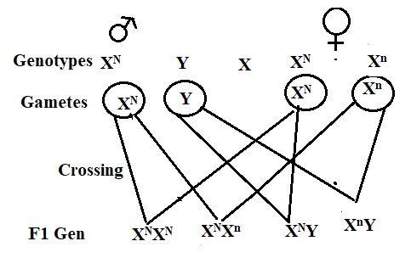
Probability = $\frac{1}{2}$
c) – Early maturity; rej. Faster maturity.
- High yields;
- Resistance to pests and diseases; Mark first 1
- Resistance to drought
4. a) Bryophyta; Rej. Bryophyte Should start with a capital letter.
b) Q- Capsule;
c) Absorption of water/ mineral salts;
Anchorage; OWTTE.
d) Arachnida; should start with a capital letter
Reason – 4 pairs of legs; OWTTE
- 2 body parts (cephalo thorax and abdomen)
Reason and class tied
e) – Source of food;
- Production of antibiotics; Mark any 2
- Cause diseases;
- Causes decomposition
Any 2
5. a) Population is the number of organisms of the same species occupying a particular habitat at a given time; community is the total number of different species;
b) – Recycle nutrients
- Predators – regulation of prey;
c) Lead to (stiff) competition for available resources; leading to elimination of one of them;
d) i) Rhizobium
ii) Symbiosis
6.a)
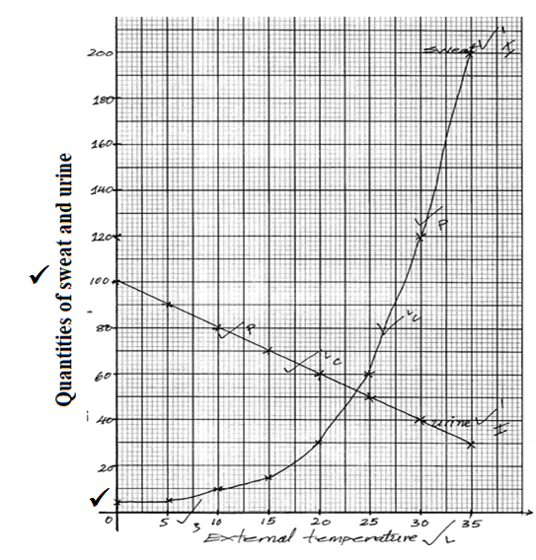
b) Amount of sweat increases with increase in temperature; high temperature stimulates the sweat glands; to secrete sweat;
c)
d) An increase in temperature leads to a decrease in the amount of urine produced; high temperature stimulates sweating leading to water loss; this leads to increase in osmotic pressure of the body fluids; thus release of ADH; which increases reabsorption of water;
Total 5 mks max 4
e) i) Hair (stand) erect/ upright; trapping a layer of air insulating the body against heat loss;
ii) Vasoconstriction; reducing the amount of blood flowing through the skin surface thus heat loss;
7. a) Position of scrotal sac out of abdominal cavity provide cooler temperature for sperm development/ spermatogenesis; Has seminiferous tubules, highly coiled whose lining consist of actively dividing cells; between them are interstitial cells which produce androgens; Seminiferous tubules unite to form epididymis; a coiled tube; which provide surface for sperm storage; Seminal vesicles provide alkaline fluid which nourishes spermatozoa; prostate gland secretes alkaline fluid to neutralize the vaginal fluids; it also activates sperms; Cowper’ s gland secretes an alkaline fluid that neutralize acidity along the urethra; penis which projects from the body, made of spongy tissue, muscle and blood vessel; erects by having spaces in its spongy tissue filled with blood enabling it to penetrate vagina during coitus, to deposit sperms in the female reproductive tract;
(Total 12 marks; max 10 marks)
b) (i) Cervical Vertebra.
• Has vertebraterial canal for passage of vertebral artery and nerves;
• It has branched and broad transverse process to provide surface for attachment of neck muscles;
• Short neutral spine for attachment of neck muscles;
• Wide neural canal for passage of spinal cord;
• Centrum and a neural arch for protection of the spinal cord;
• Prezygapophysis and postzygapophysis for articulation with the vertebrae in front and behind;
• Atlas has broad surface for articulation with condyles of the skull and this allows the nodding movement of the heard;
• Axis has a projection of the centrum, the odontoid process that fits into atlas and allows for the rotatory / turning movement of the head;
(Total 8marks; max 5 marks)
(ii) Thoracic Vertebra.
• Long neural spine for muscles attachment;
• Short transverse process for muscle attachment and for articulation with the ribs;
• Neural arch and centrum protect the spinal cord;
• Large centrum to support the body weight;
• Facets for articulation with other vertebrae adjacent to it:
• Turbercular and capitular demi facets for articulation with the rib:
(Total 6 marks; max 5 marks)
NB. Structure and function 1 mark. `
8. - Broad leaves; to increase the surface area; for maximum trapping of sunlight; for photosynthesis;
- Thin; to reduce diffusion distance of carbon (IV) oxide; (for photosynthesis)
- Transparent cuticle; and epidermis; for easy penetration of light;
- Extensive veins; with vascular bundles; for transport of water and mineral salts; and translocation of food;
- Numerous stomata; for gaseous exchange; and transpiration;
- Leaf mosaic arrangement; prevent overlapping; for maximum absorption of light;--
- Numerous chloroplasts; for maximum trapping of light; for photosynthesis

