**NAME…………………………………………………………………….ADM NO………….............…**

**SCHOOL……………………………………………………CANDIDATES SIGN …………............…**

**DATE……………………… TEACHER.....................................CLASS...................................................**

**231/1**

**BIOLOGY**

**PAPER 1**

**TIME: 2 HOURS**



**CEKENAS END OF TERM ONE EXAM-2022**

**FORM FOUR EXAM**

*Kenya Certificate of Secondary Education.(K.C.S.E)*

BIOLOGY THEORY

PAPER 1

**INSTRUCTIONS TO CANDIDATES**

* Write your name, admission number, date, and signature and school name in the spaces provided.
* Answer all the questions
* Answers must be written in spaces provided
* ***This paper consists of 12 printed pages. Candidates should check the question paper to ascertain that all pages are printed as indicated and that no questions are missing.***

**FOR EXAMINERS USE ONLY**

|  |  |  |
| --- | --- | --- |
| **SECTION** | **MAXIMUM SCORE** | **STUDENTS SCORE** |
| **1-24** | **80** |  |
| **TOTAL** | **80** |  |

1.a) Define the term specimen. (1mk)

.........................................................................................................................................................................

b) Give two significances of collecting specimens in biology. (2mks)

.........................................................................................................................................................................

.........................................................................................................................................................................

.........................................................................................................................................................................

2. Give three reasons why *Drosophila melanogaster* is considered suitable for use in genetic experiments. (3mks)

.........................................................................................................................................................................

.........................................................................................................................................................................

.........................................................................................................................................................................

.........................................................................................................................................................................

.........................................................................................................................................................................

.........................................................................................................................................................................

3. List two factors you would consider before selecting a microscope for use in a biological study. (2mks)

.........................................................................................................................................................................

.........................................................................................................................................................................

4. A group of form two students placed a fresh leaf in warm water. They observed that air bubbles formed on the surface of the leaf.

a) What biological process were they investigating? (1mk)

.........................................................................................................................................................................

b) Name the structures from which the air bubbles were coming from. (1mk)

.........................................................................................................................................................................

c) Explain the distribution of the structures named in (b) above on the leaf surfaces of an aquatic plant.

(2mks)

.........................................................................................................................................................................

.........................................................................................................................................................................

.........................................................................................................................................................................

5. Differentiate between hydrolysis and condensation. (2mks)

.........................................................................................................................................................................

.........................................................................................................................................................................

6. (a) Which sets of teeth would be used in chewing sugarcane for maximum extraction of sap? (2mks)

.........................................................................................................................................................................

.........................................................................................................................................................................

.........................................................................................................................................................................

(b) What is the advantage of heterodont dentition over homodont dentition? (1mk)

.........................................................................................................................................................................

.........................................................................................................................................................................

(b) During digestion name the enzyme that acts on the sugarcane sap and give the final products. (2mks)

Enzyme

.........................................................................................................................................................................

Final products

.........................................................................................................................................................................

7. Study the diagram below and answer the questions that follow.

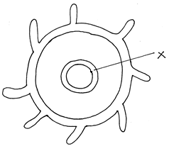

a) The part labelled X turned blue black after iodine solution was applied on the cut cross section of the above specimen

i) Name part X (1mks)

.........................................................................................................................................................................

ii) Give a reason for your answer. (1mks)

.........................................................................................................................................................................

.........................................................................................................................................................................

b) State two phenomenons of stomata which reduce the rate of transpiration. (2mks)

.........................................................................................................................................................................

.........................................................................................................................................................................

.........................................................................................................................................................................

8. a) What is respiratory quotient? (1mks)

.........................................................................................................................................................................

.........................................................................................................................................................................

b) Explain why it is difficult to measure respiratory quotient in plants. (2mks)

.........................................................................................................................................................................

.........................................................................................................................................................................

.........................................................................................................................................................................

.........................................................................................................................................................................

9. Study and complete the table below. (3mks)

|  |  |  |
| --- | --- | --- |
| Character | Monocot | Dicot |
| a) Number of stamens |  |  |
| b) Arrangement of vascular bundle in stem |  |  |
| c) Type of root |  |  |

10. The diagram below shows blood circulation in a mammalian tissue.

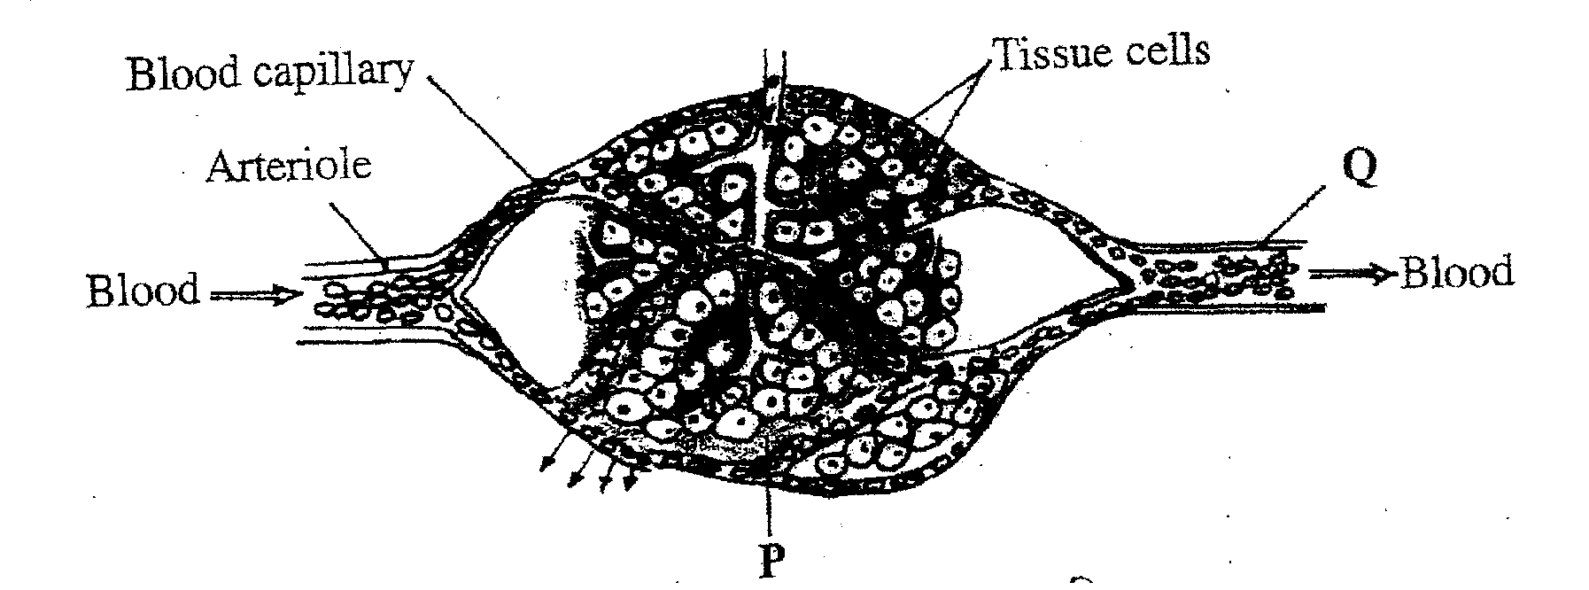

a) Give the name of the above section of the blood circulation system. (1mks)

.........................................................................................................................................................................

b) Explain two the adaptation of the above section to its function. (2mks)

.........................................................................................................................................................................

.........................................................................................................................................................................

.........................................................................................................................................................................

.........................................................................................................................................................................

c) What is the name of blood vessel Q. (1mk)

.........................................................................................................................................................................

11. Differentiate between dioecious and monoecious plants. (2mks)

.........................................................................................................................................................................

.........................................................................................................................................................................

.........................................................................................................................................................................

.........................................................................................................................................................................

.........................................................................................................................................................................

12.a) Why does endosperm weight of a germinating seed decrease as the weight of the shoot increases. (l mks)

.........................................................................................................................................................................

.........................................................................................................................................................................

.........................................................................................................................................................................

b) State three importance of the pupa stage of metamorphosis to insects. (lmks)

.........................................................................................................................................................................

.........................................................................................................................................................................

13. The diagrams below show a pair of homologous chromosomes. Study them and answer the questions that follow.

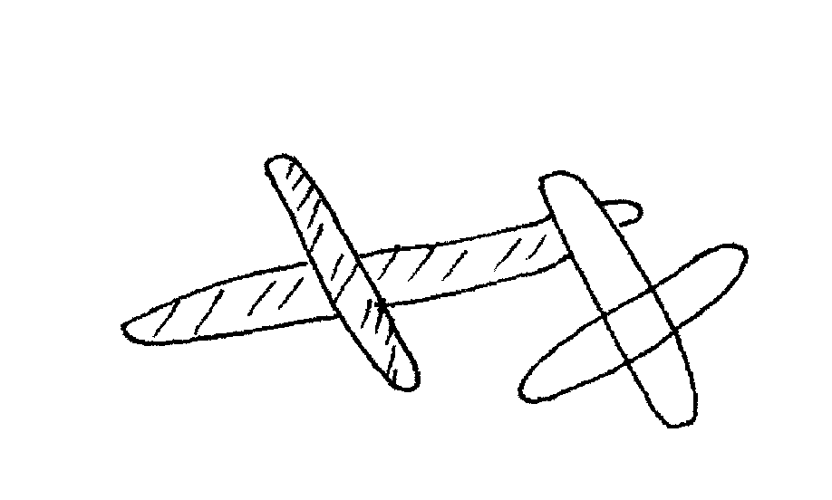

i) State the phenomenon shown above. (lmk)

.........................................................................................................................................................................

ii. What is the genetic significance of the phenomenon above? (lmk)

.........................................................................................................................................................................

iii. Name the type of mutation caused by the above phenomenon. (2mks)

.........................................................................................................................................................................

.........................................................................................................................................................................

14. In an experiment to determine the population of Tilapia fish in a school fish pond, students of Canada school decided to use capture-recapture method.

a) Name three vital tools the students would need for the exercise. (3mks)

.........................................................................................................................................................................

.........................................................................................................................................................................

.........................................................................................................................................................................

.........................................................................................................................................................................

b) State two factors that might affect the accuracy of their results. (2mks)

.........................................................................................................................................................................

.........................................................................................................................................................................

.........................................................................................................................................................................

15. The table below show description of sizes of glomeruli and renal tubules of two animals, which are in different environments.

|  |  |  |
| --- | --- | --- |
|  | Animal Q | Animal W |
| Glomeruli | Few | Many |
| Renal tubules | Long | Short |

a) Name the likely environment in which each animal lives. (2mks)

Q –

.........................................................................................................................................................................

W-

.........................................................................................................................................................................

b) Suggest the main nitrogenous waste produced by animal W. (lmk)

.........................................................................................................................................................................

c) What is the importance of the renal tubules being long? (lmk)

.........................................................................................................................................................................

.........................................................................................................................................................................

16. What is the role of the following hormones in human reproduction?

i) Follicle stimulating hormone in male (lmk)

.........................................................................................................................................................................

.........................................................................................................................................................................

ii) Luteinizing hormone during menstrual cycle. (lmk)

.........................................................................................................................................................................

.........................................................................................................................................................................

17. Below is representation of an experiment that was carried out on a tree in Kayombe forest.

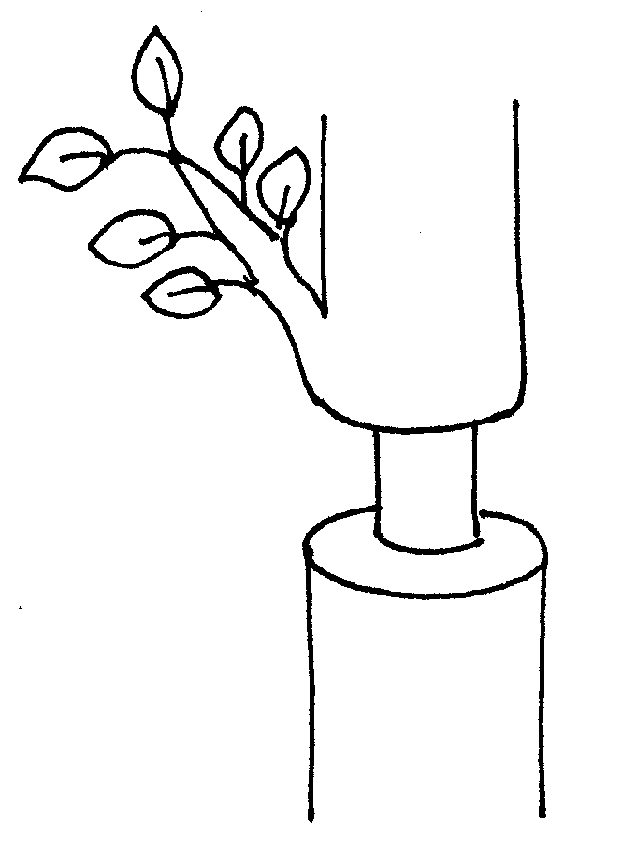

a) Which two tissues are removed in a ring bark experiment? (2mks)

.........................................................................................................................................................................

.........................................................................................................................................................................

b) Removal of the tissues above leads to some effects to the plant. Name these 2 effects. (2mks)

.........................................................................................................................................................................

.........................................................................................................................................................................

.........................................................................................................................................................................

c) State and explain the observation that would be made in the plant above after some time. (3mks)

.........................................................................................................................................................................

.........................................................................................................................................................................

.........................................................................................................................................................................

.........................................................................................................................................................................

.........................................................................................................................................................................

.........................................................................................................................................................................

18. A section of nucleic strand contains the following sequence.

A — C — ­­ G — A — G — A — T — A— C

a) i) Write the complimentary DNA stand. (lmk)

.........................................................................................................................................................................

ii) Write the mRNA strand of the strand in (a) above. (lmk)

.........................................................................................................................................................................

b) Name the site for protein synthesis in a cell. (lmk)

.........................................................................................................................................................................

c) State one disorder caused by non-disjunction mutation. (lmk)

.........................................................................................................................................................................

.........................................................................................................................................................................

19. i) State the importance of rings of chitin in the tracheal system of insects. (lmk)

.........................................................................................................................................................................

ii) Explain the significance of maintaining a steep concentration gradient in the respiratory surfaces of animals. (lmk)

.........................................................................................................................................................................

.........................................................................................................................................................................

iii) Explain why a bony fish dies shortly after being removed from water. (3mks)

.........................................................................................................................................................................

.........................................................................................................................................................................

.........................................................................................................................................................................

.........................................................................................................................................................................

.........................................................................................................................................................................

20. Explain why Lamark’s theory of evolution is not accepted by modern scientist. (2mks)

.........................................................................................................................................................................

.........................................................................................................................................................................

.........................................................................................................................................................................

.........................................................................................................................................................................

21. Name the branch of biology that deals with;

a) Relationship between antelopes and gazelles in their environment. (lmk)

.........................................................................................................................................................................

b) Study of Ebola virus. (lmk)

.........................................................................................................................................................................

c) Explain what would happen if a given of living things lose their ability to reproduce. (lmk)

.........................................................................................................................................................................

.........................................................................................................................................................................

22. Explain the following when testing a leaf for starch.

i) Boiling the leaf in hot water. (lmk)

.........................................................................................................................................................................

.........................................................................................................................................................................

ii) Destarching (lmk)

.........................................................................................................................................................................

.........................................................................................................................................................................

iii) Boiling the leaf in methylated spirit. (lmk)

.........................................................................................................................................................................

23. Explain why osmosis is a special type of diffusion. (lmk)

.........................................................................................................................................................................

.........................................................................................................................................................................

24. Explain three protective functions of the blood. (3mks)

.........................................................................................................................................................................

.........................................................................................................................................................................

.........................................................................................................................................................................

.........................................................................................................................................................................

.........................................................................................................................................................................

.........................................................................................................................................................................

.........................................................................................................................................................................

.........................................................................................................................................................................

**THIS IS THE LAST PRINTED PAGE!**