NAME…………………………………………….………..ADM NO………….….....................………
SCHOOL…………………………………..CLASS............................... SIGN…………....................….
231/1
BIOLOGY
PAPER 1
TIME: 2 HOURS
AUGUST-2022
CEKENAS END OF TERM TWO EXAM-2022
FORM FOUR EXAM
Kenya Certificate of Secondary Education. (K.C.S.E)
BIOLOGY PAPER 1
231/1

INSTRUCTIONS TO CANDIDATES
- Write your name and Adm. number in the spaces provided above
- Sign and write date of examination in the space provided.
- All working must be clearly shown where necessary.
- Answer ALL questions in the spaces provided.
- Answer all questions in English.
For examiners use only
QUESTION | MAXIMUM SCORE | CANDIDATE’S SCORE
1-29 | 80

1. Explain why ferns are considered to be more advanced than mosses. (2mks)
…………………………………………………………………………………………………………………...
…………………………………………………………………………………………………………………...
…………………………………………………………………………………………………………………...
2. A student estimating a cell size of an onion epidermal cell observed the following on the microscope field of view using a transparent ruler.
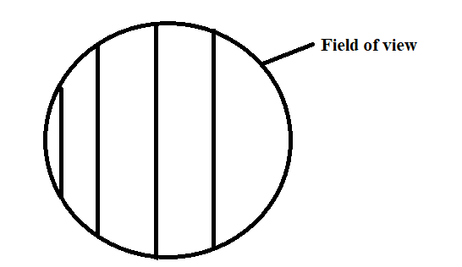
The student identified 20 cells across the field of view. Calculate the size of the cell in micrometers. (Show your working). (3mks)
…………………………………………………………………………………………………………………...
…………………………………………………………………………………………………………………...
…………………………………………………………………………………………………………………...
3. What role do the following play in the movement a Tilapia fish? (2mks)
a) Myotomes
…………………………………………………………………………………………………………………...
b) Swim bladder
…………………………………………………………………………………………………………………...
4. Name the tissues whose cells are thickened with;
a) Cellulose and pectin (1mk)
…………………………………………………………………………………………………………………...
b) Lignin (1mk)
…………………………………………………………………………………………………………………...
5. The diagram below shows the position of an image formed in a defective eye.
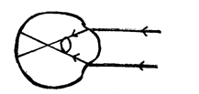
a) Name the defect. (1mk)
…………………………………………………………………………………………………………………...
b) Explain how the defect named in (a) above can be corrected. (2mks)
…………………………………………………………………………………………………………………...
…………………………………………………………………………………………………………………...
6. The paddles of whales and the fins of fish adapt these organisms to aquatic habitat.
a) Name the evolutionary process that may have given rise to the structures. (1mk)
…………………………………………………………………………………………………………………...
b) What is the name given to such structures? (1mk)
…………………………………………………………………………………………………………………...
c) Give two examples of vestigial organs in man. (2mks)
…………………………………………………………………………………………………………………...
…………………………………………………………………………………………………………………...
7. a) Define the term mutation. (1mk)
…………………………………………………………………………………………………………………...
…………………………………………………………………………………………………………………...
b) State two disorders due to gene mutation. (2mks)
…………………………………………………………………………………………………………………...
…………………………………………………………………………………………………………………...
8. An experiment was set to investigate a certain aspect of response. A seedling was put on a horizontal position as shown in figure M below. After 24 hours, the set up was shown in figure N.
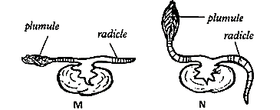
a) Name the response exhibited by the shoot. (1mk)
…………………………………………………………………………………………………………………...
b) Explain the curvature of the shoot upwards. (3mks)
…………………………………………………………………………………………………………………...
…………………………………………………………………………………………………………………...
…………………………………………………………………………………………………………………...
9.a) A student visiting a game park observed an adult elephant flapping its ears twice as much as its calf in order to cool its body when it is hot. Explain. (2mks)
…………………………………………………………………………………………………………………...
…………………………………………………………………………………………………………………...
b) Explain why some desert animals excrete uric acid rather than ammonia. (2mks)
…………………………………………………………………………………………………………………...
…………………………………………………………………………………………………………………...
10. The table below shows the concentration of important plant nutrients.
Ion | Concentration in pond water (ppm) | Concentration in cell sap (ppm)
Potassium | 1 | 15
Chloride | 200 | 50
Name the process by which the above ions could have been taken up by the plants.
i) Potassium (1mk)
…………………………………………………………………………………………………………………...
ii) Chloride (1mk)
…………………………………………………………………………………………………………………...
11. Name two hormones produced by the duodenal cells in response to the presence of acidic chyme from the stomach. (2mks)
…………………………………………………………………………………………………………………...
…………………………………………………………………………………………………………………...
12. Name the disease causing microorganism in the following respiratory diseases. (2mks)
i) Pneumonia
…………………………………………………………………………………………………………………...
ii) Pulmonary tuberculosis
…………………………………………………………………………………………………………………...
13. State the role of the following hormones during menstruation. (3mks)
a) Oestrogen
…………………………………………………………………………………………………………………...
b) Luteinising hormone
…………………………………………………………………………………………………………………...
c) Progesterone
…………………………………………………………………………………………………………………...
14. Give one aspect of dichogamy in flowers. (1mk)
…………………………………………………………………………………………………………………...
15. The equation below shows an oxidation reaction of a food substance.
a) Determine respiratory quotient of the oxidation of the food substance above. (2mks)
…………………………………………………………………………………………………………………...
…………………………………………………………………………………………………………………...
…………………………………………………………………………………………………………………...
b) Identify the food substance. (1mk)
…………………………………………………………………………………………………………………...
16. State two pollution effects of radioactive emissions. (2mks)
…………………………………………………………………………………………………………………...
…………………………………………………………………………………………………………………...
17. A blood group A mother gave birth to a blood group O child with a blood group B husband.
a) State the genotype of the parents. (2mks)
…………………………………………………………………………………………………………………...
…………………………………………………………………………………………………………………...
b) What is the genotype of the child? (1mk)
…………………………………………………………………………………………………………………...

c) State other blood groups likely to occur in the children of the couple. (1mk)
…………………………………………………………………………………………………………………...
18. Name the organelle that would be most abundant in:
i) White blood cell (1mk)
…………………………………………………………………………………………………………………...
ii) Salivary glands (1mk)
…………………………………………………………………………………………………………………...
19. Name three mechanisms through which plants excrete. (3mks)
…………………………………………………………………………………………………………………...
…………………………………………………………………………………………………………………...
…………………………………………………………………………………………………………………...

20. a) Nitrogen in the atmosphere cannot be directly utilized by plants. State two ways through which Nitrogen is made available for plant use. (2mks)
…………………………………………………………………………………………………………………...
…………………………………………………………………………………………………………………...
b) State the importance of saprophytic bacteria in the environment. (1mk)
…………………………………………………………………………………………………………………...
21. The diagram below shows regions of a root tip.
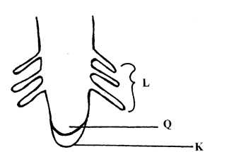
a) What is the function of the part labelled K. (1mk)
…………………………………………………………………………………………………………………...
b) Name the region labelled L. (1mk)
…………………………………………………………………………………………………………………...
c) Give two characteristics of the cell in the part labelled Q. (2mks)
…………………………………………………………………………………………………………………...
…………………………………………………………………………………………………………………...
22. Name the hormones that control the following activities;
a) Metamorphosis in young insect (1mk)
…………………………………………………………………………………………………………………...
b) Formation of abscission layer in leaves and fruits. (1mk)
…………………………………………………………………………………………………………………...
23. Give the formula for calculating magnification of a specimen using: (2mks)
i) Light microscope
…………………………………………………………………………………………………………………...
ii) Hand lens
…………………………………………………………………………………………………………………...

24. A student met a lion as he walked along a forest path.
i) Name the hormone that was secreted in his blood stream and state its source. (2mks)
Name
…………………………………………………………………………………………………………………...
Source
…………………………………………………………………………………………………………………...
ii) What is the effect of the hormone in his? (2mks)
a) Circulatory system
…………………………………………………………………………………………………………………...
b) Respiratory system
…………………………………………………………………………………………………………………...
25. State the function of the following structures found in the walk of the trachea. (3mks)
i) Cilia
…………………………………………………………………………………………………………………...
ii) Mucus
…………………………………………………………………………………………………………………...
iii) Rings of cartilage
…………………………………………………………………………………………………………………...
26. Explain the basis for the ever changing drugs for malaria. (3mks)
…………………………………………………………………………………………………………………...
…………………………………………………………………………………………………………………...
…………………………………………………………………………………………………………………...
27. During an accident a victim suffered injuries in the head. After the accident he lost his memory and was passing excessive amount of dilute urine. Suggest the part of the brain that was damaged in relation to:
(2mks)
a) Memory
…………………………………………………………………………………………………………………...
b) Passing large amounts of dilute urine
…………………………………………………………………………………………………………………...

28. State two structural differences between bicep muscles and muscles of the gut. (2mks)
Bicep muscles | Gut muscles

29. The diagram below represents an experimental set up to investigate a certain scientific concept. The potted plant was first destarched by keeping it in the dark for four days.
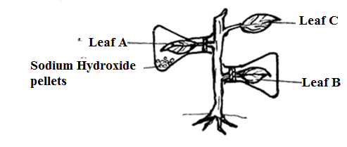
The setup was then placed in sunlight for five hours and leaves were tested for starch.
a) What scientific concept was being investigated? (1mk)
…………………………………………………………………………………………………………………...
…………………………………………………………………………………………………………………...
b) i) Give the results likely to be obtained after starch test for A and B.
A (1mk)
…………………………………………………………………………………………………………………...
B (1mk)
…………………………………………………………………………………………………………………...
c) Why was leaf C included in the set-up? (1mk)
…………………………………………………………………………………………………………………...
…………………………………………………………………………………………………………………...

THIS IS THE LAST PRINTED PAGE!

