NAME……………………………………………………………………………………………CLASS…………………………
SCHOOL………………………………………………………………………………………..SIGNATURE…………………
231/1
KENYA CERTIFICATE OF SECONDARY SCHOOL
@west Practice papers
NOVEMBER/DECEMBER 2021
TIME: 2HOURS
INSTRUCTIONS
a. Write your name, school and class in the spaces provided
b. Answer all the questions in the spaces provided.
c. This paper consists of 9 printed pages
d, Candidates should check the question paper to ascertain that all the pages are printed as indicated and no questions are missing.

FOR EXAMINERS USE ONLY
QUESTION | MAXIMUM SCORE | CANDIDATE’S SCORE
1-31 | 80

1. Name two branches of microbiology (2marks)
…………………………………………………………………………………………………………………………………………………………………………………………………………………………………………………………………………………………………………
2. Give two important functions of a fruit with regard to a plant (2marks)
…………………………………………………………………………………………………………………………………………………………………………………………………………………………………………………………………………………………………………
3. Construct a food chain with the following: (1mark)
Orange fruit, large bird, fruit fly, small bird

4. A student wrote the scientific name of Baobab tree as adansonia Digitata.
(a) Identify two mistakes made by the student (2marks)
…………………………………………………………………………………………………………………………………………………………………………………………………………………………………………………………………………………………………………
(b) Identify the species name (1mark)
……………………………………………………………………………………………………………………………………………………
5. State the differences between light and electron microscopes in terms of the following: (2marks)
(a) way of illumination
…………………………………………………………………………………………………………………………………………………….
(b) Source of illumination
…………………………………………………………………………………………………………………………………………………………………………………………………………………………………………………………………………………………………………
(c) State two factors to consider the type of microscope to be used in a given biological investigation (2marks)
…………………………………………………………………………………………………………………………………………………………………………………………………………………………………………………………………………………………………………
6. Explain how parasitism differ from predation (2marks)
…………………………………………………………………………………………………………………………………………………………………………………………………………………………………………………………………………………………………………
7. (a) Explain how papain is used as a meat tenderizer in food processing industries (2marks)
………………………………………………………………………………………………………………………………………………………………………………………………………………………………………………………………………………………………………….
(b) Name a plant excretory product that is toxic to plasmodium (1mark)
…………………………………………………………………………………………………………………………………………………………………………………………………………………………………………………………………………………………………………
8. Distinguish between ilium and ilium (1mark)
…………………………………………………………………………………………………………………………………………………………………………………………………………………………………………………………………………………………………………
9. Explain why Egyptian mummies are not regarded as fossils (1mark)
…………………………………………………………………………………………………………………………………………………………………………………………………………………………………………………………………………………………………………
10. Explain what would happen to digestion and blood sugar regulation if the pancreatic duct of a mammal was blocked. (3marks)
………………………………………………………………………………………………………………………………………………………………………………………………………………………………………………………………………………………………………………………………………………………………………………………………………………………………………………………………
11. Equal amounts of three different sugar solutions were placed in the visking tubings X, Y and Z. the tubings were placed in a beaker of water containing 5% sugar solution. The set up was left for two hours. The results were as shown below.
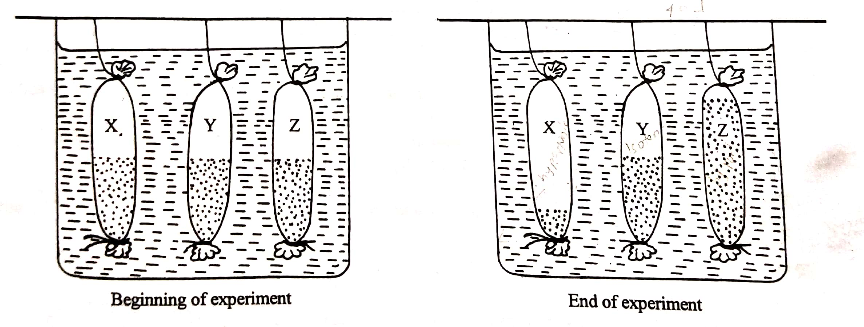
(a) Name the process being tested in this experiment (1mark)
……………………………………………………………………………………………………………………………………………………
(b) Account for the observation (3marks)
…………………………………………………………………………………………………………………………………………………………………………………………………………………………………………………………………………………………………………………………………………………………………………………………………………………………………………………………………………………………………………………………………………………………………………………………………………………..
12. (a) Define the term allergy (1mark)
………………………………………………………………………………………………………
(b) Distinguish between allograft and isograft (2marks)
………………………………………………………………………………………………………………………………………………………………………………………………………………
13. State two adaptations of the placenta to its function (2marks)
..................................................................................................................................................................................................................................................................................................................
14. The diagram below shows chemical reactions I and II which are controlled by enzymes.
Glucose + Glucose

Reaction II Reaction I
Enzyme B Enzyme A
X + Water
- Into which class of carbohydrates is X? (1mark)
………………………………………………………………………………………………………
- Name reaction I and enzyme A (2marks)
Reaction I…………………………………………………………………………………...
Enzyme A…………………………………………………………………………………...
15. The figure below illustrates aerobic respiration in a cell
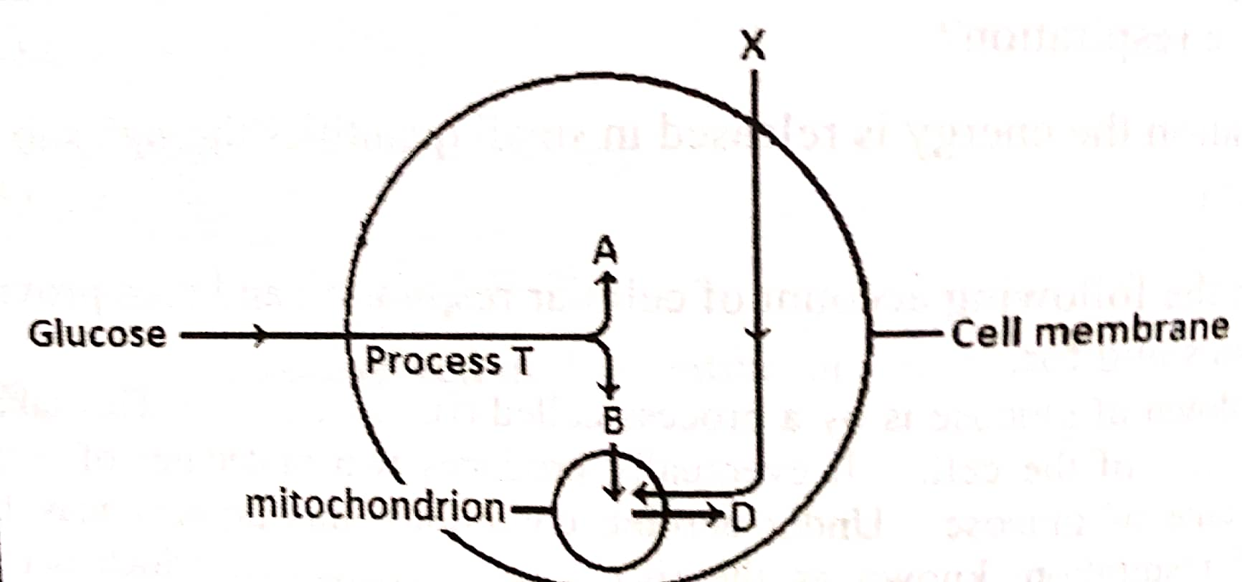
(a) Name the raw material named X and products A and B (3marks)
…………………………………………………………………………………………………………………………………………………………………………………………………………………………………………………………………………………………………………….
(b) Identify process T (1mark)
...........................................................................................................................................................
16. Name a characteristic in man controlled by multiple alleles (1mark)
………………………………………………………………………………………………………
17. Some scientists argue that Lamarck’s theory is false and not valid. What is your scientific view on this? (3marks)
…………………………………………………………………………………………………………………………………………………………………………………………………………..
18. State two natural ways in which in which seed dormancy can be terminated (2marks)
…………………………………………………………………………………………………………………………………………………………………………………………………………..
19. Explain why the temperate bears have thick adipose tissues (2marks)
..................................................................................................................................................................................................................................................................................................................
20. Study the diagram shown below of the anterior view of a lumbar vertebra of a mammal.
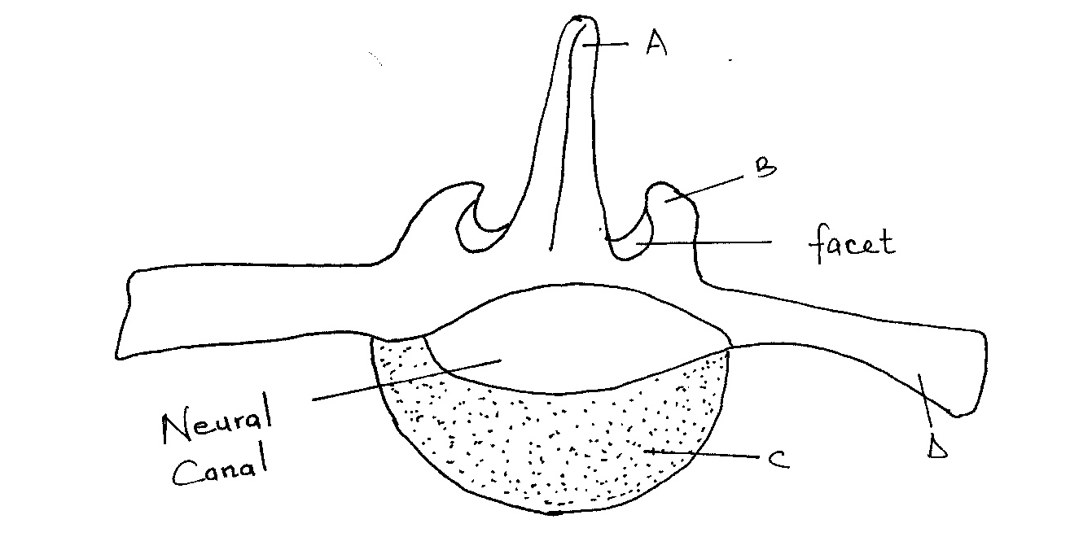

(a) Name the parts labelled: A, and B, (2 marks)
……………………………………………………………………………………………………………………………………………………………………………………………………………………………………………………………………………………………………………..
(b) State the adaptation of the part labelled D. (1 mark)
………………………………………………………………………………………………………
21. Distinguish between parthenocarpy and parthenogenesis (2marks)
..................................................................................................................................................................................................................................................................................................................
22. State three symptoms of menopause (3marks)
…………………………………………………………………………………………………………………………………………………………………………………………………………………………………………………………………………………………………………….
23. The figure below shows feet of various birds. Study the diagram and answer the questions that follow.
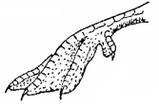
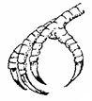
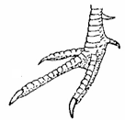
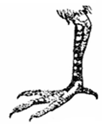
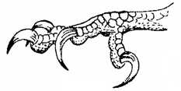
bird A
bird B
bird C
bird D
bird E

(i) Name the type of evolution represented by the diagrams. (1 mark)
………………………………………………………………………………………………………
  - Using Darwin’s theory of evolution, explain how the feet of bird E would have evolved. (3 marks)
………………………………………………………………………………………………………………………………………………………………………………………………………………………………………………………………………………………………………………………
24. Describe how contraction of the diaphragm muscles leads to inhalation (4marks)
………………………………………………………………………………………………………………………………………………………………………………………………………………………………………………………………………………………………………………………………………………………………………………………………………….
25. Explain the effect of burning of fossil fuels on the health of humans (3marks)
……………………………………………………………………………………………………………………………………………………………………………………………………………………………………………………………………………………………………….
26. State two distinguishing characteristics of members of the kingdom Monera (2marks)
…………………………………………………………………………………………………………………………………………………………………………………………………….
27. State two structural differences between the xylem and the phloem (2marks)
………………………………………………………………………………………………………………………………………………………………………………………………………………………………………………………………………………………………………
28. Explain why seeds buried deep in the soil fail to germinate (2marks)
…………………………………………………………………………………………………………………………………………………………………………………………………………………………………………………………………………………………………….
29. Explain how starch provides energy for living organisms (2marks)
……………………………………………………………………………………………………………………………………………………………………………………………………………………………………………………………………………………………………….
30. The diagram below shows part of the inner ear

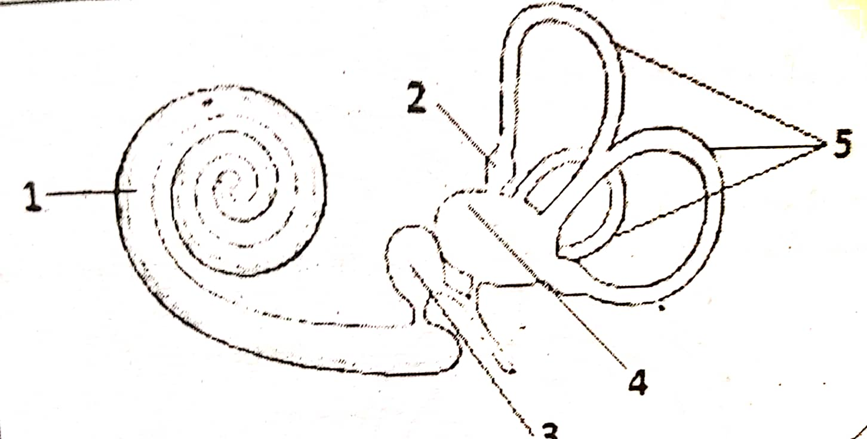

(a) Name the apparatus (1mark)
…………………………………………………………………………………………………..
(b) State the function of the apparatus (1mark)
............................................................................................................................................................
(c) Name the parts labeled 1 and 5 (2marks)
……………………………………………………………………………………………………………………………………………………………………………………………………
31. (a) state the role of the following hormones during lactation (2marks)
(i) Prolactin
……………………………………………………………………………………………………………………………………………………………………………………………………
(ii) Oxytocin
……………………………………………………………………………………………………………………………………………………………………………………………………
(b) Other than the role mentioned above, give another role of oxytocin in the body of a female (1mark)
…………………………………………………………………………………………………

THIS IS THE LAST PRINTED PAGE

