Name………………………………………………Index No. …………………….

School ………………………………………………...Sign…………………………….

231/2
BIOLOGY
PAPER 2 (THEORY)
NOV/DEC.2021
Time: 2 HOURS

@west Practice papers-2021
BIOLOGY 2021.
Kenya Certificate of Secondary Education (K.C.S.E)

231/2
BIOLOGY PAPER 2 (THEORY)
2HRS
NOV/DEC.2021

INSTRUCTIONS TO CANDIDATES
- Write your name, index number and the name of the school in the space provided.
- This paper consists of 2 sections A, and B
- Answer ALL the questions in section A.
- In section B, answer question 6 (Compulsory) and either question 7 or 8 in the spaces provided after question 8.

FOR EXAMINERS USE ONLY
Section | Questions | Maximum Score | Candidates Score
A | 1  2  3  4  5 | 8  8  8  8  8
B | 6  7  8 | 20  20  20
TOTAL SCORE |  | 80

This paper consists of 10 printed pages
Candidates should check the question paper to ensure that all pages are printed as indicated
and no questions are missing
SECTION A.
- (a) Viable seed may not germinate even when provided with favorable condition. State the importance of the above phenomena. (2mks)
………………………………………………………………………………………………………………………………………………………………………………………………………………………………………………………………………………………………………………………………………………………………………………………………………………………………
(b) Monocotyledonous plants do not undergo secondary growth. Explain. (2mks)
………………………………………………………………………………………………………………………………………………………………………………………………………………………………………………………………………………………………………………………………………………………………………………………………………………………………
(c) In the diagram below, a bean seedling was pinned in a horizontal position inside a clinostat.
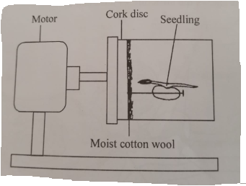
- Explain what you would expect to observe after 48 hours if the clinostat was not rotating. (2mks)
………………………………………………………………………………………………………………………………………………………………………………………………………………………………………………………………………………………………………………………………………………………………………………………………………………………………
- Explain what you would expect to observe after 48 hours if the clinostat was rotating slowly. (2mks)
………………………………………………………………………………………………………………………………………………………………………………………………………………………………………………………………………………………………………………………………………………………………………………………………………………………………

- (i) Explain the concept of the negative feedback mechanism. (3mks)
………………………………………………………………………………………………………………………………………………………………………………………………………………………………………………………………………………………………………………………………………………………………………………………………………………………………………………………………………………………………………………………………………………………………………………………………………………………………………………
- Study the diagram below and answer the question that follows.
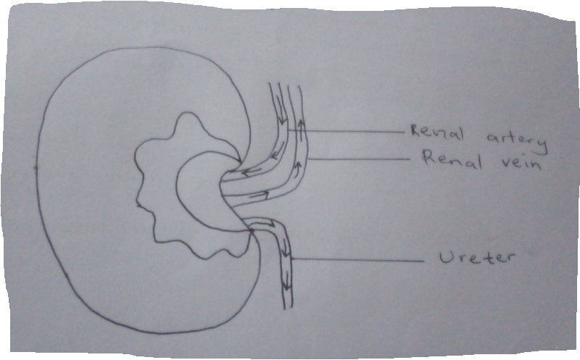
On the organ above, draw a small circle and label it X to show where the adrenal gland is located. (1mk)
- Explain the effect of the hormone secreted by the adrenal gland in blood sugar regulation. (2mks)
………………………………………………………………………………………………………………………………………………………………………………………………………………………………………………………………………………………………………………………………………………………………………………………………………………………………………………………………………………………………
- Name two diseases that affect organ labeled A. (2mks)
………………………………………………………………………………………………………………………………………………………………………………………………………………………………………………………………………………………………………………………………………………………………………………………………………………………………

- The pedigree diagram below show part of a family tree in which the inherited condition of phenylketonuria occurs.
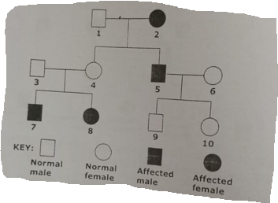
(a) Identify and explain one piece of evidence from this family tree to show that the allele for phenylketonuria is a recessive to allele for the normal condition. (2mks)
……………………………………………………………………………………………………………………………………………………………………………………………………………………………………………………………………………………………………………………………………………………………………………………………………………………………………………………………...
(b) If individual 10 married a man who is the heterozygous for the gene, what is the probability that their first child will be affected? (2mks)
………………………………………………………………………………………………………………………………………………………………………………………………………………………………………………………………………………………………………………………………………………………………………………………………………………………………………………………………
(c) A garden pea plant was crossed with a dwarf garden pea plant and all the offspring’s were tall. Using later T to represent the gene for tallness, determine the genotype of the F₂ if the F1 were test crossed. (4mks)

- (i) Distinguish between dentition and dental formula. (2mks)
………………………………………………………………………………………………………………………………………………………………………………………………………………………………………………………………………………………………………………………………………………………………………………………………………………………………
- The diagram below represents the lower jaw of a mammal.
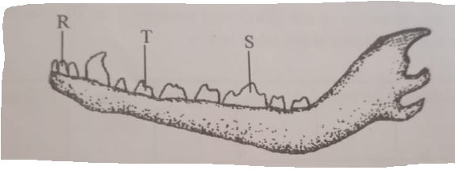
- Name the mode of nutrition of mammal whose jaw is shown. (1mk)
……………………………………………………………………………………………………………………………………………………………………………………………………
- State one structural and one functional difference between the teeth labeled R and T. (2mks)
………………………………………………………………………………………………………………………………………………………………………………………………………………………………………………………………………………………………………
…………………………………………………………………………………………………………………………………………………………………………………………………………………………………………………………………………………………………………………………………………………………………………………………………………
- ((i) Name the tooth labelled S. (1mk)
……………………………………………………………………………………………………………………………………………………………………………………………………
(ii) State how the tooth named in C (i) above is adapted to its function. (2mks)
………………………………………………………………………………………………………………………………………………………………………………………………………………………………………………………………………………………………………………………………………………………………………………………………………………………………………………………………………………………………
- The figure bellow is a cross-section of retinol cells of a mammalian eye.
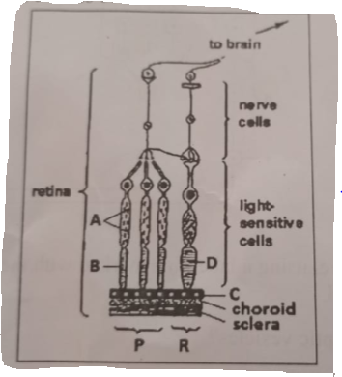
(a) Identify the retinol cells labeled P and R. (2mk)
………………………………………………………………………………………………………………………………………………………………………………………………………………………………………………………………………………………………………………………
(b) Label each of the parts marked A, B, C and D. (2mks)
………………………………………………………………………………………………………………………………………………………………………………………………………………………………………………………………………………………………………………………………………………………………………………………………………………………………
(c) Based on the diagram, explain why it takes long for the eye to adjust when one move from a
Lit room to a dark room. (3mks)
………………………………………………………………………………………………………………………………………………………………………………………………………………………………………………………………………………………………………………………………………………………………………………………………………………………………
(d)State structural difference between cell P and cell R. (1mk)
………………………………………………………………………………………………………………………………………………………………………………………………………………………………………………………………………………………………………………………………………………………………………………………………………………………………

SECTION B.

- The pressure in the flow of blood in a mammal was determined at two different vessels; X and Y. The data was taken within a period of 1 minute and was presented as follows.

Time in seconds | Blood pressure in
 | Vessel X | Vessel Y
0 | 160 | 320
10 | 165 | 360
20 | 170 | 320
30 | 180 | 400
40 | 170 | 360
50 | 160 | 320
60 | 160 | 360

(a) Plot the graph of blood pressure in both vessels against time in the same axis. (7mks)
(b) Describe the trend of each curve. (2mks)
………………………………………………………………………………………………………………………………………………………………………………………………………………………………………………………………………………………………………………………………………………………………………………………………………………………………
(c) From the graph, suggest the possible identity for:
(i) Blood vessel X. (1mk)
………………………………………………………………………………………………………………………………………………………………………………………………………………
(ii) Blood vessel Y. (1mk)
………………………………………………………………………………………………………………………………………………………………………………………………………………
(d) Give reason for your answer in (c) (i) and (ii) above. (2mks)
……………………………………………………………………………………………………………………………………………………………………………………………………………………………………………………………………………………………………………………………………………………………………………………………………………………………… (e)Explain a factor that would result in to an increase in blood pressure in both the blood vessels above. (2mks)
………………………………………………………………………………………………………………………………………………………………………………………………………………………………………………………………………………………………………………………
- State two structural differences between the two vessels mentioned in C above. (2mks)
………………………………………………………………………………………………………………………………………………………………………………………………………………………………………………………………………………………………………………………………………………………………………………………………………………………………
- Name two diseases of the circulatory system in humans. (2mks)
………………………………………………………………………………………………………………………………………………………………………………………………………………………………………………………………………………………………………………………………………………………………………………………………………………………………

- Other than, transport of substances state one other function of blood. (1mk)
………………………………………………………………………………………………………………………………………………………………………………………………………………………………………………………………………………………………………………………………………………………………………………………………………………………………
- (a) Discuss the economic importance of bacteria. (10mks)
(b) Discuss the adaptation of Schistosoma mansoni to its survival. (10mks)
- (a) Describe the photosynthetic theory. (10mks)
(b) Describe gaseous exchange in terrestrial plant. (10mks)
………………………………………………………………………………………………………………………………………………………………………………………………………………………………………………………………………………………………………………………………………………………………………………………………………………………………
………………………………………………………………………………………………………………………………………………………………………………………………………………………………………………………………………………………………………………………………………………………………………………………………………………………………
………………………………………………………………………………………………………………………………………………………………………………………………………………………………………………………………………………………………………………………………………………………………………………………………………………………………
………………………………………………………………………………………………………………………………………………………………………………………………………………………………………………………………………………………………………………………………………………………………………………………………………………………………
………………………………………………………………………………………………………………………………………………………………………………………………………………………………………………………………………………………………………………………………………………………………………………………………………………………………
………………………………………………………………………………………………………………………………………………………………………………………………………………………………………………………………………………………………………………………………………………………………………………………………………………………………
………………………………………………………………………………………………………………………………………………………………………………………………………………………………………………………………………………………………………………………………………………………………………………………………………………………………
………………………………………………………………………………………………………………………………………………………………………………………………………………………………………………………………………………………………………………………………………………………………………………………………………………………………
………………………………………………………………………………………………………………………………………………………………………………………………………………………………………………………………………………………………………………………………………………………………………………………………………………………………
………………………………………………………………………………………………………………………………………………………………………………………………………………………………………………………………………………………………………………………………………………………………………………………………………………………………
………………………………………………………………………………………………………………………………………………………………………………………………………………………………………………………………………………………………………………………………………………………………………………………………………………………………
………………………………………………………………………………………………………………………………………………………………………………………………………………………………………………………………………………………………………………………………………………………………………………………………………………………………
………………………………………………………………………………………………………………………………………………………………………………………………………………………………………………………………………………………………………………………………………………………………………………………………………………………………
………………………………………………………………………………………………………………………………………………………………………………………………………………………………………………………………………………………………………………………………………………………………………………………………………………………………
………………………………………………………………………………………………………………………………………………………………………………………………………………………………………………………………………………………………………………………………………………………………………………………………………………………………
………………………………………………………………………………………………………………………………………………………………………………………………………………………………………………………………………………………………………………………………………………………………………………………………………………………………
………………………………………………………………………………………………………………………………………………………………………………………………………………………………………………………………………………………………………………………………………………………………………………………………………………………………
………………………………………………………………………………………………………………………………………………………………………………………………………………………………………………………………………………………………………………………………………………………………………………………………………………………………
………………………………………………………………………………………………………………………………………………………………………………………………………………………………………………………………………………………………………………………………………………………………………………………………………………………………
………………………………………………………………………………………………………………………………………………………………………………………………………………………………………………………………………………………………………………………………………………………………………………………………………………………………
………………………………………………………………………………………………………………………………………………………………………………………………………………………………………………………………………………………………………………………………………………………………………………………………………………………………
………………………………………………………………………………………………………………………………………………………………………………………………………………………………………………………………………………………………………………………………………………………………………………………………………………………………
………………………………………………………………………………………………………………………………………………………………………………………………………………………………………………………………………………………………………………………………………………………………………………………………………………………………
………………………………………………………………………………………………………………………………………………………………………………………………………………………………………………………………………………………………………………………………………………………………………………………………………………………………

