** MARANDA HIGH SCHOOL**

**Kenya Certificate of Secondary Education**

**MOCK EXAMINATIONS 2022**

**231/1 Biology (Theory) Paper 1**

**September, 2022 Time: 2 Hours**

**Name**: ………………………………………….…….…… **Adm** **No**: ………………

**Class**: ………………**Candidate’s** **Signature**: ………..…….. **Date: 7th September, 2022**

**Time: 2.00-4.00 PM** **Instructions to candidates**

1. *Write your name and admission number in the spaces provided above.*
2. *Sign in the spaces provided above.*
3. *Answer* ***ALL*** *questions in the spaces provided.*
4. *All workings* ***must*** *be clearly shown where necessary.*
5. *This paper consists of* ***12*** *Printed pages.*
6. *Candidates should check the question paper to ensure that all the pagess are printed as indicated and no questions are missing*

FOR EXAMINERS USE ONLY

|  |  |  |
| --- | --- | --- |
| **Question** | **Maximum Score** | **Candidates Score** |
| **1 – 30** | **80** |  |

**1**. Name the organelle that performs each of the following functions in a cell

(i) Protein synthesis. (1mark)

………………………………………………………………………………………………………..............

(ii) Transport of cell secretions. (1mark)

………………………………………………………………………………………………………………

**2**. (a) Define the term ‘parthenocarpy’. (1mark)

………………………………………………………………………………………………….……………………………………………………………………………………………………………………………..

(b) Name **two** plant growth hormones that promote parthenocarpy. (2marks)

………………………………………………………………………………………………………………………………………………………………………………………………………………………………

**3**. The diagram below shows a longitudinal section of mammalian skin.

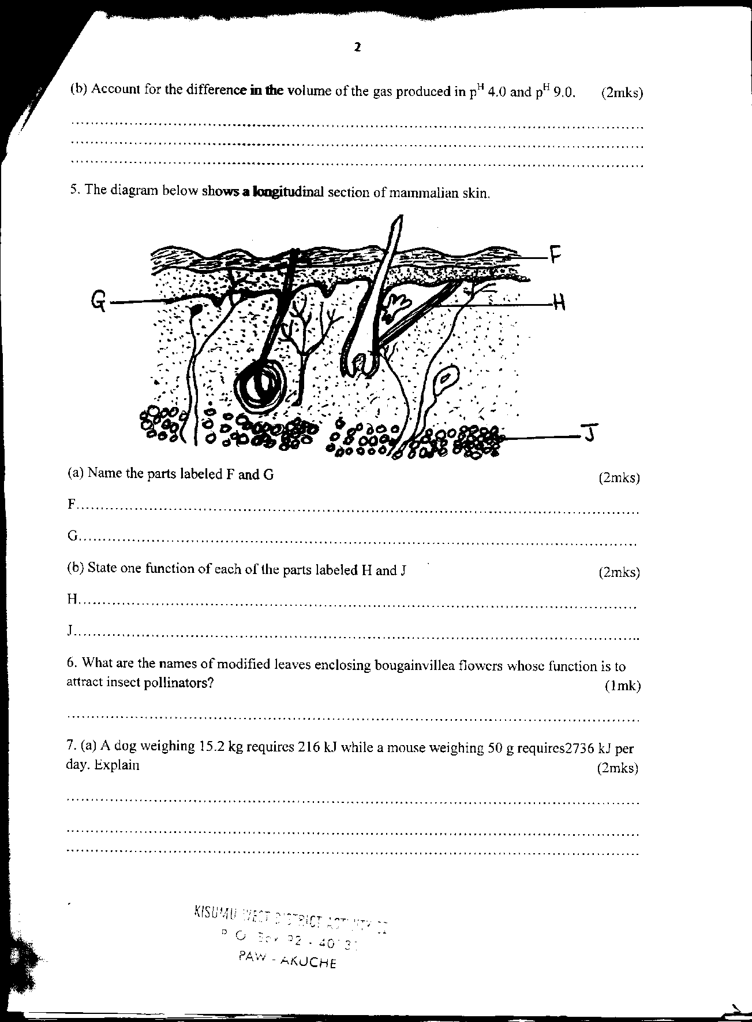

a) Name the parts labelled **F** and **G.** (2marks)

**F**……………………………………………………………………………………………….......................

**G**……………………………………………………………………………………………………………

b) State **one** function of each of the parts labelled **H** and **J** (2marks) H……………………………………………………………………………………………………………

J ……………………………………………………………………………………………………………...

4. (a) State **two** characteristics used to divide the phylum Arthropoda into classes (2marks) ………………………………………………………………………………………………………………………………………………………………………………………………………………………………………………………………………………………………………………………………………………

(b)Name the class with the largest number of individuals in the phylum Arthropoda. (1mark)

………………………………………………………………………………………………………..............

5. The diagram below represents a longitudinal section of a fruit

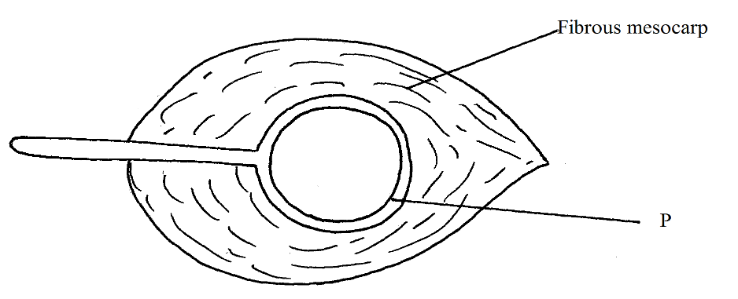

(i)Identify the mode of dispersal (1mark)

………………………………………………………………………………………………………………

(ii) Describe **two** adaptations of the fruit to its mode of dispersal (2marks)

………………………………………………………………………………………………………………

………………………………………………………………………………………………………………

………………………………………………………………………………………………………………

………………………………………………………………………………………………………………

6. (a) What causes the following diseases?

(i)Diabetes mellitus. (1mark)

………………………………………………………………………………………………………..............

(ii) Diabetes insipidus. (1mark)

………………………………………………………………………………………………………………

b) An individual shows the symptoms for diabetes mellitus, how would you determine in the school laboratory whether they are positive for the condition? (2marks)

………………………………………………………………………………………………………………

………………………………………………………………………………………………………………

……………………………………………………………………………………………………………… 7. (a) Give **two** examples of natural selection in action. (2marks)

………………………………………………………………………………………………………………

………………………………………………………………………………………………………………

……………………………………………………………………………………………………………… (b) List **two** features that make man the most dominant species on earth. (2marks)

………………………………………………………………………………………………………………………………………………………………………………………………………………………………

………………………………………………………………………………………………………………

………………………………………………………………………………………………………………

8.Study the diagram **below** of a neurone in human being.

(a)Identify the neurone. (1mark)

………………………………………………………………………………………………………………

(b)Name the part labeled **B** (1mark)

………………………………………………………………………………………………………………

9. Study the diagram of the mammalian tooth **below** and answer the questions that follow.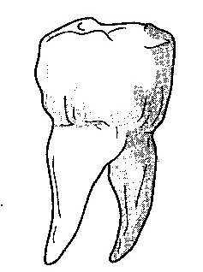

(a) Identify the tooth. (1mark)

………………………………………………………………………………………………………………

(b) Give a reason for your answer in (a) above. (1mark)

………………………………………………………………………………………………………………

………………………………………………………………………………………………………………

(c) State **one** adaptation of the tooth to its function. (1mark)

………………………………………………………………………………………………………………

………………………………………………………………………………………………………………

10. It was found that during germination of pea seeds 9.3cm3 of carbon (iv) oxide was produced while 9.1cm3 of oxygen was used up.

a) Calculate the respiratory quotient (RQ) of the reaction taking place. (2marks)

………………………………………………………………………………………………………………

………………………………………………………………………………………………………………

………………………………………………………………………………………………………………

………………………………………………………………………………………………………………

………………………………………………………………………………………………………………

b) Explain why it is difficult to measure respiratory quotient in plants during the day. (1mark)

………………………………………………………………………………………………………………

………………………………………………………………………………………………………………

………………………………………………………………………………………………………………

11. The diagrams below represent two types of bacteria species that causes some human diseases.

**A 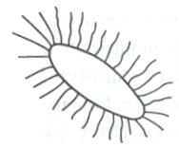 B** 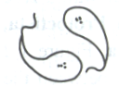

Identify each bacterium and state the disease it causes. (4 marks)

**A:** ....................................................................................................................................................................

Disease it causes:……….................................................................................................................................

**B:** .....................................................................................................................................................................

Disease it causes:............................................................................................................................................

12. a) What is metamorphosis? (1mark)

………………………………………………………………………………………………………………

………………………………………………………………………………………………………………

b) What is the biological significance of metamorphosis to an insect? (2marks)

………………………………………………………………………………………………………………

………………………………………………………………………………………………………………

………………………………………………………………………………………………………………

13. Study and complete the table below. (3mks)

|  |  |  |
| --- | --- | --- |
| Feature | Monocot | Dicot |
| a) Number of stamens |  |  |
| b) Arrangement of vascular bundle in stem |  |  |
| c) Type of root |  |  |

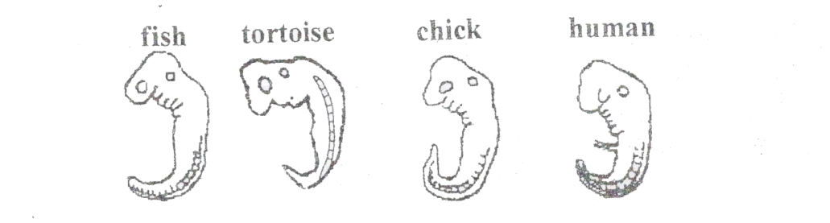14. The diagrams below show embryos of certain vertebrates animals. Study them and answer the question that follows.

1. Mention two observable structural features in these embryos that suggest that they have a common ancestral origin. (2marks)

………………………………………………………………………………………………………………

………………………………………………………………………………………………………………

………………………………………………………………………………………………………………

(b)What phenomenon in organic evolution is exhibited by these diagrams of embryos? (1mark) ………………………………………………………………………………………………………………

………………………………………………………………………………………………………………

………………………………………………………………………………………………………………

15. What is meant by the terms? (2marks)

a) Hypogynous flower

………………………………………………………………………………………………………………

………………………………………………………………………………………………………………

1. Dichogamy

………………………………………………………………………………………………………………

………………………………………………………………………………………………………………

16. What is the main difference between the phloem tissues of sub divisions Gymnospermaphyta and Angiospermaphyta. (1mark)

………………………………………………………………………………………………………………

………………………………………………………………………………………………………………

17. State **two** ways in which the skin of a frog is adapted for gaseous exchange. (2marks)

………………………………………………………………………………………………………………

………………………………………………………………………………………………………………………………………………………………………………………………………………………………

………………………………………………………………………………………………………………

18. What would be the effect of the following treatments on the nerve transmission?

(i) Inducing the axon with metabolic inhibitors. (1mark)

………………………………………………………………………………………………………………

………………………………………………………………………………………………………………

(ii) Removing myelin sheath from a nerve fiber. (1mark)

………………………………………………………………………………………………………………………………………………………………………………………………………………………………

………………………………………………………………………………………………………………

19. Give one reason why blood leaving the lungs may not be fully oxygenated (1mark)

………………………………………………………………………………………………………………………………………………………………………………………………………………………………

………………………………………………………………………………………………………………

20. What is the importance of retina in vision? (2marks) ………………………………………………………………………………………………………………

………………………………………………………………………………………………………………

………………………………………………………………………………………………………………

………………………………………………………………………………………………………………………………………………………………………………………………………………………………

21.The diagram below represents a simple endocrine feedback mechanism in human male.

PITUITARY GLAND

HORMONE **X**  HORMONE **Y**

TESTES

(a)Name the hormone labelled **X** (1mark)

………………………………………………………………………………………………………………

(b)State **two** differences that may be observed between a normal male and one who is incapable of producing hormone labelled **Y**. (2marks)

………………………………………………………………………………………………………………

………………………………………………………………………………………………………………

22. a) Name the cartilage found between the bones of the vertebral column. (1mark)

………………………………………………………………………………………………………………

b) State the function of the cartilage named in (a) above. (1mark)

………………………………………………………………………………………………………………

………………………………………………………………………………………………………………

………………………………………………………………………………………………………………

23. The cells shown below were obtained from two different plant cells which were immersed in 2% and 25% salt solutions ****(a)Which of the two cells **A** and **B** was immersed in 2% salt solution? (1mark)

………………………………………………………………………………………………………………

(b) Comment on the nature of 25% salt solution in relation to the cell sap. (1mark)

………………………………………………………………………………………………………………

(c)What biological phenomenon leads to the observation made in **A**. (1mark)

………………………………………………………………………………………………………………

………………………………………………………………………………………………………………

………………………………………………………………………………………………………………

24. Name **one** structures found in the cortex of the kidney (1mark)

………………………………………………………………………………………………………………

………………………………………………………………………………………………………………

………………………………………………………………………………………………………………

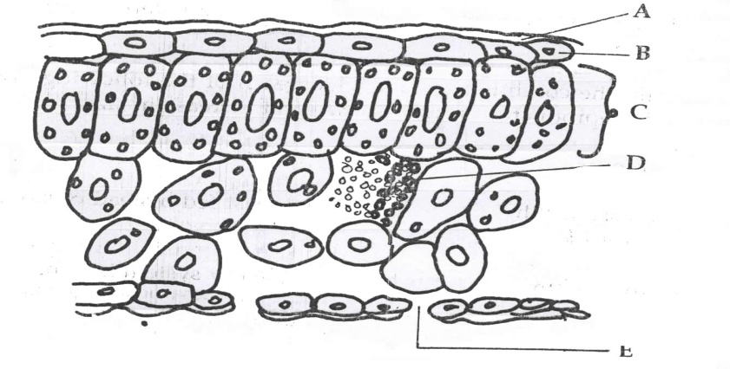 25. The diagram below shows the internal structure of a leaf

**E**

(a)Name the part labelled **B** (1mark)

………………………………………………………………………………………………………………

………………………………………………………………………………………………………………

(b)State the function of the part labelled **C**. (1mark)

………………………………………………………………………………………………………………

………………………………………………………………………………………………………………………………………………………………………………………………………………………………

(c) State **two** difference between xerophytic and hydrophytic leaves. (2marks)

|  |  |
| --- | --- |
| Xerophytic | Hydrophytic |
|  |  |
|  |  |

26. a) Distinguish between gaseous exchange and respiration. (1mark)

………………………………………………………………………………………………………………

………………………………………………………………………………………………………………

………………………………………………………………………………………………………………

………………………………………………………………………………………………………………

b) Explain the disadvantages of anaerobic respiration in plant roots. (2marks)

………………………………………………………………………………………………………………

………………………………………………………………………………………………………………

………………………………………………………………………………………………………………

27. a) Suggest the significance of the following adaptations in bony fish.

(i) Flexible vertebral column (1mark)

………………………………………………………………………………………………………………

………………………………………………………………………………………………………………

(ii) Presence of swim bladder (1mark)

………………………………………………………………………………………………………………

………………………………………………………………………………………………………………

b) State **two** features which reduce resistance in fish during swimming. (2marks)

………………………………………………………………………………………………………………

………………………………………………………………………………………………………………

28. State **two** protective feature of human eye. (2marks)

………………………………………………………………………………………………………………

………………………………………………………………………………………………………………

………………………………………………………………………………………………………………

29.State **two** differences between photosynthesis and respiration (2marks)

|  |  |
| --- | --- |
| **Photosynthesis** | **Respiration** |
|  |  |
|  |  |

30. Explain why malaria cannot be transmitted through blood transfusion (2marks)

………………………………………………………………………………………………………………

………………………………………………………………………………………………………………

………………………………………………………………………………………………………………

………………………………………………………………………………………………………………

**THIS IS THE LAST PRINTED PAGE**