OPENER EXAM: TERM 1 - 2023
BIOLOGY FORM 4
50 MARKS.
TIME 1HR 30 MIN. MARKING SCHEME.

- Name the organelles that perform each of the following functions: 2 MRKS
- Digestion and destruction of worn out organelles.
lysosomes
- Osmoregulation
Contractile vacoules

- a) In which kingdom do bacteria belong? 1MRK
Monera
- Give any two benefits of bacteria to man 2MRKS
Producing antibiotics; vaccines; hormones and in producing transigenic organisms in modern technology;

- Study the dental formula given below:
I 0; C 0 ; PM 3; M 2
4 0 3 3
(a) Identify with reasons the mode of feeding of the animals whose dental formula is
given above 3MRKS
Herbivorous; Absence of upper incisors and upper canines ;lack lower canines
(b) Calculate the total number of teeth in the mouth of the above animal. 1MRKS
15x2=30 teeth
- Explain why small mammals such as moles feed more frequently than larger ones such
as elephants 1MRKS
Small mammals have large surface area to volume ratio; hence lose heat quickly to environment; to replace the heat , lost, their metabolism is high making them to feed more frequently

- The flow diagram below represents blood clotting process
Prothrombum
Vitamin K
Platelets
Z
X
Ca²⁺
Y
Fibrinogen

a) Name the proteins represented by the letters; V, Y, Z 3MRKS
X- Thromboplastin
Y- Fibrin
Z-- Thrombin
b) State the importance of blood clotting 1MRK
Promotes wound healing; stops further loss of blood/ bleeding; prevents entry of
pathogens/ injection

c) Why doesn’t the physiological process above occur in undamaged blood
vessels 1MRK
Blood contain leparin/ anti clotting factor eight; that inhibits blood
coagulation

- State two major structural differences between fruit and a seed 2MRKS

A fruit has two scars while a seed has a single scar
Fruits are covered by epicarp while seeds have seed coats/testa

- The eggs of birds are relatively much larger than those of mammals. Explain. 2MRKS
In birds the embryo develops externally. It is totally dependent on food stored in the egg for its nourishment; In mammals the embryo receives nourishment from the mother through the placenta

- Differentiate between continuous and discontinuous variations 2MRKS
Continuous variation shows gradation in characteristic with intermediate; discontinuous shows distinct characteristics between organisms with no intermediate groupings;

- Members of the same species of organism tend to differ due to variation. State three causes of variation in organisms. 3MRKS
mutation;
intermixing of genes already in the population through sexual reproduction recombination;
crossing over during prophase of meosis I
interdependent assortment of chromosomes, during metaphase of meosis I

- Wekesa and Wanjiku who are siblings are both normal as their parents but have a hemophilic brother. Give the Genotype of their parents. 2MRKS

Father X^{H}Y ;
Mother X^{H}X^{h} ;
- There are at least 205 known sex – linked recessive disorder
- Name any two of them. 2MRKS
Colour blindness; haemophilia;
Sickle cell anaemia;

- State a reason why sex – linked recessive traits tend to effect the male child. 1MRK

Part of X chromosome has homologous portion on the Y chromosome therefore if the X has the recessive trait, it will show on the male phenotype
- State why if a mother has the trait all her sons will have it. 2MRKS

The son inherits the X chromosome from the mother while the daughter inherits the
X chromosome from the father;

- State the meaning of the following terms giving an example in each case: 2MRKS
- Sex-linked genes
Genes which are located on the sex- chromosomes and therefore are transmitted along with them. Example Haemophilia ; colour blindness;

- Multiple alleles

Where more than two genes control a particular characteristic/ trait;
Example ABO blood group system;

- Give an example of a sex-linked trait in human on: 2MRKS
Y – Chromosome
hairy pinna, pre-mature boldness; ; (any one)

- X – Chromosome

- haemophilia (bleeders disease); colour blindness; (any one)

- Study the genetic chart below showing the inheritance of the gene responsible for haemophilia in a family.
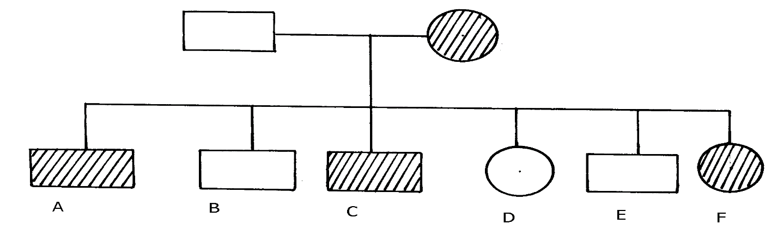

a) Write the genotype of individuals A, B, F 3MRKS A – X^{h}Y;
B – X^{H}Y;
F – X^{H}X^{h}
b) A member of this family labelled F marries a haemophiliac male. What will be the
phenotypic ratio of the offspring? Show your workings using a genetic cross.

X^{H} X^{h}; X X^{h};Y;
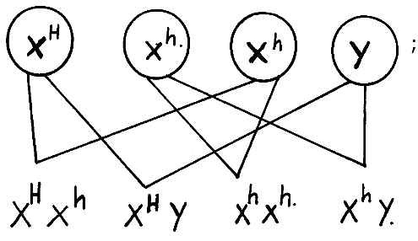

(b)

4MRKS
- Other than the condition stated above, state any other two common genetic disorders
that result from gene mutation. 2MRKS
Albinism; sickle cell anaemia; colour blindness; chondrodystrophic dwarfism;

- In man blood group inheritance is controlled by multiple alleles in which allele A is co dominant to allele B. a woman heterozygous for blood group A married a man heterozygous for blood group B
a) State the genotype of both parents 2MRKS Woman AO
Man BO

b) Using a punnet square, show the genotypes of F₁ generation. 4MRKS
Parental genotypes
i
 | A | O
B | AB | BO
O | AO | OO

c) State one application of knowledge of blood group inheritance in man 1MRK
Determining compatible blood groups in blood transfusion
Cases of disputed paternity settlement

