BIOLOGY PRACTICAL MARKING SCHEME
- You are provided with the following materials;
Substance labelled L
2cm³ Copper sulphate solution
2cm³Sodium hydroxide solution
2cm³ DCPIP solution
2cm³ Benedict’s solution
Source of heat
3 test tubes
3 droppers
You are provided with a substance labeled L. Make a solution of substance L by adding 20 ml of distilled water and stir thoroughly. Design an experiment to investigate the food materials present in L (9mks)
Substance | Chemical test | Procedure | Observations | Conclusion
L | DCPIP  Reject Vitamin C plus subsequent steps | Put 1cm³ of DCPIP into a test tube.  Add solution L dropwise; | Colour of DCPIP disappears/purple;  Reject DCPIP decolourised | DCPIP present;
L | Benedict’s  Reject Reducing sugars plus subsequent | Put 1cm³ of solution L into a test tube  Add 1cm³ of Benedict’s solution  Boil ; | Green ; | Traces /little reducing sugars present;  Reject Reducing sugars alone
L | Biuret’s  Reject Proteins plus subsequent | Put 1cm³ of solution L into a test tube  Add 1cm³ of Sodium Hydroxide solution  Add 1cm³ of Copper Sulphate solution; | (Light) purple; | Proteins present;

- State the importance of the food substances present in L to the human body. (2mks)
(a)Tied to the table
Proteins –used in formation of body tissues/enzymes/hormones
Glucose –oxidised by cells to release energy
Vitamin C-protection against diseases mark any 2
- Describe how the body deals with the substances mentioned in (a) above when they are in excess. (2mks)
Proteins –excess amino acids deaminated
Glucose –converted to glycogen and stored in liver cells
Vitamin C-excreted (as oxalates) mark any 2
2. Study the photographs below and answer the questions that follow.
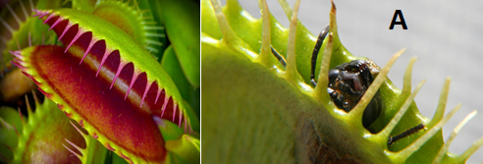
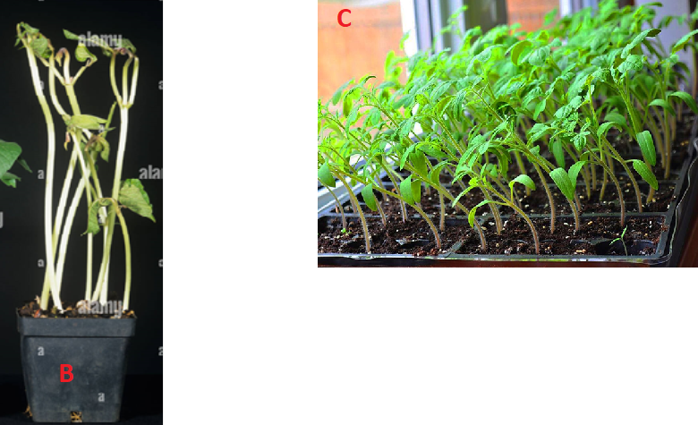
- (i) Identify the type of response exhibited by specimen A (1mk)
Haptonasty
(ii)What is the survival value of the response you have identified in (a)(i) above (1mk)
A way of obtaining some limited mineral nutrients
- (i) Identify the phenomenon exhibited by specimen B (1mk)
Etiolation
(ii) State the significance of the phenomenon in (b) (i) above (1mk)
To reach/search/seek/obtain light

- Explain how the response exhibited by seedlings in photograph C occurred (3mks)
Seedlings subjected to unilateral/ unidirectional source of light ;causing auxins to migrate / diffuse to the dark side of the shoot;/ high concentration of auxins on dark side causing faster growth; on that side than the lit side/ faster cell elongation/ faster cell enlargement/ faster cell growth on the side than the lit.
- Study the photograph below showing a certain trait in man.
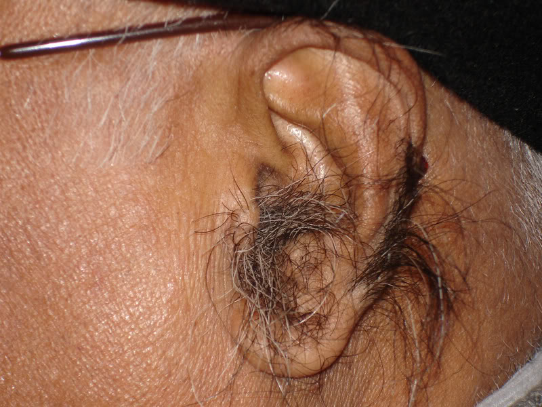
- Identify the trait exhibited in the photograph above (1mk)
Hairy pinna
- The trait you have identified in (d)(i) above is sex linked. In which chromosome is it contained (1mk)
Y
- Name any other sex linked trait in man (1mk)
Premature baldness
Colourblindness
Haemophilia

- The man in the photograph married a woman. Use a genetic cross to predict the offspring of the above marriage. Let Y^{H} represent the gene for the trait above. (4mks)

- The photographs below show certain chromosomal mutations.
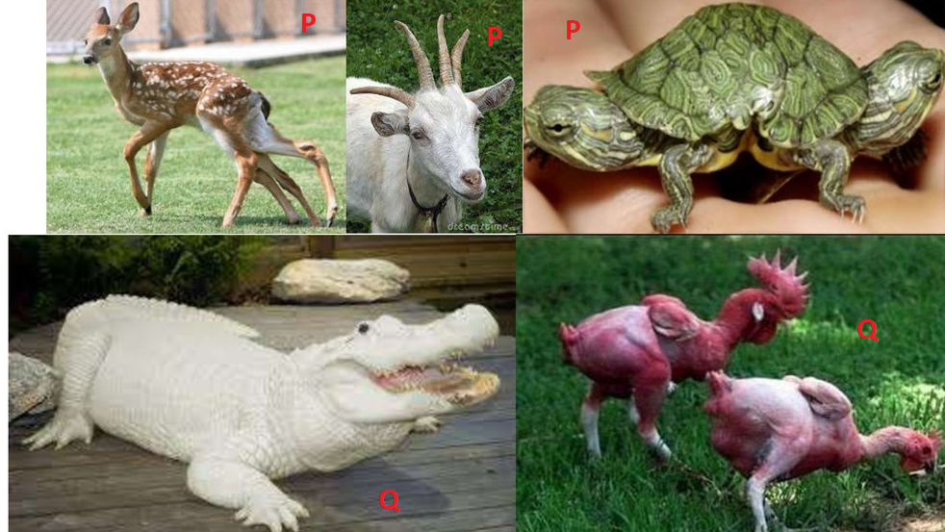
- Identify them
P Duplication
Q Deletion

3. Study the photographs below and answer the questions that follow.
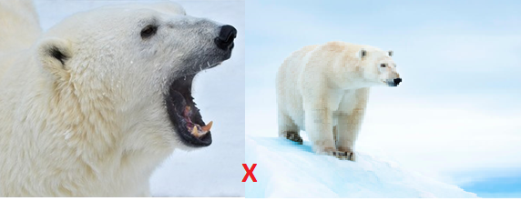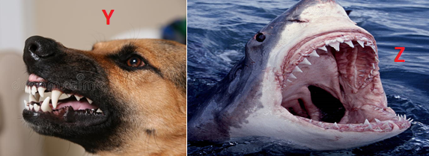
- Give two visible survival adaptive features for the organism in photograph X (2mks)
- Presence of ( large/long/curved) sharp/sharp pointed canine for piercing ;
- Camouflage/blend well with environment concealing/hiding themselves from their predators/prey ;
- Presence of fur to insulate against the low temperature
- Identify the dentitions exhibited in photograph Y and Z (2mks)
Y Heterodont
Z Homodont
- Study the photographs below showing a certain type of tooth and teeth arrangement in man.
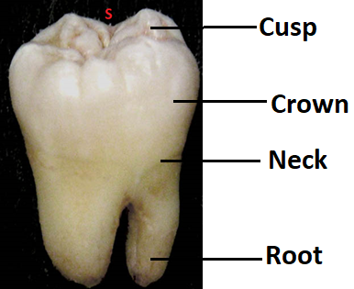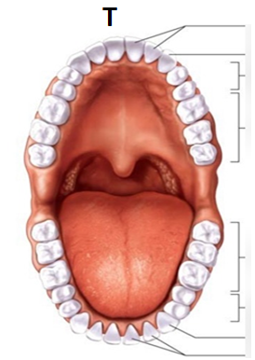
- Label any three parts of the tooth in photograph S (3mks)
- Give two observable adaptations of the tooth to its function (2mks)
- Broad surface to increase surface area for chewing
- Cusps /ridges to increase surface area for chewing
- Write the dental formula for the teeth arrangement in photograph T (1mk)
2 1 2 3
i — c - pm — m -
2 1 2 3
Reject
- If Commas and capital letters are used in the dental formula
- If Divisional line is missing in the dental formula

This is the last printed page

