BUNAMFAN CLUSTER EXAMINATION - 2022

Kenya Certificate of Secondary Education
231/3 – BIOLOGY(PRACTICAL) – Paper 3

June 2022 - 1 ¾ hours

Name………………………………………Adm No……

Class…………… Date……………………………
Name………………………………………Adm No…….............
Index Number.......…………….......... Date………………........
Instructions to Candidates
- Write your name, Admission number and your other details in the spaces provided above.
- Spend the first 15 minutes of the time allocated to read through the question paper before commencing your work
- Answer ALL the questions in the spaces provided.
- Additional pages must not be inserted
- For Examiner's Use Only
Question | Maximum Score | Candidate’s Score
1 | 13
2 | 13
3 | 14
Total Score | 40

- You are provided with the following materials;
- Specimen A
- Scalpel
- 50ml beaker
- Glass rod
- 8cm visking tubing
- 2 pieces of strings
- 20ml distilled water in a wash bottle
- 100ml beaker
- 10ml Iodine solution
- You are provided with a specimen labeled A. Make a transverse section of the specimen.
- Draw and label the section (3mks)

- What type of fruit is specimen A? (1mk)
……………………………………………………………………………………………………….
- Slice off about 2cm thick disc from the specimen. Peel it. Place the piece into a beaker and mash it into a paste using a glass rod. Add 20ml of distilled water and stir. Tie one end of the transparent tubing provided. Decant the extract into the tubing and tie the other end tightly, ensuring there is no leakage.
Immerse the tubing with its contents in a 100ml beaker containing Iodine solution for 20 minutes.
- Record your observations in the table below (4mks)
 | Extract inside visking tubing | Iodine solution outside the visking tubing
Before the experiment
After the experiment

- Explain the results obtained from c(i) above. (5mks)
………………………………………………………………………………………………………………………………………………………………………………………………………………………………………………………………………………………………………………………………………………………………………………………………………………………………………………………………………………………………………………………………………

- Study the photographs below and answer the questions that follow.
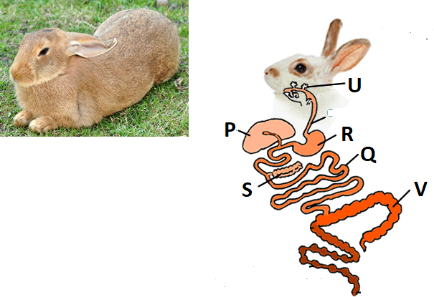
- With observable reasons identify the class of the specimen in the photograph .
- Class…………………………………………………………………………..(1mk)
- Reasons (2mks)
…………………………………………………………………………...……….
……………………………………………………………………………………
- (i) Name the structures labeled (4mks)
P …………………………………………………………………………………………...
Q …………………………………………………………………………………………...
R …………………………………………………………………………………………...
S …………………………………………………………………………………………..
- State the function of the parts labeled (2mks)
U …………………………………………………………………………………………...
V …………………………………………………………………………………………...

- Study the photographs below depicting plants growing in different habitats.
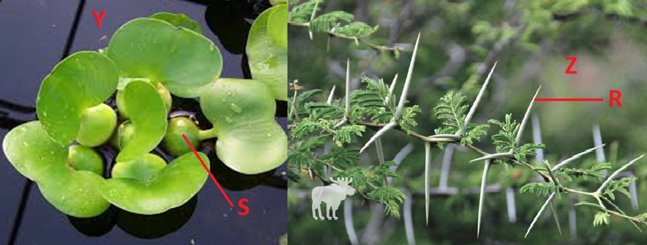
- Identify the habitats in which they are found (2mks)
Y …………………………………………………………………………………………...
Z …………………………………………………………………………………………...
- State the significance of the following structures found in the specimens shown above (2mks)
R …………………………………………………………………………………………...
S …………………………………………………………………………………………...

3. Below are photographs showing some observable features of animals
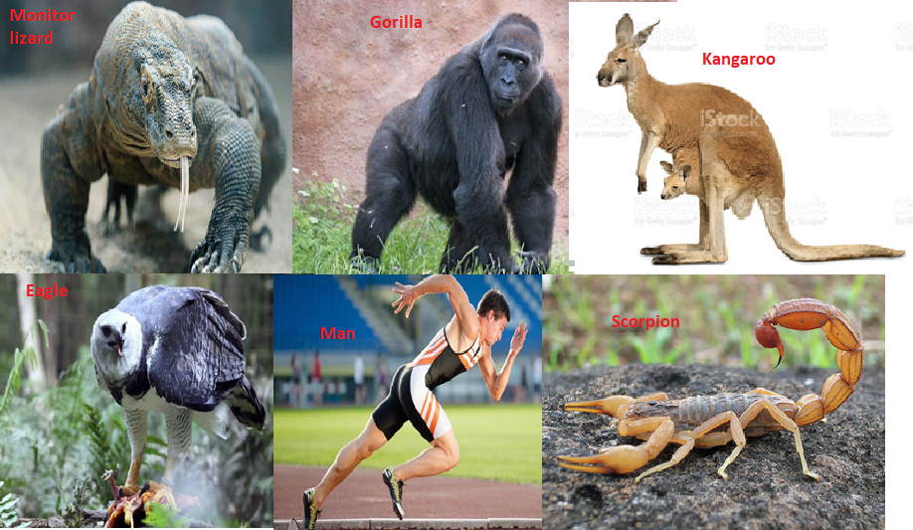
- Using the features in the order given below, construct a dichotomous key that can be used to identify the specimens in the photographs. (10mks)
- Presence or absence of backbone
- Presence or absence of wings
- Presence or absence of scales
- Presence or absence of pouch
- Bipedal or quadripedal

………………………………………………………………………………………………
………………………………………………………………………………………………
………………………………………………………………………………………………
………………………………………………………………………………………………
………………………………………………………………………………………………
………………………………………………………………………………………………
………………………………………………………………………………………………
………………………………………………………………………………………………
………………………………………………………………………………………………
………………………………………………………………………………………………
- Study the photographs below showing blood vessels in man.
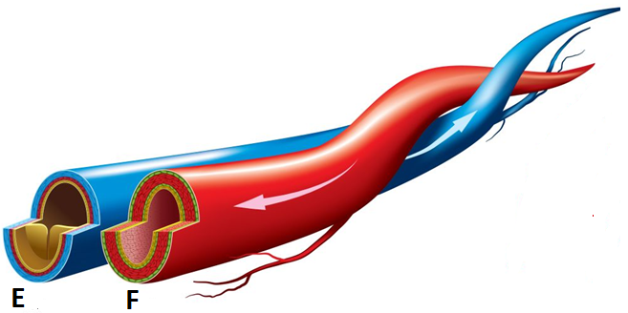
- Using observable features identify the blood vessels (2mks)
E …………………………………………………………………………………………...
F …………………………………………………………………………………………...
- Using observable features only, give two differences between the two blood vessels (2mks)
E | F

THIS IS THE LAST PRINTED PAGE

