BIOLOGY
Paper 2
JUNE 2022
BUNAMFAN FORM 4 MARKING SCHEME
1 Study the diagram below and answer the questions that follow
- Identify the structure (1mks)
Villus; (rej. Wrong spp or villi)
- State the role of the part labelled R (1mk)
Secrete mucus with an alkaline pH which protects ileum from corrosion by enzymes/serves to neutralize chyme from the stomach;
c) A student took a meal of lean meat. Briefly describe the digestion of the food substance where this structure is found. (3mks)
Arrival of chyme in the ileum stimulates secretion of intestinal juice/succus entericus; which mixes with the food; It contains peptidase which breaks down peptides into amino acids;
(d)What is the role of the following: enterokinase and cholecystokinin in digestion? (2mk)
Enterokinase: Activates inactive trypsinogen to active form trypsin;
cholecystokinin:.causes gall bladder to release bile juice into duodenum; stimulates the pancreas to secrete pancreatic enzymes (reject without terms like stimulate/causes);
e) State the deficiency disease associated with lack of vitamin B2 (1mk)
pellagra; (rej wrong spp).
2 The diagram below shows how gaseous exchange occurs across the gills in fish
- (i) Name the type of flow shown above (1mk)
Counter current flow system
(ii) Explain the advantage of the above flow named in a(i) above. (1 Marks)
Maintains a steep concentration gradient ensuring efficient gaseous exchange;
- If the fish is removed from water it dies immediately. Explain why (2mks)
Fish uses dissolved oxygen for gaseous exchange; gill filament epithelium dries up; gill filaments clamp together; surface area for gaseous exchange is reduced; oxygen lacks moist surface for dissolution causing death (due to suffocation)
c) Explain mechanism of gaseous exchange in frog through the skin (4mks)
The frog has a thin and moist skin; Oxygen dissolves in the moisture and then diffuses through the skin;. There is a dense network of blood capillaries beneath the skin which transport the diffused gas/oxygen into the body tissues;. Carbon (IV) oxide in the blood diffuses out of the blood capillaries through the moist skin into the surrounding water and air;
3 a) L1 Hypotonic solution
L2 Hypertonic solution
b) L1 - Inner cells gained water by Osmosis; hence increased in length; epidermal cells did not gain water because they are covered by a water proof cuticle leading to curvature.
L2 - Inner cells lost water by osmosis; leading to (flaccidity) decrease in length; epidermal cells did not lose water due to waterproof leading to curvature
(c) Absorption of water by the roots;
Opening and closing of the stomata;

4. a (i) Structural similarity.
- Both show the pent dactyl limb structure; (1mk)

ii) Adaptational difference.
-Human arm has five digits separated into four fingers and an opposable thump for grasping
-The bat wing has five digits which are long and spread apart to support a large membranous wing for flight; (2mks)

b) Different shapes and sizes of beaks in birds;
Different feet structure in birds; (2mks)

c) Chemical evolution explains the origin of life as having occurred when simple Chemical compounds reacted to form the simplest life forms; organic evolution is the progressive development of complex organisms from simple pre-existing life forms over a long period of time; (2mks)

(d)Paleontology; (1mk)
5.
Parental Genotype R W X R W;
R
W
R
W
R R
R W
R W
W W
Gametes ;

Fertilization
;

F₂ genotypes
Phenotypic ratio 1 Red : 2 Roan : 1 White;
Rej. 1 : 2 : 1 only
(b) Work out the genotypic ratio of a cross between F₁ offspring and white bull. (3mks)
Parental genotypes R W X W W;
R
W
W
W
R W
R W
W W
W W
Gametes ;

F1 Genotype
Genotype 2R W : 2W W
Ratio 1RW : 1WW; Rej. Ratio only.
(c) Comment on the gene(s) controlling the colour of coats in cattle mentioned above. (1mk)
Gene for red colour coat and white colour coat are codominant/ have equal dominance;

a) 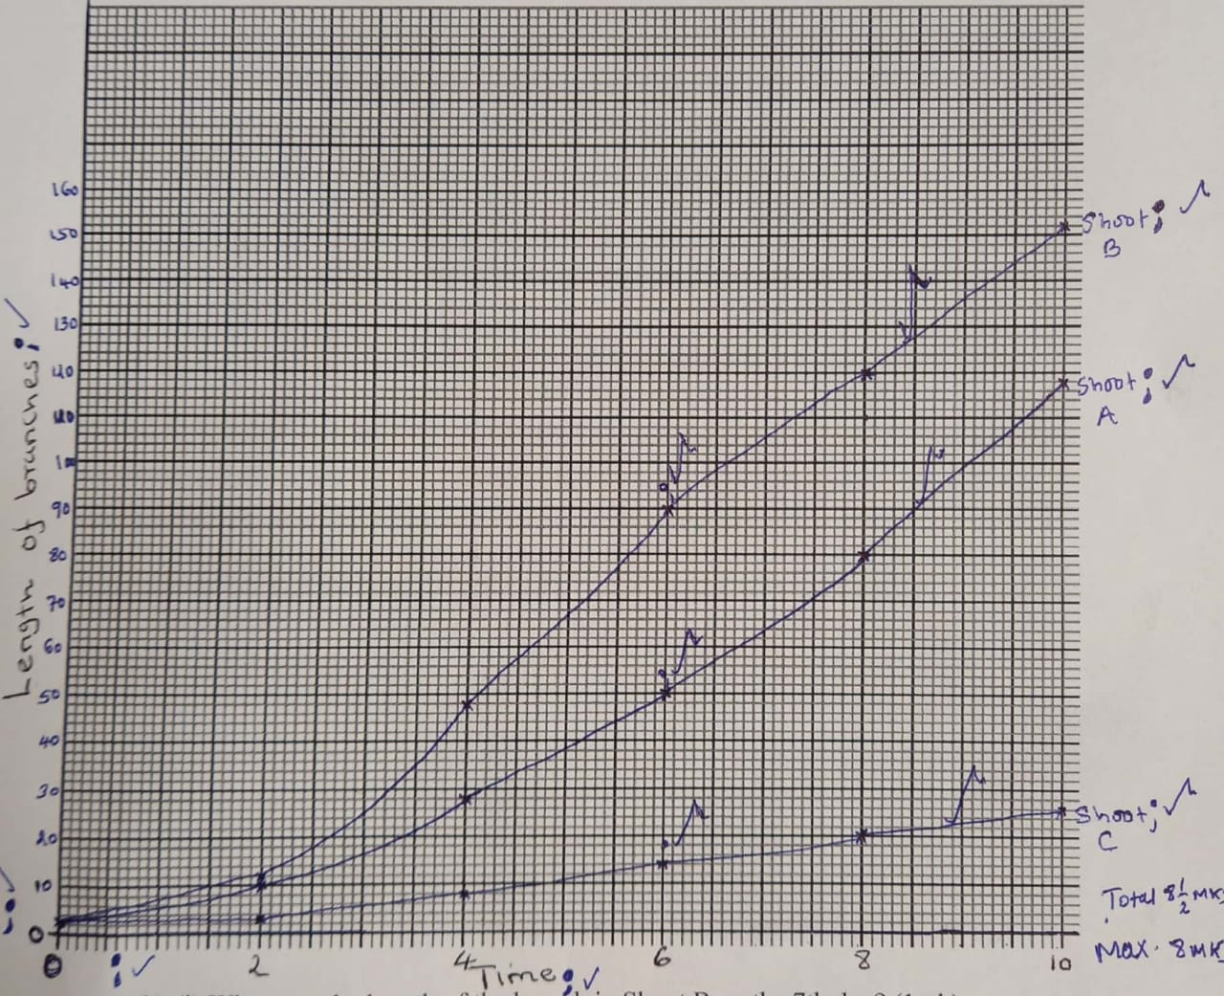
b) i) 106
ii) 109
c) Shoot A: The tip of the shoot which was removed contained Indole acetic acid (IAA) which causes apical dominance/inhibit growth/development of lateral buds; hence lateral buds sprouted/formed/grew;
Shoot B: The gibberellic acid which was added on the cut promoted the formation of lateral branches on the stem; hence the fast growth of branches on shoot B.
Shoot C: The shoot tip which remained intact contains IAA which inhibits growth/development of lateral buds; hence little change of length of lateral buds;
d) Control experiment;
e) Increase in productivity since more lateral branches are formed;
f) Promote cell division;
Induce germination in plants;
7. Pollen grains land on to the stigma; and adhere to it as a result of the stigma cells secreting a sticky substance; it absorbs nutrients; and germinates forming a pollen tube; the pollen tube grows down the style to the ovary; deriving nourishment from the surrounding tissues; the pollen tube has tube nucleus at the tip; and generative nucleus immediately behind it; As the tube grows downwards into the ovary the generative nucleus divides mitotically; to give rise to two nuclei; which represent the male gamete; the pollen tube penetrates the ovule/embryo sac through the microphyle/chalaza; after the pollen tube enters the embryo sac, the tube nucleus disintegrates; leaving a clear passage for the entry of the male nucleic (The two male nucleic) then enters the embryo sac; where one fuses with the egg (cell) nucleus to form diploid zygotes; which develops into an embryo; the other male nucleus fuses with the two polar nucleic; to form a triploid nucleus/primary endosperm; nucleus ; which becomes the endosperm; this is called double fertilization. Acc egg cell/ovum Vegetative nucleus/tube nucleus
20mks max 15
b) Integument changes into seed coat/test;
Zygote into embryo;
Ovary wall into pericarp;
Ovary into fruit;
Ovule into seed;
Triploid nucleus into endosperm;
Style dries up/fall of leaving a scar; corolla dries up (falls off); stamen dry up; ( rej degeration/disinergrates) 9mks max 5

8. - It is muscular/has cardiac muscles; which are myogenic (does not need nervous Stimulation) to pump blood;
- It is supplies by vagus and a sympathetic nerve; which controls the rate of heart beat;
(Depending on body’s physiological requirements)
- It has tricuspid valves and bicuspid valves; (between atrium and ventricles) which
Prevent back flow of the blood into the right and left ventricles respectively.
- Present of valve tendons attached to the walls of ventricles and to the atrium
Ventricular walls; to prevent atria-ventricular valves from due to changes in the
Pressure in the ventricles;
- Heart is supplied by coronary artery; which supplies food and oxygen to the cardiac
Muscle for their pumping action; the coronary vein; in heart removes metabolic wastes;
- The heart is enclosed by the pericardium membrane; that secretes a fluid which lubricates it (reducing friction on the walls as it bumps);
- The heart is divided into two by the atria-ventricular septum; that prevent mixing of
Oxygenated blood and deoxygenated blood;
- The left ventricles has a thick muscular wall; to pump blood at higher pressure to the
Distant body issues;
- The outer part of the pericardium has a fatty layer; which act as a shock absorber; keeps the heart in position.
- The Sino Atrial Node (S.A.N) the pacemaker region); which initiate the wave of contraction leading into contraction and relaxation of muscles; the arterial-ventricular
Node; in the heart spreads out waves of contraction throughout the heart creating the heart beat;

