BUNAMFAN CLUSTER EXAMINATION - 2022

Kenya Certificate of Secondary Education
231/2 – BIOLOGY – Paper 2
June 2022 - 2 hours
Name………………………………………Adm No……
Class…………… Date……………………………
Instructions to Candidates
- This paper consists of two sections; A and B.
- (b) Answer all the questions in section A in the spaces provided after each question.
(c) In section B answer question 6 (compulsory) and either question 7 or 8 in the spaces
provided after question 8.
(d) Candidates should answer the questions in English
For Examiner’s Use Only
1
2
3
4
5
6
TOTAL

SECTION A (40MKS)
1. Study the diagram below and answer the questions that follow
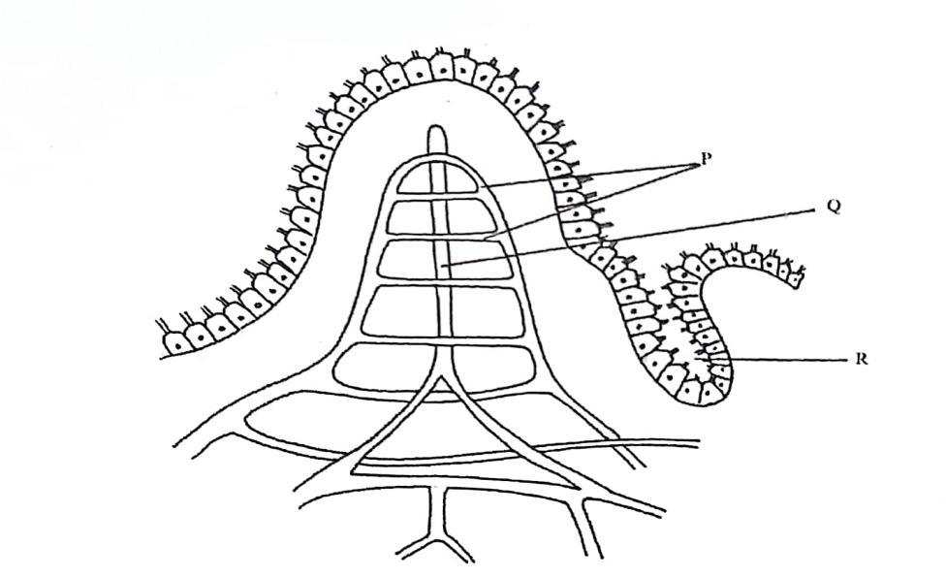
- Identify the structure (1mks)
………………………………………………………………………………………………………
- State the role of the part labeled R (1mk)
………………………………………………………………………………………………
c) A student took a meal of lean meat. Briefly describe the digestion of the food substance where this structure is found (3mks) …………………………………………………………………………………………………………………………………………………………………………………………………………………………………………………………………………………………………………………………………………………………………………………………………………………………………………………………………………………………………………………...............................
(d)What is the role of the following: enterokinase and cholecystokinin in digestion? (2mk)
Enterokinase. ……………………………………………………………………………………………………………………………………………………………………………………………………………..
Cholecystokinin…………………………………………………………………………………………………………………………………………………………………………………………
e) State the deficiency disease associated with lack of vitamin B₂ (1mk) ………………………………………………………………………………………………………
2. The diagram below shows how gaseous exchange occurs across the gills in fish.
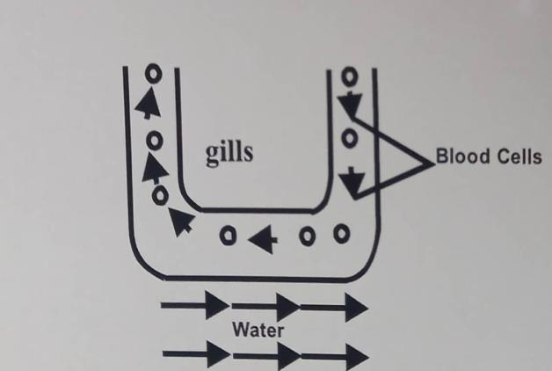
- i Name the type of flow shown above (1mk)
………………………………………………………………………………………………
ii Explain the advantage of the above flow named in a(i) above. (1mk) ………………………………………………………………………………………………………………………………………………………………………………………………………………
(b) If the fish is removed from water it dies immediately. Explain why (2mks) ………………………………………………………………………………………………………………………………………………………………………………………………………………
c) Explain mechanism of gaseous exchange in frog through the skin (4mks) …………………………………………………………………………………………………………………………………………………………………………………………………………………………………………………………………………………………………………………………………..........................................................................................................................................
3. A freshly obtained stem from herbaceous measuring 4cm long was split lengthwise to obtain two similar pieces. The pieces were placed in two different solutions of different concentrations in petri dishes (l1 and L2) for 30 minutes. The appearance after 30 minutes is as shown.

- State the type of solutions in which L₁ and L₂ was placed (2mks)
………………………………………………………………………………………………………………………………………………………………………………………………
- Account for the appearance of the pieces in solutions L₁ and L₂ (4mks) ………………………………………………………………………………………………………………………………………………………………………………………………
………………………………………………………………………………………………………………………………………………………………………………………………
………………………………………………………………………………………………………………………………………………………………………………………………
- State two significance of the biological process involved in the experiment.(2mks)
………………………………………………………………………………………………………………………………………………………………………………………………

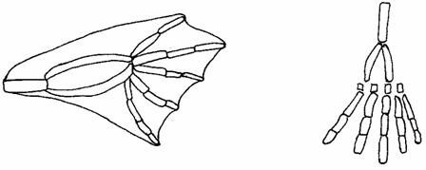4 .The diagram below shows structures of the bat wing and human arm.
Wing membrane

a) These structures are thought to have same ancestral origin. State one structural similarity and one adaptation difference between the two.
i) Structural similarity. (1mk)
………………………………………………………………………………………………………………………………………………………………………………………………………………
ii) Adaptation difference. (2mks)
………………………………………………………………………………………………………………………………………………………………………………………………………………
(b)Give two other examples of structures in nature that show the type of evolution as in (a) above. (2mks)
………………………………………………………………………………………………………………………………………………………………………………………………………………
(c)Distinguish between the terms ‘chemical evolution’ and ‘organic evolution’. (2mks)
………………………………………………………………………………………………………………………………………………………………………………………………………………
(d) What is the study of fossils called? (1mk)
…………………………………………………………………………………………………….

5. Pure breed of red cows and pure breed of white bulls were crossed to give F₁ calves which had a mixture of red and white coat known as roan. The F₁ were selfed.
(a) Using letter R to represent gene for red colour and W to represent gene for white colour work out the phenotypic ratio of F₂. (4mks)

(b) Work out the genotypic ratio of a cross between F₁ offspring and white bull. (3mks)

(c) Comment on the gene(s) controlling the colour of coats in cattle mentioned above. (1mk)
……………………………………………………………………………………………………

SECTION B (40MKS)
Answer question 6 (compulsory) and either question 7 or 8 in the spaces provided after question 8.
6. An experiment was carried out to investigate the effects of hormones on growth of lateral buds of three pea plants. The shoots were treated as follows; Shoot A – Apical bud was removed Shoot B – Apical bud was removed and gibberellic acid placed on the cut shoot.
Shoot C - Apical bud was left intact.
The length of branches developed from lateral buds was determined at regular intervals. The results obtained are as shown in the table below:
TIME IN DAYS | SHOOT A | SHOOT B | SHOOT C
0 | 3 | 3 | 3
2 | 10 | 12 | 3
4 | 28 | 48 | 8
6 | 50 | 90 | 14
8 | 80 | 120 | 20
10 | 118 | 152 | 26

- Using the same axes, draw graphs to show length of branches against time. (8mks)
- (i) What was the length of the branch in Shoot B on the 7th day? (1mk) …………………………………………………………………………………………

(ii)What would be the expected length of the branch developing from Shoot A on the 9th day? (1mk) …………………………………………………………………………………………

(c) Account for the result obtained in the experiment. (6mks) ………………………………………………………………………………………………………………………………………………………………………………………………………………………………………………………………………………………………………………………………………………………………………………………………………………………………………………………………………………………………………………………………………………………………
(d) Why was Shoot C included in the experiment? (1mk) …………………………………………………………………………………………
(e) What is the importance of gibberellic acid in Agriculture? (1mk) …………………………………………………………………………………………
(f) State two physiological processes that are brought about by the application of gibberellic acid on plants. (2mks)
……………………………………………………………………………………………………………………………………………………………………………………
7(a) Describe the process of fertilization in a flowering plant. (14mks)
(b) State the changes that take place in a flower after fertilization. (6mks)

8 Describe the structural adaptation of the mammalian heart to its functions (20mks)

………………………………………………………………………………………………………………………………………………………………………………………………………………………………………………………………………………………………………………………………………………………………………………………………………………………………………………………………………………………………………………………………………………………………………………………………………………………………………………………………………………………………………………………………………………………………………………………………………………………………………………………………………………………………………………………………………………………………………………………………………………………………………………………………………………………………………………………………………………………………………………………………………………………………………………………………………………………………………………………………………………………………………………………………………………………………………………………………………………………………………………………………………………………………………………………………………………………………………………………………………………………………………………………………………………………………………………………………………………………………………………………………………………………………………………………………………………………………………………………………………………………………………………………………………………………………………………………………………………………………………………………………………………………………………………………………………………………………………………………………………………………………………………………………………………………………………………………………………………………………………………………………………………………………………………………………………………………………………………………………………………………………………………………………………………………………………………………………………………………………………………………………………………………………………………………………………………………………………………………………………………………………………………………………………………………………………………………………………………………………………………………………………………………………………………………………………………………………………………………………………………………………………………………………………………………………………………………………………………………………………………………………………………………………………………………………………………………………………………………………………………………………………………………………………………………………………………………………………………………………………………………………………………………………………………………………………………………………………………………………………………………………………………………………………………………………………………………………………………………………………………………………………………………………………………………………………………………………………………………………………………………………………………………………………………………………………………………………………………………………………………………………………………………………………………………………………………………………………………………………………………………………………………………………………………………………………………………………………………………………………………………………………………………………………………………………………………………………………………………………………………………………………………………………………………………………………………………………………………………………………………………………………………………………………………………………………………………………………………………………………………………………………………………………………………………………………………………………………………………………………………………………………………………………………………………………………………………………………………………………………………………………………………………………………………………………………………………………………………………………………………………………………………………………………………………………………………………………………………………………………………………………………………………………………………………………………………………………………………………………………………………………………………………………………………………………………………………………………………………………………………………………………………………………………………………………………………………………………………………………………………………………………………………………………………………………………………………………………………………………………………………………………………………………………………………………………………………………………………………………………………………………………………………………………………………………………………………………………………………………………………………………………………………………………………………………………………………………………………………………………………………………………………………………………………………………………………………………………………………………………………………………………………………………………………………………………………………………………………………………………………………………………………………………………………………………………………………………………………………………………………………………………………………………………………………………………………………………………………………………………………………………………………………………………………………………………………………………………………………………………………………………………………………………………………………………………………………………………………………………………………………………………………………………
THIS IS THE LAST PRINTED PAGE

