NAME _______________________________________________________ ADM NO ______________
DATE ________________________________ SIGNATURE ____________________
INDEX NUMBER: ____________________________________________________________________

231/2
BIOLOGY
Paper 2
Time: 2 HOURS
December 2021
BUNAMFAM CLUSTER EXAMINATIONS 2021
Kenya Certificate of Secondary Education
231/2
BIOLOGY
PAPER 2
Time: 2 HOURS
Instructions to Candidates
(a) This paper consists of two sections; A and B.
(b) Answer all the questions in section A in the spaces provided after each question.
(c) In section B answer question 6 (compulsory) and either question 7 or 8 in the spaces
provided after question 8.
(d) Candidates should answer the questions in English
For Examiner’s Use Only
SECTION | QUESTIONS | MAXIMUM SCORE | CANDIDATE  SCORE
A | 1
 | 2
 | 3
 | 4
 | 5
B | 6
 | 7
 | 8
TOTAL SCORE

1. The diagram below represents the nitrogen cycle.
The diagram below represents the nitrogen cycle.
Denitrifying
NITROGEN IN THE AIR
NITRATES
NITROGEN IN PLANTS
ANIMALS
AMMONIA
B
bacteria
A
D

- Name the compound represented by B. (1mark)
……………………………………………………………………………………………………………………………………………………………………………………………………
- Name the group of organisms represented by E. (1mark)
……………………………………………………………………………………………………………………………………………………………………………………………………
- State the process labelled A and D. (2 marks)
……………………………………………………………………………………………………………………………………………………………………………………………………………………………………………………………………………………………………….
(iv) a) Name the part of the plant where nitrogen fixation takes place. (1mark)
…………………………………………………………………………………………………
(b) What is the effect of denitrifying bacteria in the soil? (1mark)
………………………………………………………………………………………………
- How would excess pesticides in the soil interfere with Nitrogen fixation? (2 marks)
……………………………………………………………………………………………………………………………………………………………………………………………………………………………………………………………………………………………………….

- The diagram below shows the results obtained in an experiment on graph of a bean seedling.

Marks made with
Waterproof ink
The same marks
After 5 days

Start of Experiment End of Experiment

- Suggest the aim of the experiment. (1 mark)
………………………………………………………………………………………………………………………………………………………………………………………………………………………………………………………………………………………………
- State the processes that occur in each of the regions marked A, B and C. (3 marks)
………………………………………………………………………………………………………………………………………………………………………………………………………………………………………………………………………………………………………………………………………………………………………………………………
- Account for the observations made in the regions A and C. (4 marks)
………………………………………………………………………………………………………………………………………………………………………………………………………………………………………………………………………………………………………………………………………………………………………………………………………………………………………………………………………………………………
- a) What is meant by the term linked genes? (1 mark)
………………………………………………………………………………………………………………………………………………………………………………………………………………………………………………………………………………………………………

b) Haemophilia is a genetic condition transmitted through a recessive gene linked to X
chromosome. The normal gene may be represented by X^{H}.

- What is the genotype of a haemophilic female? (1 mark)
…………………………………………………………………………………………………………………………………………………………………………………...
- A woman who is a carrier for the haemophilia gene marries a normal man. Work
out the phenotypic ratio for their offspring. (4 marks)

- Haemophilia is more common in males than in females. Explain this phenomenon. (2 marks)
………………………………………………………………………………………………… ………………………………………………………………………………………………… ………………………………………………………………………………………………… ……………………………………………………………………………………………….
4. A climbing plant twines around the stem of a tall tree.
(a) (i) Name the type of response exhibited by the climbing stem. (1 mark)
………………………………………………………………………………………………
………………………………………………………………………………………………
(ii) Explain how the response named in (a) (i) above takes place. (3 marks)
………………………………………………………………………………………………
………………………………………………………………………………………………
………………………………………………………………………………………………

(b) An experiment was carried out to investigate the response of white termites to a certain
stimulus. Ten termites were placed at the centre of glass tubing. Calcium chloride was
placed one end of the tubing and moist cotton wool at the other end as illustrated below.
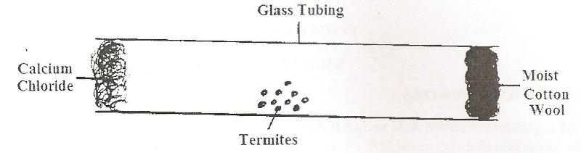

- What observations are made after 20 minutes? (1 mark)
……………………………………………………………………………………………………………………………………………………………………………………
- What type of response is exhibited by the termites? (1 mark)
….……………………………………………………………………………………….
- What is the survival value of the above response? (1 mark)
……………………………………………………………………………………………………………………………………………………………………………………..
- What is Photonasty? (1 mark)
……………………………………………………………………………………………………………………………………………………………………………………
- A group of students set up the following experiments to investigate the factors that affect enzymes.

Tube 1 | Tube 2 | Tube 3 | Tube 4
Egg white  Amylase/ptyalin at  30º C | Boiled starch  Dilute acid  Amylase 36⁰C | Boiled starch  Amylase | Boiled starch  Boiled Amylase

- Identify the property of enzymes being investigated in tubes 1 and 2 (2 marks)
………………………………………………………………………………………………
………………………………………………………………………………………………

- After 3 hours thee students tested the content in the four tubes for starch. They obtained the following results in tube 2, 3 and 4.
Tube 2 – Blue – black colour
Tube 3 – Brown colour of iodine remained
Tube 4 – Blues black colour.

Account for the results obtained in tube 3 and 4. (2 marks)
…………………………………………………………………………………………………..
…………………………………………………………………………………………………..
…………………………………………………………………………………………………..

- What results would you expect in tube 3 if temperature was maintained at 5ºC? Give a reason for your answer. (2 marks)
………………………………………………………………………………………………
………………………………………………………………………………………………

- Name two enzymes found in the pancreatic juice (3 marks)
………………………………………………………………………………………………
………………………………………………………………………………………………
……………………………………………………………………………………………….

SECTION B (40marks)
Answer question 6(compulsory) and either question 7 or 8
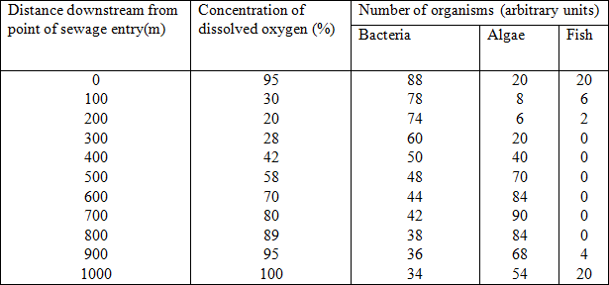
6. The table below contains information on changes that occur in a river, downstream from a sewage outflow.

  - Plot a graph of number of organisms against distance downstream. (7 marks)

  - Describe the changes in the concentration of oxygen dissolved in the water downstream from the point of sewage entry. (2 marks)
………………………………………………………………………………………………… ………………………………………………………………………………………………… ………………………………………………………………………………………………… ………………………………………………………………………………………………… …………………………………………………………………………………………………

  - Account for the changes in the numbers of each of the following organisms downstream.
i. Bacteria (3 marks)
………………………………………………………………………………………………………………………………………………
………………………………………………………………………………………………………………………………………………
ii. Algae (3marks)
………………………………………………………………………………………………………………………………………………
………………………………………………………………………………………………………………………………………………
iii. Fish (3marks) …………………………………………………………………………………
………………………………………………………………………………………………………………………………………………
………………………………………………………………………………………………………………………………………………
State two ways in which the degree of water pollution caused by sewage can be reduced. (2 marks) ………………………………………………………………………………………………………………………………………………
………………………………………………………………………………………………………………………………………………
7. a) Explain three reasons why plants lacks well developed excretory organs. (3 marks)
………………………………………………………………………………………………………………………………………………
………………………………………………………………………………………………………………………………………………

b) Name three ways in which plants excrete waste products. (3 marks)
………………………………………………………………………………………………………………………………………………
………………………………………………………………………………………………………………………………………………
c) State and explain the economic importance of plants excretory products. (14 marks)
………………………………………………………………………………………………………………………………………………
………………………………………………………………………………………………………………………………………………
………………………………………………………………………………………………………………………………………………
………………………………………………………………………………………………………………………………………………
………………………………………………………………………………………………………………………………………………
………………………………………………………………………………………………………………………………………………
………………………………………………………………………………………………………………………………………………
………………………………………………………………………………………………………………………………………………
………………………………………………………………………………………………………………………………………………
………………………………………………………………………………………………………………………………………………
………………………………………………………………………………………………………………………………………………
………………………………………………………………………………………………………………………………………………

- Describe how the various parts of the human digestive system are adapted to their functions. (20 marks)
………………………………………………………………………………………………………………………………………………………………
……………………………………………………………………………………………………………………………………………………………..
………………………………………………………………………………………………………………………………………………………………
………………………………………………………………………………………………………………………………………………………………
………………………………………………………………………………………………………………………………………………………………
………………………………………………………………………………………………………………………………………………………………
………………………………………………………………………………………………………………………………………………………………
………………………………………………………………………………………………………………………………………………………………
……………………………………………………………………………………………………………………………………………………………..
……………………………………………………………………………………………………………………………………………………………..
………………………………………………………………………………………………………………………………………………………………
………………………………………………………………………………………………………………………………………………………………
……………………………………………………………………………………………………………………………………………………………….
……………………………………………………………………………………………………………………………………………………………….
………………………………………………………………………………………………………………………………………………………………
……………………………………………………………………………………………………………………………………………………………..
………………………………………………………………………………………………………………………………………………………………
………………………………………………………………………………………………………………………………………………………………
………………………………………………………………………………………………………………………………………………………………
………………………………………………………………………………………………………………………………………………………………
………………………………………………………………………………………………………………………………………………………………
………………………………………………………………………………………………………………………………………………………………
……………………………………………………………………………………………………………………………………………………………..
……………………………………………………………………………………………………………………………………………………………..
………………………………………………………………………………………………………………………………………………………………
………………………………………………………………………………………………………………………………………………………………
……………………………………………………………………………………………………………………………………………………………….
……………………………………………………………………………………………………………………………………………………………….
This is the last printed page

