**NAME** …………………………………………………………. **ADM NO** ………………….

**SCHOOL** …………………………………………………………… **DATE** ……………………

**231/1 BIOLOGY PAPER 1 FORM 4**

**JULY 2022 TIME: $2 HOURS$**

**BIOLOGY PAPER ONE**

**BUNAMFAN CLUSTER JOINT EXAMINATION 2022**

**MARKING SCHEME**

**instructions**

**attempt all the questions**

1. Some form one students wanted to collect the following animals for study in the laboratory. **State** the suitable apparatus they should use.

i) Housefly (1 mk)

Sweep net;

ii) Scorpion (1 mk)

.

pair of forceps;

iii) Ants (1 mk)

pooter

2. State **two** reasons why a snake is classified as a reptile. (2 mks)

-skin is dry and covered by a horny/leathery scales

-fertilisation is internal

-are ectothermic/poikilothermic

-use lungs for gaseous exchange

3. (a) **Explain** the role of oxygen in Active transport (1mk)

Oxidize food to produce energy required in active transport

rej to produce energy

(b) Name **two** processes that depend on Active transport in animals (2mks)

-Reabsorption of sugar and some salts by kidney;

-Absorption of digested food from alimentary canal;

-Excretion of waste products from body cell;

- Transmission of nerve impulse.

4. **Explain** how sunken stomata lower the rate of transpiration (2mks)

Form pits that accumulate moisture; lowering saturation deficit between the atmosphere and sub stomatal airspaces; reducing transpiration.

5. **State** how xylem vessel is adapted to its function (3mks)

* Lignified walls to prevent them from collapsing /offer support
* Hollow and tubular for continuous flow of water;
* Narrow to enhance capillarity;
* Made of dead cells; /to reduce water demand

6). a) **Define** the term immunity. (1mk)

Ability of the body to identify/ recognize foreign antigens and develop mechanisms of destroying them. / ability to resist infection;

b) **Distinguish** between natural immunity and acquired immunity. (1mk)

Natural immunity is inborn /inherited /passed from parents to offspring while acquired immunity is obtained in life;

c) Identify **one** immunizable disease in Kenya. (1mk)

Tuberculosis;

poliomyelitis;

diphtheria;

whooping cough;

measles;

hepatitis

Covid -19

7. (a) State **two** adaptations of the alveolus to its functions. (2mks)

-Thin epithelium for reduction of diffusion distance of respiratory gases;

-Highly vascularized to transport gases/maintain a steep concentration gradient;

-Moist surface to dissolve respiratory gases so that they diffuse in solution form;

1. **Sugges**t a reason for asthmatic patient producing a wheezing sound during breathing? (1mk)

This is because muscles around the bronchioles contracts and so reduce their diameter.

(c) **What** is the significance of the cartilage found in the human trachea being incomplete (c- shaped rings) (1mk)

To permit swallowing in the oesophagus ;

8. **Define** the following terms;

(i) Inter specific competition. (1mk)

Competition between individuals of different species (inhabiting the same ecological area)

(ii) Carrying capacity (1mk)

Maximum number of organisms an area can comfortably support with depletion of available resources

9. Suggest **two** methods that can be used to determine the type of food eaten by animals. (2mks)

-Analyzing animal droppings

- Direct observation of the animal while feeding

-Dissection and analysis of the gut content

-Dentition

10. (a) State **one** significance of genetics counseling (1mk)

Provides information and advice to enable the victim to arrive at an informed decision on their genetic make up./disoders.

(b) Part of a strand of DNA molecules was found to have the following sequence

A-T-C-G-G-G-A-T-C-T. What is the sequence?

(i) Of the complementary strand? (1mk)

T-A-G-C-C-C-T-A-G-A

(ii) On a m- RNA strand copied (1mk)

U-A-G-C-C-C-U-G-U

11). The paddles of whales and the fins of fish adapt these organisms to aquatic habitats.

a) **Name** the evolutionary process that may have given rise to these structures. (1mk)

Convergent evolution;

b) What is the **name** given to such structures? (1mk)

Analogous structures;

c) Give **two** examples of vestigial organs in man. (2mks)

Coccyx; appendix; reduced ear muscles/nictating membrane/reduced body hair;

12). (i) lysosomes

(ii) Centrioles

(iii) Contractile vacuoles

(iv) Cell membrane

13. (a) **- Glucose is highly soluble in water/ (blood) hence is faster and easily transported to the**

**respiratory sites;**

**- Glucose is very simple in structure than sucrose hence easy to oxidize to yield energy to the body cells;**

**b) it is oxidized to release energy;**

14.**State** the difference between glycolysis and kreb”s cycle based on the following.

a) where they occur . ( 1 mk)

Krebs cycle occur in the matrix of the mitochondrion while glycolysis occurs in the cell cytoplasm

b) Amount of energy produced. ( 1 mk)

Glycolysis- less energy/2ATP molecules/210kJ Produced;

Kreb’s cycle- more energy produced/ 38 ATP molecules/2880kJ

c) End product(s) (1 mk )

Glycolysis- pyruvate/pyruvic acid

Kreb’s cycle- energy, water and carbon (IV) oxide (all as one correct)

15. (a) X40

Has a lower magnification giving a wider field of view

b) Total magnification= Eye piece lens magnification X Objective Lens Magnification

16. The illustration below shows a transverse section through a mammalian kidney.

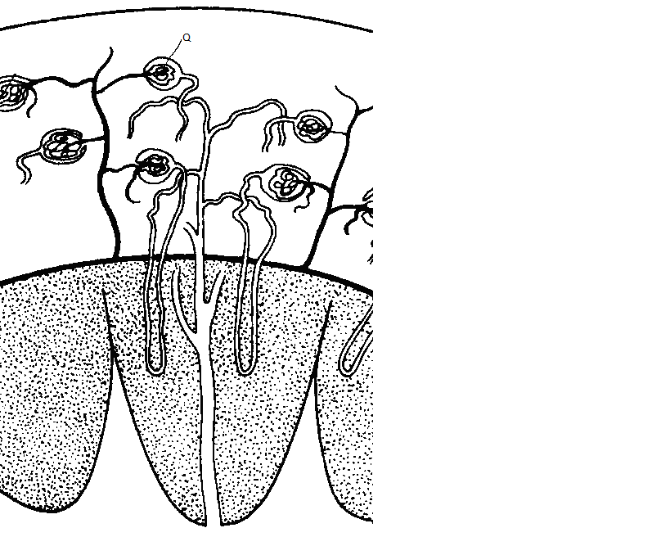

**Y**

**X**

(a) **Name** the structures labelled **X** and **Y**.

**X** ………………………………………………………………………………………………… ( 1mk)

Cortex

**Y** ………………………………………………………………………………………………… (1mk)

Medulla

(b) **State** the process in **Q** that leads to the formation of glomerular filtrate. (1mk)

**Ultrafiltration ;**

**c)-Moisten the skin/makes the skin supple;**

**-Antiseptic/kills pathogens/bacteria**

17. State **three** differences in composition between umbilical artery and umbilical vein. (3 marks)

|  |  |
| --- | --- |
| **Umbilical vein** | **Umbilical artery** |
| Rich in food nutrients e.g glucose | Less food nutrients |
| Has more Oxygen | Has less Oxygen |
| Has less nitrogenous wastes e.g urea | Has more nitrogenous wastes |
| less Carbon(IV) oxide | more Carbon (IV) oxide |

18. (a)**What** is meant by the term taxonomy? (1mk)

It is the science/study of classification/grouping of organisms (into respective ranks/units using their characteristics)

(b)**When** are two organisms considered to belong to the same species. (2mks)

When they can freely/naturally interbreed; to give rise to viable/fertile offspring;

19).The diagram below shows part of alimentary canal of a mammal

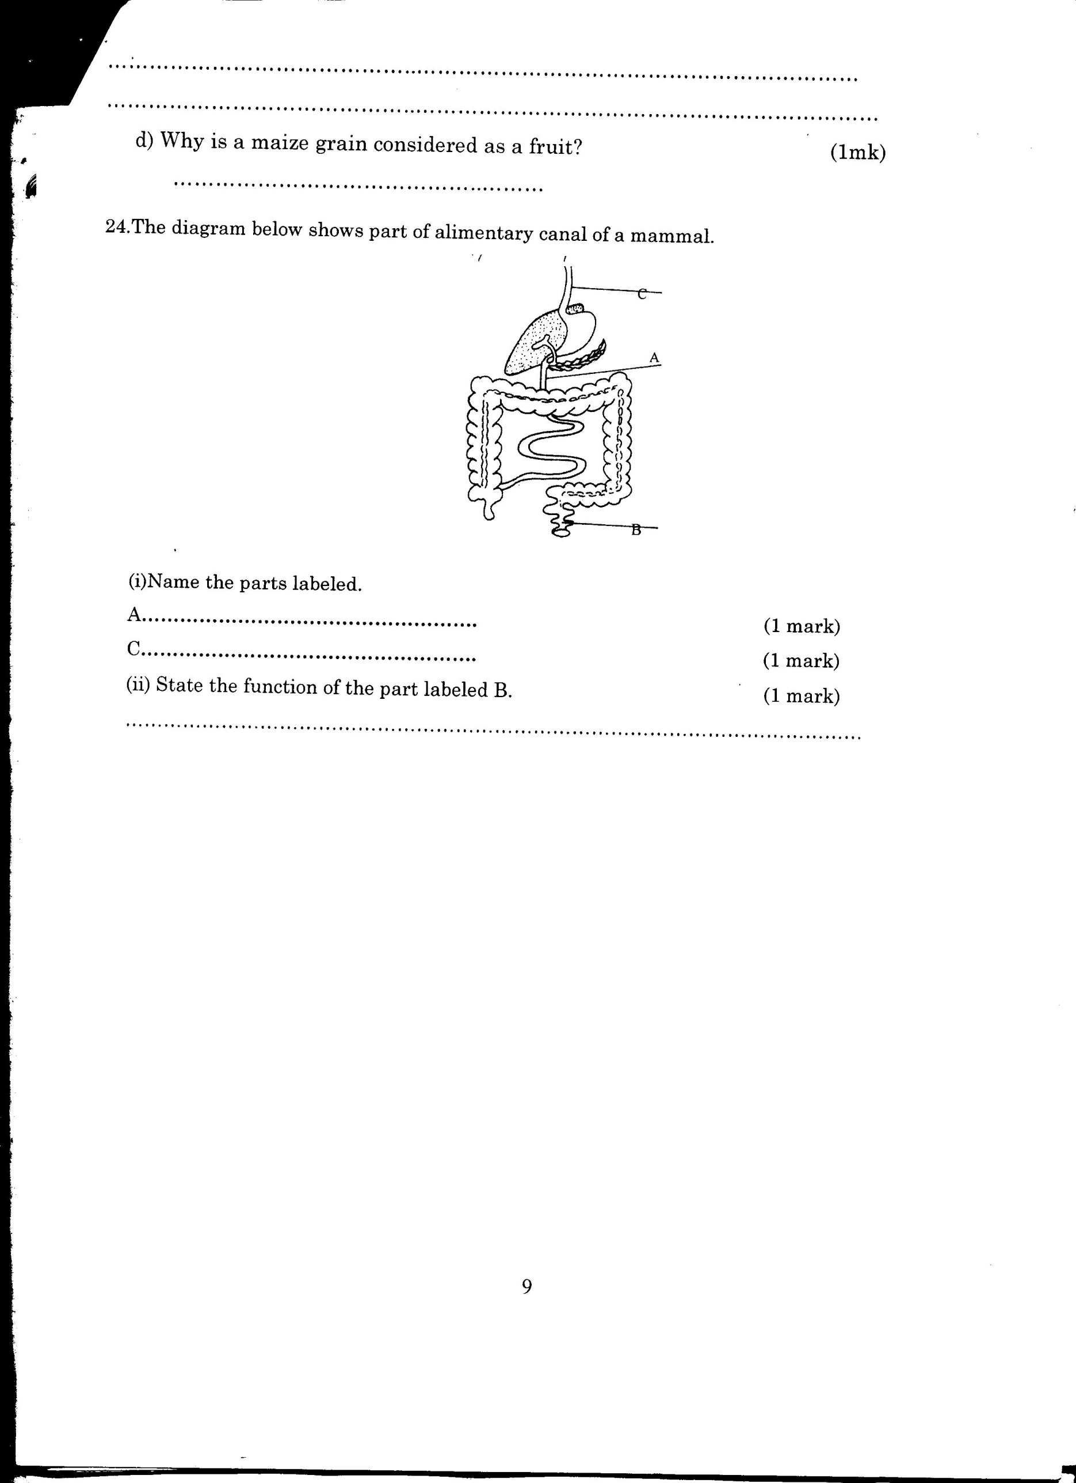

(i)**Name** the parts labeled **A** and **C** (2mks)

**A** - Duodenum

**C** - Oesophagus /gullet (reject food pipe)

(ii)**State** the function of the part labeled **B.**  (1mk)

Temporally storage of feaces / undigested /indigestible materials

/Absorption of water;

20). The graph below shows the relationship between body temperatures and external temperatures in a human being and a snake. **Study** it and answer questions that follow.

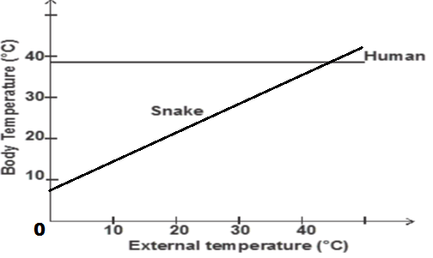

 a**) What** happens to the temperature of each organism as the external temperature increases. (2 mks)

Human –

remains constant;

Snake –

increases;

**b)** Humans are described as homoithermic. **State** the advantage of this condition. (2mks)

- enables them to be active throughout;

- enables them exploit different habitats;

(*any one 1mk)*

21State **three** differences between light stage and dark stage of photosynthesis. (3 mks)

|  |  |
| --- | --- |
| **Light stage** | **Dark stage** |
| -Occur in presence of light  - occur in grana  - produce hydrogen atoms and oxygen gas | - occur any time;  - occur in stroma;  produce glucose; |

22 **.**The diagram below represents a plant cell that was subjected to a certain treatment.



**At the start At the end of the experiment**

**a) Account** for the shape of the cell at the end of the experiment. (2 mks)

Plant cell was placed in hypertonic solution to its cell sap, it lost water by osmosis: it became plasmolysed

**b)** **Draw** a diagram to illustrate how an animal cell would appear if subjected to the same treatment. (1 mk)

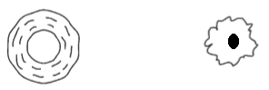

At Start At end

24. a) **Give** a reason why each of the following steps are followed when preparing cross sections of a leaf for examination under a microscope.

i) Cutting thin sections. (1 mk)

 To reduce the layers of cells/sections preventing overlapping hence better penetration of light ( for illumination)

ii) Placing the sections in water. (1 mk)

To avoid drying up which may distort the cells;

To maintain turgidity of the cells

25. Explain **why** the population of people with sickle cell anaemia is higher in malaria prone areas. ( 3 mks)

Their red blood cells carry defective haemoglobin (type S) which carries little or no oxygen;

Plasmodium do not survive in their red blood cells hence survive malaria attack; they reproduce successfully giving rise to more population;

26. The diagram below is of a stage in cell division

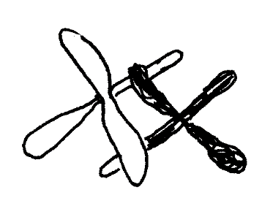

With a reason identify the stage.

Stage (1 mk)

Prophase I

Reason (1 mk)

**-Chromatids cross over each other at chiasmata**

**-Formation of a bivalent**

1. The graph below represents growth pattern in a group organism

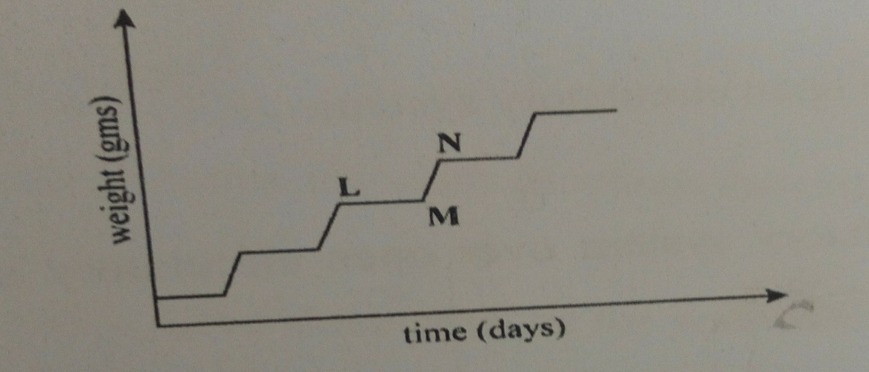

1. Name the type of growth curve (1 mk)

Intermittent

1. Name the phylum that shows this type of pattern (1 mk)

Arthropoda

1. State one disadvantages of this type of pattern (1 mk)

-Hardened exoskeleton limits the growth/size of the organism