NAME _______________________________________________________ ADM NO ______________
DATE ________________________________ CLASS ______________________________________
INDEX NUMBER: ____________________________________________________________________

231/1
BIOLOGY
Paper 1
TIME: 2HRS
December 2021
BUNAMFAM CLUSTER EXAMINATIONS 2021
Kenya Certificate of Secondary Education
231/1
BIOLOGY
PAPER 1
December 2021
TIME: 2HRS
INSTRUCTIONS:
- Write your name, class, admission number and index number on the space provided.

- Answer all the questions in the spaces provided

- Candidates should check to ensure that all the pages are printed as indicated and that no questions are missing.
- This paper consists of 10 pages.

1. (a) Define the following terms as used in Biology.
(i) Chemosynthesis (1 mark)
……………………………………………………………………………….
……………………………………………………………………………….
………………………………………………………………………………..
(ii) Mutualism (1 mark)
……………………………………………………………………………….
……………………………………………………………………………….
………………………………………………………………………………..
(b) State the importance of photosynthesis in nature. (2 marks)
…………………………………………………………………………………………..
…………………………………………………………………………………………
…………………………………………………………………………………………..
2. What is the importance of the stroma in the chloroplast? (2 marks)
…………………………………………………………………………………………………..
………………………………………………………………………………………………….
………………………………………………………………………………………………….
3. Name two cell structures that synthesize the following cell organelles.
(a) Ribosomes (1 mark)
…………………………………………………………………………………………..
(b) Lysosomes (1 mark)
…………………………………………………………………………………………..
4. Name three plant leaf excretory products. (3 marks)

…………………………………………………………………………………………………..
………………………………………………………………………………………………….
………………………………………………………………………………………………….
5. A student mixed a sample of urine from a patient with Benedict’s solution and boiled the mixture.
The colour changed to orange.
(a) What was present in the urine sample? (1 mark)
…………………………………………………………………………………………..

(b) What did the student conclude about the health status of the patient? (2 marks)
…………………………………………………………………………………………..
…………………………………………………………………………………………
…………………………………………………………………………………………..
(c) Which organ in the patient may not be functioning properly? (1 mark)
…………………………………………………………………………………………..
6. Name two types of values in the heart. (2 marks)
…………………………………………………………………………………………………..
………………………………………………………………………………………………….
………………………………………………………………………………………………….
7. Sometimes when one stands up very quickly after a long period of sitting, she may feel faint or dizzy. Explain. (2 marks)
…………………………………………………………………………………………………..
………………………………………………………………………………………………….
………………………………………………………………………………………………….
8. The cardiac muscles are said to be myogenic. What is the meaning of the term myogenic.
(1 mark)
…………………………………………………………………………………………………..
………………………………………………………………………………………………….
………………………………………………………………………………………………….
9. A Form 3 student carried out an experimental set up as shown below.
Bromothymol blue is sensitive to pH change (bromothymol is yellow in low pH)
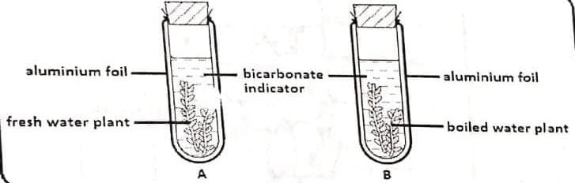

(a) What was the aim of the experiment? (1 mark)
…………………………………………………………………………………………..
………………………………………………………………………………………….

(b) Why was set up B included in this experiment? (1 mark)
…………………………………………………………………………………………..
………………………………………………………………………………………….

(c) Why was aluminium foil used in this experiment? (1 mark)
…………………………………………………………………………………………..
………………………………………………………………………………………….
(d) Explain why bromothymol changed its colour from blue to yellow in tube A after 30 minutes. (1 mark)
…………………………………………………………………………………………..
………………………………………………………………………………………….

10. Differentiate between the cell wall found in fungi and the one in plants. (2 marks)
…………………………………………………………………………………………………..
………………………………………………………………………………………………….
………………………………………………………………………………………………….
11. State three adaptations that enable prey to evade predators. (3 marks)
…………………………………………………………………………………………………..
………………………………………………………………………………………………….
………………………………………………………………………………………………….
………………………………………………………………………………………………….

12. The diagram below represents a simplified trend of nitrogen circulation in an ecosystem. 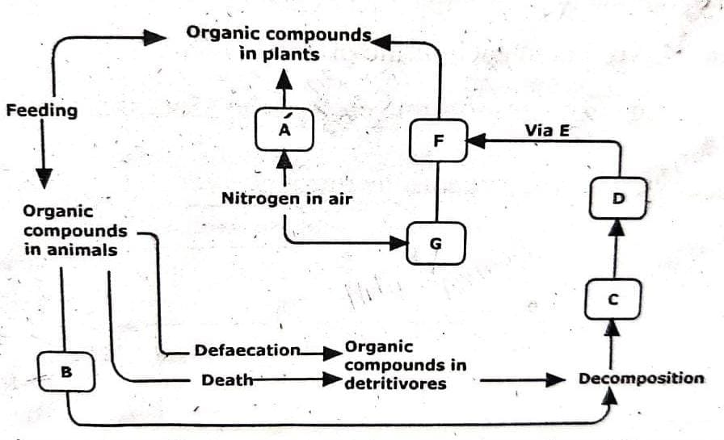
(a) What is the descriptive term applied to each of the organisms A and D.
A ……………………………………………………………………………..
D ……………………………………………………………………………..
(b) Name each of the processes. (3 marks)
(i) Marked B ………………………………………………………………………
(ii) Facilitated by organisms D ……………………………………………………..
(iii) One group of organisms that can act as saprophytes
…………………………………………………………………………………
(c) Name the chemicals C, F and E.
C …………………………………………………………………………………
F ………………………………………………………………………………..
E …………………………………………………………………………………

13. The diagram below is a summary of the sequence of blood flow through the heart and associated blood vessels.
E Heart
D A

C B
(a) Name the blood vessels labelled A and E. (2 marks)
A ………………………………………………………………………………………
E ………………………………………………………………………………………
(b) State two differences between blood vessel B and D. (2 marks)
…………………………………………………………………………………………..
………………………………………………………………………………………….
…………………………………………………………………………………………..
………………………………………………………………………………………….
(c) State two adaptations of the blood vessel labeled C to its functions. (2 marks)
…………………………………………………………………………………………..
………………………………………………………………………………………….
…………………………………………………………………………………………..
14. How does light as a biotic factor influence the distribution of plants in an ecosystem?
(3 marks)
………………………………………………………………………………………………....
…………………………………………………………………………………………………
………………………………………………………………………………………………….
15. Seed germination is affected by certain plant growth regulators.
Describe two actions of gibberellins during seed germination. (2 marks)
………………………………………………………………………………………………..
………………………………………………………………………………………………..
………………………………………………………………………………………………..

16. The diagram below shows a foetus in the uterus.
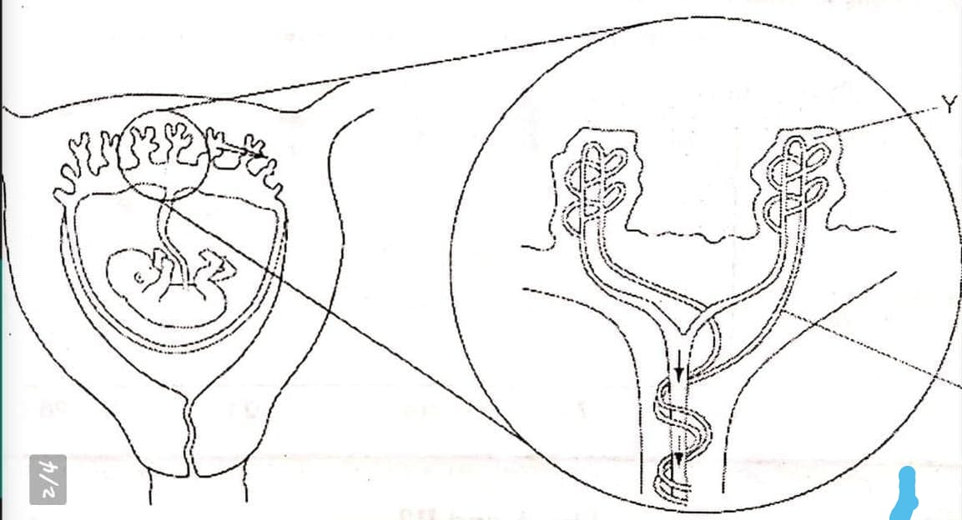
(a) Name two substances that will be at a higher concentration at Y that at X. (2 marks)
…………………………………………………………………………………………..
………………………………………………………………………………………….
…………………………………………………………………………………………..
(b) State two observable adaptations of the placenta to its functions. (2 marks)
…………………………………………………………………………………………..
………………………………………………………………………………………….
…………………………………………………………………………………………..
17. (a) Name the genetic disorder in humans that is characterized by inability of blood to clot.
(1 mark)
…………………………………………………………………………………………..
………………………………………………………………………………………….
(b) A female human was found to have an extra sex chromosome in her cells.
(i) Give the total number of chromosomes in the male individual’s cells.
(1 mark)
…………………………………………………………………………………………..
…………………………………………………………………………………………...
(ii) Explain the possible causes of this condition. (2 marks)
…………………………………………………………………………………………..
………………………………………………………………………………………….
…………………………………………………………………………………………..

(iii) State two physical characteristics observed in the female individual with such a condition. (2 marks)
…………………………………………………………………………………..
………………………………………………………………………………….
…………………………………………………………………………………..
18. (a) Explain why fossil records as evidence of organic evolution are usually incomplete.
(3 marks)
…………………………………………………………………………………………..
………………………………………………………………………………………….
…………………………………………………………………………………………..
…………………………………………………………………………………………..
(b) Name the evidence of organic evolution exhibited by occurrence of similar amino acid molecules in a range of organisms. (1 mark)
…………………………………………………………………………………………..
………………………………………………………………………………………….
…………………………………………………………………………………………..
19. Bumble bees are insects that live in the arctic tundra. They have adaptations to keep their body temperature above that of the environment. One adaptation is shivering which involves rapid muscle contraction. A second adaptation is a very hairy body.
Explain how those adaptations help to keep the body temperature above that of the environment. (3 marks)
……………………………………………………………………………………………….
………………………………………………………………………………………………..
………………………………………………………………………………………………..
………………………………………………………………………………………………..
…………………………………………………………………………………………………

20. The photograph below shows a bone from an animal.

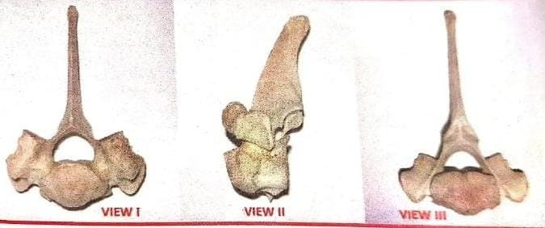

(a) (i) Identify the bone shown. (1 mark)
…………………………………………………………………………………..
………………………………………………………………………………….

(ii) Give one reason for your answer. (1 mark)
…………………………………………………………………………………..
………………………………………………………………………………….
(b) Name the body region from which the bone was obtained. (1 mark)
…………………………………………………………………………………………..
………………………………………………………………………………………….
…………………………………………………………………………………………..
(c) State three adaptations of the bone in the photograph to its functions. (3 marks)
…………………………………………………………………………………………..
………………………………………………………………………………………….
…………………………………………………………………………………………..

21. The photograph below shows a potted plant in horizontal position.

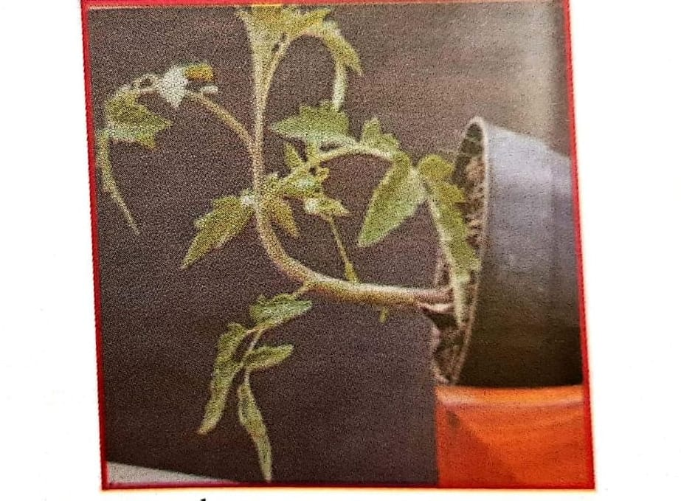

(a) Name the type of response shown. (1 mark)
…………………………………………………………………………………………..
………………………………………………………………………………………….
(b) State the biological significance of the response above to the plant. (1 mark)
…………………………………………………………………………………………..
………………………………………………………………………………………….
…………………………………………………………………………………………..
(c) Explain the mechanisms of the response. (4 marks)
…………………………………………………………………………………………..
………………………………………………………………………………………….
…………………………………………………………………………………………..
………………………………………………………………………………………….
…………………………………………………………………………………………..
(d) (i) State the class to which the plant belongs. (1 mark)
…………………………………………………………………………………..
………………………………………………………………………………….
(ii) Give one reason for your answer. (1 mark)
…………………………………………………………………………………..
………………………………………………………………………………….

