BUSINESS STUDIES (565/2)
FORM 4 PAPER 2
Time: 2:30 Hours
VIULMACKNARBS 2 MARKING SCHEME
1a)Features of economic resources
- Scarcity in supply –they are found in small quantities compared to the many uses into which they have to be put.
- Monetary value –they have price which have to be paid for their use.
- Unevenly distributed-resources are not equally distributed some places have few resources while others have more.
- Have utility –resources have the ability to satisfy human want.
- Transferable –resources can be moved from one place to another.
- Can be combined-two or more resources can be put together in different proportions to produce goods and services.5x2=10 mks 1b) Internal economies of scale that a firm can enjoy as its scale of production increases
- managerial economies-specialization and division of labour enhance management.
- Research economies- firm can afford to finance research and development
- Financial economies-firm have access finance from banks as they have enough assets to act as collateral.
- Technical economies-firm are able to use modern machinery which increase efficiency.
- Marketing economies-firms are able to buy raw materials and stock in bulk getting discounts which in turns enables them to sell product as competitive prices.
- Welfare economies-firms can provide recreation and other facilities e.g. housing, transport for their workers. 5x2=10mks
2a) Important of filing documents in an organization
- It keeps an office tidy or clean as documents are well and neatly arranged
- It is easy to make future reference by easily retrieving documents that are properly numbered, coded or labelled
- Documents are safe from damaged by bad weather, pests as they are stored in safe facilities
- Ensures security of documents from loss or theft as they are kept well from unwanted persons
- It safeguards the secrets of a firm as documents are kept away form un authorized persons by using pins cctvs locks
- Stores information for future reference in computers desks shelves
- Saves space in an office as documents are compactly kept e.g in computers, flash disks etc.
5x2=10mks)

b) Factors that determine the size of a firm
- Number of employees – a firm with large number of employees is said to be large, while the one with small number is said to be small
- Sales volume – the amount of sales that a firm makes within a given period can be used to determine the size. i.e. large volume is said to be large firm and vice versa.
- Market served – a firm that serves a large market is said to be large while the one that serves a small market is said to be small
- Volume of output – a firm with high output is said to be large while the one with low output is said to be small
- Floor area covered by premises- a firm with large floor area covered by premises is said to be large and vice versa.
- Capital invested – the large the capita of the firm in terms of assets the large and vice versa
- Production methods – a firm that is associated with specialization and division of labour is said to be large and vice versa. 5x2=10mks)
- Not all potential customers are able to read newspapers

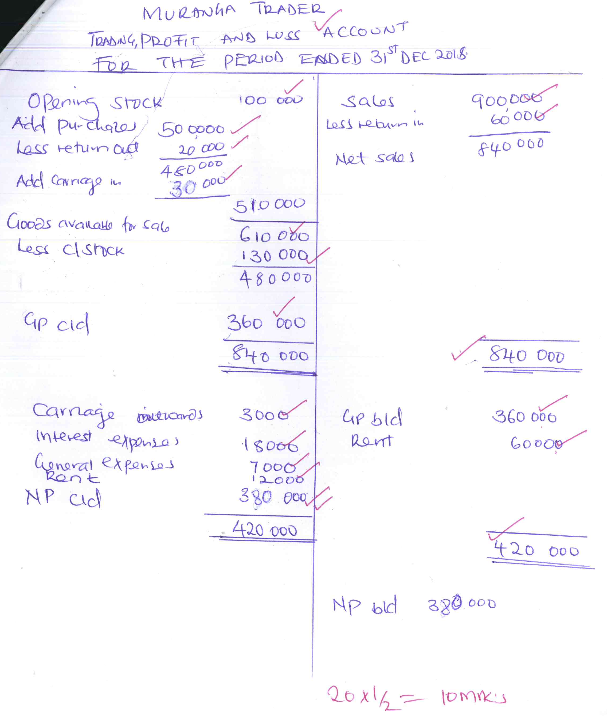

3b) Limitations of advertising goods in newspapers
- Not all potential customers are able to read newpapers
- The newpapers may be written in a language or medium that is not familiar to customers
- It is expensive to buy newspapers and many people cannot afford
- It is expensive to advertise using newpapers as one incurs extra cost
- Newspapers are nto able to discriminate between the intended group and others
- Newspapers may not reach all parts of the country
- Newspapers have a short life and therefore easily discarded. 5x2=10mks)
4a) Ways of correcting balance of payment
- Increasing volume of export-this is done through the provision of exports incentives eg export compensation scheme.
- Reducing volume of imports-is done through raising import duty and exchange controls.
- Devaluation of currency-lowering value of country currency relative to other currencies to make import expensive and export cheaper.
- Diversification of export-increasing range of commodities exported.
- Borrowing from IMF and other lender to finance the deficit.
- Encouraging the foreign direct investments in the country. 5x2=10 marks

b) Factors are likely to lead to high birth rate in Kenya
- Some culture practice taking children as security in old age therefore getting many children.
- Early marriage prolong woman’s reproductive life.
- People wanting to have many children in areas of high mortality so that if some dies other will be left.
- Children seen as cheap labour.
- Where people are opposed or ignorant of family planning methods e.g. catholic people. 5x2=10mks
5a) Challenges faced by a producer who sells goods directly to consumers.
- Losses /bad debts as a result of some consumers failing to pay
- Lack of storage facilities as consumers may not buy goods in large quantities.
- Inability to cover/reach the whole market especially if consumers are widespread.
- Financial problems as some consumers may not buy in cash
- High cost of distribution especially if consumers are widespread.
- Failure to concentrate on production activities as time has to be spent distributing goods.
- Spoilage of goods in cases where goods are perishable and are not in good time.
5 x 2 = 10mks

b) Lyon Traders
3 column cashbook
For the month of March 2017
Date | Details | Disc Allowed | Cash (Kshs) | Bank (Kshs) | Date | Details | Disc received | Cash (Kshs) | Bank  (Kshs)
2017  March 1  March 2  March 7  March 20  March 24  March 29  March 31  1st Aug. | Balances  Sales  Henry  Sales  Bank ‘c’  Alvin  Cash ‘C’  Bal/b/d | 4,000  1,000  5,000  GL | 87,000  60,000  32,000  17,000  196,000  24,000 | 250,000  76,000  165,000  108,800  599,800  380,300 | 2017  March 3  March 3  March 17  March 22  March 24  March 25  March 31  March 31 | Salaries  Office furni  Marita  Wages  Cash ‘C’  Drawings  Bank ‘C’  Balances c/d | 800  800 | 34,200  25,000  4,000  108,800  24,000  196,000 | 101,500  86,000  32,000  380,300  599,800

6a) Difference between life assurance and property insurance 5x2=10mks)
Life | Property
- Risks are bound to happen  - May be used as security for loan  - Value of the policy appreciates and sum assured paid t maturity date  - The insured may insure same risk with different companies  - Not subject to the principal of indemnity, subrogation and contribution  - No limit on amount spelt out on a cover | - Risk may or may not occur  - Not used a security for loan  - Sum insured remains constant  - The insured is normally required to insure risk with one company  - Subjected to all insurance principles  - Cover value depends on the value of the property
6b) Circumstances under which personal selling may be appropriate
- When launching a new product because it requires a lot of awareness creation, persuasion and convincing.
- When a product is tailored to meet customers specification because customers have got varying tastes and preferences.
- When demonstrations are required – especially for technical products.
- When the value of the product is high to avoid risks of losing such products if other methods were used.
- When the organization can afford to finance the sales force as the cost of maintaining them may be very high
- Where the market is concentrated in one area as the cost of accessing the market is reduced if personal selling is used. 5x 2 = 10mks

