NAME …………………………………………………………. ADM NO……………………………

SCHOOL ………………………………………………… CLASS ……………………………………

DATE …………………………………….
565/1
BUSINESS STUDIES
PAPER 1
FORM FOUR
(AUGUST/SEPTEMBER)
TIME. 2 HOURS
CEKENAS END OF TERM TWO EXAMS-2022
FORM FOUR
Kenya Certificate Of Secondary Education (K.C.S.E)

565/1
BUSINESS STUDIES
PAPER 1
FORM FOUR
(AUGUST/SEPTEMBER)
TIME. 2 HOURS

INSTRUCTIONS
- Write your name, Adm no, school and class in the spaces provided above
- Answer ALL the questions.

1.Outline four methods of Trade restriction used by the government. (4mks)
(i)…………………………………………………………………………………………………………… ……………………………………………………………………………………………………………….
(ii)……………………………………………………………………………………………………………
……………………………………………………………………………………………………………….
(iii)…………………………………………………………………………………………………………………………………………………………………………………………………………………………
(iv)………………………………………………………………………………………………………………………………………………………………………………………………………………………….
2. State the effects of the following transactions on the balance sheet totals by writing increase decrease or no effect in each case. (4mks)
(i)Bought machinery on credit………………………………
(ii)Withdrew cash from the business for own use …………………………………………
(iii)Purchased stock in cash ………………………………………………….
(iv)Paid outstanding loan by cheque ……………………………………..

3. List four benefits that may be enjoyed by Kenyans as a result of government initiatives to expand road and railway network in the country. (4mks)
(i)…………………………………………………………………………………………………………… ……………………………………………………………………………………………………………….
(ii)……………………………………………………………………………………………………………
……………………………………………………………………………………………………………….
(iii)…………………………………………………………………………………………………………………………………………………………………………………………………………………………
(iv)………………………………………………………………………………………………………………………………………………………………………………………………………………………….
4. Highlight four circumstances under which a firm would prefer open office layout. (4mks)
(i)…………………………………………………………………………………………………………… ……………………………………………………………………………………………………………….
(ii)……………………………………………………………………………………………………………
……………………………………………………………………………………………………………….
(iii)…………………………………………………………………………………………………………………………………………………………………………………………………………………………
(iv)………………………………………………………………………………………………………………………………………………………………………………………………………………………….

5.Outline four limitations of Barter trade. (4mks)
(i)…………………………………………………………………………………………………………… ……………………………………………………………………………………………………………….
(ii)……………………………………………………………………………………………………………
……………………………………………………………………………………………………………….
(iii)…………………………………………………………………………………………………………………………………………………………………………………………………………………………
(iv)………………………………………………………………………………………………………………………………………………………………………………………………………………………….
6.The following information was extracted from the books of Mangi traders on 30th June 2009.

Item | Sh
Purchases  Opening stock  Closing stock  Sales | 720 000  165,000  ?  980 000

a)Additional information.
Margin 20%
Required: Prepare the Trading account for Mangi trades for the year ended 30th June 2009. (4mks)
…………………………………………………………………………………………………………… ……………………………………………………………………………………………………………….
……………………………………………………………………………………………………………
……………………………………………………………………………………………………………….
………………………………………………………………………………………………………………………………………………………………………………………………………………………………………………………………………………………………………………………………………………
7.Identify four factors that influence entrepreneurial practices in Kenya. (4mks)
(i)…………………………………………………………………………………………………………… ……………………………………………………………………………………………………………….
(ii)……………………………………………………………………………………………………………
……………………………………………………………………………………………………………….
(iii)…………………………………………………………………………………………………………………………………………………………………………………………………………………………
(iv)………………………………………………………………………………………………………………………………………………………………………………………………………………………….
8.Stima insured his house worth sh. 800 000 for sh. 700 000 and unfortunately the house was destroyed by an inferno and he sustained losses worth sh. 600000. Calculate the amount the amount of money that Stima should claim from the insurance company as a compensation and comment. (4mks)

9. State four reasons for popularity of WhatsApp as trend in communication. (4mks)
(i)…………………………………………………………………………………………………………… ……………………………………………………………………………………………………………….
(ii)……………………………………………………………………………………………………………
……………………………………………………………………………………………………………….
(iii)…………………………………………………………………………………………………………………………………………………………………………………………………………………………
(iv)………………………………………………………………………………………………………………………………………………………………………………………………………………………….

10.State four negative effects of overpopulation in a nation. (4mks)
(i)…………………………………………………………………………………………………………… ……………………………………………………………………………………………………………….
(ii)……………………………………………………………………………………………………………
……………………………………………………………………………………………………………….
(iii)…………………………………………………………………………………………………………………………………………………………………………………………………………………………
(iv)………………………………………………………………………………………………………………………………………………………………………………………………………………………….

11.State the type of unemployment relating to each of the following descriptions. (4mks)
i) Caused by alternating trading patterns occurring at similar times.
………………………………………………………………………………………………………………
ii) Arises when a worker has more skills and higher qualification than the job requirement.
………………………………………………………………………………………………………………
iii) Arises out of mismatch between the skills possessed by a potential employee and the job available.
………………………………………………………………………………………………………………
iv)Arises when people are unwilling to take up jobs due to low pay.
………………………………………………………………………………………………………………
12.Highlight four ways in which a warehouse may be useful to a trader. (4mks)
(i)…………………………………………………………………………………………………………… ……………………………………………………………………………………………………………….
(ii)……………………………………………………………………………………………………………
……………………………………………………………………………………………………………….
(iii)…………………………………………………………………………………………………………………………………………………………………………………………………………………………
(iv)………………………………………………………………………………………………………………………………………………………………………………………………………………………….
13. Outline four distribution channels of locally produced agricultural products. (4mks)
(i)…………………………………………………………………………………………………………… ……………………………………………………………………………………………………………….
(ii)……………………………………………………………………………………………………………
……………………………………………………………………………………………………………….
(iii)…………………………………………………………………………………………………………………………………………………………………………………………………………………………
(iv)………………………………………………………………………………………………………………………………………………………………………………………………………………………….
14. Outline four levels of inflation. (4mks)
(i)…………………………………………………………………………………………………………… ……………………………………………………………………………………………………………….
(ii)……………………………………………………………………………………………………………
……………………………………………………………………………………………………………….
(iii)…………………………………………………………………………………………………………………………………………………………………………………………………………………………
(iv)………………………………………………………………………………………………………………………………………………………………………………………………………………………….
15. State four measures that a consumer may undertake to satisfy the unlimited human wants. (4mks)
(i)…………………………………………………………………………………………………………… ……………………………………………………………………………………………………………….
(ii)……………………………………………………………………………………………………………
……………………………………………………………………………………………………………….
(iii)…………………………………………………………………………………………………………………………………………………………………………………………………………………………
(iv)………………………………………………………………………………………………………………………………………………………………………………………………………………………….
16. Give four differences between shares and debentures. (4mks)
Shares | Debentures
(i)

(ii)

(iii)

(iv)

17. Highlight four factors that a firm must take in the account when choosing on the products to produce . (4mks)
(i)…………………………………………………………………………………………………………… ……………………………………………………………………………………………………………….
(ii)……………………………………………………………………………………………………………
……………………………………………………………………………………………………………….
(iii)…………………………………………………………………………………………………………………………………………………………………………………………………………………………
(iv)………………………………………………………………………………………………………………………………………………………………………………………………………………………….
18. Below is a demand and supply curve. Highlight the factors that may have caused the supply curve to shift right ward. (4mrks)
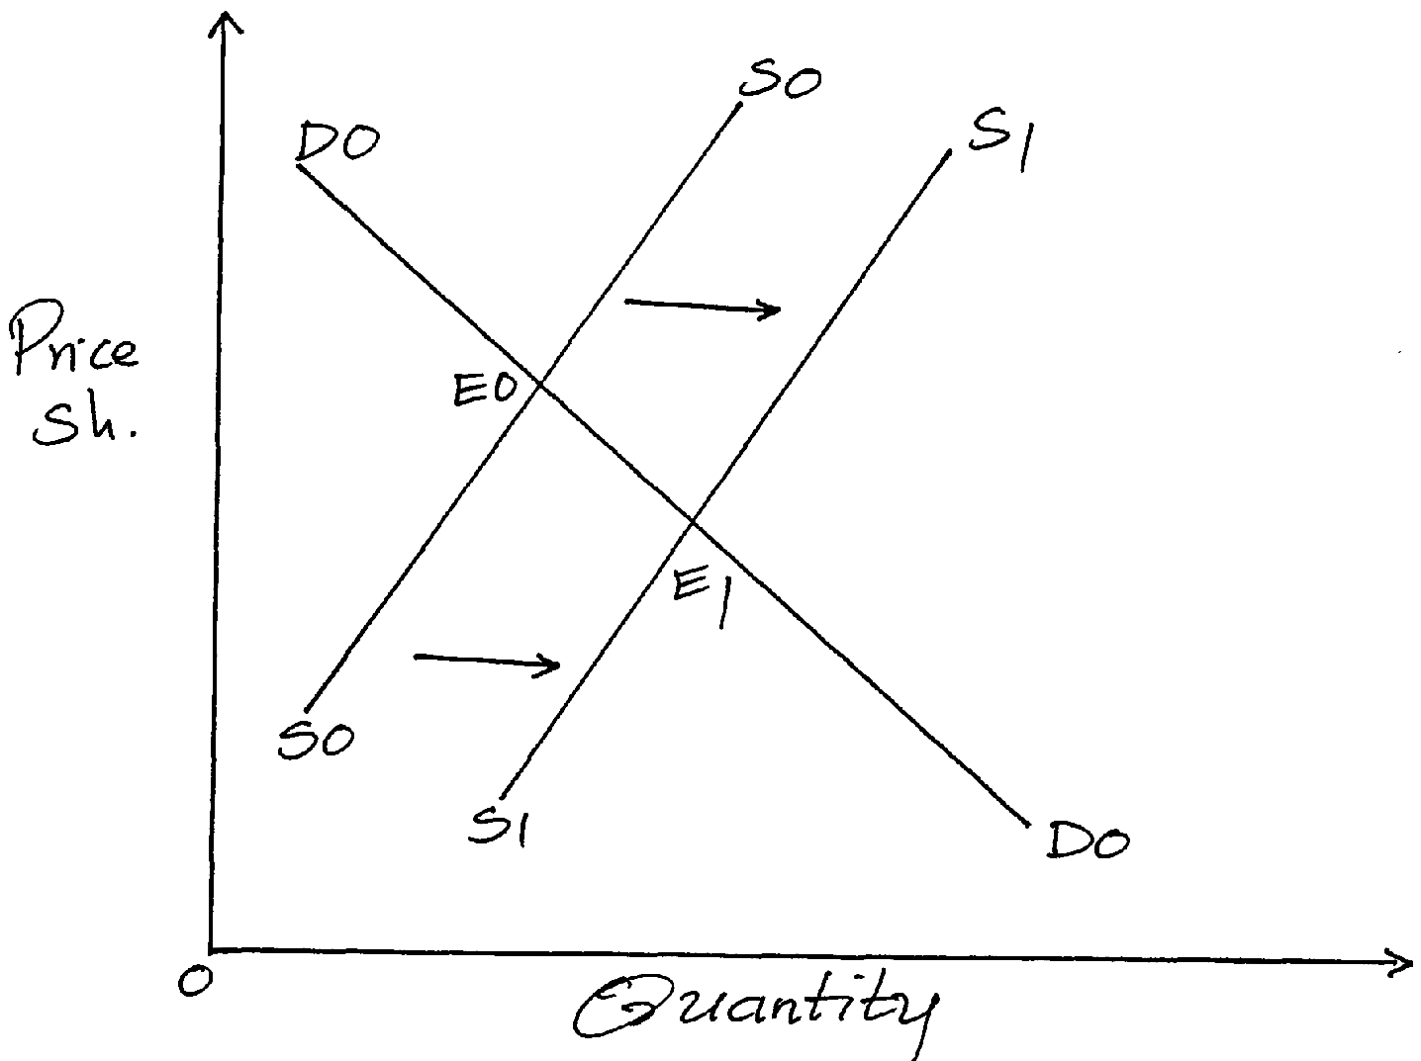
(i)…………………………………………………………………………………………………………… ……………………………………………………………………………………………………………….
(ii)……………………………………………………………………………………………………………
……………………………………………………………………………………………………………….
(iii)…………………………………………………………………………………………………………………………………………………………………………………………………………………………
(iv)………………………………………………………………………………………………………………………………………………………………………………………………………………………….
19. Outline four circumstance under which a trader can issue a credit note to a customer. (4mks)
(i)…………………………………………………………………………………………………………… ……………………………………………………………………………………………………………….
(ii)……………………………………………………………………………………………………………
……………………………………………………………………………………………………………….
(iii)…………………………………………………………………………………………………………………………………………………………………………………………………………………………
(iv)………………………………………………………………………………………………………………………………………………………………………………………………………………………….
20. Highlight four advantages of indirect tax. (4mks)
(i)…………………………………………………………………………………………………………… ……………………………………………………………………………………………………………….
(ii)……………………………………………………………………………………………………………
……………………………………………………………………………………………………………….
(iii)…………………………………………………………………………………………………………………………………………………………………………………………………………………………
(iv)………………………………………………………………………………………………………………………………………………………………………………………………………………………….
21. Highlight four duties of commercial attaches in trade promotion. (4mks)
(i)…………………………………………………………………………………………………………… ……………………………………………………………………………………………………………….
(ii)……………………………………………………………………………………………………………
……………………………………………………………………………………………………………….
(iii)…………………………………………………………………………………………………………………………………………………………………………………………………………………………
(iv)………………………………………………………………………………………………………………………………………………………………………………………………………………………….

22. Outline four advantages of using celebrities in product promotion. (4mks)
(i)…………………………………………………………………………………………………………… ……………………………………………………………………………………………………………….
(ii)……………………………………………………………………………………………………………
……………………………………………………………………………………………………………….
(iii)…………………………………………………………………………………………………………………………………………………………………………………………………………………………
(iv)………………………………………………………………………………………………………………………………………………………………………………………………………………………….
23. Highlight four features of perfect competition market. (4mks)
(i)…………………………………………………………………………………………………………… ……………………………………………………………………………………………………………….
(ii)……………………………………………………………………………………………………………
……………………………………………………………………………………………………………….
(iii)…………………………………………………………………………………………………………………………………………………………………………………………………………………………
(iv)………………………………………………………………………………………………………………………………………………………………………………………………………………………….
24. Outline four problems encountered in development planning. (4mks)
(i)…………………………………………………………………………………………………………… ……………………………………………………………………………………………………………….
(ii)……………………………………………………………………………………………………………
……………………………………………………………………………………………………………….
(iii)…………………………………………………………………………………………………………………………………………………………………………………………………………………………
(iv)………………………………………………………………………………………………………………………………………………………………………………………………………………………….
25.Identify the book of original entry in which the following transactions can be recorded. (4mks)
Transaction Book of original Entry
- Paid salaries by cheque _________________________________
- Returned goods to a supplier __________________________________
- Sold goods on credit ___________________________________
- Bought delivery van on credit _________________________________

THIS IS THE LAST PRINTED PAGE!

