MARKING SCHEME

BUNAMFAN CLUSTER EXAMINATION 2021

446/1
BUILDING CONSTRUCTION
PAPER 1
2 ½ Hours
December 2021

INSTRUCTIONS TO CANDIDATES
(a) Write your name and index number in the spaces provided above.
(b) Sign and write the date of examination in the spaces provided above.
(c) Candidates should have the following for this examination:
- Drawing paper size A3
- Drawing Instruments
-Scientific Calculator
(d) This paper consists of two sections; A and B.
(e) Answer all questions in section A in the spaces provided.
(f) From section B, answer question 11 on A3 paper and any other three questions in the spaces provided.
(g) All dimensions are in millimeters unless otherwise stated.
(h) This paper consists of 11 printed pages.
(i) Candidates should check the question paper to ascertain that all the pages are printed as indicated and that no questions are missing.
(j) Candidates should answer the questions in English.

For Examiner’s Use Only
Section | Question | Maximum  Score | Candidate’s  Score
A | 1-10 | 40
B | 11 | 15
 | 12 | 15
 | 13 | 15
 | 14 | 15
 | 15 | 15
Total Score

SECTION A (40 marks)
Answer all questions in this section in the spaces provided.
1. (a) Define the term “shelter” (1 mark)
-Is an enclosure which excludes weather elements, provides security and privacy.
(Correct explanation 1 mark)
(b) Name two tools and two equipment used for setting out a right angle of a building.
-tools
-builders square
-Manson’s square
-equipment
-sight square
-dumpy level
-surveyor’s square
(Any 4x ½ =2 marks)
2. (a) Name two areas where a building line can be measured from.
-Existing building
-Kerb line (road)
-Center line of the road
(Any 2x ½ =1)
(b) Give two reasons why the current traditional houses are better than caves.
-better living conditions.
-caves had no option of design.
-caves are not found everywhere.
(Any 2x ½ =1)
3. (a) Give two components of a business plan.
-executive summary
-Business description
-Financial information.
-product and services
-Sales and marketing.
(Any 2x 1 =2)

(b) Outline three qualities of each of the following safety attire.
(i) Boots
-hard soles
-rubber soles
-metal toe caps
(ii) Helmet
-Hard material
-Covers the whole head
-Cushioned inside
-Neck strap.-bright coloured.
(Any 6x ½ =3)

4. (a) Describe the following types of foundations and give two examples in each case.
(i) Shallow foundation
-Are those foundations which transfer the loads to subsoil at a point near the ground floor of a building.
Examples-strip foundation
-natural foundation
-raft foundation
-poled foundation.
(ii) Deep foundations
These are foundations that transfer loads to subsoil some distance below the ground floor of the building.
Examples -pad foundation.
-Deep strip foundation
-Pile foundation
(Correct explanation 1 mark)
(Examples 4x ½ =2 marks)
Total= 3 marks
(b) State the function of a goose neck bend in a cold water service layout.
-it is used to relieve pressure likely to be exerted on the mains connection.
(Correct explanation 1 mark)

5. (a) State four places where vertical damp proof courses are used.
-Reveals on doors and window openings
-Retaining walls
-Internal faces of walls enclosing laundry and dry cleaning areas.
-On tanking in basements.
(Any 4x 1 =2marks)

(b) Describe two ways through which moisture can penetrate a building.
-By rain penetrating the head of the wall and soaking down into the building below the roof level.
-By rain hitting against the external wall and soaking through the fabric into the building.
-By the ground moisture entering the building at or near the base and creeping up the wall by capillary action and entering the building above the ground.
(Any 2x ½ =1nark)

6.

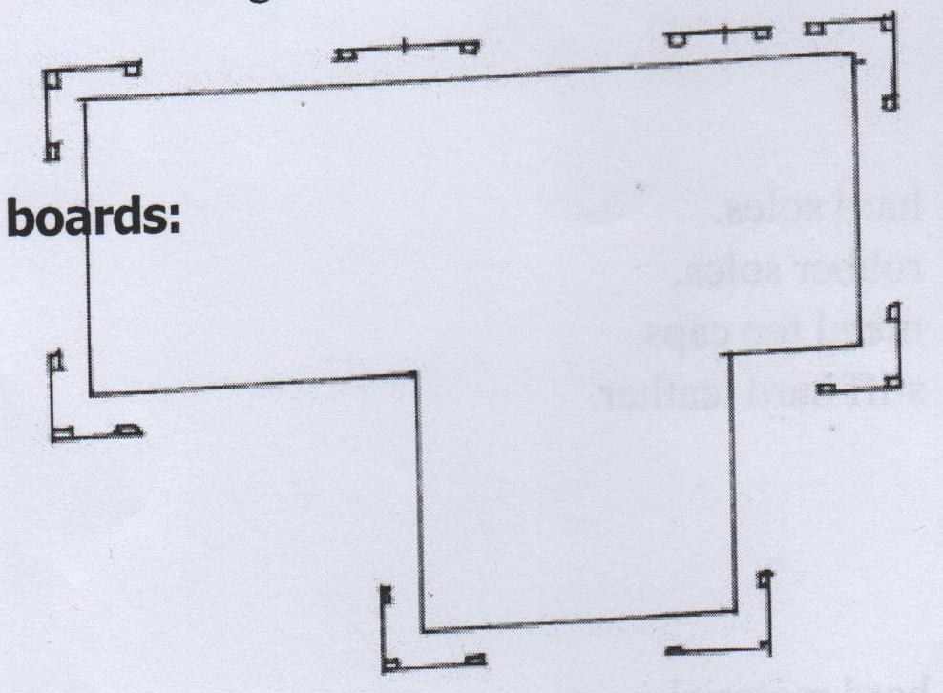
(Any 8x ½ =4 marks)

7. (a) Use labeled sketches to show the following features on a wall:
(i) Raking back
(ii) Toothing.

(b) Figure 2 shows masonry wall joints. Name the type of joints labeled (a) and (b) stating the advantage of each.

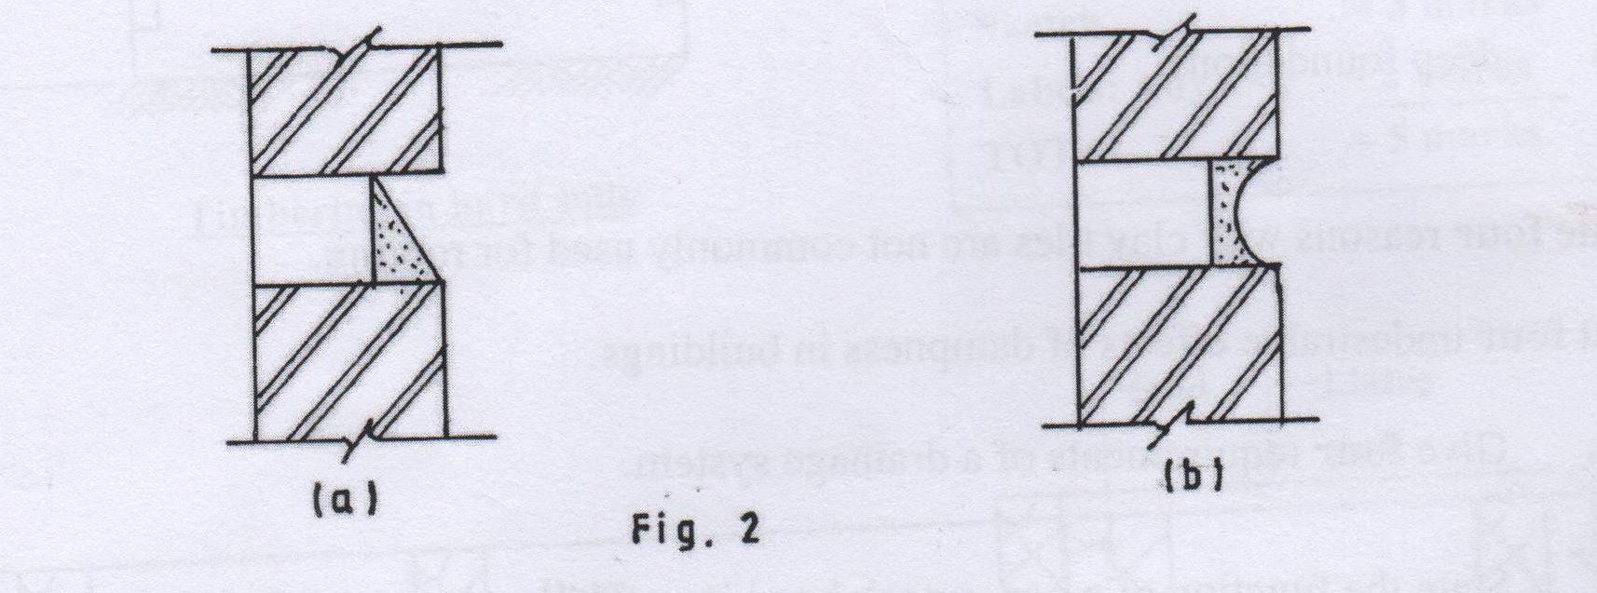

(a) Name: weather struck pointing,
Advantage: it drains off rain water easily
(b) Name: concave pointing.
Advantage: gives a decorative/ beatify finish
(Any 4x ½ =2 marks)
8. (a) list two roof covering materials for each of the following types of flat roofs.
(i) Concrete flat roof.
-build up roofing felt.
- Stone chippings mixed with tar,
-sloping screed.
(ii) Timber flat roof.
-Two coat asphalt,
- Aluminum paint on asphalt,
-Sheet metal work..
(Any 4x ½ =2 marks)
(b) State two conditions necessary when installing pipes to convey hot water.
- Pipe lengths should be short
- Related appliances should be kept in close proximity
- Joints should be water tight.
- Vertical pipes should be at 90 degrees to the horizontal
(Any 2x ½ =1 mark)

9. (a) Explain the use of pipe fittings in a pipe installation. (Give two)
- Make reduction to the diameter of pipes.
- Extend the length of pipe work.
-Change the diameter of pipe work.
-change direction
(Any 2x1 =2 marks)
(b) State two factors to be considered when sitting a septic tank.
- Possibility of connecting septic tank sewerage works later.
- Consider water table.
- Distance from houses.
- Nearby rivers, streams and flooding risks.
-Check availability of labour for maintenance and operation
(Any 2x1 =2 marks)

10.
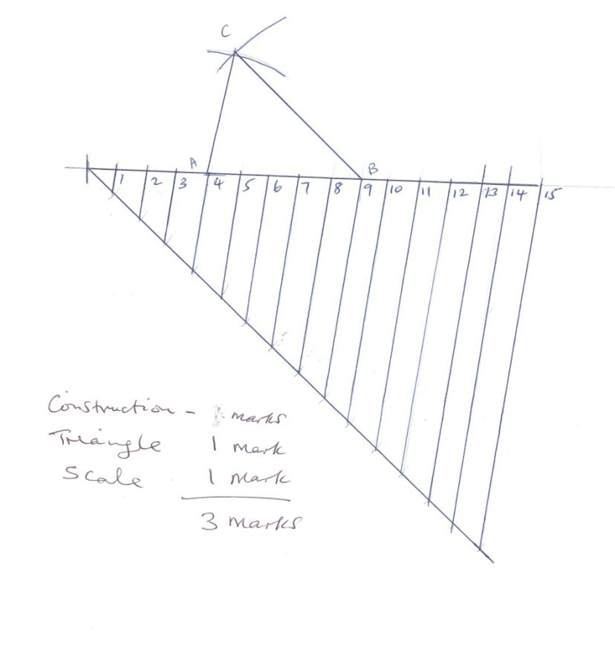

SECTION B (60 MARKS)
Answer question 11 on the A3 paper provided and any other THREE questions from this section in the spaces provided. Candidates are advised to spend not mope more than 25 minutes on question 11.

11.
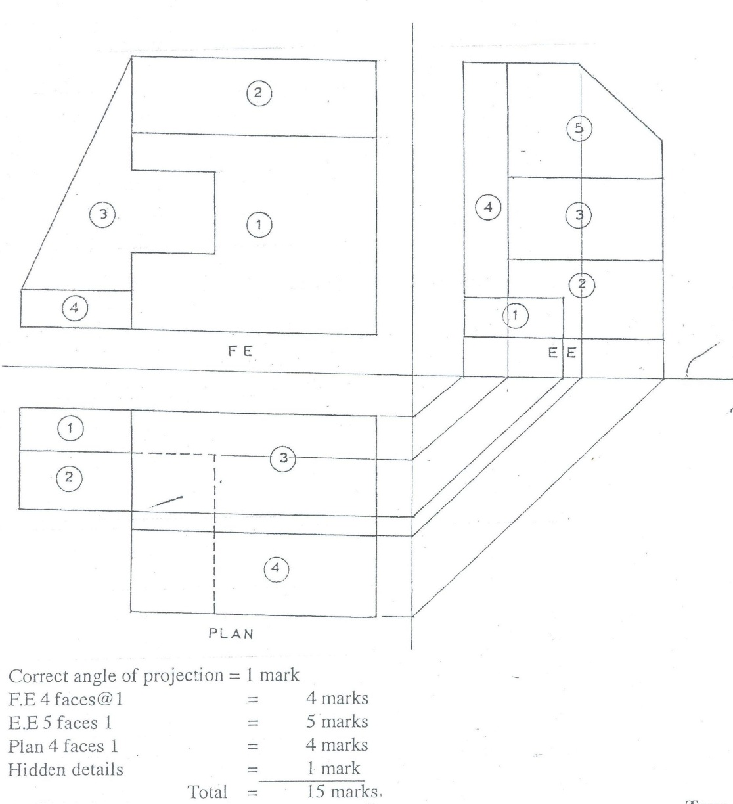

- (a) Give two advantages of twisted reinforcement bars over the round reinforcement bars when used in concrete.
-twisted bars provides better grip due to increased surface area and also increases friction.
-has higher strength.
(Any 2x1 =2 marks)

(b) Use labeled sketches to show the difference between a couple roof and a collar roof.

(c) State four methods of dropping concrete safely into a trench bottom more than 1.5 metres deep.
-chutes
-Hoist
-Convey belt
-cranes
-stepped platform
-men with karai on linen.

(Any 4x1 =4 marks

13. (a) Sketch and label an elevation of a gauged brick camber arch for a door opening.
(7 marks)

(b) State four functions of foundations in buildings.
-Provides a level base for walls.
-Transfer the loads to a firm base.
- Cover soft area in the firm base.
-Support the building.
-Load distribution over a wide area.
(Any 4x1 =4 marks)

(c) Illustrate the stages through which a standard eight leaver may undergo training up to the highest level in technical education.
-Primary level (KCPE)
-Youth polytechnic (Artisan certificate)
-Middle colleges- Craft certificate
- National polytechnic – Dip/ HND
-University (Degree / Masters / PHD
(Correct explanation 4 marks)

14. (a) Outline two reasons why concrete mixer needs a little amount of water before it’s operated?
- For easing the mix to turn properly & obtain a well prepared concrete mix.
-For safe guarding the mixture not to wear & tear easily & normally.
-To prevent sand & cement sticking on the side of the mixture.
(Any 2x1 =2 marks)

(b) Give four functional requirements of centres for arches.
- Be of sufficient strength and temporarily support the load to be imposed without distortion
-Be economical (not costly)
-Be easy to assemble and strike
- Incorporate folding wedges to allow vertical adjustment.
(Any 4x1 =4 marks)
(c) Give four precautions to take when you store cement in site.
-Check the date of manufacture.
- Store it off the ground.
-Protect it from the rain.
- Limit the height of the stacks.
- Use older cement.
(Any 4x1 =4 marks)
(d) State five functional requirements of a solid floor.
-It should prevent the passage of moisture from the ground to the upper surface of the floor
-It should be strong to carry its load and any load imposed on it.
-It should be good thermal insulator
-It should be smooth (even) without cracks
-Should not allow fungal growth to take place
-To provide a suitable wearing surface

(Any 5x1 =5 marks

15. Illustrate using a neat sketch the direct cold water supply system. Label all the parts.
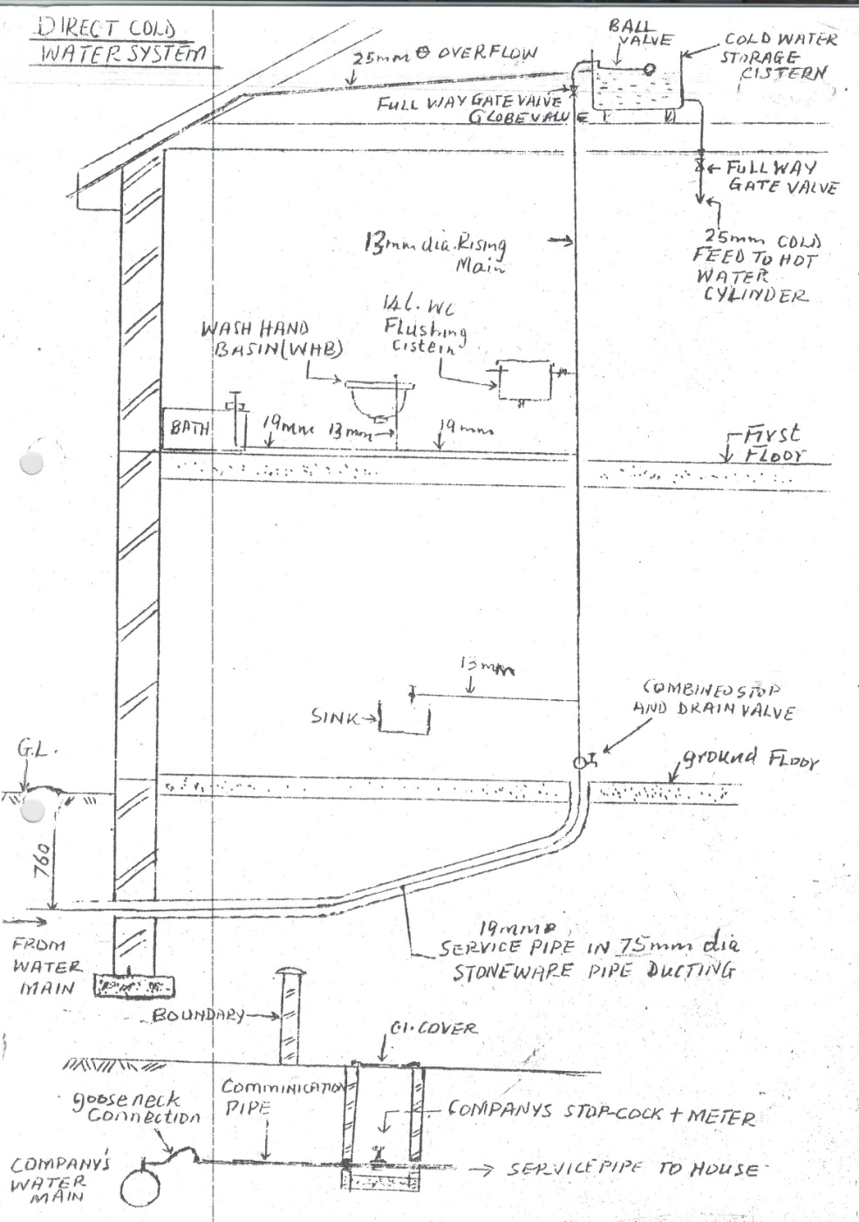

Sketch=6 marks
Any 5 appliances 5x1=5marks
Any 4 pipe sizes 4x ½ = 2marks
Any 4 valves 4x ½ =2 marks
Total =15 marks

